Yacht Club Calendar
19th-Monthly meeting/potluck

The Jib Sheet
May 2012
A publication for the Members and Friends of the Yaquina Bay Yacht Club-est. 1947
Our Mailing Address is 750 SE Bay Boulevard, Newport, OR 97365

Our Website URL
Is www.yaquinabay yachtclub.org

For questions about the Club, contact us at YBYC.email@gmail.comFor questions about or contributions to this newsletter contact Jeff Cressy, editor, at jcressy@charter.net
YBYC 2012 Officers- Commodore: Paul Erskine
Vice Commodore : Mike Fulmor
Rear Commodore: Elliott
Crowder
Secretary : Alice McNamara
Treasurer : Dorothy Bogumil

Commodores Log
Hi allya'all,

So as we get on the water, (those of us who put up in the winter), the Spring Winds are proving to be as unpredictable as ever yet there are smiles everywhere one looks while on the water. If you haven't gotten out yet, come enjoy this lovely season on the water.
There are some new boats to be dealt with in the fleet and the competition is a bit more intense than in the past, but the camaraderie after the races puts all into perspective. We are a group of people drawn together by their love of sailing and all associated endeavors and a lot of discussion and cajoling while ingesting burgers and beverages is one of the most enjoyable parts of the sport and being a member of this special community known as YBYC.
I am sad to report that Linda and Bruce Wilkinson who are our very able Membership Chair and our far reaching Publicity Chair are going to be unable to finish their terms in those positions, so we need a couple of people to step up and take those positions over.
Linda and Bruce will be able to bring you up to speed in these positions if you step up soon, and I know they have both done a lot of work to organize the output from each of their respective chair positions. The contacts with the publicity group are established and the Membership roster is up to date, Cards have been issued and the monthly addition of a member or two should be an easy transition for someone to assume. Please contact the board if you can do this, remember that it is a volunteer organization and as such requires it's members to volunteer, without that effort being put forth, we will fail...Perhaps one of the High School people with some Journalistic skills would enjoy the challenge of being the Publicity Chair and be able to advance their learning by helping out...just a thought...

We had a successful "Spring Cleanup" a week prior to the regatta. A lot of maintenance as well as some overdue issues that were dealt with, Thank you to all who came and helped with this much needed labor effort, with tools, ideas and knowhow the clubhouse was once again transformed from the Winter Blah's to a Hopeful Spring hangout.
We still have to get some details sorted out on the Boathouse and Storage issues, both projects are important and time is of the essence in regard to being able to work in better weather. The big question is can we do both with volunteer labor?
The Boathouse that remains will be moved to the East and hopefully we will be able to start on a replacement for the one we lost in March. I know there are plans being looked at and we will have a substantially larger place for the replacement to occupy.
In June, likely on the 16th we are going to try and get as many boats out on the water as possible to celebrate the Summer Solstice with our own "Sailstice" event, if you have a boat and can get free for a sail that day please join us.
Thanks to Mike and Barbara Fulmor for once again being in the Loyalty Days parade, Mac was with them and so we were represented but not well represented, it would have been nice to have had a few more members present but everyone is very busy this time of year, the Sailing Team was in Seattle for a Regatta, I was out of town for a family event, so I do understand the demands of everyday life but it is good to get exposure to potential members and this is a way to do it.
The Toledo Wooden Boat Show, Bridge to Bridge and other events are on the horizon so please think about the club when deciding how to spend some of your available time, lots of hands makes less work...
As I always say to my crew when we are discussing Racing..."remember it isn't Life or Death...it's WAY more important than that!!!
Safe travels wherever your road or waterway may lead.
Paul

Membership News

A hearty welcome to our newest sailing members:
Jeff Schrantz and Carol Ozenberger who are interested in crewing for races, cruising and kayaking & classes. They are local residents from the South Beach area. Yay Locals!
Giovanni and Annie Catalano are also a local family from Newport who are interested in cruising, racing, kayaking and classes. They bring a darling crew of 6 children. And Greg thought he had the market cornered for boat children!
A big Welcome Back to a valued past member; Don Riddell of Riddell Sheet Metals. He has been instrumental in the growth of YBYC and contributed hours and supplies for our building expansion among other things over the years. His boat is a San Juan 21 named "Going Bananas" My question is: Did the boat name come after the building project or before??? Either way, we'll enjoy having Don back.
Our beloved "Not-New Members", Pat and Mike Blackburn, have increased their family members by adding in their daughter Cathy Shields and granddaughters Avery Shields & Emily Blackburn. Welcome Girls!
Another addition is from our faithful members; Robert Jr & Cecilia Pratt, whose son Robert is in the Youth Sailing Program. They are adding their daughter Anita and we welcome the whole family.
Some great membership news is that we have been very fortunate to have 3 skilled, enthusiastic teachers that are generous in time and patience to teach the Kayaking classes. The club wants to honor their contribution and commitment to YBYC with Honorary 2012 Memberships. So please welcome Rick Hill of Seal Rock, Jack Cray of Albany Oregon, and Brian Getting of Newport.
And last but not least: Thank you to all the renewing members for 2012 who make our club active, vibrant, empowering and vital to the community. You are all valued and appreciated. See you on the water in 2012!-Linda Wilkinson

More News You Can Use

May the Vice be with You

What a pleasure it has been to get out sailing again, enjoying the excitement and challenges of racing on Yaquina Bay. Here’s hoping more boats will be joining us for the Wednesday evening fun; it’s a perfect excuse to go sailing if you need one. We’ve been showing videos afterwards taken with the gopro on Grinner, so everyone can relive the race while enjoying a burger. Though there are still some kinks to work out as far as scoring the races the night of, everyone who goes out is a winner- of great memories and great times.
The Loyalty Days Parade was lots of fun also, featuring a better parade position this year due to an early entry. That allowed us to watch the later entries after we finished, so we had our cake and ate it too. Loyal Past Commodore Mac McConnell showed up to ride with Barb in the float, and we actually won a “Special Recognition” award this year, perhaps for using the words “port of call” (this year’s theme) on our float. It was a beautiful day with not enough wind to blow decorations off, and we had several folks asking about how to join and where to sign up for lessons. Maybe next year we can have some YBYC members walking the parade passing out information to interested attendees. We also should have had some candy to give the hordes of little kids with big buckets!
After the smashing success of the Boogie for the Boathouse, there has been some talk of having more such parties to raise funds for capital improvements, both the boathouse as well as the storage building. If anybody has ideas or desires to help with planning, please post on the YBYC group or contact a board member.
Sailing classes are starting this month for Basic Keelboat, and our Adult Small Boat class scheduled for June has been getting lots of interest. Anybody interested should get signed up soon!-Mike Fulmor

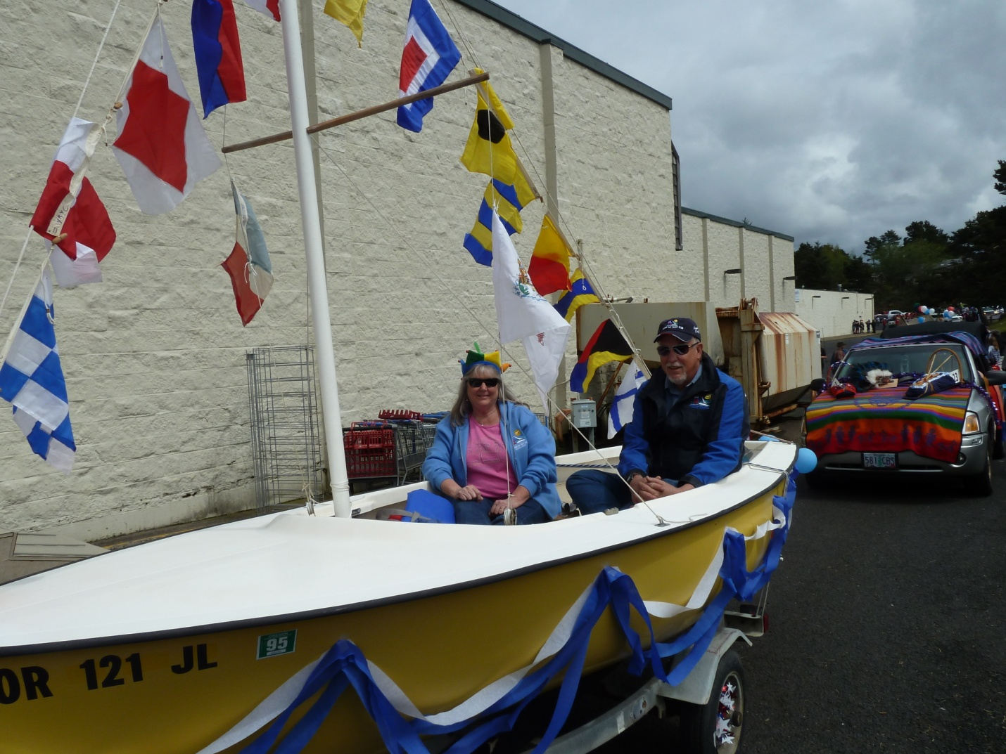

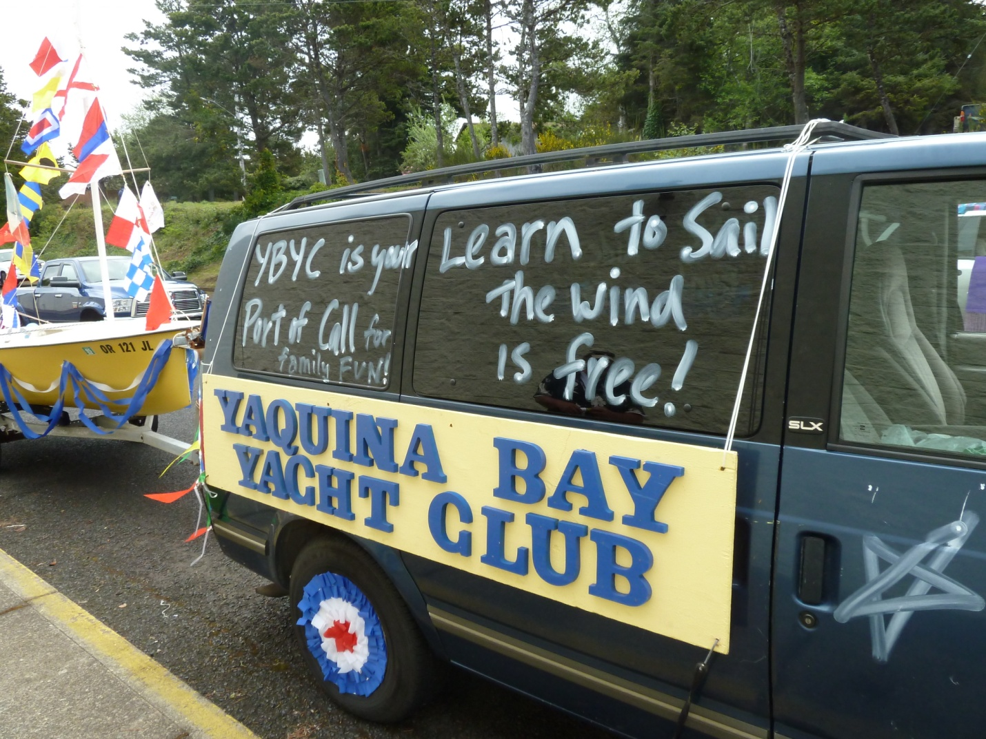

Sailing News from ‘Round the World

Giovanni Soldini and the Maderati crew are facing intense conditions, sailing through the floating icebergs of Newfoundland. At 12.36 GMT (08.36 EDT) the crew is flying at a speed of 23 knots, taking an advantage of 190 miles on Mari Cha IV, the 140 foot maxi yacht that set the New York-Lizard Point speed record in 2003.
Giovanni Soldini and his international crew of seven are facing floating icebergs and freezing 5° Celsius waters off the Newfoundland coast. Due to these severe conditions, the navigation is certainly challenging.
On board Maserati, Giovanni Soldini explains: 'We will shortly be sailing in the iceberg zone and we will be out of it in about 130 miles. The water temperature is currently at 5° Celsius. For safety reasons we have decided to slow down a little. We have been forced to follow a northerly route that takes us through the floating icebergs because the Azores high pressure is really far north. We will sail up to 49°N and then head towards Lizard Point. Both Maserati and the crew are doing great and we are really pleased with the advantage we have on Mari Cha IV. The next hours are crucial. We will keep our eyes wide open.'
Maserati left New York on May 9 at 7.20 GMT (3.20 EDT) to try and break the New York - Lizard Point speed record set by Mari Cha IV that sailed the route in 6 days, 17 hours, 52 minutes and 39 seconds. Today at 12.36 GMT Maserati still has to sail 1,862 miles.

Pictures and video at http://www.sail-world.com/index.cfm?Nid=97112&refre=y&ntid=0&rid=4

May Meeting
May 19th
6-7pm-Social
7pm Dinner

May monthly meeting and potluck will be hosted by Alice McNamara and Peggy O'Callahan. the theme... No Sinko D'Mayo!
Stay tuned to Yahoo Groups and Facebook for further explanation!

Quote of the Month
There are three sorts of people; those who are alive, those who are dead, and those who are at sea.
Old Capstan Chantey attributed to Anacharsis, 6th Century BC

Board Bits

The YBYC board met on Tues., May 1. Among the items on their agenda were: The race committee reported on the successful Spring Regatta; some specifics on upgrading the main entrance to the clubhouse to accommodate disabled persons; a new plaque to continue the sequence of commodores; upcoming events are Sailstice and the Toledo Wooden Boat Show; discussed allowing non-member parents of youth sailors to crew on the chase boat; we need more members checked out on chase boat; other issues relating to club boat use by members; looking for former members of long-standing to offer historical perspective; The Wilkinsons announced that they must resign their positions as Membership and Publicity Chairs effective July, so we'll need to appoint members to fulfill their terms. Anyone interested should contact a board member.



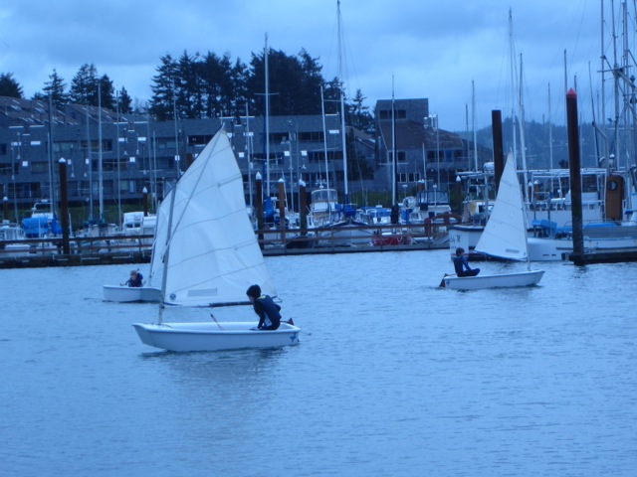
YBYC Education Classes

A big thanks to those who presented our pre race season education series, Mike Fulmor, Tom McNamara,Elliot Crowder, Laurie Weitkamp and Tim Myrick. The series was a nice addition to our program and it is good to tap into the talents within our group. Great Job!

There are both adult sailing classes and kayak classes coming up soon. The small boat sailing class is set to take place over a three week period starting June 14. Adult keelboat class information is available from Mike Fulmor.

Kayak classes start June 2 and continue until through August. The youth class schedule has been set and starts June 25 in Lincoln City and continues in various locations throughout the summer.

More information is available at the YBYC web site. Sign up early so you can enjoy the activities all summer long!

Photo from the JY portion of the Spring Regatta, Four boys age’s 6-10y competed. Tristan Scarborough (wearing a hat) took 1st place overall..-Cait Goodwin

Flotsam and Jetsam 

- Remember you can make a tax-deductible donation through the Oregon Boating Foundation. The money is used to provide community boating education and all donations are greatly appreciated. For monetary or other donations please contact OBF Chair Dan Van Calcar.

- The club has a fleet of sailboats available for club member use. These include Lidos, 420s and a small keel boat. These boats are fun to sail and explore Yaquina Bay. Check the Member's Handbook or with the YBYC Fleet Chair Tom Mcnamara at ; mailto:mcntm@msn.com for details on vessel use and to make reservations. Reservations are posted online on the club’s website http://www.yaquinabayyachtcluborg under the ‘Calendar’ tab.

Wednesday 420 reservation website-
https://spreadsheets0.google.com/spreadsheet/ccc?hl=en&key=tZvTrAppsstef-nGGCMmWDA&hl=en#gid=12

- Don’t forget to use our Yahoo group site at http://groups.yahoo.com/group/ybycgroup/ It’s the best place to keep up on club and member activities, chat and exchange info with fellow members. You can also read Board minutes. The Club also has a Facebook page, check it out! It’s updated frequently so you can be sure to keep abreast of club activities.

- Ships Store- Please do not forget to check out all the fine items at the ships store. Not only are you buying quality merchandise you can use, but it helps support the YBYC!


Editors Corner
Greetings:
It is nice to see the glory of the sunshine. I hope everyone is able to take advantage of it.
Paul does such a good job recapping the Club’s activities, I have to be careful not to be repetitive. So I will just say thank you to all who volunteered on our various activities. I can be sure I did not leave anyone out. We can always use more volunteers, of course.
As most already know, it has been a rough few weeks for the sailing community. Several incidents and fatalities serve to remind us to never take safety for granted. We all know that racing, whether it on land, sea, or air is by definition dangerous. Please be proactive in all your endeavors. Safety is no accident. Cheers.
Jeff

Member-2-Member Network
Have you ever needed a carpenter, cabinet maker, tile setter, tire company and didn’t know who to call? Ever needed to have an item on your boat or home repaired, but had no idea where to call? Rather than calling a stranger or looking in the yellow pages, call another YBYC member! Every member who runs a business or performs a service is encouraged to signup. It’s totally FREE to members! Non-members pay a nominal fee. Want to get yourself listed? Email the YBYC newsletter editor at jcressy@charter.net with your listing information. We need to support our own, especially in this economic climate. Please consider doing what you can.

Alan Brown Tire Center (Les Schwab)
Ken Brown manager (541) 265-6604
1155 SW Coast Hwy
Newport, OR 97365
Email: tyrguy@yahoo.com

Dr. Kenneth S. Bishop
Chiropractic Physician
111 SE Douglas
Suite F-1
Newport, OR 97365
541-264-8138
www.yaquinachiropractic.com

Vicki Krutzikowsky
Shaklee product distributor
www.healthydedication.com
541 264-8039
vickihoosky@hotmail.com
American Home and Stone---541-929-3100
Members: Shane and Mac McConnell
Cabinets, tile, granite countertops, stoves (wood, gas, pellet), spas: Discounts
www.americanhome
Ocean Pulse
Custom Surfboards, Skateboards, and Snowboards
Tom McNamara (541) 265-7745
428 SW Coast Hwy
Newport, OR 97365
www.oceanpulsesurf.com

Bike Newport
Elliott & Daniella Crowder, Owners
150 NW 6th Street
Newport, OR 97365
(541) 265-9917
website: bikenewport.net
email: bikenewport@charter.net

Member-2-Member-(cont.)
Kevin Raichl Cindy Milligan LMT# 6107
Visual Thinking Northwest Drift Away Massage
828 SE Crescent Pl. 310 NW 5th St. Suite 102
Newport, OR 97365 Corvallis, OR 541-753-4785
541-264-8343
541-480-2355 cell
www.visual-thinking.com

True Cut Engraving
Stephanie Brown
403 SW 10th Street
Newport, OR 97365
TrueCutEngraving@qwestoffice.net
541-265-9326

Diane Henkels, Attorney The Gallery at Otter Rock
Based in Newport and Portland Tish and Larry Epperson, owners
t: 541-270-6001 845 First Street, Otter Rock, OR
e: dhenkels@actionnet.net 97369 541-765-2365
Biz, environment, Indian law, and energy issues.

YBYC Classified

???????????
Angela Sivers, Licensed Massage Therapist
Newport: Ocean's Way Naturopathic Clinic, at 644 SW Coast Highway, Suite D
Lincoln City also. 541.264.0423
http://www.centralcoastmassage.com e-mai; centralcoastmassage@gmail.com

