Yacht Club Calendar
16th-Sailstice/monthly meeting/potluck

The Jib Sheet
June 2012
A publication for the Members and Friends of the Yaquina Bay Yacht Club-est. 1947
Our Mailing Address is 750 SE Bay Boulevard, Newport, OR 97365

Our Website URL
Is www.yaquinabay yachtclub.org

For questions about the Club, contact us at YBYC.email@gmail.comFor questions about or contributions to this newsletter contact Jeff Cressy, editor, at jcressy@charter.net
YBYC 2012 Officers- Commodore: Paul Erskine
Vice Commodore : Mike Fulmor
Rear Commodore: Elliott
Crowder
Secretary : Alice McNamara
Treasurer : Dorothy Bogumil

Commodores Log
Hi Allya'all,
We are well into the Racing Season for the Spring at this point and the mayhem of the first few races has given way to interesting wind vs tide issues and finally to one of the most fun races I've been in since racing on this bay.
Last night's race saw the lead be held, however briefly by almost every boat on the course. The tactics were many and the wind direction was within 360 degrees at all times...a parking lot of boats was at the finish line and the horn was a staccato like sound...lots of fun...
On that same vein, the cleanup after the Wednesday race was shared by many more people last night, this becomes an issue at times when it is left to a few to do the work of many. The dinners have a prep, cooking and cleanup component and if you didn't help out in at least one of those aspects and you ate dinner, you haven't done your part...A BIG thank you to all who do so much week after week...
Daniella Crowder has graciously stepped up to take the Publicity Chair position, Thank You Daniella...that leaves the position of Membership Chair with a void, Linda and Bruce Wilkinson are no longer going to be able to fulfill those roles so PLEASE step up if you can and take the Membership Chair. The position is critical to the health of our organization and at this point will be easy to assume because the organizational and beginning of the season heavy lifting has been done and at this point Linda could take you through the system she has developed.
On that note I want to thank Linda and Bruce for all their fine work on our behalf. Tthey assumed the reins on two of our board positions and did a fine job of getting the parameters of each established in a way that should make a smooth transition for whoever follows them. Go forth and do well in whatever endeavors you pursue, it has been a pleasure getting to know you.

There has been tepid response to the Bridge to Bridge race this year but fear not...there are a bunch of other opportunities to volunteer that weekend, the Toledo Wooden Boat show and a bunch of Dinghy Sailors...(aren't we all a little dinghy? ) will be participating in a Portsmouth Spectacular on the bay which will encompass a C-15 Regional championship and general racing with Portsmouth type vessels...Tuna-Q to follow...
When Englund Marine has their Parking Lot Sale in July, OBF our sister organization devoted to youth sailing and a non-profit, will be having a nautical garage sale. If you have extra gear with which you can part AND receive a deduction for your taxes, please consider donating it to their sale.
The Past Commodores Planning group have been wrestling with the Boathouse and Storage issues and hopefully can come to an agreement and proceed toward actual building of these important projects...we are outgrowing our space so this is a logical direction in which to be heading.
The Devil's Lake Revival is going to be held on August 4th this year, if there are participants amongst the youth who are interested in competing. We need to get organized in a timely manner as this is an extremely busy time of the year.
The first Kayak class has been completed for the year and we are grateful to have Tom Murphy as the master instructor for these wonderful and well done classes, there are a few more opportunities to take advantage of the classes this summer and we will have a couple of Kayaks on the dock in the very near future for those who have been checked out to use.
We still need to have Chase Boat Drivers to get checked out and participate in the Wednesday Night Races and other classes, Barry or Tom can check you out if you are able to participate. This is a fun way to get out on the water and see the Races and the Kids sailing and just enjoy our beautiful location.
I hope you all have a lovely summer and are able to thoroughly enjoy all the experiences that living in this glorious area has to offer, we are truly blessed.
Paul

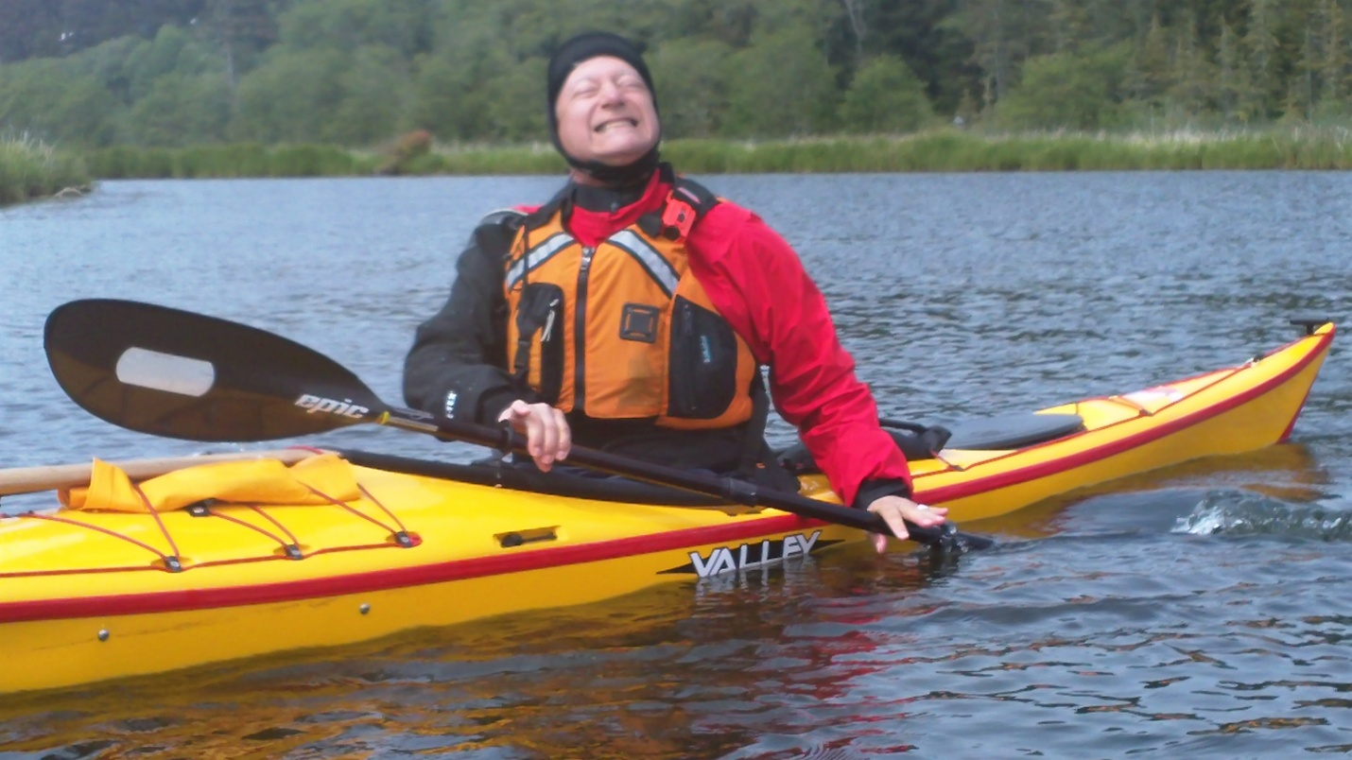
Would you buy a car from this man? Neither would I. But I’ll bet you would take a kayaking class from him. Check out the club website: http://www.yaquinabayyachtclub.org/classes/classes.php-courtesy
-courtesy of Joe Novello.

More News You Can Use

High School Sailing – District Regatta

Four of our high school sailors ended their season with a trip to the district regatta which was held at the Center for Wooden Boats in Seattle. Skippers Kim Smith and Josh Viar sailed with their crews, Austin Versteeg and Zoee Shaerer competed in fourteen races against sixteen teams over a two day period.
We arrived in Seattle on Friday early enough in the afternoon for a bit a practice on Lake Union. The sky was overcast with some drizzle and very light winds.
The light winds persisted throughout the first day of racing on Saturday. There were several delays due to a lack of wind. The first day of racing was quite an eye opener for our sailor who are used to sailing in a large area with big winds and few obstructions. Besides a large number of boats on a small course, our crews were constantly looking over their shoulders for sea planes that were using the race course as a run way. We averaged about four take offs and landings each hour and the pilots were not shy about getting close to our boats.
On Sunday the winds picked up and the skies cleared. Our crews were able to sail in conditions closer to what they were used to and began to perform much better. Their confidence showed as they placed in the middle of the fleet for most races. Josh and Zoee competed in the “A” fleet aboard a Vanguard 15. They placed 13th overall in their fleet. Kim and Austin competed in Flying Juniors (FJs) and also placed 13th in their fleet. When the fleet scores were combined, we placed 14th overall due to the 14th place boat in each fleet being from different teams.
The racing was intense and was balanced by some great relaxation off the course. Josh won the grand prize, a gift certificate for $100 at Helly Hanson. We took a quick trip to the mall where some of our youth were able to experience a multilayer parking garage, glass elevator, and escalators for the first time. Josh purchased a very cool sailing smock which he will gladly model at future local races.
We would like to thank the many people who helped make it possible for our kids participate in this event. The Newport High School Boosters and the Yaquina Bay Yacht club provided the majority of the funding. We are especially thankful to families and employers who gave the kids a weekend furlough to have this experience of a lifetime. –Joe Novello

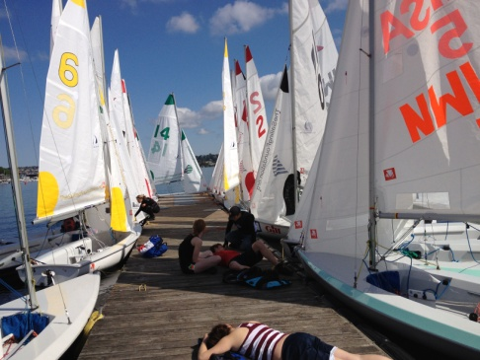
Wind delay
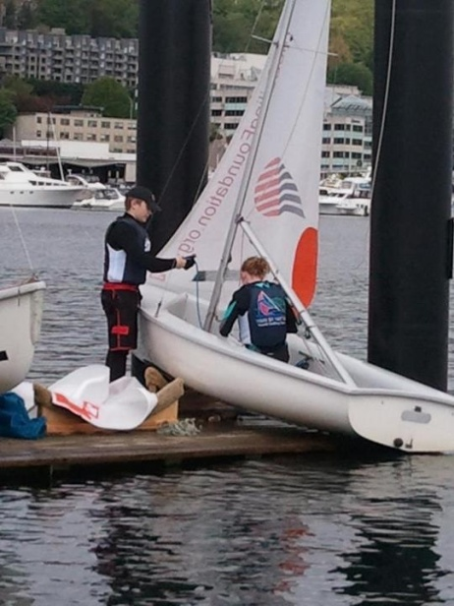
Kim and Austin prepare their
boat

boat

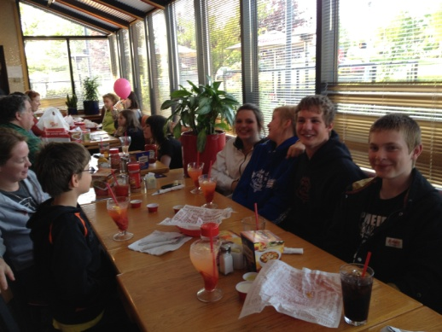
End of Regatta Celebration at Red Robin

Sailing News from ‘Round the World

In 1995 Hampton University became the first and is still the only
Historically Black College or University (HBCU) to field a competitive
sailing team. The 144 year-old institution sits on the shores of Hampton,
Virginia; providing a perfect venue for college sailing. The team was in
large part the brain child of world renowned sailor and current President
of US Sailing, Mr. Gary Jobson. Jobson recruited HU's first sailing coach,
Gary Bodie, who after 3 years at the University, went on to coach the US
Olympic Team in Australia, Greece and China.
HU's team has overcome the challenge of building a team out a student body
comprised of few individuals that had ever set foot on a sailboat before
coming to college. Through dedication and hard work, the HU team has
qualified for nearly every conference championship since 1996. HU's sailors
have also found success after graduation. For example, Devin Walker, the
team's first captain went on to be the first African American to earn a
Ph.D. in physics from Harvard, and who is now a professor at Stanford.
Hampton University has joined with perennial sailing power and close
neighbor, Old Dominion University, to host the 2013 ICSA National
Championship Semifinals, next spring. In order to host this event, HU is
responsible for purchasing 18 of the 36 new FJ boats needed for this
competition. HU and its partner, ODU, will host the top 36 teams from
around the country and is in the process of trying to raise $50,000.00
dollars to put toward the purchase of these boats.`

June Meeting
June 16th
6-7pm-Social
7pm Dinner
The Myricks and the Williams will be hosting the June meeting. It will be a fitting conclusion for the sailors after the afternoon of Salstice and a good time for all YBYC members. The theme will be a start of summer/Father's Day barbecue. The club will provide the bratwurst and all the fixings to go with them. Please bring a side dish or dessert to share. Remember to bring your own drink and table settings. Hope to see you there!

Quote of the Month
"The sea finds out everything you did wrong."
Francis Stokes

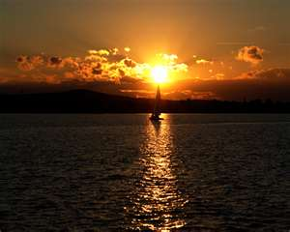

Board Bits

Your YBYC Board met on Tues. 6/5, and here are some of the items from their agenda.
Ways to improve volunteerism among more members; race safety re: conditions; Daniella Crowder has stepped up to be Publicity Chair; Cait Godwin has volunteered to edit the Newsletter; plans for kayak storage for easy access; plans to put some Lidos on the dinghy dock; Toledo Wooden Boat Show; Committee and Chase boat assignments; Bridge to Bridge race and Portsmouth Regatta in August; And plans for the August monthly meeting.


Membership News
YBYC is very happy to announce some student members, some
student members, some returning members, and some brand new
members to our clan.
Student Members are Kim Smith and Connor Mercer. Kim is a
returning student team member and Connor has jumped on board for the first time. Both of them are dedicated to the sailing program and have been out on the water working hard fine tuning their skills to contribute to the strength of their sailing team. The students practice five days a week after school and also sail on the week-end. We are proud of all our students. Go Kim and Connor!!
As far as our Returning Members:
It's a great pleasure to say, "Yay, you've returned!", to our former members Neal McIntosh and Dan Coffman, both marine biologists. Neal and I had coffee together in Corvallis and I found her to be a delightfully enthusiastic and knowledgeable sailor lady who started sailing as a child and ended up as an instructor. With her Master's completed at OSU, she and Dan are looking forward to having time to spend on the water with YBYC. They both work on research expeditions with NOAA, where Dan has been a contracted scientist for several years.
In the New Member Category we are proud to present:
Ryan Easton, Maggie Sommer & PJ Collson with son Finn Collson, plus Randy and Sarah Tripp, daughters Ashleigh and Haley Tripp.
Ryan is currently enrolled in OSU, working at the Oregon Dept of Fish & Wildlife and resides in Newport. He's looking forward to cruising, kayaking and of course Pot-lucking with YBYC, alongside his interests in fishing and power boating. We look forward to having him as crew and boating buddy.
Another local family has become part of our YBYC family and that is Maggie Sommer & PJ Collson with their delightful 5 year old Finn. Maggie also works at the Dept of Fish & Wildlife and is a very experienced sailor along with PJ who works for the Lincoln County School District. They are interested in classes, cruising, kayaking and potlucks. Finn is interested in eating and playing and eating...and playing
And a warm welcome is extended to our drop-in-for-a-beer guest Randy Tripp, with wife Sarah and daughters Ashleigh and Haley. We were fortunate to be on Randy's path to town for refreshments, when he found the fundraising party at the club and decided to walk no farther. We benefited most when we found a friendly, outgoing fellow boating mate who enthusiastically signed his family on to be our new members and friends. They will be at the June Potluck so be sure to greet them and all our new members. -Linda Wilkinson,YBYC Membership Chair

Flotsam and Jetsam 

- Remember you can make a tax-deductible donation through the Oregon Boating Foundation. The money is used to provide community boating education and all donations are greatly appreciated. For monetary or other donations please contact OBF Chair Dan Van Calcar.

- The club has a fleet of sailboats available for club member use. These include Lidos, 420s and a small keel boat. These boats are fun to sail and explore Yaquina Bay. Check the Member's Handbook or with the YBYC Fleet Chair Tom Mcnamara at ; mailto:mcntm@msn.com for details on vessel use and to make reservations. Reservations are posted online on the club’s website http://www.yaquinabayyachtcluborg under the ‘Calendar’ tab.

Wednesday 420 reservation website-
https://spreadsheets0.google.com/spreadsheet/ccc?hl=en&key=tZvTrAppsstef-nGGCMmWDA&hl=en#gid=12

- Don’t forget to use our Yahoo group site at http://groups.yahoo.com/group/ybycgroup/ It’s the best place to keep up on club and member activities, chat and exchange info with fellow members. You can also read Board minutes. The Club also has a Facebook page, check it out! It’s updated frequently so you can be sure to keep abreast of club activities.

- Ships Store- Please do not forget to check out all the fine items at the ships store. Not only are you buying quality merchandise you can use, but it helps support the YBYC!


Editors Corner
Greetings:
I know this a busy time for many people and some YBYC events are not listed in the newsletter. That is why it is extremely important to check our Facebook page, Yahoo group, and website regularly to find out the very latest on Club activities.
Congratulations to the High School Sailing Team and those who volunteer so hard to help coach, teach, and motivate these athletes. A special thanks to Joe Novello.
Elliott has put out the call for volunteers for the Toledo wooden boat show. If you can help, please contact him.
Also available on our website are several hundred pictures of Wednesday night racing courtesy of Joe Novello. They are well worth a look. -Cheers, Jeff

Member-2-Member Network
Have you ever needed a carpenter, cabinet maker, tile setter, tire company and didn’t know who to call? Ever needed to have an item on your boat or home repaired, but had no idea where to call? Rather than calling a stranger or looking in the yellow pages, call another YBYC member! Every member who runs a business or performs a service is encouraged to signup. It’s totally FREE to members! Non-members pay a nominal fee. Want to get yourself listed? Email the YBYC newsletter editor at jcressy@charter.net with your listing information. We need to support our own, especially in this economic climate. Please consider doing what you can.

Alan Brown Tire Center (Les Schwab)
Ken Brown manager (541) 265-6604
1155 SW Coast Hwy
Newport, OR 97365
Email: tyrguy@yahoo.com

Dr. Kenneth S. Bishop
Chiropractic Physician
111 SE Douglas
Suite F-1
Newport, OR 97365
541-264-8138
www.yaquinachiropractic.com

Vicki Krutzikowsky
Shaklee product distributor
www.healthydedication.com
541 264-8039
vickihoosky@hotmail.com
American Home and Stone---541-929-3100
Members: Shane and Mac McConnell
Cabinets, tile, granite countertops, stoves (wood, gas, pellet), spas: Discounts
www.americanhome
Ocean Pulse
Custom Surfboards, Skateboards, and Snowboards
Tom McNamara (541) 265-7745
428 SW Coast Hwy
Newport, OR 97365
www.oceanpulsesurf.com

Bike Newport
Elliott & Daniella Crowder, Owners
150 NW 6th Street
Newport, OR 97365
(541) 265-9917
website: bikenewport.net
email: bikenewport@charter.net

Member-2-Member-(cont.)
Kevin Raichl Cindy Milligan LMT# 6107
Visual Thinking Northwest Drift Away Massage
828 SE Crescent Pl. 310 NW 5th St. Suite 102
Newport, OR 97365 Corvallis, OR 541-753-4785
541-264-8343
541-480-2355 cell
www.visual-thinking.com

True Cut Engraving
Stephanie Brown
403 SW 10th Street
Newport, OR 97365
TrueCutEngraving@qwestoffice.net
541-265-9326

Diane Henkels, Attorney The Gallery at Otter Rock
Based in Newport and Portland Tish and Larry Epperson, owners
t: 541-270-6001 845 First Street, Otter Rock, OR
e: dhenkels@actionnet.net 97369 541-765-2365
Biz, environment, Indian law, and energy issues.

YBYC Classified

Please remember the YBYC has Lido’s for sale. If you are not
Interested, perhaps you know someone who is!
Angela Sivers, Licensed Massage Therapist
Newport: Ocean's Way Naturopathic Clinic, at 644 SW Coast Highway, Suite D
Lincoln City also. 541.264.0423
http://www.centralcoastmassage.com e-mai; centralcoastmassage@gmail.com

