Yacht Club Calendar

The Jib Sheet
April 2012
A publication for the Members and Friends of the Yaquina Bay Yacht Club-est. 1947
Our Mailing Address is 750 SE Bay Boulevard, Newport, OR 97365

Our Website URL
Is www.yaquinabay yachtclub.org

For questions about the Club, contact us at YBYC.email@gmail.comFor questions about or contributions to this newsletter contact Jeff Cressy, editor, at jcressy@charter.net
YBYC 2012 Officers- Commodore: Paul Erskine
Vice Commodore : Mike Fulmor
Rear Commodore: Elliott
Crowder
Secretary : Alice McNamara
Treasurer : Dorothy Bogumil

Commodores Log
Hi Allya'all,
Well, as I remove my water wings and look forward to launching into the Spring Racing Season many thoughts abound...What a March!!!
The"Boogie for the Boathouse" went off, and fun was had by all I hope. My wife and I have had a world class cold for the last 10 days so I chose not to take a chance on subjecting anyone to it, but the decorations were looking superb on Saturday Afternoon. Rumor has it that it was a success not only on the fundraising side but on the Fun Meter as well...thanks to all that helped to bring this together in such a quick and efficient way.
The sinking of the boathouse brings an opportunity, we can use the space and enlarge on the size of the one that is now gone to facilitate a really useful structure from which we can conduct the youth sailing program giving them more time on the water and less time schlepping items of need back and forth from the clubhouse.
In order to get this project going we have enacted a new long range planning group comprised of the recent past Commodores who are interested in the idea of staying connected through their desire to help the direction of the club continuing forward toward goals established but not realized over the past few years. This is a really good program, I look forward to joining next year...
The High School Sailing Team is off to a rousing start, the kids are out on Monday and Wednesday evenings and will be participating in the Wednesday Evening Spring Racing series as well. They have already participated in a regatta and done better than they did last year so CONGRATULATIONS to them.
I want to thank all the Members (and non members) who helped out on the "recovery" of the old boathouse we lost earlier in March. There was a concerted effort and lots of volunteering that mitigated a pretty ugly situation. There are too many people to thank individually here but I was really impressed how quickly all the resources were garnered to take the situation in hand and bring it to a satisfactory if unfortunate conclusion.

All of the pertinent items within the boathouse were saved, only the building and flotation system succumbed to Mother Nature's wrath.
There is a new check out procedure for the Chase Boat, this is to have a cadre of similarly trained operators for this most vital function, it has been brought up to date with the current requirements and you need only contact one of the instructors if you wish to get qualified.
Soon all the colorful Chutes will be flying, lighting up the afternoon sky with a vibrancy of color atop fiberglass toys full of enthusiastic, dedicated, happy people pursuing their passion and entertaining those on shore with a dazzling upgrade of an already spectacular view. This year there will be a very competitive group of sailors all of which are well prepared to be the bug or the windshield...as I see it there will be at least 6 boats under the 200PHRF status which ought to make for some great competition in that group, and to the victor go the spoils...
There are 2 more sessions of pre-race type classes before the season begins, Tim Myrick on Starts and from Mike Fulmor and Greg Krutzikowski on Rules of Racing, both of which will be very helpful, standby for updates on dates and times.
On the 21st of April we will have a "Spring Cleanup" at the clubhouse. This annual event is an opportunity to get the facilities up to speed for the busy Summer season of renters and events. There will be lots of different tasks that will need to be performed, including Gardening, Window Washing, Paint touch up, etc., etc., etc. so mark your calendars for this fun event and come meet your fellow club members to get this done, "Many hands makes for less work"
It is OUR club...
And one last thought for the month, this could work on a T-shirt...
"Sailing isn't the answer...Sailing is the question...,"..."YES is the answer..." See you on the water...Paul

CHASE BOAT CREWS NEEDED
Race season is fast approaching, and a chase/safety boat will be essential, especially during dinghy races. Over the years, many club members have been checked out in, and certified to operate our Boston Whaler. This year, for the first time, we will use the US Sailing protocol for safety boat training, and will require all persons who will volunteer for this duty to go through the new check-out with one of our recently qualified instructors. Our goal is to have a large number of members qualified, or re-qualified by mid-summer. The following members are now certified to conduct the training: Greg Krutzikowsky, Elliot Crowder, Mike Fulmore, Tom McNamara, and of course, Barry Semple, who brought us up to date on training, and certified the trainers.
Please contact one of the trainers, or Tom, fleet chairman, to set up a time for training. Allow about 2 hours for 2 or 3 people at time to complete the process.
With 4 trainers, we should be able to provide flexible shceduling.
To participate, you must have a valid Oregon Boaters Card, and a PFD. "You must also be 18 or over and have provided the fleet chairman a signed boat use agreement http://www.yaquinabayyachtclub.org/clubboats/boat%20use%20agreement.pdf)."
This is a very important responsibility, and we will all benefit from having a strong pool of Whaler drivers. Furthermore, power boat operation is a rare skill among sailors, and you will learn that is not as easy as it looks!
Tom Mcnamara
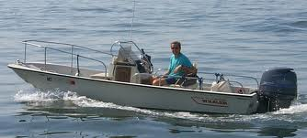

More News You Can Use

Free Ad Vice – “worth every cent”

Another month has flown by, and the sailing and racing season is starting to heat up. Everyone is waiting anxiously to find out what kind of newfangled supersonic sailboat Mac will come up with in his new bid to beat the fleet, and those of us with our tired old boats are doing all we can to remain competitive! ☺ With just a couple weeks left before the Spring Regatta (April 28-29), all the crews will be scrambling to dust off our rusty sailing skills. There is talk of a spectator boat this year, allowing more non-racers can get closer to the action, and it should be a good show with a C-15 championship and possibly small-boat regatta going on at the same time as our PHRF regatta.
The following weekend, May 5, is Newport’s famous Loyalty Day Parade, and once again your club will have an entry. We’ll be decorating the little yellow boat into a float again, and anyone who would like to help Friday afternoon before the parade is welcome, but Saturday we really need lots of parade walkers of all ages to pass out candy and show what a nice fun bunch of folks we are, not a bunch of snooty yachters. It isn’t that far to walk, and we can all use some exercise, right? We’ll have shuttle service to and from the club, by the way. Please call or e-mail Mike and Barb if you want to help make this a big success.
As liaison board member with OBF this year, I have volunteered to organize a “Treasures of the Bilge” sale to coincide with Englund Marine’s big sidewalk sale around the 4th of July. We are asking everyone to dig out those unused boating-related items from the shed, garage, basement, lazarette, and of course, bilge, and donate them for this fundraiser sale. The OBF will offer a few kayaks, a couple of anchors, and maybe a usable C-15 on a trailer for starters, and will appreciate anything we can come up with. Since OBF is a non-profit, you can deduct your donations from your taxes, so it’s a win-win. Once again call or e-mail me for pick-up or drop off arrangements. Somehow, those docks are going to get built, and we’ll all benefit. There will be more reminders, just wanted to get you thinking about what you might want to get rid of.
That’s about all I’ve got for now, hope to see everyone at the monthly potluck/meeting the 21st, until then, fair winds.-Mike Fulmor

What boat should I buy my child?

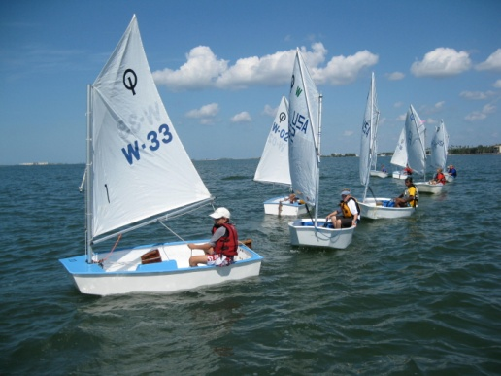A lot of conversation around the docks lately has been about what boat parents should purchase for their child who wishes to become a youth sailor. Many factors must be considered when making such a decision including, how to transport the boat, where to store it, how to maintain it and many more. The youth sailing coaches in our club have done a lot of research and spent many hours in discussion about the issue. The conclusion is the best boat for young sailors in our club is an Optimist Pram sometimes called an Opti.

The Opti is an eight foot pram designed as a youth trainer in 1948. It is a hard chined, pram bowed dinghy with a sprit sail. The boat is about 7 ½ feet long and 3 ½ feet wide. It is very easy for an eight year old to sail yet exciting and technical enough for a 15 year old to sail. Competitive boats are available in fiberglass while more affordable boats may be available in wood. The cost fiberglass boats ranges from about $800 for a used boat to about $3500 for a top of the line competition model. Some members of the club are looking into building wood models which should keep the cost below $500.

The reason we have chosen Optis as the boat for our youth is that they are the boat currently being used for youth sailing in our region as well nationally and internationally. The boat has the same hull shape and uses a sail rig identical to the JY trainers our club currently uses. The difference is that our JYs have a double hull and floatation tanks which eliminate the need for floatation bags that are used on the Opti. The trade off is on the JY is less room for larger sailors.
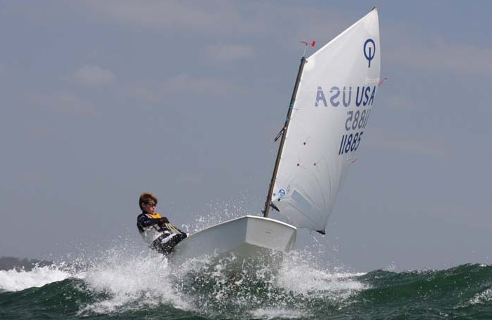
The YBYC board is currently looking at ways to help youth with boat storage. Transportation and maintenance issues would be minimized with some of the ideas currently being presented.

We are hoping club members and parents will work together to help us build a fleet of Optis for our kids. Optis and JYs can race as one fleet. This is exciting because our kids already know how to sail JYs and plan to be on the water every week during our Wednesday evening races.

For more information you may contact one of the youth sailing coaches or look up the International Optimist Pram on the web.-Joe Novello

Sailing News from ‘Round the World

American Ronnie Simpson is a wounded veteran of the Iraq war. The 27-year old was wounded in combat in 2004 and eventually medically retired. Now an aspiring solo ocean racer, he's completed one Single Handed Transpac, and this summer he's doing the race again - on his Moore 24.
Simpson claims that sailing has pretty much saved his life, a life that at 19 years of age he wasn't sure he wanted after returning severely injured from Iraq. His discovery of sailing came literally at a moment when he'd reached an all-time low in 2008, long after his return to civilian life. His brother called and suggested that they buy a boat to sail around the world. For
whatever reason the vision set with Ronnie and he instantly began researching sailboats. He'd previously never set foot on a sailboat.
Today Simpson lives on a cruising boat in Alameda, California, with his Moore 24 tied up on the same dock. His sailboat racing is sponsored by Hope For The Warriors (HFTW), an east-coast based nonprofit that aids veterans returning to civilian life. It's the first time the organization has been involved with sailing. Simpson's working not only to raise awareness for HFTW, but also for the bigger cause that he's championing - introducing wounded veterans to sailing.The benefits? Sailing is inspirational and that's what returning vets need, Simpson said.


April Meeting
As of press time, I had no firm information on this month’s meeting. It may coincide with the Spring Regatta. Please check Facebook and Yahoo Groups for upcoming information. I hope to see you there.-ed.

Quote of the Month
The lovely thing about cruising is that planning usually turns out to be of little use.
- Dom Degnon

YBYC Education Classes

Tim Myrick has agreed to do a Thursday night class on race starts April 19. The class will start at 7 pm and will be held at the club house. As we all know, Tim is wickedly good at finding the right spot at the right time at that start line. Bring questions, libations, notebook, etc...
The following Monday, April 23, the Race Committee will have a training session on how to run the committee boat. This will cover how the races are to be conducted and some of the more important rules of racing. Everyone involved with the races are encouraged to attend. It will be held at the club house at 7 pm and last about one hour. Everyone involved with the races is encouraged to attend.-Anne Williams

Board Bits

Your YBYC board met on 4/3 and here's what went down: Stephanie Brown report on "Boogie for the Boathouse" preparations; plans for the May parade were begun; needed improvements for the clubhouse include, especially access to the front door by disabled persons; safety/chase boat training will begin soon; classes on race starts, committee boat duties, and rules are being scheduled; race season details have been posted to the yahoo group; and we sadly learned that Jeff Cressy is resigning as editor of the Jib Sheet, and we will seek his replacement, though his shoes will be hard to fill.


Funny Bonz

Definitions from: SAILING (a pocket dictionary) by Henry Beard
and Roy McKie, c. 2001 Workman Publishing, NY.

Day Sailer, n. Open sailboat without living accommodations or amenities, used by sailors whose idea of fun is to see how far they can get from the nearest toilet in just a few short hours.
Deck Shoe n. A canvas shoe with a rubber sole having a specially designed tread that provides for secure footing on deck unless the deck is wet, the shoe is somewhat worn, the deck is worn, or the shoe is wet.
High School Sailing Update
Lincoln County High School Challenge Cup

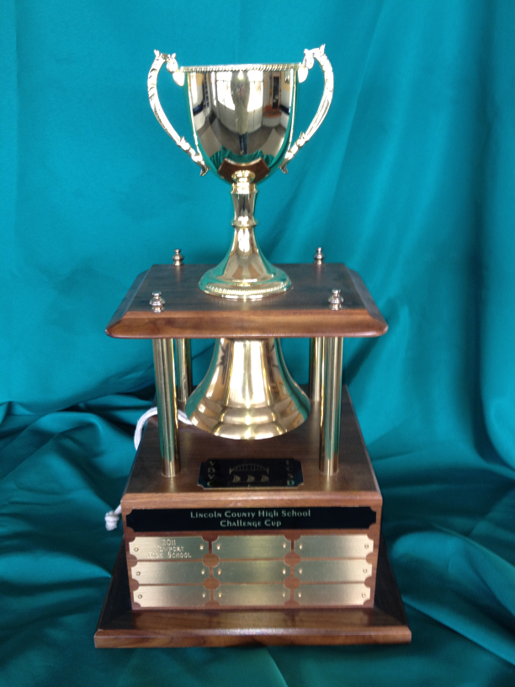
Student athletes from Taft High School and Newport High School will compete for the second year of the Lincoln County High School Challenge Cup. Team Taft has been strategizing all year about how to take the trophy from defending Team Newport. Teams of two boats from each school will compete as part of the Club 420 fleet during the annual Spring Regatta. The team with the combined lowest score overall for the regatta will take the trophy home to their school to proudly display for the next year. Come cheer on your favorite school team/sailor. Racing should be viewable from the area in front of the swimming pool at the Embarcadero. Better viewing spots are available from volunteer positions aboard the committee and various support boats. Contact Greg Krutzikosky or Joe Novello for more information.

Youth Sailing Update (2)

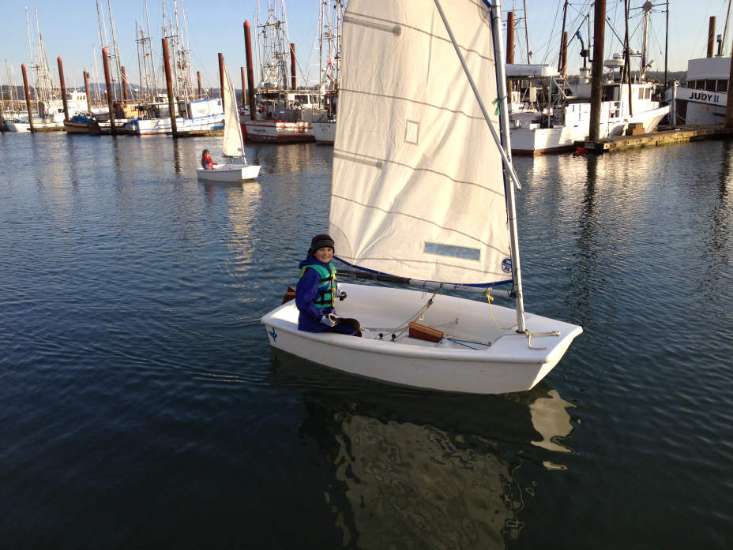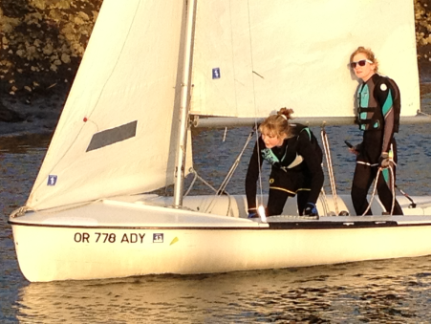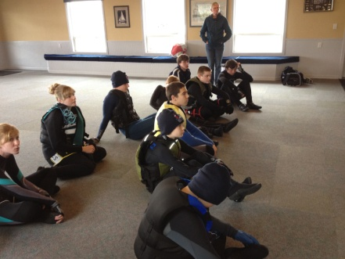

We are experiencing a lot of excitement around the growth and energy of our youth program. This year we have 24 kids ages 6 through 18 participating. Practices are held every Monday and Wednesday when 15 to 20 kids go out on our six Club 420s and five JY trainers. Practice is held in the inner harbor in front of the clubhouse and out on the bay in front of the Embarcadero Resort.

High school aged students have competed in the Northwest Interscholastic Sailing Association Regatta at the Willamette Sailing club in Portland and are gearing up for the district regatta to be held at the Center for Wooden Boats in Seattle on May 5th through 7th. In addition two teams each from Taft and Newport High Schools will compete for the Lincoln County High School Challenge Cup which is held within the Yaquina Bay Yacht Club Spring Regatta.

Spectators are always welcome to cheer the kids on both at practices and regattas. For more information contact Joe Novello (joenovello3@gmail.com). –Joe Novello

Membership News

We'd like to welcome our new members this month:
Jeff Breazile has joined us from Yamhill Oregon with his wife Norma. They have a Martin 241 called Wild Hare and are interested in cruising, racing, raft-ups, Kayaking and of course our famous monthly Potlucks. (Which amazingly coincide with our monthly Membership Meetings!)
We are happy to have Jeff and Norma aboard and look forward to having them on the water with us this year.
The new student members this year are: Cristian Ramirez, Chase Dillon, Kendra Knudson, Rachael Turner and Tristan Scarborough. We welcome you, and the returning student sailors. You are all awesome!
SPECIAL MEMBERSHIP NEWS
We are very happy to honor John and Barbara Dougherty this month with a Life Time Membership for their 20 years of dedicated work, their faithfulness to the Yaquina Bay Yacht Club and the enjoyment and expertise they brought to their fellow members. They will be presented with their Life Time Membership Name Badges as a token of our love, respect and gratitude. Congratulation John and Barbara!- Bruce Wilkinson ed. note-This article was mistakenly omitted from the last issue-oops!

Boogie for the Boathouse

Thanks to everyone for the show of support for this project, not only did it rally the group behind rebuilding, it also got us a great head start on funding. Please thank our sponsors and consider patronizing the following organizations; Rogue Ales, Bier One, Holy Cakes, Champagne Patio, Cindy Milligan Massage, Bright Horizons, Alder House Glass, American Home & Stone, Angela Sivers Massage, Nana's Irish Pub, Oregon Coast Aquarium, Oregon Coast Cutters, Bike Newport, Pacific Jem, Flying Dutchman, Diane Henkels -Attorney at Law, True Cut Engraving, CRC Band, Yaquina Bay Sailing School, and finally Bonfire Catering, who provided the live onsite BBQ.
Together we raised nearly $2000 and added at least one new membership to the ranks of YBYC- and it was fun! –Stephanie Brown
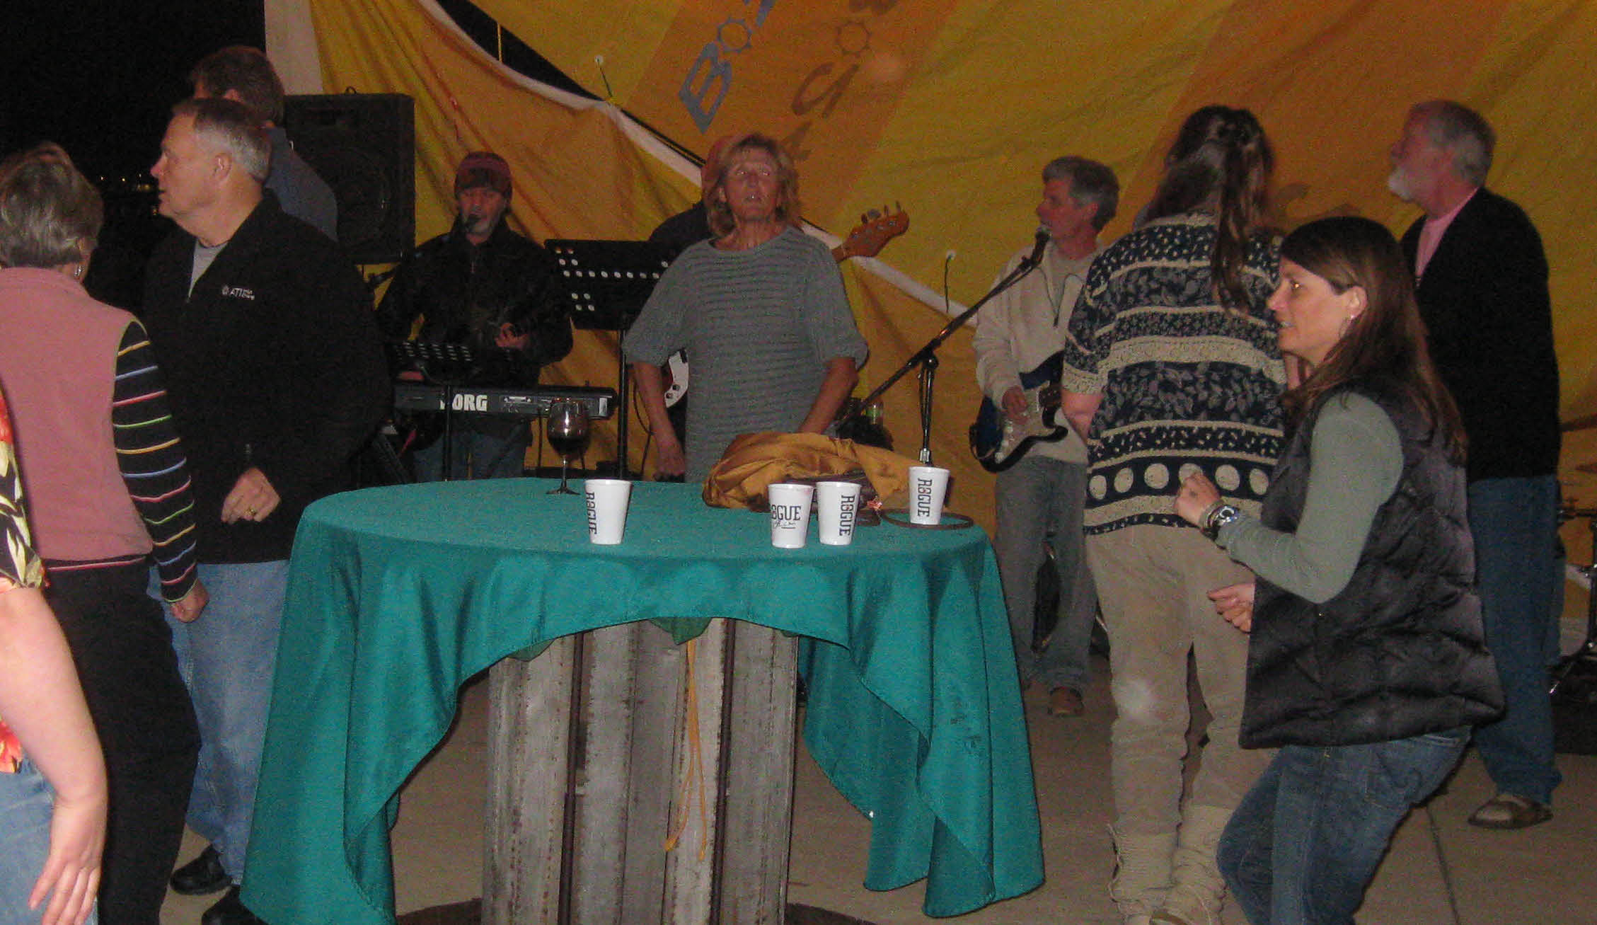

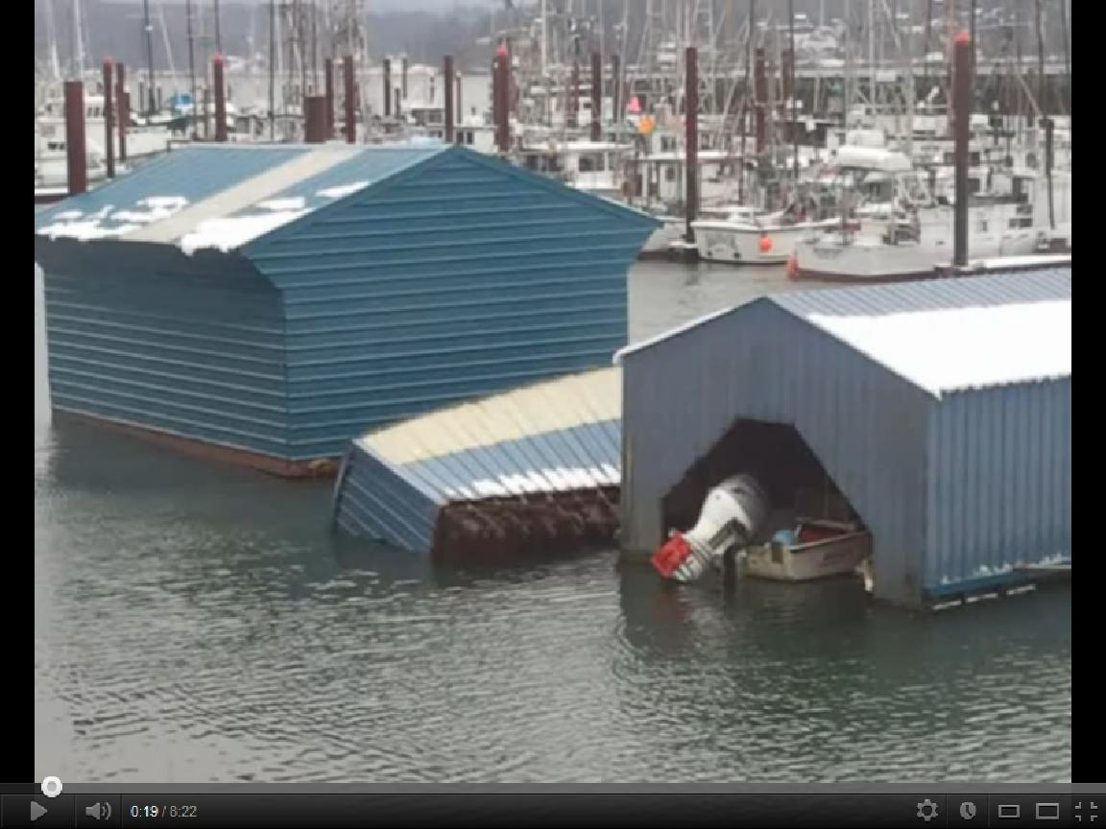

Flotsam and Jetsam 

Remember you can make a tax-deductible donation through the Oregon Boating Foundation. The money is used to provide community boating education and all donations are greatly appreciated. For monetary or other donations please contact OBF Chair Dan Van Calcar.

- The club has a fleet of sailboats available for club member use. These include Lidos, 420s and a small keel boat. These boats are fun to sail and explore Yaquina Bay. Check the Member's Handbook or with the YBYC Fleet Chair Tom Mcnamara at ; mailto:mcntm@msn.com for details on vessel use and to make reservations. Reservations are posted online on the club’s website http://www.yaquinabayyachtcluborg under the ‘Calendar’ tab.

Wednesday 420 reservation website-
https://spreadsheets0.google.com/spreadsheet/ccc?hl=en&key=tZvTrAppsstef-nGGCMmWDA&hl=en#gid=12

- Don’t forget to use our Yahoo group site at http://groups.yahoo.com/group/ybycgroup/ It’s the best place to keep up on club and member activities, chat and exchange info with fellow members. You can also read Board minutes. The Club also has a Facebook page, check it out! It’s updated frequently so you can be sure to keep abreast of club activities.

- Ships Store- Please do not forget to check out all the fine items at the ships store. Not only are you buying quality merchandise you can use, but it helps support the YBYC!


Editors Corner
Greetings:
Many thanks to all those who helped rescue the old boathouse and raise money for our new one. As you can see from the pictures, a great time was had at the Boogie, and the old boathouse really got slammed by wind and snow.
As most members know, I will be resigning as Jib Sheet editor at the end of Paul’s term. Just as Board members rotate, I think it is important to let others share their vision as newsletter editor. It has been a fun three years, but it is time for someone else to take the helm. I am giving plenty of notice because it is important that we have a seamless transition. Please let Paul or me know if you are interested.
Thanks to everyone involved in the High School team, athletes and coaches! Cheers, Jeff

Member-2-Member Network
Have you ever needed a carpenter, cabinet maker, tile setter, tire company and didn’t know who to call? Ever needed to have an item on your boat or home repaired, but had no idea where to call? Rather than calling a stranger or looking in the yellow pages, call another YBYC member! Every member who runs a business or performs a service is encouraged to signup. It’s totally FREE to members! Non-members pay a nominal fee. Want to get yourself listed? Email the YBYC newsletter editor at jcressy@charter.net with your listing information. We need to support our own, especially in this economic climate. Please consider doing what you can.

Alan Brown Tire Center (Les Schwab)
Ken Brown manager (541) 265-6604
1155 SW Coast Hwy
Newport, OR 97365
Email: tyrguy@yahoo.com

Dr. Kenneth S. Bishop
Chiropractic Physician
111 SE Douglas
Suite F-1
Newport, OR 97365
541-264-8138
www.yaquinachiropractic.com

Amy Lynn Greer
Certified Public Accountant
Ph/fax: 541-961-6814 Cell: (541) 961-6814
60586 Ridge Hts Bend, OR 97702
amygreercpa@bendbroadband.com

Vicki Krutzikowsky
Shaklee product distributor
www.healthydedication.com
541 264-8039
vickihoosky@hotmail.com
American Home and Stone---541-929-3100
Members: Shane and Mac McConnell
Cabinets, tile, granite countertops, stoves (wood, gas, pellet), spas: Discounts
www.americanhome
Ocean Pulse
Custom Surfboards, Skateboards, and Snowboards
Tom McNamara (541) 265-7745
428 SW Coast Hwy
Newport, OR 97365
www.oceanpulsesurf.com

Bike Newport
Elliott & Daniella Crowder, Owners
150 NW 6th Street
Newport, OR 97365
(541) 265-9917
website: bikenewport.net
email: bikenewport@charter.net

Member-2-Member-(cont.)
Kevin Raichl Cindy Milligan LMT# 6107
Visual Thinking Northwest Drift Away Massage
828 SE Crescent Pl. 310 NW 5th St. Suite 102
Newport, OR 97365 Corvallis, OR 541-753-4785
541-264-8343
541-480-2355 cell
www.visual-thinking.com

True Cut Engraving
Stephanie Brown
403 SW 10th Street
Newport, OR 97365
TrueCutEngraving@qwestoffice.net
541-265-9326

Diane Henkels, Attorney The Gallery at Otter Rock
Based in Newport and Portland Tish and Larry Epperson, owners
t: 541-270-6001 845 First Street, Otter Rock, OR
e: dhenkels@actionnet.net 97369 541-765-2365
Biz, environment, Indian law, and energy issues.

YBYC Classified

None this month; please sell your stuff here!!!!

Angela Sivers, Licensed Massage Therapist
Newport: Ocean's Way Naturopathic Clinic, at 644 SW Coast Highway, Suite D
Lincoln City also. 541.264.0423
http://www.centralcoastmassage.com e-mai; centralcoastmassage@gmail.com

