Yacht Club Calendar
17th-Monthly general meeting

The Jib Sheet
September 2011
A publication for the Members and Friends of the Yaquina Bay Yacht Club-est. 1947
Our Mailing Address is 750 SE Bay Boulevard, Newport, OR 97365

Our Website URL
Is www.yaquinabay yachtclub.org

For questions about the Club, contact us at YBYC.email@gmail.comFor questions about or contributions to this newsletter contact Jeff Cressy, editor, at jcressy@charter.net
YBYC 2010 Officers- Commodore: Greg Krutzikowsky
Vice Commodore : Paul Erskine
Rear Commodore: Mike Fulmor
Secretary : Alice McNamara
Treasurer : Dorothy Bogumil

Commodores Log

September is a month of change. As summer draws to a close, the autumnal equinox brings a change from daylight hours out numbering those of darkness. We may have moved the start time of Fall Series Wednesday night races up to 6 PM to accommodate the shorter days, but our sailing season is still in full swing until early next month when we hold our biggest regatta of the year on Columbus Day weekend. Another change for September is the format of this month's general meeting on September 17th, which will feature a progressive party visiting club member's boats in the Embarcadero Marina for drinks and appetizers followed by a baked potato bar at the clubhouse.
A BIG THANK YOU to all the YBYC volunteers that have made (or are making) the blitz of late summer events a success! With the Bridge to Bridge, Toledo Wooden Boat Show, Devil's Lake Revival Festival all in quick succession, and Wild Seafood Festival happening this month, YBYC members have been very busy. Rumor has it that there was also a great raft up party featuring swimming and margaritas (or was it margaritas first and swimming optional) recently while I was out of town visiting the Southwest. This is your club and members are the ones that make things happen on our journey.
While the pace may soon slow as daylight wanes, this is a delightful time of year that often offers lovely weather on the Oregon coast. So get out and enjoy, before the next change of seasons.
Fair Winds,
Greg

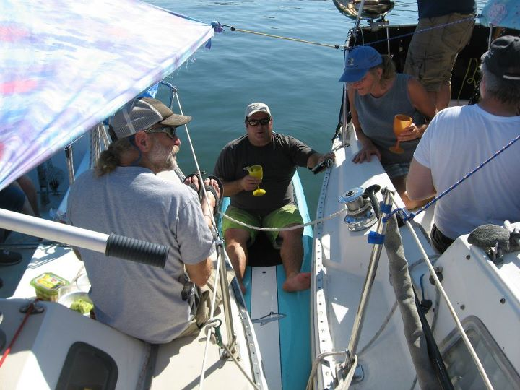

Raft Up Revelers
(Story below)

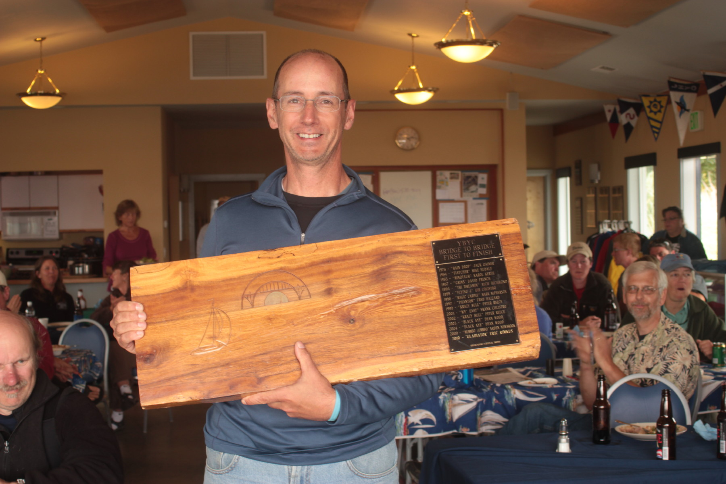
B2B winning skipper Jim Calnon of s/v Katzenjammer

More News You Can Use

Bridge to Bridge Wrap-up
Huge thank you to all who helped put on this year's Bridge to Bridge race on August 19-21! Mike and Pat Blackburn made the trip to Astoria to enjoy the pre-race festivities and help with safety inspections. The captain's meeting at the Rogue in Astoria also included 2 cruisers headed to Newport, who used the 'safety in numbers' theory and joined the pack. On Saturday, Mike B ventured offshore aboard the start boat and is ready for a bigger boat, I hear. Meanwhile in Newport, George picked up the beer, and the fridge was magically packed full of breakfast goodies.
Saturday evening the overnight crew of Mac, Crowders, Betts, Archie & Irene (and puppies), Pat, Mike, Ken and I gathered at the clubhouse and alternated between naps, movies, coffee and beer while waiting for the first boats to close the gap and cross the line. We got the first call around 2am and rallied the chase boat drivers for their first guide service. With the thick morning fog, the visiting boats were happy to see us on the water! The first 2 boats did not finish, but retired, one with a broken boom, the other had reached their limit of drifting.
The first finishing boat, Katzenjammer, came across around 6:30am followed closely by Siren and Aja. Later in the morning came Wildfire, then Catmandu and Penelope.
Breakfast was terrific thanks to all the wonderful cooks Betts, Cindy and the others! At 7am, Dave and George started the pig roasting process, which was grandly presented at 1pm for lunch and awards. But more magic had occurred - in their spare time, Cindy and Donna had sewn up a new set of tablecloths with bright nautical themes! The potluck dishes kept arriving at the club all afternoon, replenishing the never ending buffet of breakfast, brunch, and lunch. Thanks to all the club members who helped with the food, hot towels, cold beers, and warm smiling hospitality. We also managed to get the sailors pretty well cleaned up - thanks to borrowed Embarcadero keycards.
Huge thanks to Dave and Chalet Restaurant, for the Pig roast and the pies and the equipment! Also a giant thank you to Pat and Mike Blackburn, who put in a very long weekend jam packed full of stuff going on! There are dozens of others who helped and put their special touch on the weekend, thank you to YBYC and your amazing spirit for putting together another unforgettable race - all the boats vowed to enter again and bring their friends next year.
-Steph and Ken

Brb
Funny Bonz
Definitions from: SAILING (a pocket dictionary) by Henry Beard
and Roy McKie, c. 2001 Workman Publishing, NY.

Yardarm, n. Horizontal spar mounted in such a way that when viewed from the cockpit, the sun is always over it.
Zephyr, n. Warm, pleasant breeze. Named after the mythical Greek god of wishful thinking, false hopes, and unreliable forecasts.
Sea Monster, n. Mythical giant sea creature, usually described a snakelike. Thought by credulous sailors to appear suddenly and gobble up the unwary. Obviously a proposterous supersti-Tom “the Joker” McNamara

Sailing News from ‘Round the World

Following a successful collegiate coaching career, Gary Bodie was head
coach for the US Sailing Team at the Olympic Games in 2000 Sydney, 2004
Athens and 2008 Beijing. Under his leadership, the program won 8 medals at
the Olympic Games, 5 medals at the Paralympic Games, and 12 medals at the
Pan Am Games. Bodie continues to be involved with US SAILING's Rolex Miami
OCR as Regatta Chairperson and is a member of the ISAF Events Committee.
Here is an excerpt from a recent interview on Clever Pig:
* Can you give us an overview of the 2016 Olympics for the sport of
sailing? What are the major changes compared to the 2012 Olympics?
GARY BODIE: The 2016 Olympic Games will not have any keelboats. The
venerable Star class will be eliminated after 2012. Women's Match Racing
will only make one appearance in 2012, and then it is gone for 2016. The
Rio Games will however include a women's skiff event and a first ever mixed
event in multihulls. There are also likely to be significant changes in
format for 2016 that have not been determined yet. These format changes may
be even more significant than the boat changes.
* How does the outlook to Rio 2016 change the game for Youth Sailing?
GARY BODIE: My advice is don't be afraid to try something really different.
Too often our best sailors do not consider all of the options simply
because they have the most experience with a club 420 or FJ, and those look
the most like a 470. Go for the multihull, the board and the skiff. Listen
to our elite coaches from the US Sailing Team AlphaGraphics. If they tell
you that you're too small, too short, or too large for one event then get
their advice on which event is best suited to your body type.

Meeting Notice

Date: September 17th
Time:TBA

This will be a progressive party where members are invited to visit boats for libations and appetizers and rendezvous back at the Clubhouse for a baked potato bar. Please check Yahoo groups and Facebook for more info.
Quote of the Month
“Any fool can carry on, but a wise man knows how to shorten sail in time.”
Joseph Conrad

Board Bitz
Editor’s note: Many
thanks to Board Secretary Alice McNamara.

The YBYC board met on Sept. 1. Among the items on their agenda: A nominating committee will soon be formed in order to present a slate of officers for next year at the general meeting. The ship's store reported good sales during the Wooden Boat Show and at the Bridge to Bridge race/ meeting. Notice our clubhouse looks bright and clean, thanks to painting by Scott McCollough. We still have 2 Lidos for sale. Three new membership applications were approved. Decided to build a broom closet in the main hall, getting cleaning supplies out of the back room. Other topics of discussion included youth classes, keelboat classes, and increasing student and parent participation in the HS sailing program.


Summer Series Racing

Ed. Note: this was submitted shortly after the last issue was published, so I decided to run it in this issue.

Wow! What a summer so far. One Wednesday night seems to blend right into the next and summer is streaming by like a fleet of 420s. Or is it the J24s? So far, knock on wood, we’ve had great wind on Wednesday nights. We need to stay in the lower bay though because it falls off to nothing between the LNG tank and #14 mark with the wind out of the NW to NNW.
Three weeks ago we had gusts to 29 and it seemed that it was nothing but gusts: on-off-slam-off! Knock down, pop up. It was invigorating to say the least. I was thinking that I should have gone with the 130 Genoa instead of the 150. I also should have been wearing my gloves and it was a good thing we left Pat at the clubhouse. Exhilarating!
Just the week before that, we had a steady moderate breeze on a warm, sunny evening so we sailed beyond the jaws and around buoy #3 and back. There were smiles all around. Two weeks back the wind was lighter but sufficient and steady. We’ve had real variety and it’s all been great fun.
I got to disqualify a boat last week for fouling another boat and not doing penalty turns. Sure, it was me, but I had to do it anyway. One of the 420s had to turn away to avoid me while they were on a STBD tack and I was on a Port tack. We should have gotten clear and done turns but we didn’t so we got a DSQ. It’s the rule and if I don’t follow it who will? It’s part of learning to race along with everything else: starting strategy, finding the best line to a mark, working with or against the current or finding the best breeze. Foul a mark, do a full 360 degree turn. Foul another boat, do two full turns. Don’t do the turns and you get a DSQ. We all get in one another’s way from time to time but as I get serious about participating in races, I have to take fouling seriously, too, especially as Race Committee Chair. No more sailing through the starting line on a port tack getting in everyone’s way.
Mike Blackburn

First Annual Labor Day Raft up
On the warmest day of the year so far, Saturday, September 3rd, a mini-flotilla of four YBYC vessels set sail for a leisurely drift upriver, seeking a day of fun in the sun away from the mobs of holiday tourists. There were Tom & Alice Macnamara, Scott McCollough and his daughter Ella on Spirit, new members Bruce and Linda Wilkenson on their yet-nameless Catalina 22, and Barb and Mike Fulmor on Grinner. Mike & Pat Blackburn and Brent Piercy had gone ahead on Hispaniola to get well anchored. Equipped with coolers full of tasty edibles and appropriate beverages, we found the Mother ship anchored just across and upstream from Riverbend Marina, awaiting our arrival with pre-heated barbeque and bratwursts at the ready.

Brent, our soon-to-be departing for the Bay Area guest of honor, was barbeque maestro and Alice shared her delicious margaritas as we tied up, rigged awnings, and settled in for some serious relaxation. Soon a stand-up paddler came into view, and he was none other than Jeff Brazile making his arrival just in time for a margarita and brat.
Though it was hot enough to make the 51⁰ water look inviting, few took the plunge, wisely opting for internal cooling with icy beverages. Since a picture is worth a thousand words, we’ll let a few tell the rest of the tale, but suffice it to say, as we headed home into the setting sun, everyone must have thought the same thing- “we have to make this an annual event!”-Mike Fulmor

The Paddlers Box

Concept of the month: “Body, Boat & Blade”

Thanks to the combined efforts of several board members and 6 volunteer coastal kayak instructors, we’ve had quite a Year! Using the Club’s new fleet of instructional kayaks, we had 61 participants and brought in a total of $ 3,500 from our various classes. In addition to offering 7 group classes, we provided private instruction for one couple, sponsored a Paddlesports America class with 16 students taught by the USCG Auxiliary, and initiated a YBYC Kayak Safety Day at Olalla Lake. We now have 19 members who have demonstrated the skills necessary to check out Club kayaks.
Since the inception of our coastal kayak instructional program in 2005, we have taught 32 classes of various sizes, served a total of 139 participants and brought in $ 9,100. The Club offers the only readily available coastal kayak instruction in this area and provides classes at three levels proficiency: introductory, basic and intermediate.
Much of the success of this year’s program can be attributed to “Team YBYC” which has included: the very supportive YBYC Boards of 2010 & 2011, Anne Williams for excellent publicity, Barb Fulmor for her help in scheduling the Clubhouse, and Joe Novello for assisting in the instruction throughout the summer. The following ACA Certified Coastal Kayak Instructors have been of immense help, several of whom have taught more than one class and only 3 of whom are YBYC club members: Richard Appicello, Brian Getting, Tom Murphy, Rick Hill, Jack Cray and Jerry Davis.-Tom Murphy

“Body, Boat and Blade” -- “To paddle effectively the blade must be square to the stroke, the body must safely utilize large muscle groups to increase power and reduce fatigue, and the boat must be “quiet in the water” to reduce resistance and misdirection. Paddling efficiently requires the blending of these potentially contradictory considerations.” ACA Instructor Manual.



Flotsam and Jetsam 

- Remember you can make a tax-deductible donation through the Oregon Boating Foundation. The money is used to provide community boating education and all donations are greatly appreciated. Please contact Ron Cole for further information.

- The club has a fleet of sailboats available for club member use. These include Lidos, 420s and a small keel boat. These boats are fun to sail and explore Yaquina Bay. Check the Member's Handbook or with the YBYC Fleet Chair Tom Mcnamara at ; mailto:mcntm@msn.com for details on vessel use and to make reservations. Reservations are posted online on the club’s website http://www.yaquinabayyachtcluborg under the ‘Calendar’ tab.

Wednesday 420 reservation website-
https://spreadsheets0.google.com/spreadsheet/ccc?hl=en&key=tZvTrAppsstef-nGGCMmWDA&hl=en#gid=12

- Don’t forget to use our Yahoo group site at http://groups.yahoo.com/group/ybycgroup/ It’s the best place to keep up on club and member activities, chat and exchange info with fellow members. You can also read Board minutes. The Club also has a Facebook page, check it out! It’s updated frequently so you can be sure to keep abreast of club activities.

- Ships Store- Please do not forget to check out all the fine items at the ships store. Not only are you buying quality merchandise you can use, but it helps support the YBYC!


Editors Corner

Greetings: The YBYC member of the month feature will return next month. This month’s meeting gives members a chance to check out some of the great boats owned by our members. Remember to wear a PFD when going from boat to boat if you have had a wee too much o’ the grog!
I am still looking for more participants in the Member 2 Member network as well as more classifieds. Thanks to all who contribute.
It is certainly starting to feel like Fall so take advantage of as many of the Club’s activities while you can. A special welcome aboard to our new members. See you at the meetings. Cheers,
Jeff

Member-2-Member Network
Have you ever needed a carpenter, cabinet maker, tile setter, tire company and didn’t know who to call? Ever needed to have an item on your boat or home repaired, but had no idea where to call? Rather than calling a stranger or looking in the yellow pages, call another YBYC member! Every member who runs a business or performs a service is encouraged to signup. It’s totally FREE to members! Non-members pay a nominal fee. Want to get yourself listed? Email the YBYC newsletter editor at jcressy@charter.net with your listing information. We need to support our own, especially in this economic climate. Please consider doing what you can.

Alan Brown Tire Center (Les Schwab)
Ken Brown manager (541) 265-6604
1155 SW Coast Hwy
Newport, OR 97365
Email: tyrguy@yahoo.com

Dr. Kenneth S. Bishop
Chiropractic Physician
111 SE Douglas
Suite F-1
Newport, OR 97365
541-264-8138
www.yaquinachiropractic.com

Amy Lynn Greer
Certified Public Accountant
Ph/fax: 541-961-6814 Cell: (541) 961-6814
60586 Ridge Hts Bend, OR 97702
amygreercpa@bendbroadband.com

Vicki Krutzikowsky
Shaklee product distributor
www.healthydedication.com
541 264-8039
vickihoosky@hotmail.com
American Home and Stone---541-929-3100
Members: Shane and Mac McConnell
Cabinets, tile, granite countertops, stoves (wood, gas, pellet), spas: Discounts
www.americanhome
Ocean Pulse
Custom Surfboards, Skateboards, and Snowboards
Tom McNamara (541) 265-7745
428 SW Coast Hwy
Newport, OR 97365
www.oceanpulsesurf.com

Bike Newport
Elliott & Daniella Crowder, Owners
150 NW 6th Street
Newport, OR 97365
(541) 265-9917
website: bikenewport.net
email: bikenewport@charter.net

Member-2-Member-(cont.)
Kevin Raichl Cindy Milligan LMT# 6107
Visual Thinking Northwest Drift Away Massage
828 SE Crescent Pl. 310 NW 5th
Newport, OR 97365 Corvallis, OR 541-753-4785
541-264-8343
541-480-2355 cell
www.visual-thinking.com

True Cut Engraving
Stephanie Brown
403 SW 10th Street
Newport, OR 97365
TrueCutEngraving@qwestoffice.net
541-265-9326

YBYC Classified

For Sale and Looking for a good home.

S/V Vela, 1965 Mercator 30, Tall Rig with Sprit (Located on B Dock)

F/G hull, with wooden deck, house & spar; 4 cyl gas engine, rebuilt trans w/variable pitch prop; new standing rigging, mainsheet traveler, head & upholstery; rebuilt mast; many additional upgrades. Hauled out Fall, 2011. Electronics include a GPS, VHF, Depth and Stereo. Sail inventory is in good shape & extensive. The boat come fully equipped with gear, parts, tools, receipts and housekeeping items. There are several unsourced leaks in the house and the wiring should be upgraded. She performs beautifully in light air and has a responsive helm. She is a delight to sail and a beautiful vessel. We no longer have the time to maintain a wooden boat and believe that the price is reflective of on-going projects. Asking $14,750.00 obo. Contact Ron at (541) 265-5900.

