The Jib Sheet
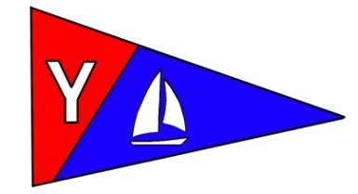
Yacht Club Calendar
September
12- Wild seafood brunch
14-Board meeting
18-monthly potluck

Commodores Log
September 2010
A publication for the Members and Friends of the Yaquina Bay Yacht Club-est. 1947
Our Mailing Address is 750 SE Bay Boulevard, Newport, OR 97365

Our Website URL
Is www.yaquinabay yachtclub.org

For questions about the Club, contact us at YBYC.email@gmail.comFor questions about or contributions to this newsletter contact Jeff Cressy, editor, at jcressy@charter.net

YBYC 2010 Officers
Mac McConnell- Commodore
Vice Commodore : Greg Krutzikowsky
Rear Commodore : Paul Erskine
Secretary : Alice McNamara
Treasurer : Dorothy Bogumil
READ THIS OUT-LOUD LIKE A RACE BROADCASTER
Welcome, to the final race of the summer series. Kiwanda is Committee boat and Captain Elliot has set the course. The one minute horn has sounded and coming to the line now is Cheap Sunglasses with Vela tight on her Port. Flamingo is trailing Sunglasses stern with Alchemy flanking. Annies Fannie is charging in with Commodore Mac at the helm, Tom on the sheets, Garth foredeck and Jeff at the traveler. Oh no, Cheap is early and looks like she is going to cross the line before the start horn and so is Vela!! Last second-- they veer off and slack their sails!! Now, sails’ luffing at the line, the clock is ticking down--- twenty seconds to the start. Vela and Sunglasses are like stallions pawing the ground at the start gate, sails luffing wildly in the late afternoon breeze in anticipation! Annies Fannie is tightening- up and is charging the start now with Alchemy slightly ahead. And there goes Cheap Sunglasses and Vela !!, sails pulled tight, turning into the wind as the horn blows. And, it’s Cheap Sunglasses, Vela, Flamingo, Alchemy and Annies Fannie blasting through the start with El Coyote, Slam Dunk, Hot Tub, I don’t give a rip, Hejira and Eastwind hot in pursuit. Curt and Pam Voss and Ian Williams in their 420’s are in the mix dodging the behemoths and blasting though the start. Sailing hard to buoy 9 for a Starboard tack is Cheap Sunglasses, Flamingo, Annies Fannie and El Coyote. Oh my golly, Flamingo is hard aground at Garth flats and Hot Tub is smoking and passing Annies Fannie!! Alchemy is coming up fast. Whoa!! Hijara almost broached with keel nearly out of the water and Vela, overpowered by her massive sail, is falling off!!! On to Coast Guard and 12A with Spinnakers unfurled are Cheap Sunglasses, Flamingo, Alchemy, Slam Dunk and Annies Fannie. Now comes Vela and Hot Tub in hot pursuit. Hejira is picking up speed and moving ahead. Rounding 12A now is Sunglasses with Captain Steph at the helm followed by Flamingo, El Coyote, Alchemy, Slam Dunk and Annies Fannie.

Now comes Vela and Hot Tub in hot pursuit. Hejira is picking up speed and moving ahead. Rounding 12A now is Sunglasses with Captain Steph at the helm followed by Flamingo, El Coyote, Alchemy, Slam Dunk and Annies Fannie. Coming on fast are Vela, Hejira and Hot Tub. Tom is working Fannies sheets while Alice is tuning Vela’s Traveler (does Tom know?). Sarah is flashing as Cheap Sunglasses rages toward the finish. East Wind is out there somewhere. Crossing the line, it’s Sunglasses, Alchemy, Flamingo and Annies Fannie with Slam Dunk, Vela, Hot Tub, Hejira, Eastwind and dinghy sailors Voss and Ian pulling in behind. And now, Wild celebration as Captain Steph throws her arms in the air and her crew cry’s out!!!. You can hear beer cans opening and wild jubilation on the water as the summer season pulls to a glorious finish!! There’s going to be celebration at the Clubhouse this night you can be sure. As the tide turns, let the burgers flip!!

What an awesome summer season this has been and it is almost sad to see it coming to an end. The Bridge to Bridge celebration was fantastic with breakfast serving almost 60 and roast pig coming out of the cooker on time, in perfect condition and serving nearly one hundred racers, club members and guests. Every last beer drunk, every ounce of pork eaten, all went away very content and satisfied saying that nothing would keep them away next year.

Paul’s efforts at the Wooden Boat Show in Toledo were well received and it was a huge success bringing in over $600 and new members.
Kayak instruction was outstanding as usual with Tom Murphy organizing his team to give great teaching and exposure for new kayakers. There was more demand than time and space for all who wanted to participate this year so next year promises to be even better with our new fleet of teaching kayaks (we have pre-commitments for 5 of the boats if you want one, better call Tom ASAP).
OBF has twelve students in the Adult Sailing program ongoing now with Terry and Lori, Dianne and Dan instructing. Merry did a wonderful job with the kids program both in Eugene and at the Oregon Coast.
November elections are looming so please think about joining the Board of Directors and becoming involved. There are many positions available and I can tell you from experience that it’s fun, rewarding and great camaraderie. Contact Greg K. for more information.
The Wild Seafood Weekend this week is going to be huge so plan to come.
YBYC’s programs have been wonderful, the volunteer participation never better showing that we are a family of sailors who welcome all who love celebration, the water and its many sports. So now, let’s welcome the Fall Series and the October Regatta—we gotta!!. It’s going to be awesome so come and be a part of it all.

Fair winds and I’ll see you on the water
Mac

News You Can Use

Meeting Notice
September 18 6pm Social Hour-7pm dinner
This month George Benton and Dave Schmaltz will be
hosting a good ‘ol fashioned Cajun shrimp boil. Veggies
are boiled and shrimp added at the end to make a perfect
Gulf coast feast. Ketchup, tabasco, horseradish and
lemon will be provided for your dippin’ sauce. Please
bring a salad or dessert. Also bring your dancin’ shoes
because a fais do do (traditional Cajun dance party) may
break out!

Special Thank You

I wanted to thank all the members who helped out at the Toledo Wooden Boat Show making it a great success for OUR organization, we handed out a lot of membership applications and received two back with checks, we handed a lot of info out on the OBF, we sold over $600.00 worth of gear and depleted the overstock which clogs the back room, and thanks to Ron Cole, Diane Henkels and Bernie Stohl, we engendered a newfound interest in the sport of sailing by giving rides to an excited public.
There were demonstrations of Kayaking skills by Tom Murphy to the delight of the crowd and the exposure for OUR club was well received, the weather was nearly perfect, and the crowds were in a great mood enjoying the festival.
All in all it was a GREAT weekend and that was only a part of our public exposure...B-B was a simultaneous event, thanks again to all who helped out, it made my job so much easier. Paul Erskine...special events dude...

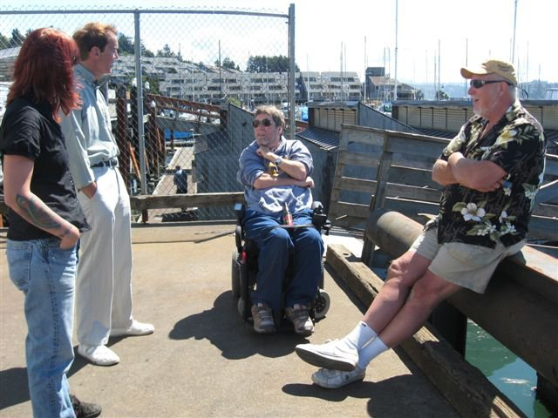

A meeting of the minds between Newport and Astoria

Cookbooks Still Available!

In case you haven’t heard, our new YBYC Cookbook has over 150 recipes gathered from our members. These delicious recipes are full of local flair and personality. At only $10 each, they're a great gift for family and friends, too! I cannot believe they are not sold out! Thanks again to Stephanie and the cookbook committee and all who contributed their recipes. My wife and I have made several and they were delicious.-Jeff
Sailing News from ‘Round the World

Around 1,500 children across Birmingham and Worcestershire have been introduced to sailing and windsurfing through the RYA’s OnBoard grassroots programme this year. And on Sunday (12 September) some 40 of those rookies will descend on Bartley Sailing Club in Birmingham to put their new skills to the test at the 2010 Birmingham Partnership OnBoard Festival. RYA OnBoard is all about providing youngsters from local schools, community organisations and youth groups with opportunities to get their first taste of sailing and windsurfing and give them the chance to continue participating at low cost.
The sessions take place at six specially-designated OnBoard clubs in Birmingham and Worcestershire, which are considered recognised RYA centres of excellence for teaching and instruction, ensuring the kids get access to the best first experience possible to enjoy themselves while learning new sailing skills.This weekend’s OnBoard Festival will see the new sailors, representing four of the six Birmingham Partnership OnBoard clubs, take part in a series of fun games and short races while it will also be the first time many of them will get to test their fledgling sailing skills against like-minded newcomers from other clubs.With another 1,500 kids getting their first taste of sailing and windsurfing this summer, an incredible 5,200 Birmingham and Worcestershire youngsters in total have now been introduced to the sports since OnBoard began in the region with no fewer than 48 schools across Birmingham and Worcestershire now linked with OnBoard. Editors note: The Royal Yacht Associaton (RYA) is the national body for all forms of boating in the UK.


Quote of the Month
A lot of people ask me if I were shipwrecked, and could only have one book, what would it be? I always say 'How to Build a Boat’.
Stephen Wright

Membership News
Welcome new members: Neal McIntosh and Daniel Coffman, Jim Burke, Hugh Cochrane, Sandi Lusk & Woody Richards, Jim Rice & Cait Goodwin with children Sophie & Noah, Russell Morley & Rosalina Wong and son Evan, and Jeff Olsen. We have 2 applications pending approval for September, too. Thanks for sharing YBYC with all your friends, it's great word of mouth that reaches all these nice people. If you see new faces, go be friendly and help them get the most from the club.

Columbus Day Regatta

We need volunteers for Committee Boat, Chase Boat and Clubhouse Crew! Signup sheet is on the clubhouse bulletin board or email Ken at tyrguy@yahoo.com or Stephanie at alaskamissy_2000@yahoo.com

Sign your boat up for Columbus Day Regatta! Notice of Race and registration form is on the club website at www.yaquinabayyachtclub.org under the 'racing' tab and at the end of the newsletter. Your preregistration helps us order enough t-shirts, trophies, beverages and food for everyone.
2011 Board of Directors
YBYC is now recruiting for the 2011 Board of Directors, if you have ideas about the club and how to help, this is your chance! Space is available on all Committees and several Board members positions will be open also. In Search Of: Race Chair, Membership Chair, House Committee, Rear Commodore Candidate, and others! Contact Greg K, Paul E or Stephanie for info on joining the board and guiding the club forward!
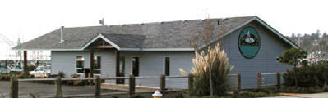
The infamous YBYC Clubhouse

Bridge to Bridge Wrap-up

A huge thank you to everyone who helped with this event! We had 12 boats enter the race, 2 withdrew before starting, 2 retired to Astoria overnight due to calm conditions. The remaining 8 continued on to Newport, with Gladiator finishing at 9:05 a.m. Cool Change also sailed the entire course, but finished past the race cut-off time at 4:10 p.m. The others motored in and arrived throughout the day.
On the finish crew, Mac, George, Dave, Mike, Ken and Pat were on call overnight, and began the radio watch for Gladiator's finish at 3am; though their progress slowed and they finally arrived after daybreak. Thanks Dave, George, Mac, Paul, Mike B, Joe and Mike F for their time in the chase boats escorting these yachts in safely. The Fog bank was thick!
In the clubhouse, the work started on Saturday to decorate our clubhouse and prepare the food for these hungry sailors. Betts, Dave, Donita, Barb F, Mac, Cindy, Donna and Jeff slaved in the kitchen to prepare both the breakfast for the Monthly Potluck and the afternoon Pig Roast for the Finish Party. Speaking of Pig Roast...Mac constructed the cooking box, Dave, Tony and George prepared the pig and carefully monitored the roasting process all day. Even with all the variables, it was done right at 3pm and unveiled to an amazed crowd.
Thanks to those of you armed with cameras! Pat, Cindy, Donna, Nairne took great photos of the crews, the prep crews, the party and the pig. I'm hoping to get those all assembled into a nice storyboard to share with everyone soon. The beautiful shiny trophies were painstakingly polished by Pat and Mike, who also shaped the statuesque bases from really nice hardwood.
The arriving race crews were absolutely overjoyed to receive their steaming hot towels and cold beer. We shared this enjoyable task with as many people as possible; Jeff and Donna took a turn, as well as Peggy and Henry, Cindy, Pat, Alice, Nairne, Mac, Ken, Tony, Barb and Mike, Betts, and more!
With so many helping hands, I know we've missed someone, and apologize for any oversight! Ken and I were pretty worn out after this weekend, but it pays off to see so much good energy and sharing such great experiences with others. YBYC should be proud of this event! All up and down the Columbia, yacht clubs are already asking about dates for next year's race, and it's because you all do such a spectacular job!
-Steph and Ken
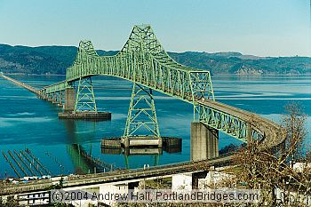


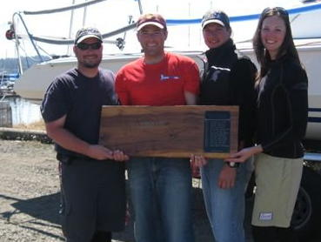
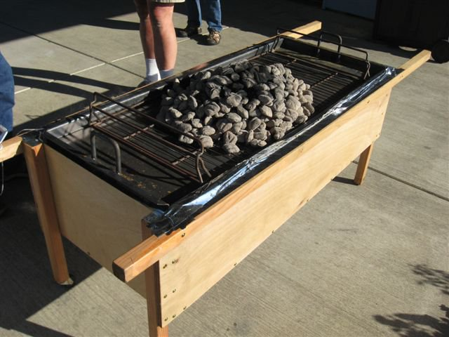
The winning crew and the losing, but delicious pig cooking away in a BBQ built special by Mac.
i
Flotsam and Jetsam 
- Remember you can make a tax-deductible donation through the Oregon Boating Foundation. The money is used to provide community boating education and all donations are greatly appreciated. Please contact Ron Cole for further information.
- The club has Lido 14 sailboats available for club member use. These 2 or 3 person dinghies are fun to sail and explore Yaquina Bay. They’re conveniently located on the port dock near the clubhouse. To use the Lidos, check the online calendar for availability, and place your reservation by contacting Tom Mcnamara at ; mcntm@msn.com reservations are posted online on the club’s website www.yaquinabayyachtcluborg under the ‘Calendar’ tab.
- Don’t forget to use our Google group site at groups.google.com/group/ybyc It’s the best place to keep up on club and member activities, chat and exchange info with fellow members. The Club also has a Facebook page, check it out! It’s updated frequently so you can be sure to keep abreast of club activities.
- Ships Store- Please do not forget to check out all the fine items at the ships store. Not only are you buying quality merchandise you can use, but it helps support the YBYC!
- September Birthdays: Asher Doyle, Jim Rice, Zoee Shearer, Jerry Yearous, Jalene Case, Nairne Dickey, Mike Blackburn .Happy Birthday! Your name not listed? Contact the Membership Chair for an Information Update Form.
- Help is still needed to clean up the outside of the clubhouse. Such gardening chores as weeding trimming etc. Please contact Mac if you can help.
- Fall Series starts next week and continues until October 6 - the start time is moved to 6:00pm to take advantage of the shorter daylight hours.


Editors Corner
Thanks to everyone who contributes to this newsletter. I’ve thanked her numerous times in person, but I want to give a special thank you to Stephanie Brown. She contributes much to this newsletter and is always there when I run into trouble. I encourage members to submit more pictures and stories.
The Bridge to Bridge finale was a tremendous success. The YBYC has no peers when it comes to welcoming weary sailors. Thanks to Mac and Cindy for hosting breakfast, and to George and Dave for their work on the porcine part of our feast.
Please don’t forget the Wild Seafood Brunch this weekend the 12th. Betts and others have worked very hard to make this a success.
We didn’t get much of a summer, so we are due for a great autumn. Please take advantage of all the YBYC has to offer! Cheers, Jeff
American Home and Stone---541-929-3100
Members: Shane and Mac McConnell
Cabinets, tile, granite countertops, stoves (wood, gas, pellet), spas: Discounts
www.americanhome
Ocean Pulse
Custom Surfboards, Skateboards, and Snowboards
Tom McNamara (541) 265-7745
428 SW Coast Hwy
Newport, OR 97365
www.oceanpulsesurf.com

Bike Newport
Elliott & Daniella Crowder, Owners
150 NW 6th Street
Newport, OR 97365
(541) 265-9917
website: bikenewport.net
email: bikenewport@charter.net
Member-2-Member Network
Have you ever needed a carpenter, cabinet maker, tile setter, tire company and didn’t know who to call? Ever needed to have an item on your boat or home repaired, but had no idea where to call? Rather than calling a stranger or looking in the yellow pages, call another YBYC member! Every member who runs a business or performs a service is encouraged to signup. It’s totally FREE to members! Non-members pay a nominal fee. Want to get yourself listed? Email the YBYC newsletter editor at jcressy@charter.net with your listing information. We need to support our own, especially in this economic climate. Please consider doing what you can.

Alan Brown Tire Center (Les Schwab)
Ken Brown manager (541) 265-6604
1155 SW Coast Hwy
Newport, OR 97365
Email: tyrguy@yahoo.com

Dr. Kenneth S. Bishop
Chiropractic Physician
111 SE Douglas
Suite F-1
Newport, OR 97365
541-264-8138
www.yaquinachiropractic.com

Amy Lynn Greer
Certified Public Accountant
Ph/fax: (541) 563-5147 Cell: (541) 961-6814
PO Box 1341 Waldport, OR 97394

Vicki Krutzikowsky
Shaklee product distributor
www.healthydedication.com
541 264-8039
vickihoosky@hotmail.com

Member-2-Member-(cont.)
Kevin Raichl
Visual Thinking Northwest
828 SE Crescent Pl.
Newport, OR 97365
541-264-8343
541-480-2355 cell
www.visual-thinking.com
YBYC Classified

For Sale: 1974 Catalina 27, can be seen at B-98 Embarcadero I would like $8,000 but am very willing to listen to reasonable offers. If you would like more information call Jeff Longmore 541-225-7533 to arrange a tour.

NRS Women's Boaters Gloves, medium
http://www.nrsweb.com/shop/product.asp?pfid=24302&pdeptid=944
Bought 1 month ago, wore only a handful of times. Perfectly fine, just
realized I should have gotten a different style. $10 OBO ($24.95 new).
Email me at cpvoss@comcast.net.

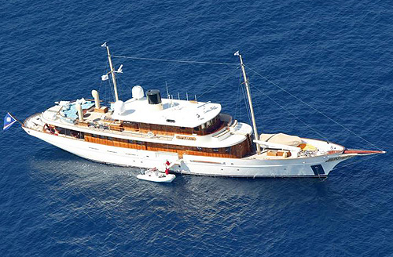
Johnny Depp’s 156 foot yacht which can now be rented for a mere $130k a week. Brother can you spare a dime?

Yaquina Bay Yacht Club
www.yaquinabayyachtclub.org
Notice of Race
2010 Columbus Day Regatta
October 9-10, 2010
Rules: The regatta will be governed by the Racing Rules of Sailing 2009-2012 including
US Sailing Prescriptions except as any of these are altered by the sailing instructions.
Entries: Open to all keelboat and centerboard classes. Separate scoring for keelboat
(PHRF), centerboard (Portsmouth), and one-design fleets with 5 or more boats registered.
Social: Saturday morning clubhouse opens 8am for continental breakfast. Saturday Fresh Grilled Tuna
Dinner, 6:30 p.m. Sunday morning clubhouse opens at 9am for continental breakfast.
Lodging, Launching and Mooring: Keelboat hoisting available at Port hoists near club for $35 round
trip, or Sawyer’s Landing for $30 round trip. Small boats (approximately Lido 14 and smaller) can
hand launch at Port dock 7 near club. South Beach has a launch ramp and moorage; they can be
reached at 541-867-3321. Lodging and moorage are available through the Embarcadero; 800-547-
4779, and lodging is available at The Landing; 541-574-6777
Schedule of Events:
Saturday, October 9 (as many races as possible) Sunday, October 10 (as many races as possible)
8:30-9:30 AM Registration at clubhouse
10:00 AM Skipper’s meeting
12:00 PM Warning, Race 1
6:30 PM Dinner – Clubhouse
9:00 AM Clubhouse open
11:00 AM Warning, first race of the day
3:00 PM No races after
Scoring: The low point scoring system will apply. Each boat’s score will be the sum of all races
sailed with no throw outs. PHRF scoring will use time on distance method.
Boats without PHRF certificates will be assigned a rating by the YBYC race chair.
Sailing Instructions: Available at registration.
Registration: Please make your check payable to Yaquina Bay Yacht Club or YBYC
Entry Fee (includes 1 t-shirt) $45.00
US Sailing Member Discount -$5.00
After Sept 30 $10.00
Dinner Tickets _____ x $12.00 =
Kids 5-14 Dinner _____ x $5.00 =
T-shirts size(s) _____ x $15.00 =
Total
Yacht Name____________________________________________________________________________
Boat Make/Model/Length_________________________________________ Rating_________________
Skipper Name___________________________________________________________________________
Address________________________________________________________________________________
Phone__________________________________Email___________________________________________
I represent to the organizers that my boat has liability insurance in effect and that my boat meets the requirements of the
U.S. Coast Guard. I acknowledge that all competitors participate in this regatta entirely at their own risk. I agree to be
bound by the Racing Rules of Sailing with respect to all claims arising out of participation of my boat in this event. I
acknowledge that the Yaquina Bay Yacht Club, its officers and the race committee will not accept any liability for material
damage or personal injury or death sustained in conjunction with or prior to, during, or after this regatta.
Skipper’s Signature ______________________________________________________Date____________
Questions? Contact Ken Brown at tyrguy@yahoo.com or 541-265-4575

