The Jib Sheet
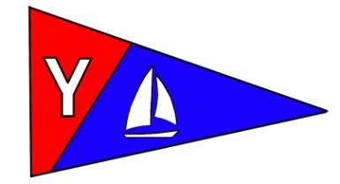
Yacht Club Calendar
September
9-10 Columbus Day Regatta
12-Board Meeting
16- Monthly Meeting

Commodores Log
October 2010
A publication for the Members and Friends of the Yaquina Bay Yacht Club-est. 1947
Our Mailing Address is 750 SE Bay Boulevard, Newport, OR 97365

Our Website URL
Is www.yaquinabay yachtclub.org

For questions about the Club, contact us at YBYC.email@gmail.comFor questions about or contributions to this newsletter contact Jeff Cressy, editor, at jcressy@charter.net

YBYC 2010 Officers
Mac McConnell- Commodore
Vice Commodore : Greg Krutzikowsky
Rear Commodore : Paul Erskine
Secretary : Alice McNamara
Treasurer : Dorothy Bogumil
It all happened so fast. The little 14 foot boat pitched, knocking the crabbers off balance and to the leeward rail as the little craft lifted high and flopped over. Gasping in the shockingly cold water and scrambling to get a hold on the boat, total panic flooded Mark and Evelyn’s thought processes. Only minutes in the water, frantic and exhausted Evelyn and a would-be kayak rescuer began swimming for shore. The lifejackets that they decided not to wear floated lazily on the surface of the bay, moving further and further away. Looking back they could see Mark clinging to the kayak being pummeled in the surf. The 5-10-60 rule was kicking into high gear now as the time flicked by. In the first five minutes most persons who fall into these chilled waters drown from gasping inhalation due to the shock of the numbing cold waters. In ten minutes, the peripheral blood flow slows to preserve body heat and the muscles begin to retract, not able to work. After 60 minutes hypothermia sets in and typically you just give-up and fall deeply into non-consciousness and a painless, watery demise. Looking back out to sea, Mark was no longer holding onto the kayak, he was nowhere to be seen and the kayak was being sucked out to sea.
Two weeks now have passed and still no body. How will we mourn? What will we say? Why didn’t you wear your PFD? Why? Why? How could you be so selfish to make us bear such a loss? We are not ready to say goodbye especially when it could have so easily been prevented.
Two children, a wife and numerous friends are bereft at their loss of this wonderful man, the faithful and joyous husband, the ever loving father, son, magnificent builder, wonderful neighbor.

The clock can’t be turned back, the life preserver has floated away, there is no respite; there is no hope. And it all happened so fast. It was an accident! It always is, isn’t it?
My dear YBYC sailors, I had to write this because if I had not and lost one of you without it being said would haunt me forever. I care too much about you. While we don’t have a hard and fast rule about wearing PFD’s when we are on the water I would like to ask each of you to do so, as your Commodore, as your friend. It is the thing that we teach in our youth sailing program “what is the most important piece of equipment on every boat?” “The PFD”. We are setting an example not only to the youth sailors but those new members to our organization. It isn’t too much to ask, it is a seat belt, something that you shouldn’t even consider being on the water without wearing. We should advise regatta sailors that this is our request, as keepers of this cold body of water, to ensure their safety and to promote safety in sailing to those who watch us and might emulate us. It is security, warmth, and most of all hope because it all happens so fast.

Please join me in saying “everyone on my boat wears a PFD”.

The Fall series has come to an end and the Columbus Day Regatta is going to be very well attended this year with well over thirty entries. The food of course will be glorious and the libations flowing as sailors gather in camaraderie to tell stories and share in their common endeavor that might be called a vice for providing so much pleasure.
The new Board of Directors is being selected so if you are interested in getting more involved in club activities I encourage you to contact Paul, Greg, Steph or Amy and let them know where your interests might be and become more involved either as a director or on someone’s team. It is fun, very rewarding and it makes this Club ever the better.
I look forward to sharing in Celebration with you and wish you fair winds and smooth sailing.
l’ll see you on the water.
Mac
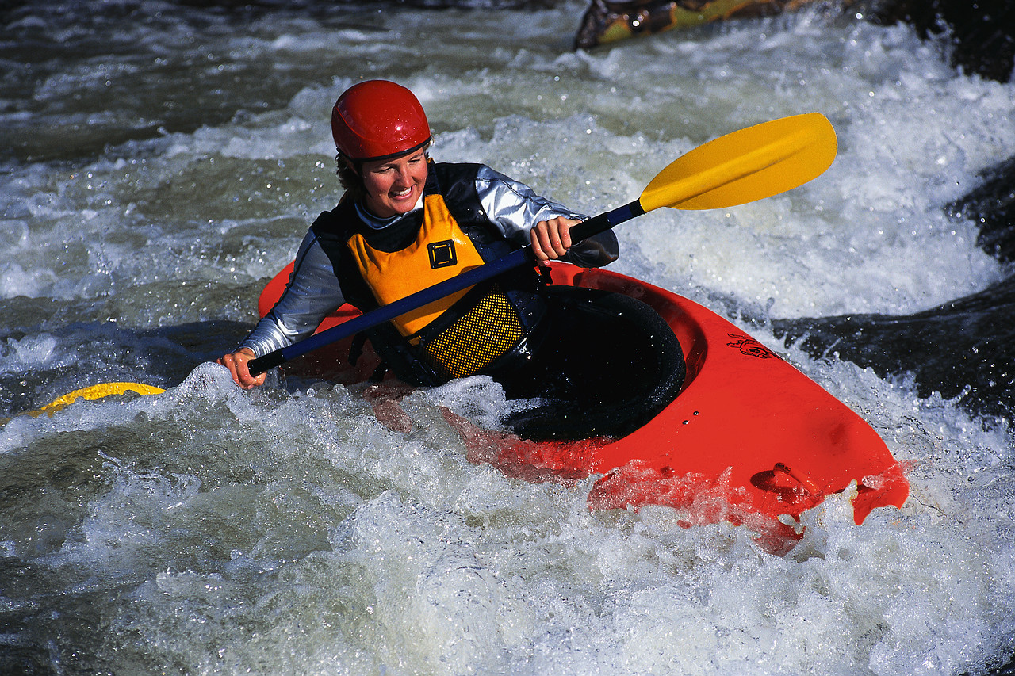

News You Can Use

Meeting Notice October 16
Seafarer’s Ball
Hear ye’ Hear ye’! All ye Seafarer’s
Pirates, Ghouls and Landlubbers alike!
Come dressed for the October Meeting as ye favorite seafaring or other character, be it Horatio Hornblower, Anne Bonney or Davey Jones his self! Thar will be prizes for thems that do it right! A feast fit for the Commodore and all the frivolity that goes with it.
Time: 6-7: Swashbucklers, Pirates, and Ghosts and Ghouls social time-
7pm Dinner is served
Bring: Your favorite ghoulish side dishes, salad or dessert to share
Main Dish: TBA

Octoberfest in September

The September meeting was a great success. Unfortunately I have
only one picture to prove it, so you will just have to take my word for it
if you were not there. A big thanks to Dave Schmaltz for hosting and providing
the delicious sausages as well as the refreshing libations. Keep an eye out on Facebook
and Google groups for information on the November annual meeting.
Member Renewal Time
Be sure to check your mail in the next week or two for your 2011 Renewal Notice, which will be coming with your invitation to our Annual Awards and Election Meeting on November 20. Renewing your Household or Individual Membership before the Nov 20 meeting saves you $20 and helps YBYC get the New Year started right.
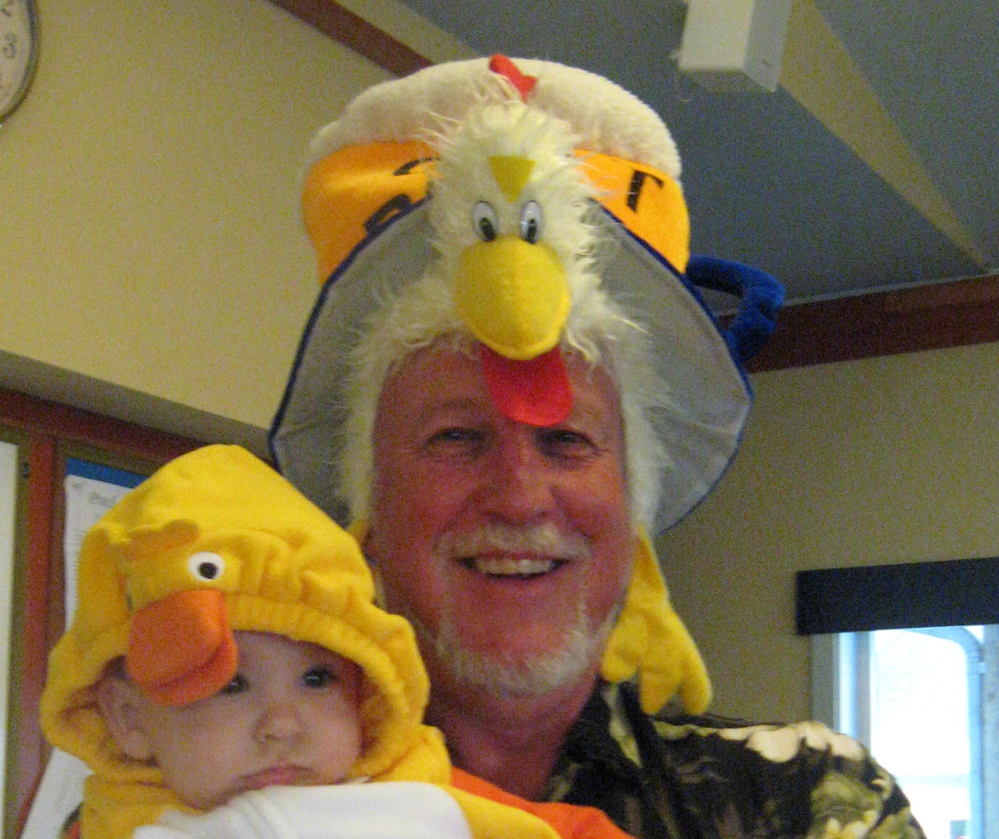
Our intrepid Commodore replete with his chicken dance hat and baby chick

Cookbooks Still Available!

In case you haven’t heard, our new YBYC Cookbook has over 150 recipes gathered from our members. These delicious recipes are full of local flair and personality. At only $10 each, they're a great gift for family and friends, too! I cannot believe they are not sold out! Thanks again to Stephanie and the cookbook committee and all who contributed their recipes This is the last time we will run this in the newsletter so please check your holiday gift lists.-Jeff
Sailing News from ‘Round the World

Newport, RI (October 6, 2010) - While many expected the Spanish teams to
sail well and put on a good show at the Newport J/80 Worlds, it's doubtful
many expected them to be dominating in their second day of sailing in the
strong, shifty northwesterly winds off Newport.
After five races, the top three teams are all Spanish J/80 Champions of one
form or another, with Carlos Martinez on PERALEJA GOLF winning, putting his
mark on the fleet with a 1-2 today for a total of 16 points. Jose Maria
"Pichu" Torcida lies second six points back after a 5-7. And, like a phoenix
rising from the ashes, Rayco Tabares Alvarez on HOTEL PRINCESA CANARIAS
sailed to the second best record with a 2-3 for a total of 28 points.
To illustrate how tight the competition is so far, four different boats in
five races have won a race, the only double-winner being the American team
of QUANTUM RACING sailed by Scott Young and Terry Flynn from Austin, TX.
Event website: http://www.j80worlds2010.org/

Quote of the Month
Noah was a brave man to sail in a wooden boat with two termites
Anonymous

Membership News
Welcome to new members Archibald and Irene Bailey with children Toni and Katie, they have a Santana 20 and Cheoy Lee 36. They live in Newport and look forward to sailing more.
Also welcome Don Baker and children Marci and Kyle, from Lincoln City. He's been sailing on Wednesdays off and on with Joe, and met many of our members at the Bridge to Bridge party and Toledo Wooden Boat Show.
We have several memberships pending for the October Board Meeting.

Columbus Day Regatta

It’s late, but we may still need volunteers for the Regatta. Contact Ken at tyrguy@yahoo.com or Stephanie at alaskamissy_2000@yahoo.com Please come out to support the sailors in one of our very important events!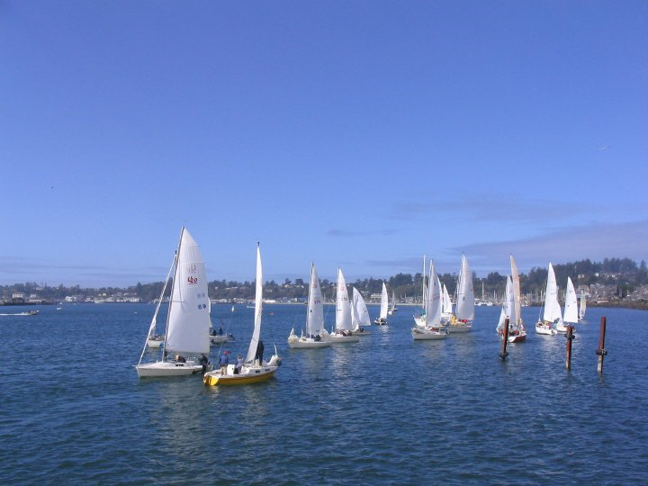
2011 Board of Directors
YBYC is now recruiting for the 2011 Board of Directors, if you have ideas about the club and how to help, this is your chance! Space is available on all Committees and several Board members positions will be open also. We are still in need of several positions. Contact Greg K, Paul E or Stephanie for info on joining the board and guiding the club forward!
Previous Regatta

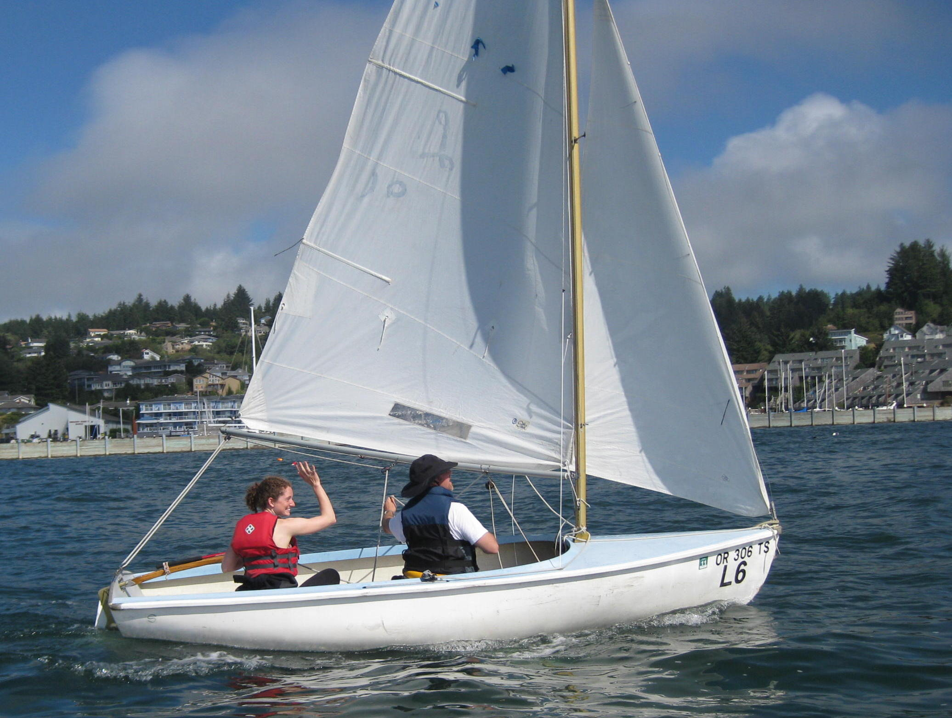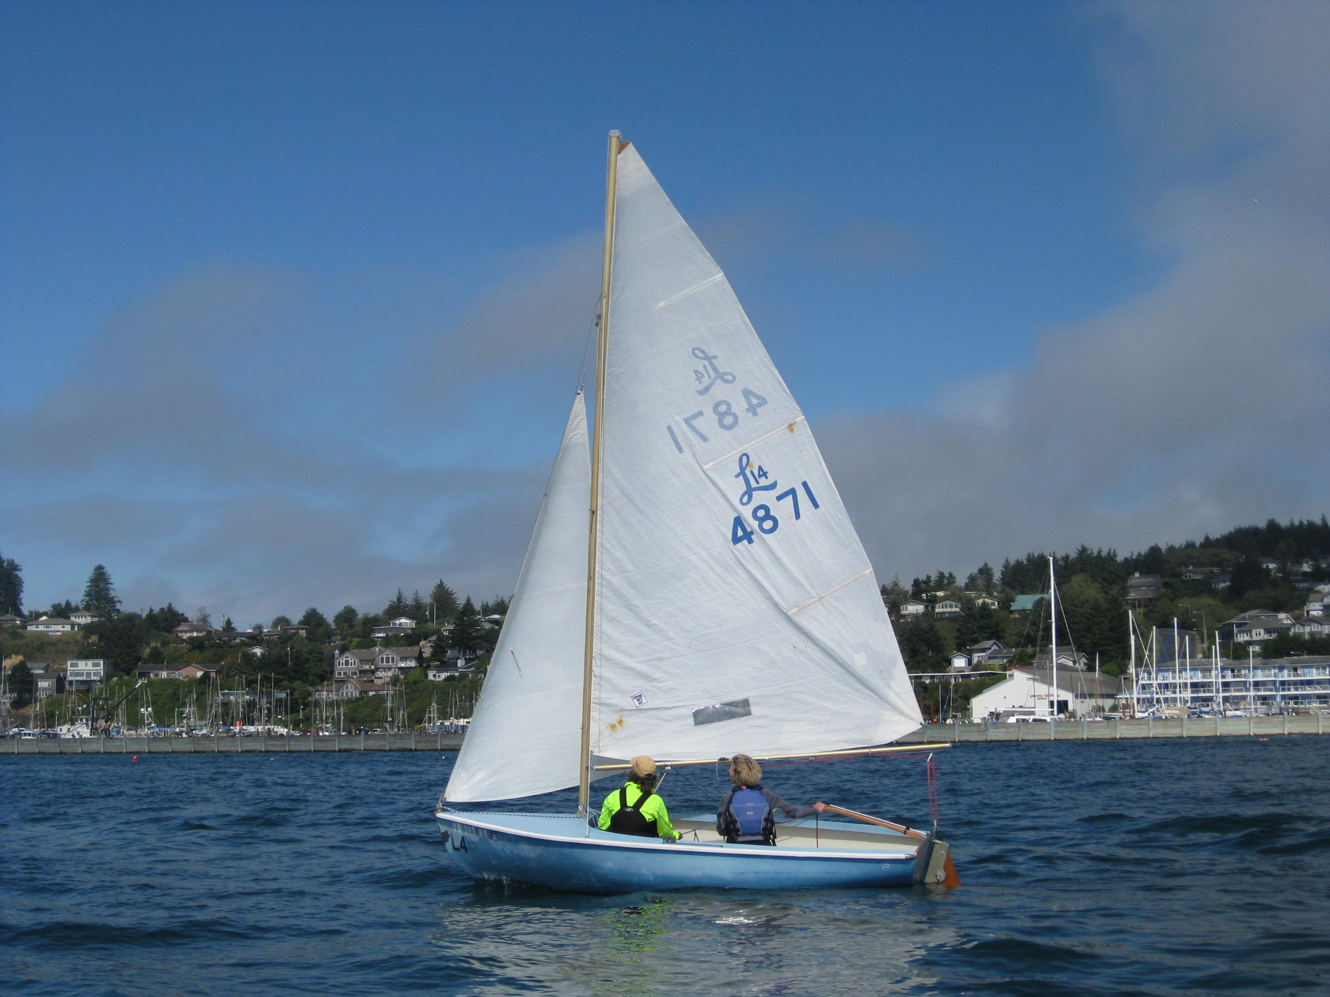
Pictures of the adult sailing class courtesy of Diane Henkels

i
Flotsam and Jetsam 
- Remember you can make a tax-deductible donation through the Oregon Boating Foundation. The money is used to provide community boating education and all donations are greatly appreciated. Please contact Ron Cole for further information.

- The club has Lido 14 sailboats available for club member use. These 2 or 3 person dinghies are fun to sail and explore Yaquina Bay. They’re conveniently located on the port dock near the clubhouse. To use the Lidos, check the online calendar for availability, and place your reservation by contacting Tom Mcnamara at ; mcntm@msn.com reservations are posted online on the club’s website www.yaquinabayyachtcluborg under the ‘Calendar’ tab.

- Don’t forget to use our Google group site at groups.google.com/group/ybyc It’s the best place to keep up on club and member activities, chat and exchange info with fellow members. The Club also has a Facebook page, check it out! It’s updated frequently so you can be sure to keep abreast of club activities.

- Ships Store- Please do not forget to check out all the fine items at the ships store. Not only are you buying quality merchandise you can use, but it helps support the YBYC!

- October Birthdays-Dave Schmaltz, Connor Price, Annebelle Brown, Brad Frevert, Keith Matteson, Paul Erskine, Judy Bateman and Larry Sharpless.Happy Birthday! Your name not listed? Contact the Membership Chair for an Information Update Form.

- Help is still needed to clean up the outside of the clubhouse. Such gardening chores as weeding trimming etc. Please contact Mac if you can help.


Editors Corner
Most likely there are YBYC members who do not always use their PFD’s when on the water. Mac certainly makes a compelling case to use them. I am in complete agreement with him. I spent 26 years working at a rehabilitation center with people who had suffered catastrophic injuries and I have worked extensively in injury prevention. In the 1980’s I fought hard for airbag and seatbelt legislation. For many it was an unwelcome, foreign concept. Now it is standard practice. The National Institute for Highway Safety estimated that nationally 16,040 lives were saved by seatbelts and airbags in 2008. Last year 736 people died in recreational boating and 84% were not wearing PFD’s according to the USCG. I realize most of those were probably not in Yacht Club activities, but I also realize that it only takes a split second to lead to a lifetime of regret, please be safe.
On a different note, good luck to all the sailors who are racing in our Columbus Day Regatta, the weather will test the mettle of all, Cheers, Jeff
American Home and Stone---541-929-3100
Members: Shane and Mac McConnell
Cabinets, tile, granite countertops, stoves (wood, gas, pellet), spas: Discounts
www.americanhome
Ocean Pulse
Custom Surfboards, Skateboards, and Snowboards
Tom McNamara (541) 265-7745
428 SW Coast Hwy
Newport, OR 97365
www.oceanpulsesurf.com

Bike Newport
Elliott & Daniella Crowder, Owners
150 NW 6th Street
Newport, OR 97365
(541) 265-9917
website: bikenewport.net
email: bikenewport@charter.net
Member-2-Member Network
Have you ever needed a carpenter, cabinet maker, tile setter, tire company and didn’t know who to call? Ever needed to have an item on your boat or home repaired, but had no idea where to call? Rather than calling a stranger or looking in the yellow pages, call another YBYC member! Every member who runs a business or performs a service is encouraged to signup. It’s totally FREE to members! Non-members pay a nominal fee. Want to get yourself listed? Email the YBYC newsletter editor at jcressy@charter.net with your listing information. We need to support our own, especially in this economic climate. Please consider doing what you can.

Alan Brown Tire Center (Les Schwab)
Ken Brown manager (541) 265-6604
1155 SW Coast Hwy
Newport, OR 97365
Email: tyrguy@yahoo.com

Dr. Kenneth S. Bishop
Chiropractic Physician
111 SE Douglas
Suite F-1
Newport, OR 97365
541-264-8138
www.yaquinachiropractic.com

Amy Lynn Greer
Certified Public Accountant
Ph/fax: (541) 563-5147 Cell: (541) 961-6814
PO Box 1341 Waldport, OR 97394

Vicki Krutzikowsky
Shaklee product distributor
www.healthydedication.com
541 264-8039
vickihoosky@hotmail.com

Member-2-Member-(cont.)
Kevin Raichl
Visual Thinking Northwest
828 SE Crescent Pl.
Newport, OR 97365
541-264-8343
541-480-2355 cell
www.visual-thinking.com
YBYC Classified

For Sale: 1974 Catalina 27, can be seen at B-98 Embarcadero I would like $8,000 but am very willing to listen to reasonable offers. If you would like more information call Jeff Longmore 541-225-7533 to arrange a tour.

NRS Women's Boaters Gloves, medium
http://www.nrsweb.com/shop/product.asp?pfid=24302&pdeptid=944
Bought 1 month ago, wore only a handful of times. Perfectly fine, just
realized I should have gotten a different style. $10 OBO ($24.95 new).
Email me at cpvoss@comcast.net.

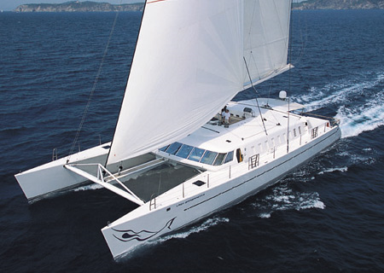
Sir Richard Branson’s modest catamaran, purchased in 2005 for a mere $9.2 million. The shabby interior can only accommodate 10 guests.
