The Jib Sheet
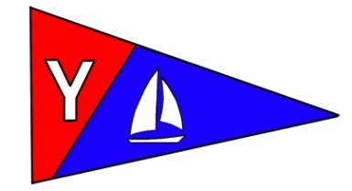
Yacht Club Calendar
June
19-Monthly Meeting

Commodores Log
June 2010
A publication for the Members and Friends of the Yaquina Bay Yacht Club-est. 1947
Our Mailing Address is 750 SE Bay Boulevard, Newport, OR 97365

Our Website URL
Is www.yaquinabay yachtclub.org

For questions about the Club, contact us at YBYC.email@gmail.comFor questions about or contributions to this newsletter contact Jeff Cressy, editor, at jcressy@charter.net

YBYC 2010 Officers
Mac McConnell- Commodore
Vice Commodore : Greg Krutzikowsky
Rear Commodore : Paul Erskine
Secretary : Alice McNamara
Treasurer : Dorothy Bogumil
"Breeze on, there's sheep in the paddock" (Kiwi speak for whitecaps). We've had our share of calm weather so far this season but we too have had some weather that made us wonder if we should be racing or not. Is it worthwhile to face sail and spar failures if the wind is too much? Is it dangerous? Beer cans and weekend sailors around the globe have dropped wind limits so that there is little racing in heavy air. But is there a reason other than personal comfort to cancel a race in heavy air?
It is personal choice but it is great to go out and test your skills
against the elements as well as the competitions. I know that after racing in heavy, puffy winds, we hear that those races were some of the best we have had. Accidental jibes, downwind sprints and reefed sails are all part of the skill building excitement that makes ours a great sport. The wind is our friend: Embrace it, learn from it thrive in its challenge.
As well you know, the Student Sailing Team did fantastic under the coaching of Dave Schmalz with the skilled assistance of Laurie, Terry, Bernie and many others. Joe Novello challenged us with this big audacious dream of a sailing team that may produce an Olympian and the fever was catching. "Breeze on" doesn't even ruffle the plumage of these daredevils who met the winds with calm and deliberation and rose to the challenges
that mother nature threw at them.
The YBYC is very grateful to you coaches and support staff, very grateful. Next year promises to be fantastic. Thanks Joe for your vision, support, and organization of the TEAM.

And to you student sailors, get more involved and sail with YOUR club on Wednesday nights either with the 420's or on one of the bigger keel boats---there will always be place for you, just be at the docks and ready to go as I know you will. And come to the monthly meetings bringing friends or family that are always welcome!!
I also want to thank Tom Murphy for the energy and dedication he has put
into the kayak portion of the club. It is growing albeit slowly and it is
getting to be time for some outings. We do need a little better organization with the kayak group and welcome anyone who would like to help in that arena. Contact Rear Commodore Paul if you would and let’s get to paddling or Tom if you are wanting more instruction.
Monthly meetings are a great time to get together and chat about all the good things that the YBYC is doing so try to make it an important part of your month. The food is always fantastic, the entertainment exciting and the fellowship nourishing. Bring friends---let’s keep building this fantastic organization.
Notice the new docks that the Toledo Port has lent us that give us an additional space of 22 feet for more boat storage on the water (thanks Bernie, George, Tony and Dave). Remember we have motor boats, a keelboat, crab pots and more, ready for your use. We will soon have some kayaks on the water for club use too. We're growing!!
These last couple of weeks has found the Commodore patrolling the Irish pubs of Butte, Helena and Virginia City Montana as well as the wild life of Yellowstone and the Grand Tetons, Jackson Hole and the Wasatch Mountains of Utah. Today finds Dave the Irishman and me in Malheur Wildlife refuge watching the feisty tactics of red and yellow winged blackbirds, sandhill cranes and the other denizens of this marshluscous land all the while keeping it safe for sailor-kind as that is the
Commodores charge and grateful I am for the duty.
Breeze on and fair sail, shipmates
I'll see you on the water.
Mac

Meeting Notice
Time and Place: Saturday, June 19, 2010 at 6:00pm
YBYC Clubhouse, 750 SE Bay Boulevard
As of press time, the theme is still to be announced.

Summer Festival Cruise
Saturday July 24- join us on the water for a cruise upriver to Toledo. Once in Toledo, you can anchor and raft up there for a picnic or go ashore to enjoy the Summerfest. Plan on staying for the fireworks show at dusk and perhaps overnight!

News You Can Use

Funny Bonz

An old sea captain was sitting on a bench near the wharf when a young man walked up and sat down. The young man had spiked hair and each spike was a different color.... green, red, orange, blue, and yellow.
After a while the young man noticed that the captain was staring at him.
"What's the matter old timer, never done anything wild in your life?
The old captain replied, "Got drunk once and married a parrot. I was just wondering if you were my son!"

Toledo Wooden Boat Show

Another Volunteer Opportunity awaits you: August 20-22 is the Toledo Wooden Boat Show, and there will be a booth from YBYC which will need volunteers to man or woman it.
Please consider participating in these ventures as it is one of the ways we can show our value to the community and get our message out...besides it is likely to be warm and what's better than warm weather by the water? A signup sheet will be forthcoming as the time gets nearer, but for now save the dates.

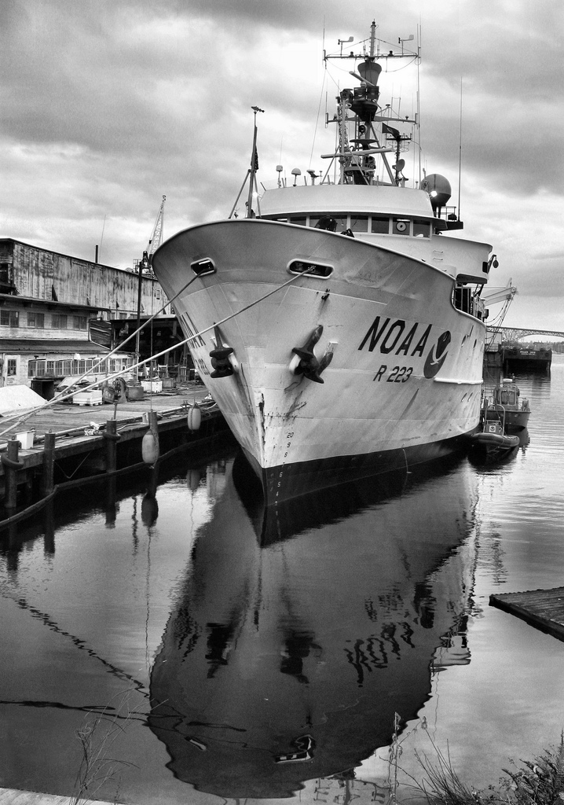


NOAA Arrives!

The 215 foot R/V Miller Freeman docks in Newport, the new home of NOAA Marine Operations Center-Pacific. There will be docks for the four NOAA research ships as well as up to two visiting ships. The NOAA Marine Operations Center-Pacific is comprised of approximately 175 employees, including more than 110 officers and crew assigned to the NOAA ships McArthur II, Miller Freeman, Rainier and Bell M. Shimada. We welcome them with open arms and hope some will be future members!

Cookbooks Still Available!

In case you haven’t heard, our new YBYC Cookbook has over 150 recipes gathered from our members. These delicious recipes are full of local flair and personality. At only $10 each, they're a great gift for family and friends, too! Be sure to get your copy before they are all gone. Thanks again to Stephanie and the cookbook committee and all who contributed their recipes. My wife and I have made several and they were delicious.-Jeff
Sailing News from ‘Round the World

Modern society seems to be obsessed with things large and grand. We
celebrate the biggest, fastest, tallest, strongest, most expensive, and so
forth. But sometimes good things come in small packages too. The large yacht
clubs get plenty of attention, and deservedly so, because they have the
means, facilities and personnel to host major events. Their place in sailing
is important and assured, and in many cases they are the guardians of the
yachting tradition. However, for every one of the large clubs there are a
number of smaller ones with memberships just as dedicated and enthusiastic, mostly run by tireless volunteers. These clubs don't get the same billing in the yachting press, but they are an indispensable connection to the sport for the average sailor.
The same thing applies to the types of boats we sail. Some classes are well
known and grab the headlines. If the boat has the name Melges or Farr
attached to it, for example, chances are you will see the results well
publicized. But there are many more sailors whose "yacht" is a 30 year old
PHRF warrior, maybe not even designed as a true racer, but to that owner and
crew it is the warhorse they can't wait to go to battle on every Wednesday
night.
So let's not get all wrapped up in the bigger is better thing, enjoy what we
have, and respect our fellow sailors regardless of where they are from or
what they sail. Excellent sailors are all around us, in boats of all
descriptions, and in places large and small. -- Don Finkle, RCR Yachts,


Quote of the Month
"If you can't repair it, maybe it shouldn't be on board."
- Lin and Larry Pardey

KAYAK CLASSES

Summer is for kayakers who want a good paddling (and some instruction too!). The June 19-20th class filled before it could be advertised, but don’t despair. Another class will be available on July 17-18th, and the last class for the year is set for the weekend of July 31st-August 1st.

To register or for further information contact: Tom Murphy, coastalkayak@msn.com or call 541.265.9648 (home) or 541.602.5293 (cell).

Adult Sailing Classes Have Started
Adult sailing cases will be offered on Yaquina Bay this summer. There will be a three week class in June and another in September. The schedule is:
SEPTEMBER CLASS
Thurs Sept 9 6pm, Sat/Sun Sept 11/12 9:30am – 4pm
And Thurs Sept 16 6pm, Sat/Sun Sept 18/19 9:30am – 4pm and Thurs Sept 23, 6pm Sat/Sun Sept 25/26 9:30am – 4pm

July 4 at YBYC
Celebrate Independence Day at the YBYC. We've got one of the best views on the water for the fireworks show. Come down to the club for dinner, bring your own beverages and something to throw on the grill. The fireworks start at dusk. But be warned; parking fills fast, come early if you want to park close.


High School Sailing Team

A big round of applause goes to Joe Novello who was instrumental in putting the sailing team together by coordinating with YBYC members and the school district in order for this to happen. Thank Joe for your help.
Thank you Laurie Weitkamp, Terry Lettenmaier, for passing years of sailing skills on to the students eager to learn.This life skills will be with them the rest of their lives. We are hoping it is the beginning of a new competitive sport with Lincoln County schools.

A great big thank you to George Benton,Bernie Stoll ,Tony Shearer ,Anne Willams,Greg Krutzikowsky,Stephanie Doll, Mac McConnell for all the hours of help assisting with all aspects required to teach a sailor before departure from the docks, to keeping a boat a float once out on the water, and the assistance needed when WELL YOU ALL KNOW!! WE ALL HAVE BEEN THERE!!! (CAPSIZE)
I cannot tell you how easy it was with all your help
THANK YOU VERY MUCH!
Dave Schmaltz

HIGH SCHOOL SAILING
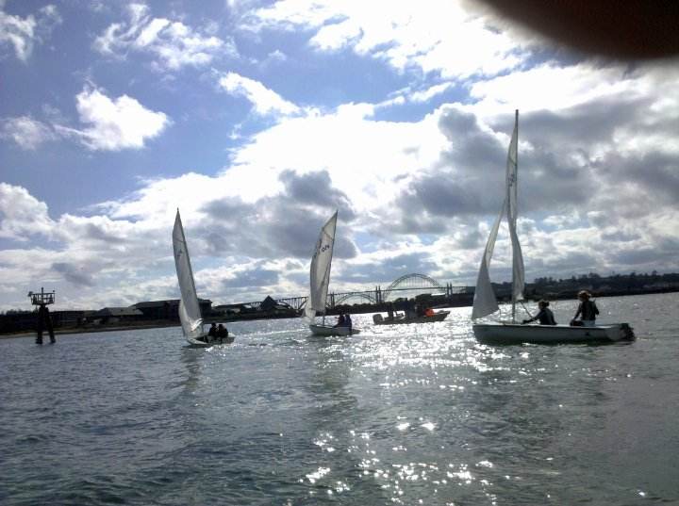

i
Flotsam and Jetsam 
- Welcome New Members Mike and Barbara Fulmore and Rejoining Members Rita Petrosik and Don Miller. We have 4 more memberships pending for approval in June, thanks to everyone for sharing YBYC with your friends and neighbors!
- Remember you can make a tax-deductible donation through the Oregon Boating Foundation. The money is used to provide community boating education and all donations are greatly appreciated. Please contact Ron Cole for further information.
- The club has Lido 14 sailboats available for club member use. These 2 or 3 person dinghies are fun to sail and explore Yaquina Bay. They’re conveniently located on the port dock near the clubhouse. To use the Lidos, check the online calendar for availability, and place your reservation by contacting Tom Mcnamara at ; mcntm@msn.com reservations are posted online on the club’s website www.yaquinabayyachtcluborg under the ‘Calendar’ tab.
- Don’t forget to use our Google group site at groups.google.com/group/ybyc It’s the best place to keep up on club and member activities, chat and exchange info with fellow members. The Club also has a Facebook page, check it out! It’s updated frequently so you can be sure to keep abreast of club activities.
- Ships Store- Please do not forget to check out all the fine items at the ships store. Not only are you buying quality merchandise you can use, but it helps support the YBYC!
- June Birthdays:. George Benton, Ellen Germaneri, Karel Murphy, Marion Voss, Barbara Fulmore, Nathaniel Germaneri, Jerry Anderson, Tom Murphy, John Dougherty. Happy Birthday! Your name not listed? Contact the Membership Chair for an Information Update Form.

- Spring series Wednesday night Club racing runs April 28-October 6. Wednesday races are free for skippers who are YBYC club members. The entry fee for skippers who are not YBYC club members is $50 per series. Non-members new to racing at YBYC may race on two Wednesdays before being subject to entry fees.

- Join us to work on planning for the 2010 Bridge to Bridge Offshore Race. This year's race is August 20-22 and we need a people to help with the race. We'll be meeting once in June, once in July and twice in August. Please get in touch if you can join this committee. We'd really like to find someone interested in learning all the aspects of planning this race so they can take it over or teach a new person this role in a year or two. Stephanie and Ken alaskamissy_2000@yahoo.com 541-265-4575


Editors Corner

It is hard to overestimate the value of teaching young people athletics. In particular, at a time when budget issues are forcing many schools to abandon interscholastic sports piecemeal or entirely. (There are numerous states that don’t even require physical education classes anymore.) The YBYC, with the help of those mentioned above, was able to start a whole new sports program. What a tremendous feat. Bravo!

Because he is so cute, I have to publish young
Arlo. Arlo is Betts Haswell’s first grandchild.
What a fine looking young man! We hope he
doesn’t have any trouble at Alice’s Restaurant!
(young people consult Wikipedia)
Cheers, Jeff

American Home and Stone---541-929-3100
Members: Shane and Mac McConnell
Cabinets, tile, granite countertops, stoves (wood, gas, pellet), spas: Discounts
www.americanhome
Ocean Pulse
Custom Surfboards, Skateboards, and Snowboards
Tom McNamara (541) 265-7745
428 SW Coast Hwy
Newport, OR 97365
www.oceanpulsesurf.com

Bike Newport
Elliott & Daniella Crowder, Owners
150 NW 6th Street
Newport, OR 97365
(541) 265-9917
website: bikenewport.net
email: bikenewport@charter.net

Member-2-Member Network
Have you ever needed a carpenter, cabinet maker, tile setter, tire company and didn’t know who to call? Ever needed to have an item on your boat or home repaired, but had no idea where to call? Rather than calling a stranger or looking in the yellow pages, call another YBYC member! Every member who runs a business or performs a service is encouraged to signup. It’s totally FREE to members! Non-members pay a nominal fee. Want to get yourself listed? Email the YBYC newsletter editor at jcressy@charter.net with your listing information. We need to support our own, especially in this economic climate. Please consider doing what you can.

Alan Brown Tire Center (Les Schwab)
Ken Brown manager (541) 265-6604
1155 SW Coast Hwy
Newport, OR 97365
Email: tyrguy@yahoo.com

Dr. Kenneth S. Bishop
Chiropractic Physician
111 SE Douglas
Suite F-1
Newport, OR 97365
541-264-8138
www.yaquinachiropractic.com

Amy Lynn Greer
Certified Public Accountant
Ph/fax: (541) 563-5147 Cell: (541) 961-6814
PO Box 1341 Waldport, OR 97394

Vicki Krutzikowsky
Shaklee product distributor
www.healthydedication.com
541 264-8039
vickihoosky@hotmail.com

