The Jib Sheet
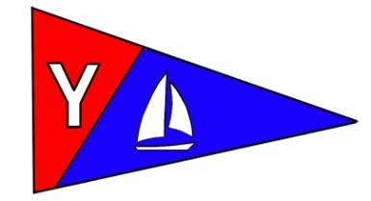
Yacht Club Calendar
July
13-Board Meeting

17-Monthly Meeting

Commodores Log
July 2010
A publication for the Members and Friends of the Yaquina Bay Yacht Club-est. 1947
Our Mailing Address is 750 SE Bay Boulevard, Newport, OR 97365

Our Website URL
Is www.yaquinabay yachtclub.org

For questions about the Club, contact us at YBYC.email@gmail.comFor questions about or contributions to this newsletter contact Jeff Cressy, editor, at jcressy@charter.net

YBYC 2010 Officers
Mac McConnell- Commodore
Vice Commodore : Greg Krutzikowsky
Rear Commodore : Paul Erskine
Secretary : Alice McNamara
Treasurer : Dorothy Bogumil
Spring may have forgotten us, but summer has sprung and so has the Summer sailboat RACING (popular nautical contact sport) series. BOATS (Break Out Another Thousand) are on the water; sails ready with tightened LEECH (crewmember not having a dime when it comes to paying for drinks and meals) and REEF POINTS (rock sticking out of the water) at the ready. CLEWS (what new sailors don't have an inkling of) are set and the BOATs are ready to RACE (go the same direction). KEELS ( bay depth sounder) are newly painted and cleaned. The HELMSMEN (person attached to rudder who enjoys accidental jibes) are practiced. MASTS (religious service performed on the water) and BOOMS (sound made during accidental jibe---boom, boom for slow crew with throbbing heads) are positioned and ready to make sail. So, let's make way, set BOW (waist-bend performed for outstanding dock maneuvering) to the wind, unfurl the sails and get to the start. The summer racing season is on!!

This summer will be a busy one to be sure. Regular Wednesday Night Racing, the Toledo Wooden Boat Show, Sailfest, Kayak instruction, Junior and Adult sailing instruction, Bridge to Bridge event and now YBYC's hosting the "Wild Brunch"---that's not Wild Bunch, but it could be. It's the Newport Wild Seafood Weekend September 11th and 12th. We are also planning on some boat camping trips up the river, more ocean sailing and kayak paddles. All these activities compliment our wonderful monthly meetings (the next one is July17th) where we come together to fellowship and celebrate.

Paul can use help with the Toledo Wooden Boat Show, Donita needs help with the Sailfest, Steph is building a team to work the Bridge to Bridge and Betts can use any help she can get for the Wild Brunch. Contact one of the organizers and see where you can plug in. Your club is only as good as its members make it and so far we be mighty fine, but we could do better!!

It would be nice to hear some of your summer stories and adventures. Dave (the Irishman who visited us for a couple of months) became radically infected by the sailing bug and altered his worldly tour plans heading for Sydney and the Barrier Reef to try to get on a boat heading---anywhere. Betts and daughter Erin are in Morocco after touring the Netherlands, Germany, Italy and Spain. Erin is studying Arabic in Marrakech this summer. Betts is heading off to the mountains of Spain for some day packing and adventure before returning home. Do you have a summer story about camping, sailing, playing? Let others of us enjoy your adventures. Share them with us. Contact Jeff at the Jibsheet.

Remember, we have dinghys, motor boats, kayaks and a keel boat as well as our wonderful clubhouse for MEMBER use. You've seen the activities that we play at. All these things are the added value of your membership with the YBYC. We are membership driven and always looking to expand our ranks so, take opportunities to share the benefits of Membership with your friends and family and invite them to be a part of this remarkable organization---the one that supports youth sailing and the future Olympians of Lincoln County. Membership applications are available at the Clubhouse or ask Membership Chair Steph for some.

Help us promote the YBYC in our community by getting involved. It will make you feel real good.
A quick shout-out to Ken for donating the ship to shore radio and Joe for installing it. It's nice to be able to get current weather and hear the boat chatter (As The Tide Turns). Stay tuned.
Special thanks to Jeff Cressy for the Jib Sheet---it's really wonderful and getting better all the time. Notice the new classified section.

The Website is very readable and fun thanks to Steph. Her google mail reminders are very helpful to those of us who are a wee bit scattered.
Blane is back from Hawaii for a few months and anxious to sail. He welcomes female crew members aboard so if you want to sail but don't have a boat, Blane can be found at the end of A dock.

Fair winds mates; I'll see you on the water
Mac

News You Can Use

June Meeting
The June meeting was a blast as we were
treated to a performance by the local
youth Ballet Folklorico De Mexico troupe
Quetzalcolti.

They performed and dressed in traditional
style. There were numerous costume
changes to reflect the diverse nature of
Mexican regional song and dress. We thankthank
Peggy for arranging it.

We also enjoyed the fine Mexican food,
the pedal-powered blender and the
traditional piñata which made this fiesta
complete.

Toledo Wooden Boat Show

We really need volunteers for the August 20-22 Toledo Wooden Boat Show. There will be a booth from YBYC which will need volunteers to man or woman it.
Please consider helping. Events like this show our value to the community and get our message out...besides it is likely to be warm and what's better than warm weather by the water? A signup sheet will be forthcoming as the time gets nearer, but for now please save the dates.

Meeting Notice
Let the games begin!

Our monthly meeting and potluck will feature games for
all, croquet, bocce ball, badminton, kids races, Frisbee, and
Wii. Hosted by Alice McNamara.
Choose your activity and enjoy happy hour from 5:00 to 7:00 pm on Saturday July 17th.
Kabob and potluck dinner at 7:00, with dinner music. Hope to see you there!


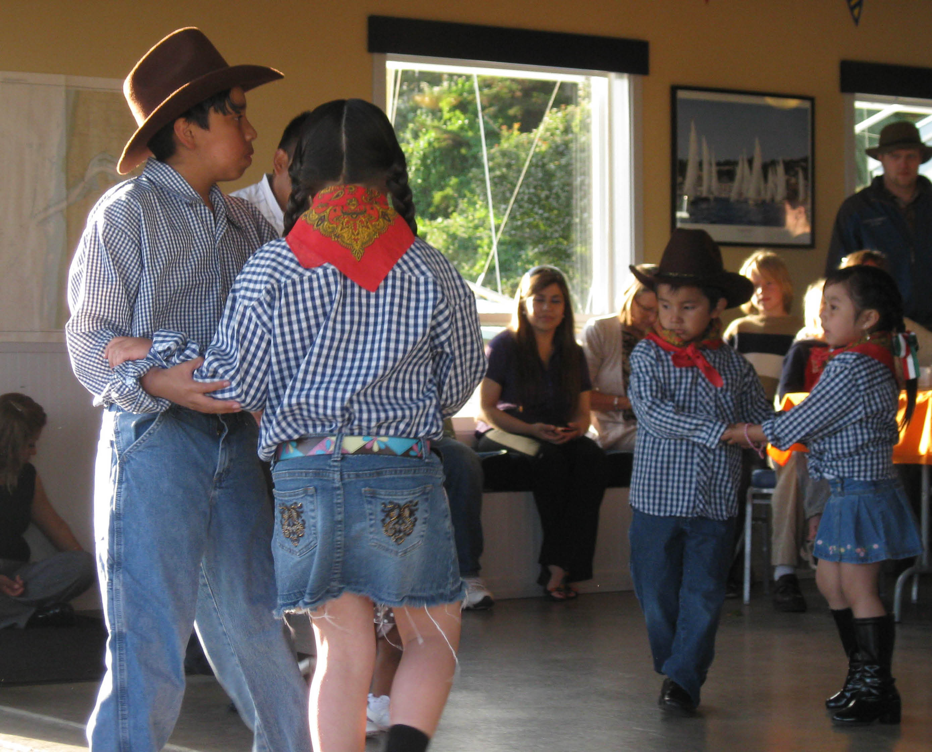

Cookbooks Still Available!

In case you haven’t heard, our new YBYC Cookbook has over 150 recipes gathered from our members. These delicious recipes are full of local flair and personality. At only $10 each, they're a great gift for family and friends, too! I cannot believe they are not sold out! Thanks again to Stephanie and the cookbook committee and all who contributed their recipes. My wife and I have made several and they were delicious.-Jeff
Sailing News from ‘Round the World

When 183 sailboats made the start on June 18th for the 635 miles Bermuda
Race, the diverse fleet was a far cry more competitive and prepared than its
predecessors that sailed the inaugural 1906 race. Long shifts on watch and
freeze-dried meals are no longer the domain of the elite grand prix crowd,
but are considered options for anyone seeking to succeed. It is therefore
refreshing to hear owner Jim Madden, whose J/65 "Brand New Day" ("BND") took
a 2nd in IRC and a 3rd under ORR, explain their passage to the Onion Patch:
“It was a relatively short 3 day event - finishing on Monday, June 21st at
8:24pm ET. The ride to Bermuda on the J/65 was a very comfortable venture.
The air conditioning in each of the cabins, heads, galley and salon kept the
interior of the boat at a constant 68 degrees. This made for some strange,
but very satisfying, sensations when coming off watch from the hot
stickiness of Gulf Stream weather to a chilled interior. Hors D'ouevres were
served promptly each evening at 5pm. The cooked dinners of lasagna, pork,
and chicken were accompanied by white and red wine.”
Maybe ‘proper’ ocean racing is still possible.

Quote of the Month
Sails are just like wings
the wind can make ‘em sing
songs of life, songs of hope
songs to keep your dreams afloat-
Guy Clark-singer/songwriter from Boats to Build

Membership News
Please welcome new members Hugh Cochrane, Jim Burke, Neal McIntosh and Daniel Coffman. This is a great time to enjoy Yaquina Bay, if you need an extra hand aboard, there are lots of YBYC members that love getting on the water, too. You can find boating partners at the club’s group on Google, just send a message to ybyc@googlegroups.com We also have several memberships pending approval at the July board meeting – be sure to say hello if you see new faces at the club.
Bridge to Bridge
Help – We need a few people to join forces in the planning and prep for this amazing once-a-year event. We have urgent need for a Dock Team Leader, Photographer and an Understudy. Thanks to Donita for planning the food for the reception, Mike B for taking charge of the Whaler Team, and Pat for getting creative with the Trophies. Our next planning meeting will be on Sunday July 18. Also thanks to those who are already planning to be part of this event. Don’t forget about the Toledo Wooden Boat Show and help Paul out with that. You can do Both!
Cruise Upriver with us on July 24
Saturday July 24 will find several ships of YBYC pirates heading upriver to plunder Toledo’s Summerfest before retiring to anchorages to view the fireworks show. Hot Tub will be heading up in the early afternoon, with plans to stay overnight on the boat. Bring your boat, your dinghy, and your barbecue and join us.
Wednesday Night Racing News
Spring Series is all finished and in the books – find complete race results on the web at www.yaquinabayyachtclub.org
Summer Series runs each Wednesday from July 7- September 1, with starts at 6:15 p.m. Each boat that participates is encouraged to be the Committee Boat at least once during the series; the sign-up sheet is posted at the clubhouse. Burgers are available at the clubhouse after racing; your donation is appreciated to cover costs.

KAYAK CLASSES

Summer is for kayakers who want a good paddling (and some instruction too!). The June 19-20th class filled before it could be advertised, but don’t despair. Another class will be available on July 17-18th, and the last class for the year is set for the weekend of July 31st-August 1st.

To register or for further information contact: Tom Murphy, coastalkayak@msn.com or call 541.265.9648 (home) or 541.602.5293 (cell).

Adult Sailing Classes Have Started
Adult sailing cases will be offered on Yaquina Bay this summer. There will be a three week class in June and another in September. The schedule is:
SEPTEMBER CLASS
Thurs Sept 9 6pm, Sat/Sun Sept 11/12 9:30am – 4pm
And Thurs Sept 16 6pm, Sat/Sun Sept 18/19 9:30am – 4pm and Thurs Sept 23, 6pm Sat/Sun Sept 25/26 9:30am – 4pm

i
Flotsam and Jetsam 
- Remember you can make a tax-deductible donation through the Oregon Boating Foundation. The money is used to provide community boating education and all donations are greatly appreciated. Please contact Ron Cole for further information.
- The club has Lido 14 sailboats available for club member use. These 2 or 3 person dinghies are fun to sail and explore Yaquina Bay. They’re conveniently located on the port dock near the clubhouse. To use the Lidos, check the online calendar for availability, and place your reservation by contacting Tom Mcnamara at ; mcntm@msn.com reservations are posted online on the club’s website www.yaquinabayyachtcluborg under the ‘Calendar’ tab.
- Don’t forget to use our Google group site at groups.google.com/group/ybyc It’s the best place to keep up on club and member activities, chat and exchange info with fellow members. The Club also has a Facebook page, check it out! It’s updated frequently so you can be sure to keep abreast of club activities.
- Ships Store- Please do not forget to check out all the fine items at the ships store. Not only are you buying quality merchandise you can use, but it helps support the YBYC!
- June Birthdays:. Elliott and son Elliott Crowder, Mary Ann Beggs, Curt Voss, Richard Baczynski, and Daniella Crowder. Happy Birthday! Your name not listed? Contact the Membership Chair for an Information Update Form.
- Help is needed to clean up the outside of the clubhouse. Such gardening chores as weeding trimming etc. Please contact Mac if you can help.


Editors Corner

It seems as if summer is finally upon us, and not day too soon. At first I wasn’t sure what that glowing orb in the sky was, and then it all came back to me. What a great time to get involved in Club activities.
It is a perfect time to get into sailing, kayaking, racing or the many other events and opportunities offered by the Club. And please do not forget about all of the watercraft Mac mentioned available for members. They are there to be used.
I hope to have pictures and exotic tales from our travelling YBYC members in the next issue. I had planned to start a member profile column for this issue, maybe next time.
Cheers,
Jeff

American Home and Stone---541-929-3100
Members: Shane and Mac McConnell
Cabinets, tile, granite countertops, stoves (wood, gas, pellet), spas: Discounts
www.americanhome
Ocean Pulse
Custom Surfboards, Skateboards, and Snowboards
Tom McNamara (541) 265-7745
428 SW Coast Hwy
Newport, OR 97365
www.oceanpulsesurf.com

Bike Newport
Elliott & Daniella Crowder, Owners
150 NW 6th Street
Newport, OR 97365
(541) 265-9917
website: bikenewport.net
email: bikenewport@charter.net
Member-2-Member Network
Have you ever needed a carpenter, cabinet maker, tile setter, tire company and didn’t know who to call? Ever needed to have an item on your boat or home repaired, but had no idea where to call? Rather than calling a stranger or looking in the yellow pages, call another YBYC member! Every member who runs a business or performs a service is encouraged to signup. It’s totally FREE to members! Non-members pay a nominal fee. Want to get yourself listed? Email the YBYC newsletter editor at jcressy@charter.net with your listing information. We need to support our own, especially in this economic climate. Please consider doing what you can.

Alan Brown Tire Center (Les Schwab)
Ken Brown manager (541) 265-6604
1155 SW Coast Hwy
Newport, OR 97365
Email: tyrguy@yahoo.com

Dr. Kenneth S. Bishop
Chiropractic Physician
111 SE Douglas
Suite F-1
Newport, OR 97365
541-264-8138
www.yaquinachiropractic.com

Amy Lynn Greer
Certified Public Accountant
Ph/fax: (541) 563-5147 Cell: (541) 961-6814
PO Box 1341 Waldport, OR 97394

Vicki Krutzikowsky
Shaklee product distributor
www.healthydedication.com
541 264-8039
vickihoosky@hotmail.com

Member-2-Member-(cont.)
Kevin Raichl
Visual Thinking Northwest
828 SE Crescent Pl.
Newport, OR 97365
541-264-8343
541-480-2355 cell
www.visual-thinking.com
YBYC Classified

For Sale: 1974 Catalina 27, can be seen at B-98 Embarcadero I would like $8,000 but am very willing to listen to reasonable offers. If you would like more information call Jeff Longmore 541-225-7533 to arrange a tour.

NRS Women's Boaters Gloves, medium
http://www.nrsweb.com/shop/product.asp?pfid=24302&pdeptid=944
Bought 1 month ago, wore only a handful of times. Perfectly fine, just
realized I should have gotten a different style. $10 OBO ($24.95 new).
Email me at cpvoss@comcast.net.

Club Lighthouse Sail
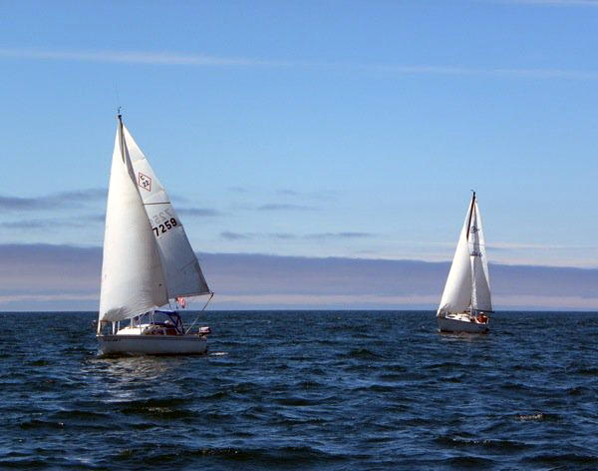
Gulf oil spill-Day 81
7/9/2010
Let us not forget how lucky we are

