The Jib Sheet
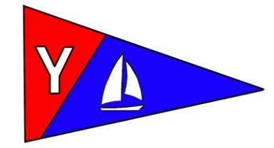
Yacht Club Calendar
August
22-Bridge to Bridge arrival/feast; Toledo wooden boat show

Commodores Log
August 2010
A publication for the Members and Friends of the Yaquina Bay Yacht Club-est. 1947
Our Mailing Address is 750 SE Bay Boulevard, Newport, OR 97365

Our Website URL
Is www.yaquinabay yachtclub.org

For questions about the Club, contact us at YBYC.email@gmail.comFor questions about or contributions to this newsletter contact Jeff Cressy, editor, at jcressy@charter.net

YBYC 2010 Officers
Mac McConnell- Commodore
Vice Commodore : Greg Krutzikowsky
Rear Commodore : Paul Erskine
Secretary : Alice McNamara
Treasurer : Dorothy Bogumil
We’re flyers and sailors, you and me. High and low, fast and slow we love the exhilaration of controlling an airfoil that moves through the air. Sailors call their airfoil a sail sails and flyers call theirs wings but they are really the same. A sailor manages the force of the wind by changing the rigging, rudder, keel or centerboard while a flyer uses pitch, thrust and airfoil shape to create lift and forward drive. Speed is created by how the force of the wind is managed on the air foil. The way that an airfoil moves through the air is the result of skill, knowledge and experience in varying winds and (sea) conditions as well as knowledge of the sailing craft and local conditions. This is the art of sailing, on land and in the air. We are all sailors and flyers, we who love the wind at our backs, in our face and beneath our feet. But, there is a difference.

There is an art and passion to sailing and racing in the sun, rain, fog, and drizzle that maybe only sailors can fully understand and appreciate:
1. Location, location, the variety of which inspires and brings satisfaction—the rugged beauty of the mighty Yaquina, its seascape and wild life.
2. The right sailing partner(s) provides good conversation, motivation, pace and camaraderie.
3. Thinking warm thoughts with the help of good food, grog and after race celebration brings contentment, inner peace and feeling of job well done amongst this family of friends.
4. Feeling the environment as it chills and wets, stings and caresses lets sailors be in the moment, in the arms of the wind and in the cradle of the sea--- his (her) birthright, our collective
passion. Without that passion it’s only wind over the water.

Ok, ok, we (Annies Fanny) placed first or close to first tonight in the Wednesday night races—good enough cause for long winded waxing. After years of being first to be last it is nice to look back at the pack; all because of the mentoring, friendship and advice from fellow YBYC sailors who took time to share their passion.

August is busy for the YBYC. Wednesday night sailing, cruising, over- nighting and events. August 22-23 is the Toledo Wooden Boat Show where we’ll be showing off sailing and who we are. August 22-23 is also the Bridge to Bridge extravaganza. From Astoria to Newport, around 16 ocean- worthy boats will race to finish at our clubhouse. My mouth watering eggs Benedict will be featured at the Sunday monthly meeting brunch/potluck. Scrumdiddlyumptious, this promises to be a heart stopping, girth enhancing extravaganza. Sailors from many yacht clubs will be arriving exhausted and ready for food and refreshments, anxious to show off their racing craft, and ready to be received by the gracious members of the YBYC. At three in the afternoon, the pig will come off the roast and tables set to feed the many racing sailors and those of you that want to stay for the celebration.

Kayak classes were so successful that the Club is moving to purchase seven new teaching kayaks. Tom Murphy has done a phenomenal job and having just taken the kayak class, I can say that I am really excited to learn more, do more and discover the freedom that safe kayaking brings. In purchasing the new kayak fleet there is opportunity for you to buy a Wilderness Systems Tsunami kayak below wholesale due to a special purchase and in house financing. Contact Tom if you are interested. I’m definitely getting one!

Youth sailing through OBF got off to a slow start but picked-up speed with full classes and many happy kids. Many thanks to Merry, Ron, Donita and the rest of the OBF team for introducing young folks to the sport that we love. The last OBF adult sailing classes of the season are upcoming. Tell your friends.

And that’s not all. In September we have been asked to host food for the Wild Seafood Weekend put on by the Fishermen’s Wives. The money that we earn will be earmarked for our varied education programs. Betts is welcoming volunteers and for this we will need many.

The YBYC is strong with membership up 50% from two years ago. We are in good financial shape and the clubs activities are growing in number and quality. We’re having a mighty fine time and there is always a place for you, our valued family of members, in everything that we do.

Fair winds and I’ll see you on the water or at the clubhouse!

Mac

News You Can Use

July Meeting

Everyone had a great time at the July meeting. The weather cooperated and games and
barbequed kabobs were the order of the day. There was even a
drum circle. Our fearless leader Mac and Cameron proved they
had more than just the rhythm of the sea coursing through their
veins, as did others.
Many thanks to Tom and Alice McNamara for hosting and
preparing the delicious kabobs, it was a lot of work and no one
left hungry!

Toledo Wooden Boat Show

Yet another...though the last for now...opportunity to get involved with the Toledo Wooden Boat show, a few slots still available in the booth on Sunday, and for boat ride skippering on Saturday or Sunday...Let me know on Googlegroups or by emailing pmerskine@yahoo.com This is on the weekend of August 21/22.

Adult Beginning Sailing Classes

There are still a few spaces available in the September Adult Learn to Sail class. Tell your friends and family and let’s get those spaces filled.
Classes will be held at the YBYC clubhouse on Thursdays from 7:00 to 9:00 PM on September 9, 16 & 23 and on the water Saturdays & Sundays from 8:00 to 12:00 on September 11/12, 18/19, & 25/26. The cost is $175 per person but discounts are available for YBYC members and for those who chose to join the club. Class members will need to provide their own life vest. Wet suits are highly recommended.
Please contact Diane Henkels at 541-270-6001 or at dhenkels@actionnet.net to sign up.

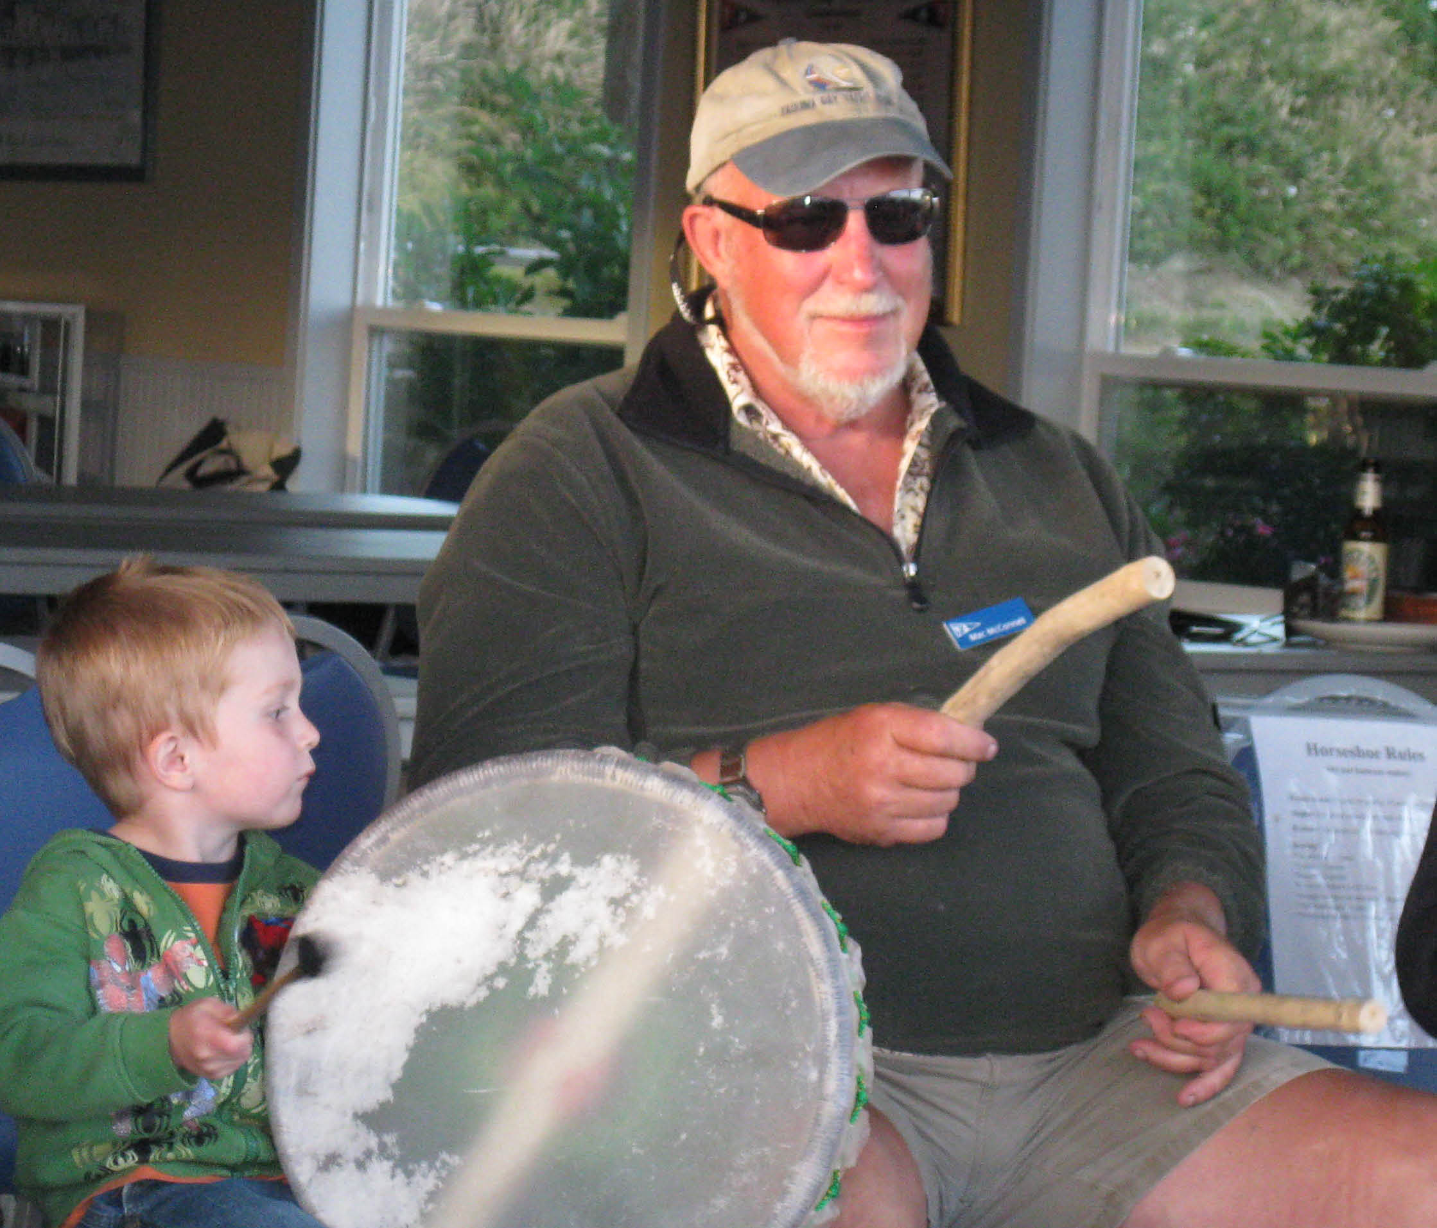

Cookbooks Still Available!

In case you haven’t heard, our new YBYC Cookbook has over 150 recipes gathered from our members. These delicious recipes are full of local flair and personality. At only $10 each, they're a great gift for family and friends, too! I cannot believe they are not sold out! Thanks again to Stephanie and the cookbook committee and all who contributed their recipes. My wife and I have made several and they were delicious.-Jeff
Sailing News from ‘Round the World

Weymouth, England (August 11, 2010) - The damp cold weather from Tuesday was
replaced today by sunny skies as the fleets completed the qualifying rounds
of Skandia Sail for Gold 2010. The Gold fleets will be separated out
tonight, and Thursday will get down to the business end of the regatta.
The current standings amid the Olympic events find the contingent from North
America mostly nipping at the podium, but with only a few teams making a
strong case to land a medal finish. Leading the cause are the Americans from
their 2008 Olympic Team, with Zach Railey pulling a 4-1 today to hold down
4th overall in the Finn, and skippers Anna Tunnicliffe and Sally Barkow
advancing to the gold round in Women's Match Racing after strong results in
the early elimination series.
Racing concludes on Saturday August 14th.
Event website: http://www.skandiasailforgoldregatta.co.uk/
U.S. team update: http://tinyurl.com/2crllzl

Quote of the Month

I don't know who named them swells. There's nothing swell about them. They should have named them awfuls.
--Hugo Vihlen

Membership News
We would like to extend a hearty welcome to new members; Jim Rice and Cait Goodwin, Russell Morely, Rosalina Wong and son Evan, and Sandi Lusk and Woody Richards.
Bridge to Bridge

Join us on Sunday August 22 at the clubhouse and nearby docks to welcome
the racers across the finish line! 15 or more yachts will be departing
Astoria on their 100 mile race to Newport and you can be there to see it
all. We still have opportunities for you to help with the escort boat,
dock-side welcoming and clubhouse hospitality. No experience necessary,
just bring your smile. Contact Stephanie for information 541-961-1823
Wednesday Night Racing News
Spring Series is all finished and in the books – find complete race results on the web at www.yaquinabayyachtclub.org
Summer Series runs each Wednesday from July 7- September 1, with starts at 6:15 p.m. Each boat that participates is encouraged to be the Committee Boat at least once during the series; the sign-up sheet is posted at the clubhouse. Burgers are available at the clubhouse after racing; your donation is appreciated to cover costs.
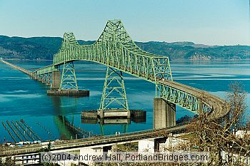




THE PADDLER’S BOX *

The weekend of September 31st-August 1st concluded YBYC’s most productive kayaking instruction season. Five classes were given with a total of 24 students participating. Their registration fees contributed $2250.00 to the Club. Four of the classes were at the basic coastal kayaking level, and for the first time we offered a class at the intermediate level, with four students enrolled. Our instruction was greatly enhanced through the efforts of five of the instructors who completed the five-day instructor development and certification examination sponsored by the Club late last summer. Two served as lead instructors.
Over the six years we have been offering coastal kayaking instruction, we have taught 77 students, 11 of whom have been YBYC members. Over this period we have brought in approximately $6200.00, but more importantly we have contributed to a safer kayaking community at the Coast. Throughout these years we have been using an assortment of borrowed kayaks. While these have served the purpose, we now have an “aging fleet” which is in need of replacement and the addition of more boats to accommodate the wide range of sizes and increased numbers we have in our classes.
Preliminary contacts have been made to ascertain possible reductions in costs if we were to buy a number of boats from the same manufacturer, and it appears that we would find substantial savings if we were to do so. It’s possible that we may be able to acquire some boats for a rental fleet that could be purchased by Club members after a year, perhaps in a “rent to own” program. We will keep the membership informed about future developments.
Submitted by Tom Murphy
*A square produced by your chest, arms, and the paddle shaft which is maintained throughout various paddle strokes and is critical for power, endurance, and injury prevention

Toledo Summer Fest
A merry band of sailors traveled miles and miles in search of elephant
ears and pyrotechnics one warm July afternoon. The caravan of Little
Annie's Fannie, Hot Tub, and Son O Beech docked up in Toledo mid
afternoon and soon were joined by Hejira and Western Flyer (who both
sailed up). The afternoon's sun gave way to evening breeze and transom
mounted grills, punctuated by Alice's margarita blender. At the stroke of
10pm the rockets were launched directly overhead, beginning an amazing
display of fireworks to which we had a front-row seat. After a restful
night aboard, we awoke to mudflats aplenty. Instead of our gentle morning
cruise back to home-port, we spent a couple hours watching the tide fill
in to float us off again.
i
Flotsam and Jetsam 
- Remember you can make a tax-deductible donation through the Oregon Boating Foundation. The money is used to provide community boating education and all donations are greatly appreciated. Please contact Ron Cole for further information.
- The club has Lido 14 sailboats available for club member use. These 2 or 3 person dinghies are fun to sail and explore Yaquina Bay. They’re conveniently located on the port dock near the clubhouse. To use the Lidos, check the online calendar for availability, and place your reservation by contacting Tom Mcnamara at ; mcntm@msn.com reservations are posted online on the club’s website www.yaquinabayyachtcluborg under the ‘Calendar’ tab.
- Don’t forget to use our Google group site at groups.google.com/group/ybyc It’s the best place to keep up on club and member activities, chat and exchange info with fellow members. The Club also has a Facebook page, check it out! It’s updated frequently so you can be sure to keep abreast of club activities.
- Ships Store- Please do not forget to check out all the fine items at the ships store. Not only are you buying quality merchandise you can use, but it helps support the YBYC!
- June Birthdays: Tim Myrick, Donna Cressy, Jane Myrick, Anne Williams, Jeff Longmore, Don Miller, Josh Viar.Happy Birthday! Your name not listed? Contact the Membership Chair for an Information Update Form.
- Help is still needed to clean up the outside of the clubhouse. Such gardening chores as weeding trimming etc. Please contact Mac if you can help.


Editors Corner

Mac did a great job in letting everyone know what is coming up. It’s quite a busy time. I keep running the cookbook information because they are still available. I’m sure all Club members have one, but I’m thinking everyone knows someone who could use a gift. There is a Hawaiian theme for Bridge to Bridge, so dress accordingly.
The notice of race (NOR) for the Columbus Day Regatta is at the end of the newsletter. I know, where did the time go?
Betts could use all manner of help for September’s Wild Seafood Weekend, please contact her.
I include the Olympics related story because I can’t wait until one of the athletes we trained represents us.
Cheers, Jeff

American Home and Stone---541-929-3100
Members: Shane and Mac McConnell
Cabinets, tile, granite countertops, stoves (wood, gas, pellet), spas: Discounts
www.americanhome
Ocean Pulse
Custom Surfboards, Skateboards, and Snowboards
Tom McNamara (541) 265-7745
428 SW Coast Hwy
Newport, OR 97365
www.oceanpulsesurf.com

Bike Newport
Elliott & Daniella Crowder, Owners
150 NW 6th Street
Newport, OR 97365
(541) 265-9917
website: bikenewport.net
email: bikenewport@charter.net
Member-2-Member Network
Have you ever needed a carpenter, cabinet maker, tile setter, tire company and didn’t know who to call? Ever needed to have an item on your boat or home repaired, but had no idea where to call? Rather than calling a stranger or looking in the yellow pages, call another YBYC member! Every member who runs a business or performs a service is encouraged to signup. It’s totally FREE to members! Non-members pay a nominal fee. Want to get yourself listed? Email the YBYC newsletter editor at jcressy@charter.net with your listing information. We need to support our own, especially in this economic climate. Please consider doing what you can.

Alan Brown Tire Center (Les Schwab)
Ken Brown manager (541) 265-6604
1155 SW Coast Hwy
Newport, OR 97365
Email: tyrguy@yahoo.com

Dr. Kenneth S. Bishop
Chiropractic Physician
111 SE Douglas
Suite F-1
Newport, OR 97365
541-264-8138
www.yaquinachiropractic.com

Amy Lynn Greer
Certified Public Accountant
Ph/fax: (541) 563-5147 Cell: (541) 961-6814
PO Box 1341 Waldport, OR 97394

Vicki Krutzikowsky
Shaklee product distributor
www.healthydedication.com
541 264-8039
vickihoosky@hotmail.com

Member-2-Member-(cont.)
Kevin Raichl
Visual Thinking Northwest
828 SE Crescent Pl.
Newport, OR 97365
541-264-8343
541-480-2355 cell
www.visual-thinking.com
YBYC Classified

For Sale: 1974 Catalina 27, can be seen at B-98 Embarcadero I would like $8,000 but am very willing to listen to reasonable offers. If you would like more information call Jeff Longmore 541-225-7533 to arrange a tour.

NRS Women's Boaters Gloves, medium
http://www.nrsweb.com/shop/product.asp?pfid=24302&pdeptid=944
Bought 1 month ago, wore only a handful of times. Perfectly fine, just
realized I should have gotten a different style. $10 OBO ($24.95 new).
Email me at cpvoss@comcast.net.

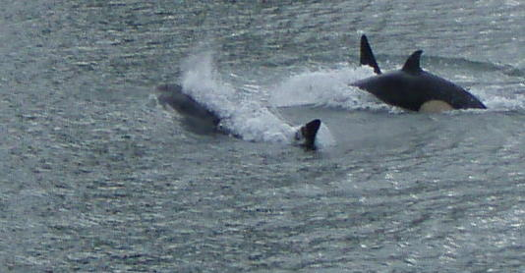
ORCAS IN THE BAY
This great picture and info comes to us from Laurie Weitkamp. On the evening of June 10th. there were two adult females and their four offspring in the bay. They were part of a transient group who feed primarily on marine mammals.

Yaquina Bay Yacht Club
www.yaquinabayyachtclub.org
Notice of Race
2010 Columbus Day Regatta
October 9-10, 2010
Rules: The regatta will be governed by the Racing Rules of Sailing 2009-2012 including
US Sailing Prescriptions except as any of these are altered by the sailing instructions.
Entries: Open to all keelboat and centerboard classes. Separate scoring for keelboat
(PHRF), centerboard (Portsmouth), and one-design fleets with 5 or more boats registered.
Social: Saturday morning clubhouse opens 8am for continental breakfast. Saturday Fresh Grilled Tuna
Dinner, 6:30 p.m. Sunday morning clubhouse opens at 9am for continental breakfast.
Lodging, Launching and Mooring: Keelboat hoisting available at Port hoists near club for $35 round
trip, or Sawyer’s Landing for $30 round trip. Small boats (approximately Lido 14 and smaller) can
hand launch at Port dock 7 near club. South Beach has a launch ramp and moorage; they can be
reached at 541-867-3321. Lodging and moorage are available through the Embarcadero; 800-547-
4779, and lodging is available at The Landing; 541-574-6777
Schedule of Events:
Saturday, October 9 (as many races as possible) Sunday, October 10 (as many races as possible)
8:30-9:30 AM Registration at clubhouse
10:00 AM Skipper’s meeting
12:00 PM Warning, Race 1
6:30 PM Dinner – Clubhouse
9:00 AM Clubhouse open
11:00 AM Warning, first race of the day
3:00 PM No races after
Scoring: The low point scoring system will apply. Each boat’s score will be the sum of all races
sailed with no throw outs. PHRF scoring will use time on distance method.
Boats without PHRF certificates will be assigned a rating by the YBYC race chair.
Sailing Instructions: Available at registration.
Registration: Please make your check payable to Yaquina Bay Yacht Club or YBYC
Entry Fee (includes 1 t-shirt) $45.00
US Sailing Member Discount -$5.00
After Sept 30 $10.00
Dinner Tickets _____ x $12.00 =
Kids 5-14 Dinner _____ x $5.00 =
T-shirts size(s) _____ x $15.00 =
Total
Yacht Name____________________________________________________________________________
Boat Make/Model/Length_________________________________________ Rating_________________
Skipper Name___________________________________________________________________________
Address________________________________________________________________________________
Phone__________________________________Email___________________________________________
I represent to the organizers that my boat has liability insurance in effect and that my boat meets the requirements of the
U.S. Coast Guard. I acknowledge that all competitors participate in this regatta entirely at their own risk. I agree to be
bound by the Racing Rules of Sailing with respect to all claims arising out of participation of my boat in this event. I
acknowledge that the Yaquina Bay Yacht Club, its officers and the race committee will not accept any liability for material
damage or personal injury or death sustained in conjunction with or prior to, during, or after this regatta.
Skipper’s Signature ______________________________________________________Date____________
Questions? Contact Ken Brown at tyrguy@yahoo.com or 541-265-4575

