The Jib Sheet
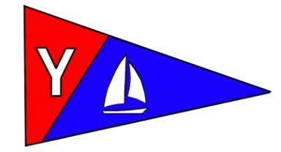
Yacht Club Calendar
April
13- Board Meeting
17-Monthly Meeting
21-Educational series
24-25 Loyalty Days Regatta

Commodores Log
April 2010
A publication for the Members and Friends of the Yaquina Bay Yacht Club
Our Mailing Address is 750 SE Bay Boulevard, Newport, OR 97365

Our Website URL
Is www.yaquinabay yachtclub.org

For questions about the Club, contact us at YBYC.email@gmail.comFor questions about or contributions to this newsletter contact Jeff Cressy, editor, at jcressy@charter.net

Ya Gotta Regatta!!!

The usually unpredictable weather of March has followed us to April, cutting into our frostbite sail time. It’s practice we need to get on the mark for the Loyalty Days Regatta coming up quickly this April 24th and 25th. Joe Novello put on a great classroom presentation, using the new projection system. He described starts, positioning, committee boat and race courses. Race Committee Chairman Ken Brown was there to offer his excellent insights. This year we will be having not only our Keelboat PHRF fleet and dinghy Portsmouth fleet but the High School students racing the Clubs 420’s. The youth sailing team has brought 12 new student members to our club and two family memberships and let me tell you, they are pumped. Using the Lido’s, 420’s and JY trainers the student athletes have been hard at practice under the excellent coaching of Dave Schmaltz and Assistant Coaches Laurie Wieltkamp, Terry Lettenmeyer and Bernie Stoll. Practicing two days a week for the last three weeks, the student sailors are already racing and jazzed-up about showing their skills at the Regatta. Many thanks to all who have helped running chase boats, organizing and making YBYC’s outreach to the youth a reality. Who knows, that audacious dream of putting a team in the Olympics may indeed come true.
Our regular Wednesday night races kick-off the first Wednesday after Loyalty Days. The crews and boats are ready. This promises to be a fun and competitive season. If you are not sailing we still have need for Committee boat helpers and Chase boat crew.

YBYC 2010 Officers
Mac McConnell- Commodore
Vice Commodore : Greg Krutzikowsky
Rear Commodore : Paul Erskine
Secretary : Alice McNamara
Treasurer : Dorothy Bogumil

Contact Ken if you would like to be of help and Tom if you would like to get checked-out on the Whaler and become a chase boat operator. So much of the fun comes after the race when we gather at the clubhouse for a burger flip and camaraderie and for that, everyone is more than welcome.
Many thanks to Stephanie and crew for the recently unveiled, wonderful and profitable YBYC COOKBOOK. There are some left so contact Steph and spend the best $10 you will ever enjoy spending and recipes you will love devouring.
The clubhouse is renting well thanks to the shared “House Committee” work of Vickie and Betts
Wednesday night Education classes under Jerry are flourishing and the classes have been excellent. Remember, they are free to members and open to all. Keep an eye on Google Groups for times and dates for those as well as Tom Murphy’s popular Kayak classes.
So, let the water- sports season begin! Kayak classes, adult and youth sailing classes, racing, touring, boat camping, seminars and presenting ourselves at the various parades and boat shows is the whole mix of who we are and what we are about. We always need more members and volunteers so bring your friends and family and tell them about the fun that we have and the community outreach that we are undertaking with the student sailing team. Invite them to become a part of the YBYC community learning to safely enjoy water sports on the beautiful Yaquina Bay and celebrate with us in our comfortable, well equipped clubhouse.
Good sailing and fair winds
Mac

Quote of the Month
Twenty years from now you will be more disappointed by the things that you didn't do than by the ones you did do. So throw off the bowlines. Sail away from the safe harbor. Catch the trade winds in your sails. Explore. Dream. Discover.
--Mark Twain
Meeting Notice

Be sure to join us on April 17th for a very special meeting hosted by Amy Greer and Barb Lepine. It’s JAMES BOND CASINO MARTINI BAR NIGHT!
Guests should bring Gin, Vodka or another beverage. We will supply the olives, lemon juice, glasses, etc, but feel free to bring what you want. Dress is as formal as you can- black tie with shorts? Everyone should bring Finger Foods (Goldfinger foods that is). It’s rumored that M will be there, so everyone be on their toes! Remember, shaken, not stirred!



News You Can Use

March Meeting
The March meeting was billed as a celebration of St. Patrick’s Day and the first day of spring. The celebration exceeded all expectations. Rebecca Lomnicky was tremendous playing traditional Scottish fiddle tunes as well as some fine originals. We were truly honored to have a musician of her caliber entertain us. At the tender age of 18, we can rest assured that the tradition of fine Celtic fiddlin’ is in good hands.

What really made this meeting special was the same thing that makes the YBYC so special, the people. Mac rigged up an outdoor light to serve as a spotlight for Rebecca. Elliott cooked 60 pounds of delicious corned beef battling the usual Newport elements. Sides for 60 people were cooked up by me, Betts and Donna as well as everyone who brought dishes. Donna and Betts also did the decorating with help from Narine, Daniella, and Vicki. What makes this Club work is the people. After the feast and concert it looked like it would take a week to clean up. Not the case. No one even had to be asked to help. Seamus started in the kitchen doing dishes, others dealt with the tables, trash disposal, taking down decorations and everything else that returned the Clubhouse to its pristine shape for the group that had it rented the next day. A heartfelt thank you to all who helped, this meeting said a lot about the character (and characters) of our membership. Below are some pictures of that wonderful night.-Jeff
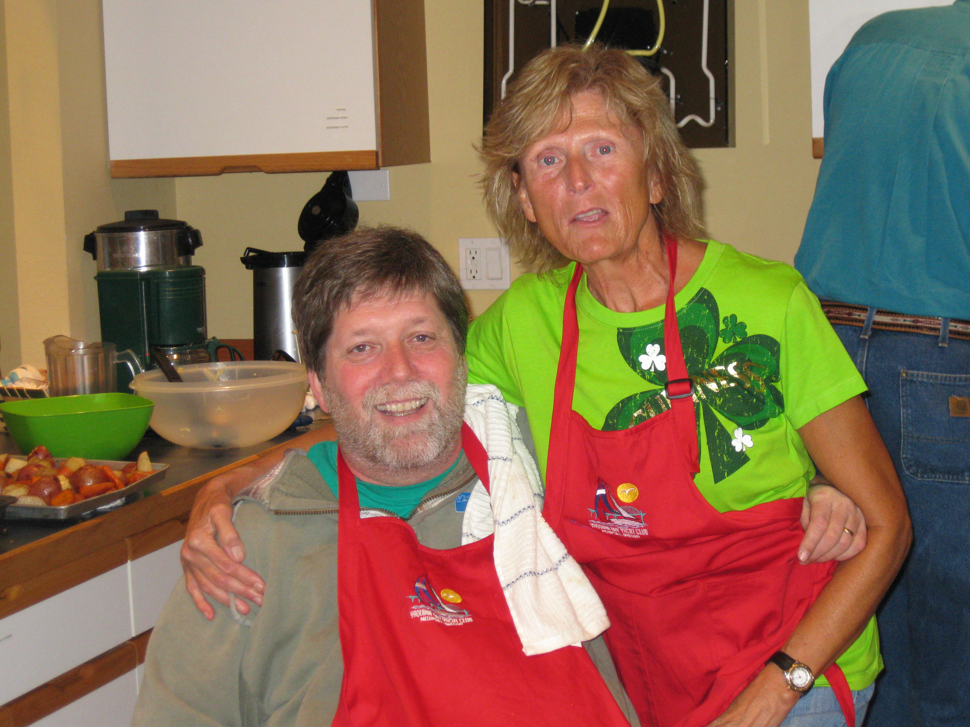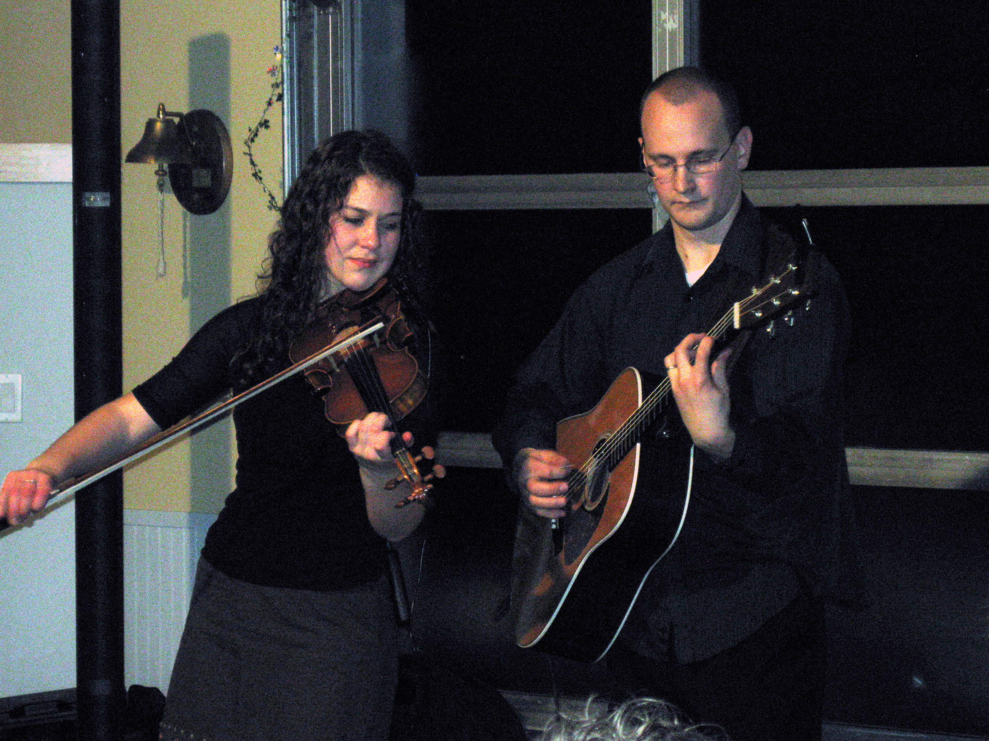
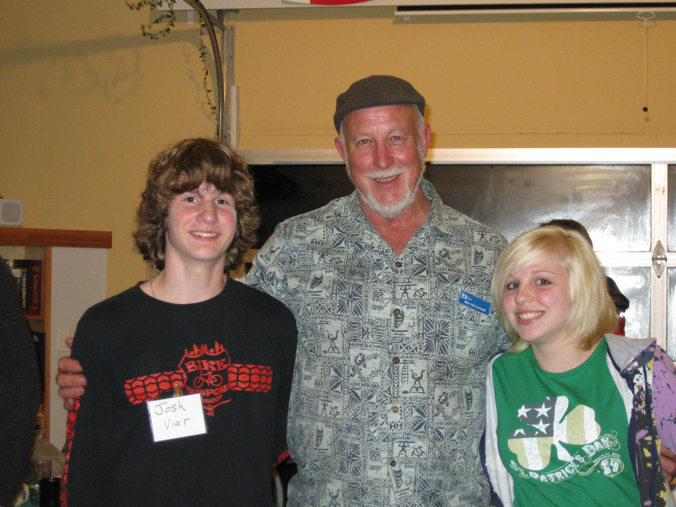
Prospective High School Sailing members
Josh Vair and Olivia Dye with Mac
Betts and myself

Rebecca Lomnicky and Peter Willis

The Cookbook is here!

Our new YBYC Cookbook has over 150 recipes gathered from our members. These delicious recipes are full of local flair and personality. At only $10 each, they're a great gift for family and friends, too! Get yours at the next meeting before they're gone.
Membership News
We have over a dozen memberships pending approval at this month's upcoming Board Meeting, which means you'll be seeing lots of new faces soon. Be sure to say hello and introduce yourselves. Many of the applicants are involved in the new County-wide High School Sailing Team and are just learning this sport. Among us we have lots of knowledge to share, so don't be shy and please welcome our newest members. You can help grow our membership, too; pass the word on about why you enjoy being a member and tell your friends. If you have questions about how to get the most out of your membership, get in touch with me. 541-265-4575 or email alaskamissy_2000@yahoo.com
-Stephanie Brown, 2010 Membership Chair
Sailing News from ‘Round the World

Nassau, Bahamas (April 7, 2010) - The last time Sir Durward Knowles decided to get into a sailboat and compete, his friends and family were impressed by
his ability. He was, after all, 80 years old. But fast-forward 12 years and
they have a different outlook on his decision to compete in next week's
Harry Knowles series, the warm up to the International Star Class Western
Hemisphere Championship 2010.
"Oh, they all think I'm crazy," laughed Knowles, "They know that to try to
stop me, that wouldn't work, so they've gone along with it and said if
you're foolish enough to try it, go ahead."
And so he is. Sir Durward, the Bahamas' first Olympic gold medalist in
Tokyo, 1964, plans to compete in one race of the Harry Knowles series.
Steven Kelly, who served as his crew in the 1988 Seoul Olympics, will be on
board with him again next week. Unlike others who will be competing in the
big event, Sir Durward isn't putting in any practice time. When asked about
a training regiment, he said "Training? If I get out in the boat once, that's it. I'm not going to try it again." In fact, he admits that his biggest concern is actually getting into the boat, but said, "If I get in, I know I've got it made."


. SEA KAYAKING INSTRUCTION LAUNCHES EARLY THIS YEAR

Several requests were received for a coastal kayaking class earlier in the year. On April 11th we had a full class for “Coastal Kayak Basic Strokes and Rescues”, and several newly certified instructors from last year’s YBYC sponsored coastal kayak 5-day instructor workshop/examination assisted in the training.

A “Spring Tune-up” class for those who have had previous training or experience is scheduled for May 23rd. The class will focus on reviewing and refining paddle strokes and boat control to achieve more effective and efficient skills. It will also provide practice to refresh self-rescue and assisted- rescue skills. Participants can look forward to an enjoyable day on the water and getting to know other kayakers in the area.

Three introductory coastal kayaking classes are scheduled for the summer months, and they will be announced in future issues for The Jib Sheet.

If you or anyone you know is interested in registering for or further information about these classes, please contact: Tom Murphy at coastalkayak@msn.com or 541.265.9648.

Adult Sailing Class Starts Soon
Adult sailing cases will be offered on Yaquina Bay this summer. There will be a three week class in June and another in September. The schedule is:

JUNE CLASS
Thurs June 3 6pm, Sat/Sun June 5/6 9:30am – 4pm
and Thurs June 10 6pm, Sat/Sun June 12/13 9:30am – 4pm
and Thurs June 17 6pm, Sat/Sun June 19/20 9:30am – 4pm
SEPTEMBER CLASS
Thurs Sept 9 6pm, Sat/Sun Sept 11/12 9:30am – 4pm
And Thurs Sept 16 6pm, Sat/Sun Sept 18/19 9:30am – 4pmAnd Thurs Sept 23, 6pm Sat/Sun Sept 25/26 9:30am – 4pm

2010 YBYC Wednesday Evening Educational Series
All Classes are on Wednesday evening in the YBYC Clubhouse starting at 7:00 PM and will end at approximately 8:30 PM. The next scheduled classes are:

April 14 –TBD
April 21- Rules of Racing-Ken Brown

Hardship Fund
In response to the continued slow economy and to help our members in need to maintain their membership in YBYC, we have begun collecting for a Hardship Fund. If you would like to help by contributing to this fund, please contact the Membership Chair, Stephanie. You can also make contributions in the Donation box at the clubhouse or simply mail your generous gift to YBYC, 750 SE Bay Boulevard, Newport, OR 97365

Loyalty Days Regatta

Hi racers! It is time again for the Loyalty Days regatta April 24Th and 25Th. This regatta starts on Saturday morning with a continental breakfast hosted by Dorothy with skippers meeting to follow then it’s out on the water racing at noon. This regatta typically provides us with great light wind racing and manageable tides. We always look forward to the visiting sailors from TYC and EYC and hope that we have racers come to compete with our growing fleet of small boat racers. We are looking for volunteers to man the committee boat and help with the dungeness crab feast on Saturday night if you would like to help or know someone that would please contact Ken Brown at 541-270-1038 or by email at tyrguy@yahoo.com

Depoe Bay Wooden Boat Show
Enjoy local, succulent crab and watch master craftsmen build and show off their wooden boats. Take part in cheering your “ducky” to the finish line during Sunday’s Ducky Derby.
April 17th 8a.m.-5p.m.
April 18th 11a.m.-5p.m.
Location: Depoe Bay Harbor and Depoe Bay Community Center
Cost: Wooden Boat show is Free and the Crab Feed is: Whole crab: $15, Half crab: $12
Please notice our need for volunteers below. This is an important event to help showcase the YBYC in the greater community.

r 18 11:00 – 5:00
(Come early on Sunday, we frequently run out of crab!)
Location: Depoe Bay Harbor and Depoe Bay Community Center
Cost: Wooden Boat show is Free and the Crab Feed is: Whole crab: $15, Half crab: $12

i
Flotsam and Jetsam 
- Save the Date- The Port of Toledo is celebrating its Centennial year and its annual wooden boat show is August 20-22. This year is promised to be special.
- Remember you can make a tax-deductible donation through the Oregon Boating Foundation. The money is used to provide community boating education and all donations are greatly appreciated. Please contact Ron Cole for further information.
- The club has Lido 14 sailboats available for club member use. These 2 or 3 person dinghies are fun to sail and explore Yaquina Bay. They’re conveniently located on the port dock near the clubhouse. To use the Lidos, check the online calendar for availability, and place your reservation by contacting Tom Mcnamara at ; mcntm@msn.com reservations are posted online on the club’s website www.yaquinabayyachtcluborg under the ‘Calendar’ tab.
- Don’t forget to use our Google group site at groups.google.com/group/ybyc It’s the best place to keep up on club and member activities, chat and exchange info with fellow members. The Club also has a Facebook page, check it out!
- Ships Store- Please do not forget to check out all the fine items at the ships store. Donna and I love our new aprons; fly the mighty blue and red even in your kitchen!
- April Birthdays: Steve Germaneri, Dorothy Bogumil, Landon Reno, Beckie
- Versteeg Happy Birthday!
- Volunteers are needed for the Depoe Bay wooden boat show on April 17&18, as well as the Loyalty Days parade which is the first weekend in May. Email Paul Erskine pmerskine@yahoo.com or call 541-765-4467
- Wednesday night Club racing runs April 28-October 6. Wednesday races are free for skippers who are YBYC club members. The entry fee for skippers who are not YBYC club members is $50 per series. Non-members new to racing at YBYC may race on two Wednesdays before being subject to entry fees


Editors Corner

Did you know that sailing is one of only three Olympic sports where both genders compete equally? Finn, 49er and Tornado class boats are open to both genders. Think of the pleasure we will get when one of our athletes competes in the Olympics.
The March meeting really was a blast. The YBYC’s members made Elliott’s 60 pounds of great corned beef disappear. It certainly was a treat to have one of the greatest Celtic fiddlers in the world play in our Clubhouse. This was another great example of what our dues go toward. Lest we forget our main mission, the water. Sailing, kayaking, racing, are all getting going. So enjoy all the YBYC has to offer! Cheers, Jeff

Member-2-Member Network
Have you ever needed a carpenter, cabinet maker, tile setter, tire company and didn’t know who to call? Ever needed to have an item on your boat or home repaired, but had no idea where to call? Rather than calling a stranger or looking in the yellow pages, call another YBYC member! Every member who runs a business or performs a service is encouraged to signup. It’s totally FREE to members! Non-members pay a nominal fee. Want to get yourself listed? Email the YBYC newsletter editor at jcressy@charter.net with your listing information. We need to support our own, especially in this economic climate, please consider doing what you can.

Alan Brown Tire Center (Les Schwab)
Ken Brown manager (541) 265-6604
1155 SW Coast Hwy
Newport, OR 97365
Email: tyrguy@yahoo.com

Dr. Kenneth S. Bishop
Chiropractic Physician
111 SE Douglas
Suite F-1
Newport, OR 97365
541-264-8138
www.yaquinachiropractic.com

Amy Lynn Greer
Certified Public Accountant
Ph/fax: (541) 563-5147 Cell: (541) 961-6814
PO Box 1341 Waldport, OR 97394

Vicki Krutzikowsky
Shaklee product distributor
www.healthydedication.com
541 264-8039
vickihoosky@hotmail.com

American Home and Stone---541-929-3100
Members: Shane and Mac McConnell
Cabinets, tile, granite countertops, stoves (wood, gas, pellet), spas: Discounts
www.americanhome
Ocean Pulse
Custom Surfboards, Skateboards, and Snowboards
Tom McNamara (541) 265-7745
428 SW Coast Hwy
Newport, OR 97365
www.oceanpulsesurf.com

Bike Newport
Elliott & Daniella Crowder, Owners
150 NW 6th Street
Newport, OR 97365
(541) 265-9917
website: bikenewport.net
email: bikenewport@charter.net

