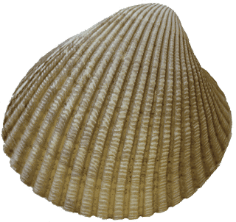

**Commodore’s Log**

By Mike Fulmor…. STARDATE 010913

**January 2013**

*A publication for the Members and Friends of the Yaquina Bay Yacht Club-est. 1947*

The Jib Sheet

**YBYC 2012 Officers**

Commodore…………Mike Fulmor

Vice Commodore... Elliott Crowder

Rear Commodore……..Kelly Greer

Secretary………...Alice McNamara  
Treasurer………..Dorothy Bogumil

Greetings! House Diva Barb and I send our best wishes to everyone for a happy, fun, healthy, prosperous, exciting and adventurous New Year. May all your dreams come true and turn out even better than you imagined they could.

Our YBYC dream of having a nice floating classroom facility for the Youth Sailing Program with storage for dinghies, gear, and kayaks is getting ever closer to coming true,

as our non-profit sister organization, Oregon Boating Foundation, has completed the Floathouse purchase and is close to finalizing the deal with us whereby we get to use it in return for paying ongoing moorage and the initial costs of moving it to our dock. It looks like a win-win for everyone, especially the youth sailors who will be benefiting from having a home of their own. There will be several opportunities for you to volunteer your labor and skilled help to accomplish the renovation and move, so please stay tuned to our Yahoo Group for work party announcements and other pleas for help if you are interested in helping to make this all happen.

Your new Board of Directors has been very patient in enduring two marathon meetings so far, both well into the three-hour mark. The new Commodore extends apologies and will be trying to shorten them now that the hurdles of the Budget and other time-consuming extra agenda items are cleared up. Special thanks to Secretary Alice McNamara who does the unenviable task of transcribing the lengthy minutes. The good side is that much has been accomplished so it has not been wasted time, and we have had more than a few laughs

#### YBYC Calendar

#### Jan 6th Frostbite Sail 12pm

#### Jan 19th Monthly Mtg/Potluck & Chili Cook-off 6pm

#### Jan 20th Frostbite Sail 12pm

#### Jan 23rd Youth Sail Mtg 5:30pm Education Series 7:00pm

**Yaquina Bay Yacht Club 750 SE Bay Blvd, Newport, OR 97365**

[www.yaquinabayyachtclub.org](http://www.yaquinabayyachtclub.org)

*Questions about YBYC? Contact Us at* [*YBYC.email@gmail.com*](mailto:YBYC.email@gmail.com)

*Submissions for the Jib Sheet newsletter? Contact* [*goodrice@earthlink.net*](mailto:goodrice@earthlink.net)

**Meet… the Cockle Clam**

*(Clinocardium nuttallii)*

If you can see this inhabitant of Yaquina Bay while you are sailing, you probably

should head to

deeper water.

Just sayin’…

**Membership**

By Angela Sivers

Membership Chair

Please welcome new member **Ted Brittsan**!

Have you moved in the past year, or changed email or phone numbers? If so, please notify our Membership ChairAngela at [centralcoastmassage@gmail.com](mailto:centralcoastmassage@gmail.com) to update your information on our Member Directory.

The new float house

**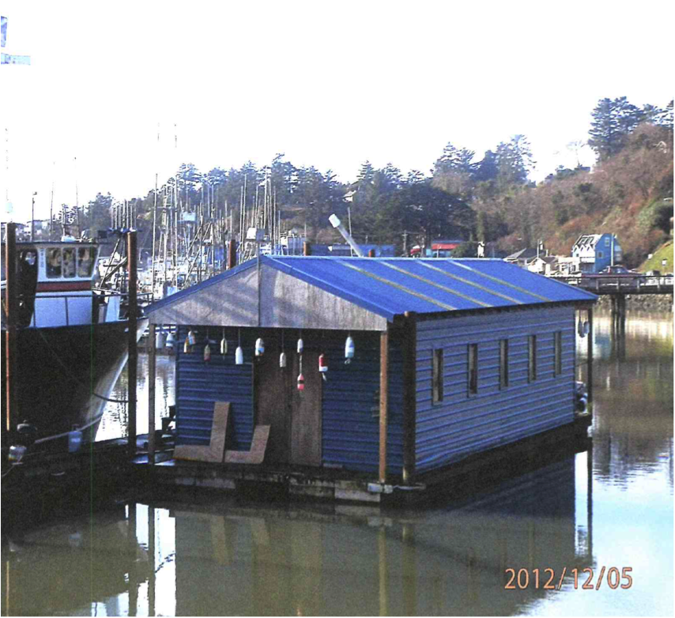**

**Commodore’s Log, cont’d**

along the way. Our main focus remains to make our club more useful and fun, in order to increase membership and member participation.

One really fun event coming up January 19 is the annual Chili Cook-off, and another will be the Wine and Seafood festival happening four days around the last weekend in February. You can read about them in separate articles below, and we hope lots of you will participate and volunteer to make them successful.

Another so far unheralded event designed to add value to membership was our decision to purchase the 23’ keelboat formerly known as *Son ‘o Beach*, now renamed *Spirit*. This sweet sailing little boat will be available for any qualified member to use after a check-out. Due to the cost of maintaining her in good condition, there will initially be a “voluntary donation” for use, suggested at perhaps $20/day or something ridiculously cheap compared with the cost of boat ownership or renting a boat anywhere else on the planet. She will remain available for overnight dock camping for the same donation, cheaper than a camp site at the park and a lot less hassle. Also, many of you know there has been an aluminum skiff for members to use (again, after a checkout) and now a motor generously donated by Joe Novello will be permanently attached so she’ll be ready to go in a jiffy. There may be a suggested donation for use of the boat and crab pots to defray fuel and maintenance expense. More details to come on that.

Thanks for sending in your membership renewals, and don’t forget to tell all your friends about the fun of being a part of the best yacht club in Newport! ☺

**Vice Commodore**

By Elliott Crowder

Ahoy y'all! First off let me tell you all it is an honor to be serving as your Vice. January is here so it's time to bust out your best chili and bring it down to the club for our annual chili cook off on the 19th, sounds like there might be some home brew as well. As Vice, it is my duty to sit on the OBF board and be a liaison between the two and report back so here goes:  OBF has bought the float house we have all been talking about and is in the final stages of paper work for YBYC to start using it. I think this is all going to work out and be a great asset for both YBYC and OBF! There will be a work party to get the float house ready to move so stay tuned for further info.

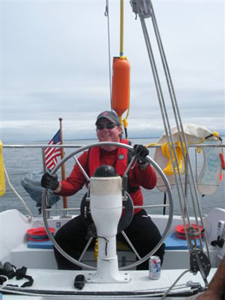

Vice Commodore Elliott Crowder

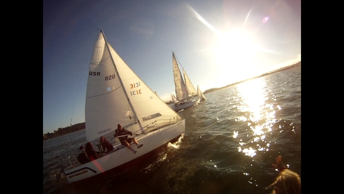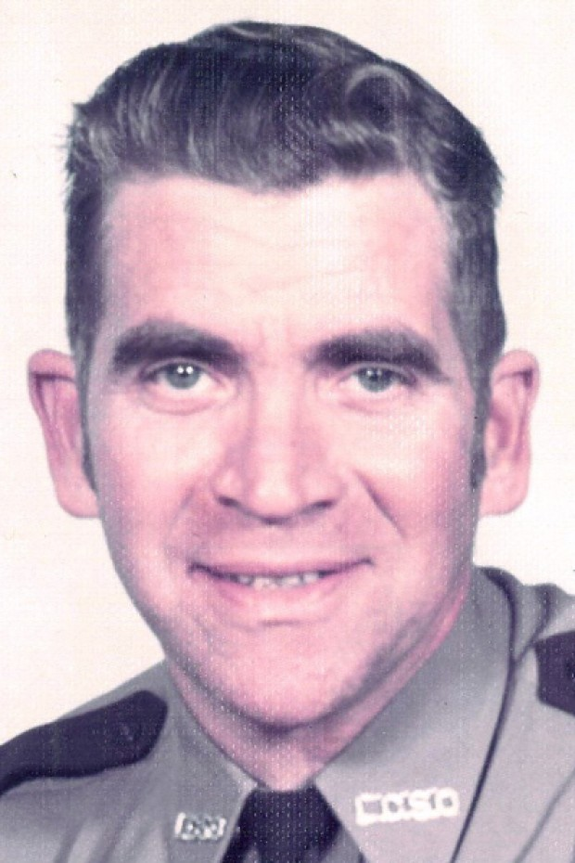

OK now on to Seafood and Wine, which will be held next month February 21-24. It looks as though we got our corner booth back this year!!! I will be hitting people up to start filling times for people to work the show.  This is our biggest fundraiser of the year so we want to make some $$$ while having a lot of fun at the same time!  If you would like to help just let us know and we will get you in a slot.  We will also need help with set up and take down.  All wine servers will need to get a temporary OLCC serving permit (they are free). The quick 20 minute class is being held at Newport Elks lodge at 6pm on Jan. 30th, Feb. 6th, or Feb. 13th. We will have sign up sheets for SF&W at the monthly meeting.

Now lets grab some coats and go sailing!

**SEAFOOD AND WINE FESTIVAL**

**February 21-24, 2013**

Volunteer to help serve, set up and/or take down the

**YBYC Booth**

Sign up at the clubhouse beginning Jan. 19th or contact Elliott Crowder, Daniella Crowder or Kelly Greer

*Cheap Sunglasses*

in the sun.

Photo by Mike Fulmor

*Spirit*, back when she was *Son o’ Beach*.

Photo by Joe Novello.

**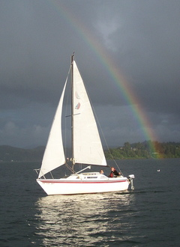**

**FORMER COMMODORE PASSES**

Carl Dudley

YBYC Commodore 1984-85

**Feb. 11, 1926 — Dec. 13, 2012**

*From the Albany Democrat-herald:*

Carlton Dudley, 86, of Albany died on December 13th, 2012.

He was born in Iowa Falls, Iowa, to Charles and Alice Dudley; one of seven children. After serving in the Navy, he attended college and played football at Linfield College in McMinnville and Oregon Technical Institute. A side job in an ice cream shop led to 65 years of marriage to Dolores Jean Cahill, the love of his life.

Carlton spent 19 years in law enforcement, 18 of which was in the Lincoln County Sheriff’s Department. He was a member of the Multnomah County Sheriff’s Posse and Lincoln County Sheriff’s Posse and a life member of the Yaquina Bay Yacht Club.

Carl is survived by his loving wife, Dee Dudley; children Dennis Dudley, Donna White, Carla McCord, Diana Kriz-Stowe and Chuck Dudley; 11 grandchildren; 17 great-grandchildren; brother Bob Dudley; and sister Bettie Smith.

He had a love for hunting, fishing, sailing, traveling, his horses and family.

*YBYC has made a donation to Samaritan Evergreen Hospice in Carl’s memory.*

**WINTER EDUCATION SERIES**

Second and 4th Wednesdays   
Jan 23 – Apr 24

YBYC Clubhouse

Coming Up - Jan 23rd 7:00pm

Racing Starts: Right of way, rules at line up, strategies and timing

Mike Fulmor & Mac McConnell

this year. Want to sail out to Yaquina Head, raft up with friends up river, go bottom fishing, how about a trip out to see how many birds you can sight and identify? This is our club, so we can do our best to schedule things that are on your wish list. So make your wish list and share it with us.

2013 started with a sunny New Year's winter day in Newport. Several members took advantage of the glorious weather to go sailing on Yaquina Bay. At least 4 club boats with members and friends were out on the water in the easterly breeze that afternoon. It was a great start to the New Year. The weather also cooperated on the following Sunday for the first of the Frostbite Series sails. I know at least one boat was out, but not sure how many others made it out that day. But it looks as though we are off to a great sailing year. Don't forget the Frostbite Series sails continue on the first and third Sunday's of each month. Next Frostbite sail is slated for the 20th of January.

Mac is starting to line up an education series and would love to get some input on member priorities. Some of the topics he is considering include race rules, so be sure to let him know what particular aspects are on your priority list so he can line it up (macmconnell@peak.org). As the race season draws nearer, we may also line up a sail measuring session for those who plan to race this year in an effort to ensure the Portsmouth Yardstick ratings for boats are in line with the sails they are carrying.

We are also starting to think about some cruise events for this season. We would love to hear from you what types of things are on your to-do list

*Be sure to dress warmly for the Frostbite Series*

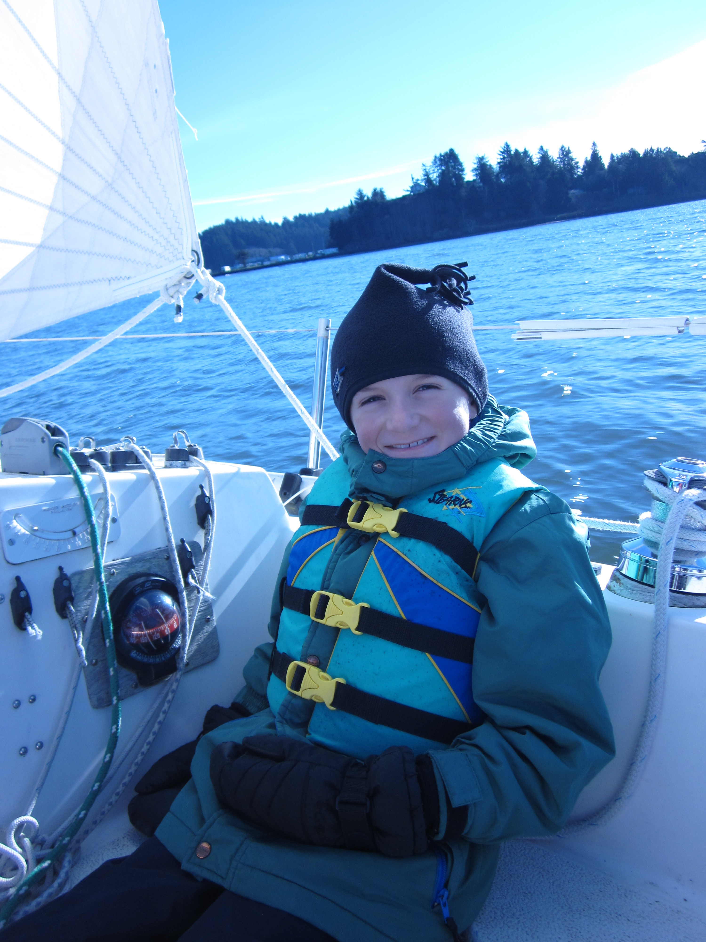

**Race and Cruise Report**

By Greg Krutzikowsky

Racing Co-chair

**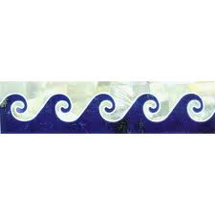**

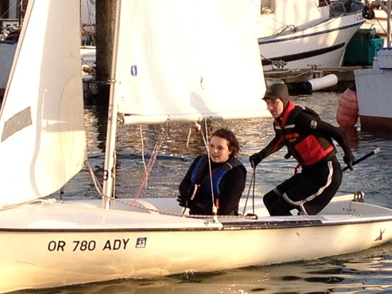

All youth are expected to help with at least one fund raising activity and/or the Loyalty Days Parade. In order to remain in the program, students must plan to attend all practices, although three excused absences may be approved by the coaches. We will be training youth to run both committee and chase boats this year so they can have a variety of on the water experiences.

**JUNIOR VARSITY (JV)**

* Must be in grades 7 - 12 (exceptions for younger students who have been on the team in prior years or who can demonstrate intermediate level sailing skills)
* Starts February 20, 2013
* Must commit to two NWISA regattas
* Must sail or support Spring Regatta
* Must sail in the junior regatta May 11, 2013

**VARSITY\***

* Must be in grades 9 - 12
* Starts February 20, 2013
* Must commit to three NWISA regattas (parents arrange transportation and lodging). Sailing in three varsity events also makes athlete eligible for Athletic Letter at their local High School.
* Must have sailed a percentage of Wednesdays evening races the previous summer
* Must participate in club events and fundraising
* Must sail in or support the Spring Regatta
* Must sail in the junior regatta May 11, 2013

**Youth Sailing Organizational Meeting**

By Joe Novello *(joenovello3@gmail.com)*

There will be a planning meeting for adults and youth sailors for the 2013 youth sailing program. **The meeting will be on Wednesday January 23, 2013 at 5:30 pm in the YBYC clubhouse.** This meeting for any parents and students interested in participating in any of the youth sailing programs listed below.

Youngsters participating in the youth program must be current members of the Yaquina Bay Yacht Club either as part of a family membership or have their own youth membership. Membership applications will be available at the organizational meeting.

This year the program will be divided into three groups; varsity, junior varsity, and juniors. Varsity is only for serious sailors, JV is for serious-but-unable-to- qualify-for-varsity sailors, and juniors are everyone else ages six through 18.

**Juniors**

* May be youth of any age 6 – 18 who are new or beginning sailors
* Practice Mondays and Wednesdays April 1st through April 24th.
* Must sail in the junior regatta May 11, 2013

**\**In order to have a VARSITY team, league rules require at least four student team members from an individual high school.***

Photo by solarsail56

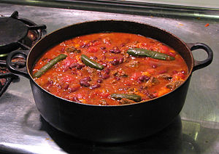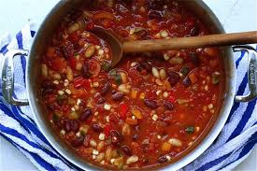

**Going to Get Hot Up in Here**

**Annual Chili Cook-Off Jan 19**

It’s time to dig out your Chili Pot and plan out your recipes for the 2013 Annual Chili Cook Off, this month’s Monthly Meeting. We will have three Newport Area Celebrity Judges: returning will be Michael Walliser, owner of Saffron Salmon, and joining him will be first-time judges Don Mann, Port of Newport General Manager, and Bier-One owner Luke Simonsen. The contest is open to all members, and in addition to the main judging, everyone there gets to vote for the People’s Choice Awards. Winners will receive gift certificates from some great local eating and drinking establishments.

Since this is not a classic Texas Red Chili contest, all varieties of Chili are welcome and judging will be based on general criteria of pleasing color, aroma, texture, and of course flavor. People’s Choice judging will be your favorite three, ranked in order. It will all be “blind” in the sense that each chili will be assigned a number, and nobody will know who made what. That way we hope it’s fair for the returning champion to enter, but otherwise he’ll just have a pot of his “Night Watch” chili to share…

As always, please remember to BYOB and place settings, and those not entering the contest are invited to bring side dishes, salads, or desserts for potluck. Some adult beverages, possibly margaritas, will be offered by your host, Commodore Mike. Hope to see you all there for a very fun evening!

**January Meeting**

**Saturday, January 19th at 6:00pm**

Entering the chili contest? Bring your pot between 6 and 6:30 to get in the judging. People’s Choice tasting starts at 7pm.

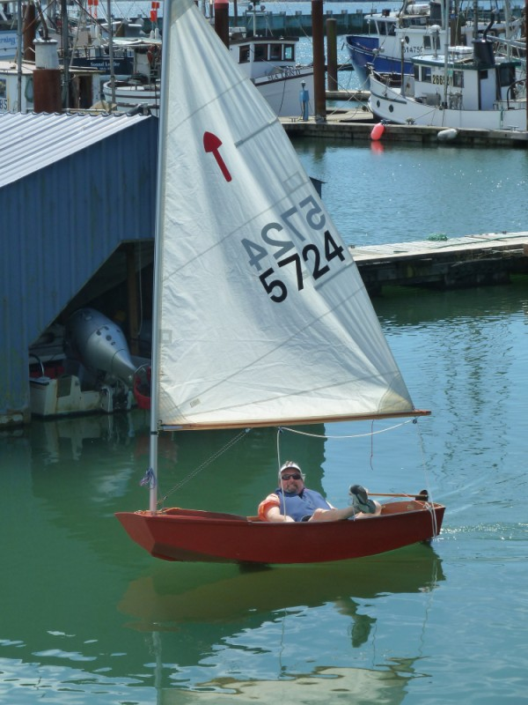

Tim Myrick spends some time in the

boat he bought “for his daughter”.

**Board Bits**

Due to the Jan. 1 holiday, the board met on Jan. 8.  Among items on their agenda were:  The 2013 budget was created and approved; heard reports from our commodore and from OBF on the new floathouse, which is making good progress; plans for this month's Chili Cook-Off were divulged; preparations for the Seafood and Wine fest are beginning; Race Committee will consider making our fall regatta part of a nation-wide series of benefit regattas for Hospice organizations; a series of pre-season classes were proposed by the Education committee; efforts are under way to consolidate and streamline our web presence; the youth program reported on preparations for the coming season, including a youth regatta here in May.

Flotsam and Jetsam 

* Remember you can make a *tax-deductible* donation through the Oregon Boating Foundation. The money is used to provide community boating education and all donations are greatly appreciated. For monetary or other donations please contact OBF Chair Dan Van Calcar.
* Visit the YBYC [Yahoo group site](http://groups.yahoo.com/group/ybycgroup/) (<http://groups.yahoo.com/group/ybycgroup/>) : It’s the best place to keep up on club and member activities, chat and exchange info with fellow members. You can also read Board minutes. **The Club also has a Facebook page, check it out!**  It’s updated frequently so you can be sure to keep abreast of club activities.

**Editors Corner**

Thanks to everyone who submitted information for this issue, and also to the six (6) people who took the newsletter survey last month ☺ We are working to help streamline YBYC communications. In the meantime:

1. Each newsletter will be posted on the YBYC website on about the second weekend of the month (which is after the Board meeting but before the monthly potluck).
2. Archives of past issues are also on the website.
3. If hyperlinks don’t work in your issue of the ***Jib Sheet***, try copying and pasting the complete URL into your browser.

**- Cait Goodwin**

**-Cait Goodwin**



**American Home and Stone**

541-929-3100

Shane and Mac McConnell

Cabinets, tile, granite countertops, stoves (wood, gas, pellet), spas: **Discounts**

[www.americanhome.com](http://www.americanhome.com)

**Ocean Pulse**  
Custom Surfboards, Skateboards and Snowboards  
Tom McNamara (541) 265-7745  
428 SW Coast Hwy  
Newport, OR 97365 [www.oceanpulsesurf.com](http://www.oceanpulsesurf.com)

**Bike Newport**  
Elliott & Daniella Crowder, Owners   
150 NW 6th Street  
Newport, OR 97365  
(541) 265-9917  
website:  bikenewport.net  
[bikenewport@charter.net](mailto:bikenewport@charter.net)

**Member-2-Member Network**

Have you ever needed a carpenter, cabinet maker, tile setter, tire company and didn’t know who to call? Ever needed to have an item on your boat or home repaired, but had no idea where to call? Rather than calling a stranger or looking in the yellow pages, **call another YBYC member!** Everymember who runs a business or performs a service i**s** encouraged to signup. It’s totally FREE to members! Non-members pay a nominal fee. Want to get yourself listed? Email the YBYC newsletter editor at [goodrice@earthlink.net](mailto:goodrice@earthlink.net) with your listing information. We need to support our own, especially in this economic climate. Please consider doing what you can.

**Alan Brown Tire Center (Les Schwab)**   
Ken Brown *manager* (541) 265-6604  
155 SW Coast Hwy   
Newport, OR 97365

Email: [tyrguy@yahoo.com](mailto:tyrguy@yahoo.com" \t "_blank)

**Dr. Kenneth S. Bishop**

Chiropractic Physician

111 SE Douglas

Suite F-1

Newport, OR 97365

541-264-8138

[www.yaquinachiropractic.com](http://www.yaquinachiropractic.com)

**Vicki Krutzikowsky**Shaklee product distributor<www.healthydedication.com>541 264-8039 [vickihoosky@hotmail.com](mailto:vickihoosky@hotmail.com)

**Member-2-Member - (cont)**

**Kevin Raichl Cindy Milligan LMT# 6107**  
Visual Thinking Northwest Drift Away Massage

828 SE Crescent Pl. 310 NW 9th St. Suite 201   
Newport, OR 97365 Corvallis, OR 541-753-4785  
541-264-8343   
541-480-2355 cell   
[www.visual-thinking.com](http://www.visual-thinking.com)

**True Cut Engraving**

Stephanie Brown

403 SW 10th Street

Newport, OR  97365

[TrueCutEngraving@qwestoffice.net](mailto:TrueCutEngraving@qwestoffice.net)

541-265-9326

**Diane Henkels, Attorney**

Based in Newport and Portland

541-270-6001

[dhenkels@actionnet.net](mailto:dhenkels@actionnet.net)

Biz, environment, Indian law, and energy issues.

**Angela Sivers, Licensed Massage Therapist**

Newport: Ocean's Way Naturopathic Clinic, at 644 SW Coast Hwy, Suite D

Lincoln City also. 541.264.0423

<http://www.centralcoastmassage.com>

centralcoastmassage@gmail.com

**The Gallery at Otter Rock**

Tish and Larry Epperson, owners

845 First Street, Otter Rock, OR

97369 541-765-2365

**Amy Lynn Greer, CPA**

Individual and Business Tax Preparation & Quickbooks Consulting

541-961-6814

[amygreercpa@charter.net](mailto:amygreercpa@charter.net)

C:\Documents and Settings\Jeff Cressy\Local Settings\Temporary Internet Files\Content.IE5\2MEWFEIS\MC900060159[1].wmf

YBYC Classified

***Flamingo* is for sale**

She is a J-24, 1978 vintage, in good condition, fully equipped, sails well, all running rigging has been replaced, New Load Path Vectran Sails X 1 season, OB motor, extra sails, depth finder (nice to have on the bay) 2 Axle Trailer....$6,500.00 OBO

Call Paul at 541-765-4467 or (Cell) 541-961-3970 or email [pmerskine@yahoo.com](mailto:pmerskine@yahoo.com)

**For Sale:** Cascade 9 fiberglass boat. Great tender for a larger boat or all around boat for multiple uses. The CD 9 can be sailed, rowed, or motored and seats two adults comfortably. My daughter and I have used the boat to fish local lakes with much success. The boat transports easily in the back of a pickup truck. The sail rig is brand new and has never been used since I bought it from Cascade Yachts three years ago. Not many of these great boats around and they don't make them any more. A nice description of the boat can be seen at the Cascade web site: <http://www.cascadeyachtworks.com/models/dinghy/> . The boat for sail is red with a white sail. All sailing gear and oars are included. This boat is ready to hit the water. Contact Joe –[joenovello3@gmail.com](mailto:joenovello3@gmail.com)