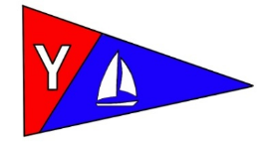
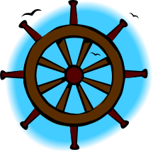
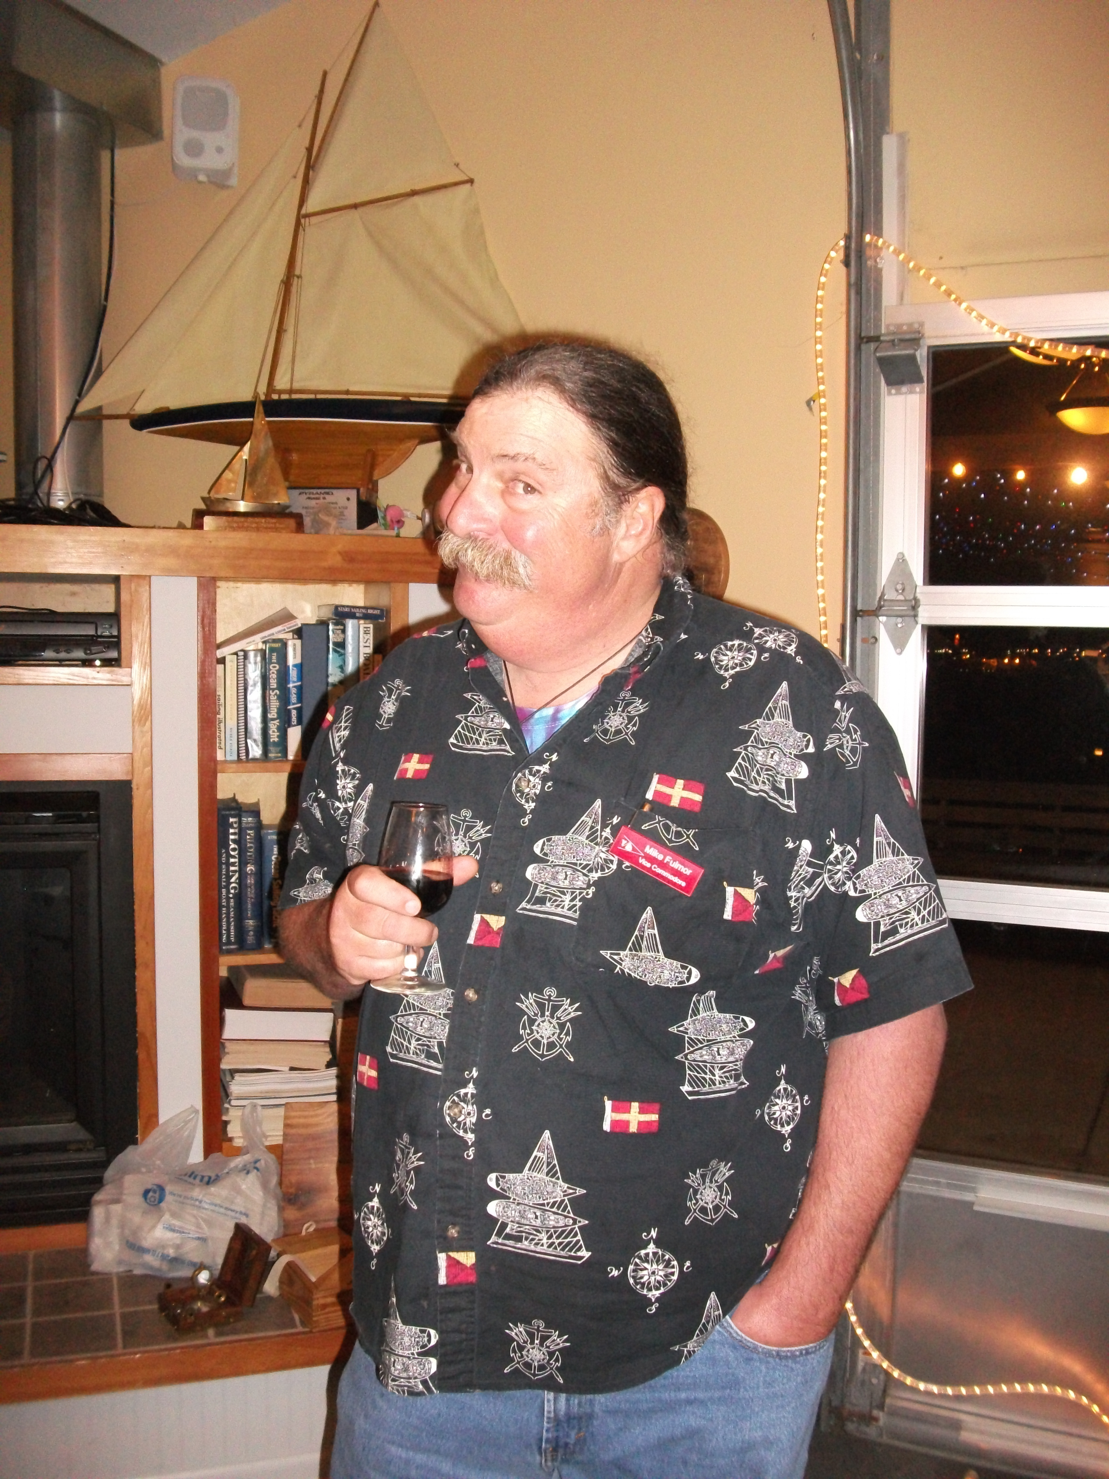
YBYC Calendar
Dec 1st
Lighted Boat Parade
Dec 15th
Monthly Mtg/Potluck 6pm
YBYC Commodore Mike
The Jib Sheet
December 2012
A publication for the Members and Friends of the Yaquina Bay Yacht Club-est. 1947
YBYC 2012 Officers
Commodore…………Mike Fulmor
Vice Commodore... Elliott Crowder
Rear Commodore……..Kelly Greer
Secretary………...Alice McNamara
Treasurer………..Dorothy Bogumil
Commodore’s Log
By Mike Fulmor
Yaquina Bay Yacht Club 750 SE Bay Blvd, Newport, OR 97365
www.yaquinabayyachtclub.org
Questions about YBYC? Contact Us at YBYC.email@gmail.com
Submissions for the Jib Sheet newsletter? Contact goodrice@earthlink.net

Likewise the YBYC Facebook page, we don’t really know how many are reading the announcements there either, or for that matter, if everybody even finds this newsletter each month. It will be a goal of mine this year to improve our communications so no members miss fun events because they just didn’t know they were going on.
Speaking of goals, one very big one - getting a floating home for the youth program- seems to be happening almost magically as you read this. With a big bunch of help from the Oregon Boating Foundation, and especially OBF board member Bud Shoemake, the kids will have a place to meet, change clothes, get a chalk talk, and store their boat bits, hopefully in the next

First I’d like to give Big Thanks to the outgoing
Commodore Paul for a great year or three of service and a steady
hand on the helm of the good ship YBYC. Likewise Big Thanks
to the retiring committee heads, Jeff Cressy as Newsletter, Peggy
O’Callahan as interim Membership, Anne Williams as Education,
and Pat Blackburn who did Hospitality and Ships Store, and big
welcome to new committee heads Cait Goodwin as Newsletter,
Angela Sivers as Membership, Mac Maconnell as Education, Carol Ozenberger as Ship Store, and Amy Greer as Hospitality. Terry Lettenmaier and Laurie Weitkamp will share the load as Youth Sailing Coordinators.
It was really great to see so many members at the big November Annual Meeting. aka “Carnivore’s Delight”. Hopefully we can create some exciting monthly events in the coming months to bring everybody out like that more often. I wish we knew what percentage of the membership actually gets the messages sent out on the Yahoo Group.
Commodore’s Log, cont’d

month or two. Getting this existing floating structure relieves us from a big expenditure and lots of hard work building one in cold rainy wintry conditions. By the way, this should also mean that there can be some kayaks and associated gear stored there and available for classes or members to use at a moment’s notice. Until now, with no place to store them, hardly any members have been able to use our club kayaks.
So that just leaves the creation of a foot path/ramp down to the water, and installation of a proper yacht club flagpole on the bayside, for me to complete my personal wish list. At some point we will still want a covered storage area/workshop for boats next to the clubhouse, but that project still has to wait for the Port’s Master Plan to be completed. The Port already loves the idea of a “green” path/ramp for hand-launching non-motorized watercraft, and apparently the Oregon State Marine Board might love it so much they might design and build it, or at least give grant funds to build it. It will take a couple years or more to complete that project, but I’d like to hope the wheels can get into motion soon. The flagpole will

2012 ANNUAL AWARDS

Volunteer of the Year - Barb Fulmor
Sportsman of the Year - Joe Novello

Spring PHRF Race Series:
1st place – Cheap Sunglasses
2nd place – Alchemy
3rd place – El Coyote

Spring Portsmouth Race Series:
1st place – Terry Lettenmaier
2nd place – Ian Williams

Summer PHRF Race Series:
1st place – Cheap Sunglasses
2nd place – Slam Dunk
3rd place – Grinner

Summer Portsmouth Race Series:
1st place – Terry Lettenmaier

Perpetual Awards:
PHRF - Stephanie Brown
Portsmouth – Terry Lettenmaier

Sailor of the Year - Stephanie Brown

See all the race results on the
YBYC website
make us look more like a traditional yacht club, provide a place to fly our burgee and the Colors, and allow us to signal the fleets during regattas. Thanks to all who answered the racing poll; looks like we’re in for a fun year trying a new handicap system, and hopefully we’ll see tons of new racers on Wednesdays taking advantage of a mellower (and easier) non-spinnaker class with a separate start and shorter course. All you single and double-handers will have no excuse not to be out there having fun and honing your sailing skills against similar type boats! Sailing with other boats is always more fun; no racing experience is necessary, just know the rules. We’ll have some educational presentations for that purpose before the season starts.
Hope to see you all at the Christmas party and White Elephant gift exchange December 15.

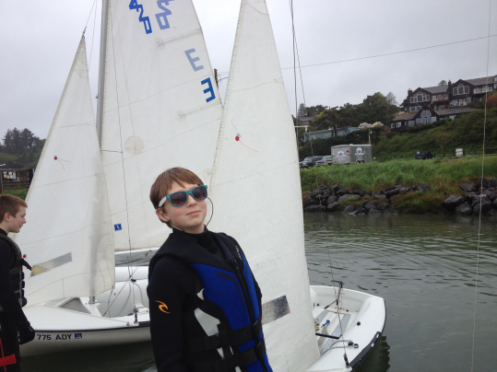
Youth Sailing Reorganization
By Joe Novello

The youth sailing coaches are proposing a reorganization of the High School/Youth Sailing Program to better meet the goals of the program. Last year we had several High School Sailors who could have benefited from more intense coaching. Due to sporadic attendance and new, inexperienced youth joining throughout the program, the senior members of our team were not able to get what they needed to be competitive in the Interscholastic Sailing Association. The coaches’ attention was diverted to basic sailing skills for the younger sailors and trying to put together consistent teams for competition.

We want to support both groups of sailors and plan to make a longer season for the more serious youth while providing a more intense beginning training program for new youth sailors.
This year the program will be divided into three groups; Varsity, Junior Varsity, and Juniors. Varsity is only for serious sailors, JV is for serious, but unable to qualify for varsity sailors and juniors are everyone else ages six through eighteen.

More details about the three groups are in the Yahoo Groups “Youth Sailing”
file folder:
http://groups.yahoo.com/group/ybycgroup/files/

All youth are expected to help with at least one fund raising activity and/or the Loyalty Days Parade. In order to remain in the program, students must plan to attend all practices, although three excused absences may be approved by the coaches. We will be training youth to run both committee and chase boats this year so they can have a variety of on the water experiences.

There will be a parent meeting on Wednesday, January 23rd at 5:30pm at the YBYC clubhouse. Youth sailors and at least one parent should plan to attend this meeting.

We are looking forward to a more comprehensive program for our kids with stronger participation in club events. Contact Laurie Weitkamp, Terry Lettenmaier, or Joe Novello for further information.

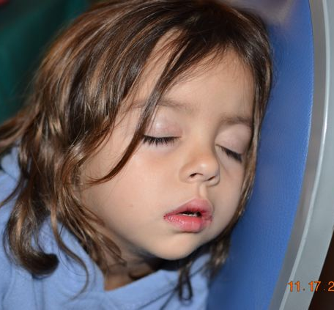
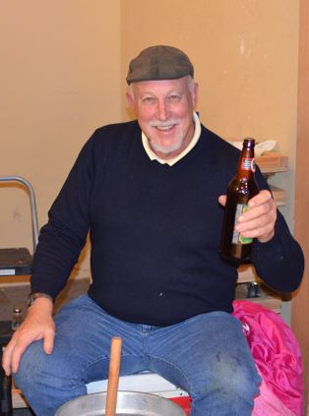
Fleet News
By Tom McNamara
Fleet Chair
A better, more powerful motor will be installed on the club's skiff soon. It will be mounted on the boat and locked in place, making member use much easier and more effective. The boat is there for member use, and can be reserved by contacting the fleet chair. See the operating procedures in your member handbook for details on boat user responsibilities. We have now officially acquired a keelboat for the club. SPIRIT is a 23-foot sloop that is very easy to sail, and will be made available to member use. Using the boat will require prior check-out on its operation, and a program to provide that will be announced soon and amended to the operating procedures. Although most of the dinghies have been secured for the winter, we have left 2 rigged on the dock, available for member use in the event that sailing conditions become suitable.

Read more about the Fleet on the YBYC Website.

Lifetime Membership
By Angela Sivers, Membership Chair
Congratulations to Larry Sharpless on being awarded a YBYC Lifetime Membership. Larry has been a member of YBYC for twenty years. Thank you, Larry, for your continued support over the years!

Larry will be honored at the 2013 Annual Meeting in November.

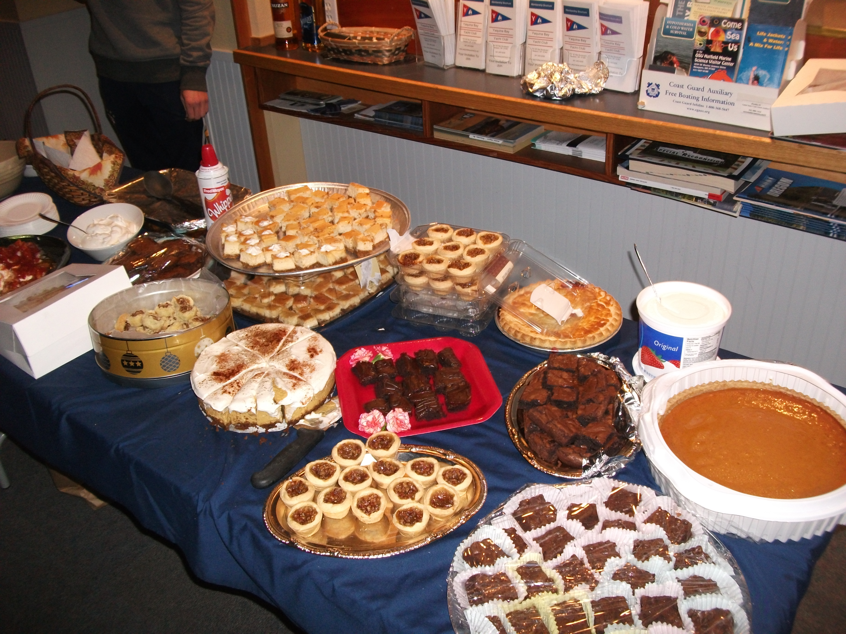
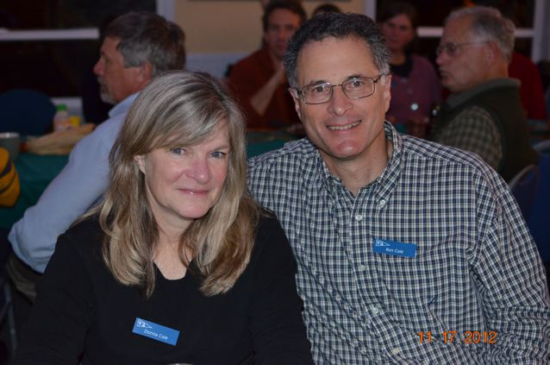
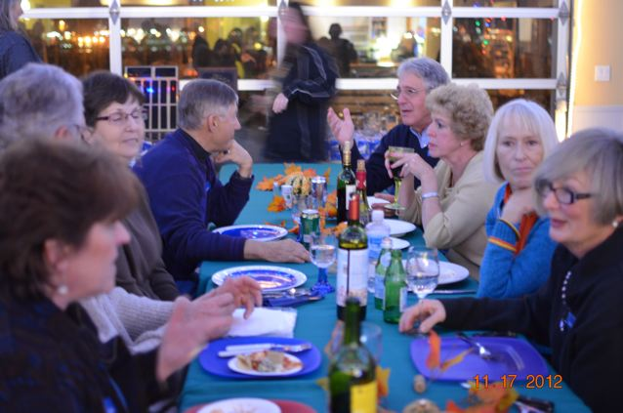
Snapshots from the
2012 Annual Meeting

submitted by Annie Catalano
Photo by krutz_sky
Race and Cruise Report
By Greg Krutzikowsky
Racing Co-chair
We had just made it under the bridge on the third race of the day, but the winds were still fluky. It was shifty and gusty, so we had to pay close attention to sail trim and weight distribution to keep our little dinghy upright and moving fast. Finally we got far enough out to get cleaner air unimpeded by the hills on the north side of the channel. Our boat took off, my crew stretched out on the trapeze in the fresh breeze and we planed toward buoy #7. Sailboat racing just doesn't get much better than this! Columbus Day Regatta was certainly fun.

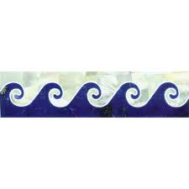
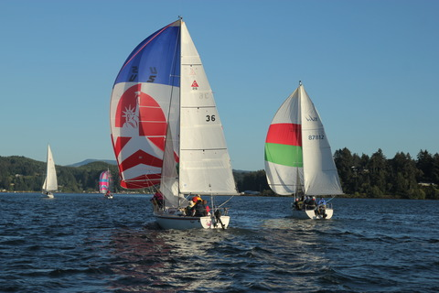
While it’s easy to feel exhilaration like this in the moment, one race or regatta is not a whole season. There is always room for improvements. Taking a step back at the end of a season to look how things went and get participant perspectives can help. We conducted an online survey to get feedback on the 2012 race season from members. The survey was announced on the Yahoo Group e-mail list and at the Annual meeting extravaganza. Twenty people responded to the survey questions which included a number multiple-choice questions and opportunity to provide feedback in more open ended written form. One question simply asked for suggestions for improvements for next year. Not all 20 people answered all the questions. The survey also stimulated discussion about the racing season, other forms of on water participation in YBYC sponsored events, and some creative thoughts on some other possible ways for folks to get involved. All of this provided valuable feedback and food for thought.

The big picture that came from all the input received is: 1) most respondents participated in 2012 races and plan to race in 2013, though there is more uncertainty about 2013;

2) Slightly more respondents favored a three equal length season structure than either of the other two choices; 3) Although when asked about the rating system currently used at YBYC more respondents said they were happy with than unhappy with it, when presented with the alternative rating system outlined in the survey the majority favored trying it and only a small percentage felt that the current system is the best possible; 4) While some folks said they plan to take their boats out of Yaquina Bay to sail elsewhere, few shared any definite plans to do; 5) An overwhelming majority of respondents felt requiring 75% participation in all races including regattas to qualify for “racer of the year” was about right, but the rest thought it was too high a bar; 6) Most folks like the after racing get together, but there was a call for a more varied menu.

Photo by solarsail56
Race and Cruise Report, cont’d

There were also a few common themes in the open ended responses and the e-mail discussion that should be mentioned. Many people noted that participation is the key ingredient and that YBYC needs to encourage people to participate in on water events. Several ideas were put forward, including a non-spinnaker class for racing, encouraging youth to participate in racing through the summer season, getting kayaks and power boat on the water, and more cruise events like the Thursday night social sails that were done a couple of years ago. Several people noted that no rating system for racing different types of boats perfectly levels the field. Another common thread was related to safety, collisions, and knowledge of racing rules. More education on rules and separating fleets came up more than once. Several folks also mentioned that scheduling the “fun” races near the holidays would be good.

So what is in store for next season?

For Race, Racing will start with the Spring Regatta on April 27-28 and end with the Columbus Day Regatta on October 12-13. YBYC will have three Wednesday evening series of roughly equal length. Exact season structure will be provided early in 2013, but we plan to schedule the “fun races” around the holidays rather than between series.
Participation requirements for consideration of “racer of the year” award will be similar to 2012 and include all series and regattas, but the percentage of races may be lowered slightly. YBYC race chairs examined information on a number of rating systems that are provided on the US Sailing website: (http://offshore.ussailing.org/Rating_Rules.htm) and decided to use the Portsmouth Yardstick rating system rather than PHRF for keel boats in 2013. This was done for a number of reasons including responses to the survey. More information on this time on time handicapping system and ratings for almost all types of boats can be found on the US Sailing website.

If there are enough participants, we plan to include a non-spinnaker class for keelboats in 2013. We will work with the Education Chair to encourage more educational opportunities for members to become more familiar with the rules. We may have a rules quiz challenge after racing on Wednesday nights with prizes.

For Cruise, we will try to schedule more events and put them on the calendar earlier for planning. These will likely include a trip up the river to Toledo for fireworks again, raft ups, ocean sailing and fishing trips. We would also like to start up the Thursday evening social sails again during the spring and summer. These trips are a great way to get people on the water including friends, family, and prospective new members. The Frostbite Series will start in January and will again be on the first and third Sunday of the month at noon, weather permitting. This is great excuse to go sailing with friends during the winter months. While the weather doesn't always work out, last winter we had some great weather for winter sails. We also will work with the kayak contingent to schedule some kayak events. We hope to paddle up Beaver Creek, get out on the Yaquina and take advantage of the Siletz Bay National Wildlife Refuge that sponsored guided trips last year.

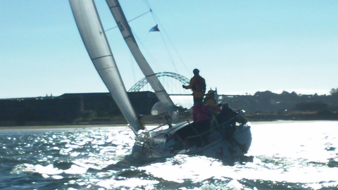
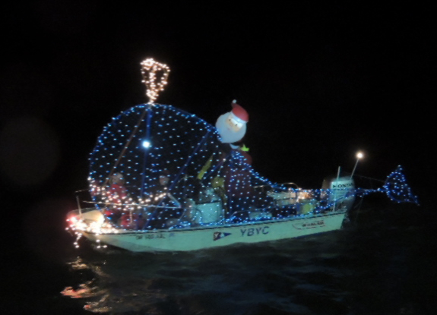
Lighting Up the Bay
By Mike Fulmor
On a slightly chilly, slightly breezy, and slightly wet evening last December 1, Seventeen boats of all sizes and shapes bravely set out, bedecked with lights, to entertain Newport residents and tourists who likewise braved the elements to observe this year’s Lighted Boat Parade.

After some normal radio-borne confusion as to who is following whom, and when do we get this ding-dang show on the road, we began our slow circuit around the bay around 5:00, led by the magnificent Coast Guard vessel Victory followed by M/V Discovery, and everybody else following along at 150-200 foot intervals. There were two laps around the bay planned, and some of us were less than fully lit by the completion of the first one. Something about mixing electric lights with rain and salt water wasn’t working for us, as well as a few generators that weren’t up to the task for various reasons.

Anyway, by all accounts it was a big success, and we who participated and survived the process had a nice after-parade party courtesy of Rogue Brewery, where prizes generously provided by local businesses were awarded to the lucky winners as well as all who came out to play. Our YBYC team who decorated the Boston Whaler as a silly little blue whale was unexpectedly rewarded with first place, though Discovery won the Grand Prize, a hunting rifle provided each year by the local Oregon Coast Bank.

Big thanks to Steph and Ken for their organizational wizardry, all who participated, and all who helped in so many ways to make this a very fun event once again. Can’t wait until we do it again next year!




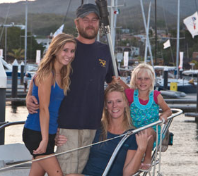
More News You Can Use

December Meeting
Saturday, December 15th at 6:00pm
In the Spirit of Giving this Holiday Season, our monthly meeting for December will be a humble meal of Soup and Bread.
Please bring a donation of food or money for the Newport Food Bank.
Potluck desserts are also welcome,
as well as a white elephant gift for a fun exchange.
If anyone knows of a group of Christmas Carolers who might want to perform for us, please call Hospitality Chair Amy Greer at 541-961-6814. Please also call Amy if you would like to help with the meal preparation.

Local Sailors in the News
Check out the November issue of Cruising World Magazine to read an article about local sailors Elias and Sara Anderson. “Safety at Sea: When fury overtakes a cruisers’ safe haven” by Diane Selkirk centers on an unexpected storm in Bahia de Banderas, Mexico, and how several families worked their way through the storm. Elias and Sara kept their boat Stepping Stone on D dock and Sarah learned to sail through our YBYC Adult Sailing Program. Read the story online at:
http://www.cruisingworld.com/people/passage-notes/safety-at-sea-when-fury-overtakes-a-cruisers-safe-haven


Flotsam and Jetsam 

- YBYC youth sailors will again be working the Jackson Hills Christmas Tree lot this year. The lot has moved to the Lincoln County Fairgrounds which means you get to shop for your tree indoors. No more dodging wind and rain! Sailing team members along with athletes from other teams will be working at the lot on December 15, 16, 23, and 24. A portion of the proceeds from tree sales goes to youth athletics in proportion to the hours the athletes work. Last year we earned enough money to pay for a trip to a Seattle Regatta! You do not need to just shop on the days our kids are there to support the program. We can still use adult and student volunteers to work the lot. Contact Joe Novello (joenovello3@gmail.com) for further information.

- Remember you can make a tax-deductible donation through the Oregon Boating Foundation. The money is used to provide community boating education and all donations are greatly appreciated. For monetary or other donations please contact OBF Chair Dan Van Calcar.

- Visit the YBYC Yahoo group site (http://groups.yahoo.com/group/ybycgroup/) : It’s the best place to keep up on club and member activities, chat and exchange info with fellow members. You can also read Board minutes. The Club also has a Facebook page, check it out! It’s updated frequently so you can be sure to keep abreast of club activities.

- Not sure what to get that Special Someone on your holiday list? Check out all the fine items at the Ships Store! Not only are you buying quality merchandise you can use, but you are also helping to support the YBYC!

Board Bits

The YBYC board met on 12/4 and among the items on their agenda were: New Commodore Fulmor and some new officers took over their posts; heard a report from Bud Shoemake on the acquisition of a "floathouse" by OBF, and formed a YBYC negotiating team to see it through; clubhouse rentals are busy, especially to NOAA; a better motor for skiff will be put in use soon; lifetime membership was awarded to Larry Sharpless; changes to the race program are coming next season; practice schedules for youth team are being set; next year's monthly meeting schedule was worked out; a purchase agreement was approved for the club keelboat SPIRIT.

Editors Corner

Well, here is my first issue of the YBYC Jib Sheet as editor. Jeff leaves big shoes to fill, and I will do my best. I really appreciate all the submissions from the board, chairs and members – keep it coming! Barry Semple and I have some ideas about how the website and newsletter can compliment each other to keep the membership informed. Many of us are curious to know how many people read the newsletter in the first place, therefore….
…Please take this anonymous online two minute survey (http://www.surveymonkey.com/s/G7VNCVJ ) to show that you’ve seen this newsletter!
-Cait Goodwin



Member-2-Member Network
Have you ever needed a carpenter, cabinet maker, tile setter, tire company and didn’t know who to call? Ever needed to have an item on your boat or home repaired, but had no idea where to call? Rather than calling a stranger or looking in the yellow pages, call another YBYC member! Every member who runs a business or performs a service is encouraged to signup. It’s totally FREE to members! Non-members pay a nominal fee. Want to get yourself listed? Email the YBYC newsletter editor at goodrice@earthlink.net with your listing information. We need to support our own, especially in this economic climate. Please consider doing what you can.

Alan Brown Tire Center (Les Schwab)
Ken Brown manager (541) 265-6604
155 SW Coast Hwy
Newport, OR 97365
Email: tyrguy@yahoo.com

Dr. Kenneth S. Bishop
Chiropractic Physician
111 SE Douglas
Suite F-1
Newport, OR 97365
541-264-8138
www.yaquinachiropractic.com

Vicki Krutzikowsky
Shaklee product distributor
www.healthydedication.com
541 264-8039
vickihoosky@hotmail.com
American Home and Stone
541-929-3100
Shane and Mac McConnell
Cabinets, tile, granite countertops, stoves (wood, gas, pellet), spas: Discounts
www.americanhome.com

Ocean Pulse
Custom Surfboards, Skateboards and Snowboards
Tom McNamara (541) 265-7745
428 SW Coast Hwy
Newport, OR 97365 www.oceanpulsesurf.com

Bike Newport
Elliott & Daniella Crowder, Owners
150 NW 6th Street
Newport, OR 97365
(541) 265-9917
website: bikenewport.net
bikenewport@charter.net

Member-2-Member - (cont)

Kevin Raichl Cindy Milligan LMT# 6107
Visual Thinking Northwest Drift Away Massage
828 SE Crescent Pl. 310 NW 9th St. Suite 201
Newport, OR 97365 Corvallis, OR 541-753-4785
541-264-8343
541-480-2355 cell
www.visual-thinking.com
True Cut Engraving
Stephanie Brown
403 SW 10th Street
Newport, OR 97365
TrueCutEngraving@qwestoffice.net
541-265-9326

Diane Henkels, Attorney The Gallery at Otter Rock
Based in Newport and Portland Tish and Larry Epperson, owners
541-270-6001 845 First Street, Otter Rock, OR
dhenkels@actionnet.net 97369 541-765-2365
Biz, environment, Indian law, and energy issues.

YBYC Classified

Flamingo is for sale
She is a J-24, 1978 vintage, in good condition, fully equipped, sails well, all running rigging has been replaced, New Load Path Vectran Sails X 1 season, OB motor, extra sails, depth finder (nice to have on the bay) 2 Axle Trailer....$6,500.00 OBO
Call Paul at 541-765-4467 or (Cell) 541-961-3970 or email pmerskine@yahoo.com

For Sale: Cascade 9 fiberglass boat. Great tender for a larger boat or all around boat for multiple uses. The CD 9 can be sailed, rowed, or motored and seats two adults comfortably. My daughter and I have used the boat to fish local lakes with much success. The boat transports easily in the back of a pickup truck. The sail rig is brand new and has never been used since I bought it from Cascade Yachts three years ago. Not many of these great boats around and they don't make them any more. A nice description of the boat can be seen at the Cascade web site: http://www.cascadeyachtworks.com/models/dinghy/ . The boat for sail is red with a white sail. All sailing gear and oars are included. This boat is ready to hit the water. Contact Joe –joenovello3@gmail.com

Angela Sivers, Licensed Massage Therapist
Newport: Ocean's Way Naturopathic Clinic, at 644 SW Coast Hwy, Suite D
Lincoln City also. 541.264.0423
http://www.centralcoastmassage.com
centralcoastmassage@gmail.com

