Yacht Club Calendar
15th-Halloween potluck/monthly meeting

The Jib Sheet
October 2011
A publication for the Members and Friends of the Yaquina Bay Yacht Club-est. 1947
Our Mailing Address is 750 SE Bay Boulevard, Newport, OR 97365

Our Website URL
Is www.yaquinabay yachtclub.org

For questions about the Club, contact us at YBYC.email@gmail.comFor questions about or contributions to this newsletter contact Jeff Cressy, editor, at jcressy@charter.net
YBYC 2010 Officers- Commodore: Greg Krutzikowsky
Vice Commodore : Paul Erskine
Rear Commodore: Mike Fulmor
Secretary : Alice McNamara
Treasurer : Dorothy Bogumil
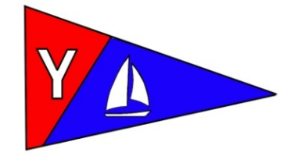

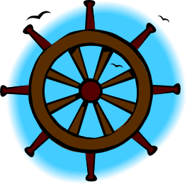
Commodores Log
A big thank you to the wonderful people that made the YBYC Wild Seafood Brunch a success again this year. The weather and altered schedule were not as conducive to the crowds we had last year. People who feasted on the fresh fruit and seafood quiche created and cooked by Dave and Barb Schmaltz remarked on how spectacularly yummy they were. Betts headed up an all star cast of volunteers at the brunch. It was great to see so many people helping out.

Fall has brought its wonders back to us: the fall salmon runs; the mushroom extravaganza in our forests; our Columbus Day Regatta; and the YBYC Halloween meeting featuring amazingly creepy edibles. You certainly won't want to miss the regatta or the meeting, even if you just come for the food and camaraderie. Look for more news about the October meeting in this issue.

At the October meeting the Board approved a number of changes to the clubs Bylaws
      - Changes include:
        - Revisions to life membership requirements/qualifications
        - Addition of Youth Sailing Chair position on Board
        - Modification/clarification of Honorary membership time period
        - Correction of last article number.
Of course any changes to the club's by-laws must also be approved by the membership. The Board decided that a voice vote on the proposed changes will be held at the November annual meeting, which is also when the membership will elect a new Board. The proposed changes to by-laws are posted in the files section of the Yahoo Group for all to inspect. All proposed changes are clearly identified. So look them over before we get all get together in November.
Fair winds,
Greg

YBYC Member Profile- Ken and Stephanie Brown
Editor’s note: This column is dedicated to our members, their stories, and the rich history of the YBYC. Stephanie was the previous newsletter editor. She was of enormous help to me as the incoming editor. Until she started her business, virtually all Jib Sheet content was provided by her.
I owe her many thanks and she and Ken and Annabelle are among our most active members-J

In 1999 I developed a plan that included living aboard a sailboat and traveling as desired; which meant that I needed a sailboat and I needed to learn how to sail. So I bought a book, a Catalina 25 (Chey-Breeze), and was gifted a subscription to Cruising World. I didn't know anyone who knew how to sail, so I faithfully drove from Salem on weekends and went out solo. After a few months, I knew most of the sailors in South Beach, met Erick Toy (ET) of YBYC infamy, and was introduced to racing and YBYC. In 2000 I moved to Newport, met Ken, and proceeded to drag him into sailing from the world of powerboats.

We raced and sailed Chey Breeze at every opportunity, and began helping John and Barb Dougherty with the Bridge to Bridge in 2001. As a competitive couple, we raced the C25 as hard as it could be raced, and the 2002 race season was so frustrating that for my birthday in 2003, Ken bought me a J24. That was also the year I volunteered for Race Chair, Regatta Chair (which used to be separate positions), B2B Chair, and organized our wedding, which featured a backdrop of spinnakers and sails draped throughout the Rogue's main brewery floor. Big thank you to Ron and Donita Cole for passing the hat at YBYC and getting us a gift certificate to Englund Marine.

Back to that 1999 plan - now we needed a bigger boat - especially after a trip to Alaska to visit my hometown, when Ken started talking about cruising, too.

Somewhere in between we started collecting kayaks (now up to 3), and acquired a 12' Corale Jr. sailboat, and a 14' alumaweld fishing boat, and 2 rubber dinghies to go along with our 2 keelboats. We went to every Seattle Boat Show, every Portland Boat Show, chartered a C&C 33 for a week out of Vancouver, BC, anchored out, went sailing and fishing, did a couple of Bridge to Bridge deliveries and races, and got pretty good at racing the J24. We didn't sell the other boat, though; we used it for camping out on weekends and sailing with folks on sunset cruises and taking out first-timers. Lots of First-timers. We took anyone and everyone, and put together a whole second crew that we trusted to take out the Catalina.

That second crew came in pretty handy in 2007, when I was pregnant with Annabelle. Unsure of how able I would be on the J24, we kept Sunglasses dry that year and ramped up a second driver to step in for me. 3 weeks late, Annabelle was born on Thursday before Columbus Day Regatta in 2007, just 18 hours after I'd been on the foredeck doing the spinnaker set and sail changes. Jeff Breazile and crew sailed Chey Breeze in the regatta for us, while Ken stayed shoreside snapping photos and I stayed home resting.

Back to the plan - now we REALLY needed a bigger boat. The perfect boat came along one winter day, when one of my co-workers dropped by Ken's shop and asked us to spread the word about his boat for sale. It didn't go any further than that - we drove up to Hermiston to check it out. It took a couple of trips to de-winterize and prep the boat for the 400 mile journey. We left Hat Rock State Park on the 4th of July, 2009 with 3 adults and a 20 month infant and headed down the Columbia. The trip was mostly strong headwinds and sloppy gorge chop; it also included sketchy anchoring, diapers, 100f sunshine, transiting 4 locks, a couple of bridges, and a beautiful view of Multnomah Falls. We had the boat hauled and painted in Portland and returned a week later for the last 100 mile leg to Astoria, then left the boat there while we prepped it for the Bridge to Bridge. Now we've got 2 boats here to race and cruise around Yaquina Bay. We've retired from the YBYC Board for a while so we can concentrate on family and work, but are still involved in the club; Ken heads up the Seafood and Wine Festival, I like to help organize meetings and special events. We're on the water as often as we can be. See you there!-Ken and Stephanie Brown


More News You Can Use

Yaquina Bay Bridge turns 75
On October 2nd hundreds marched across the Bridge to
celebrate 75 years of service. YBYC members attended
on land and water. Member Sophie-Goodwin Rice wrote this
poem for her 7th grade Language Arts Class. Thanks for
sharing Sophie!
The Bridge
By Sophie Goodwin-Rice

Every week, when the sun’s sinking low
We set sail in our boat with the clouds aglow

There’s no wind under the bridge, so we come to a stop
It looks like our mast will graze the top

From our position on the rolling sea
We look no bigger than a pea

Compared to the bridge, we’re small and petite
Yet this moment in time is precious and sweet

Underneath this gigantic thing
You feel like you can do anything

This giant bridge of metal and steel
Looming in the clouds, it seems so unreal
Maybe it’s a painting, with delicate strokes
Providing an image for visiting folks

Or model clay with ultimate strength
Daring anyone to cross its length

Eventually, the wind picks up speed
In no time we’re racing like a fast moving steed

As we’re leaving the jetty gate
I look back once more before it’s too late

The fog swallows up that colossal bridge
Leaving just a light blinking from the bridge

It will be there to guide us in
The little sailboat just the size of a pin

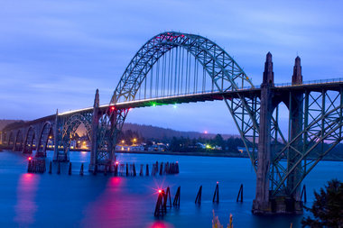

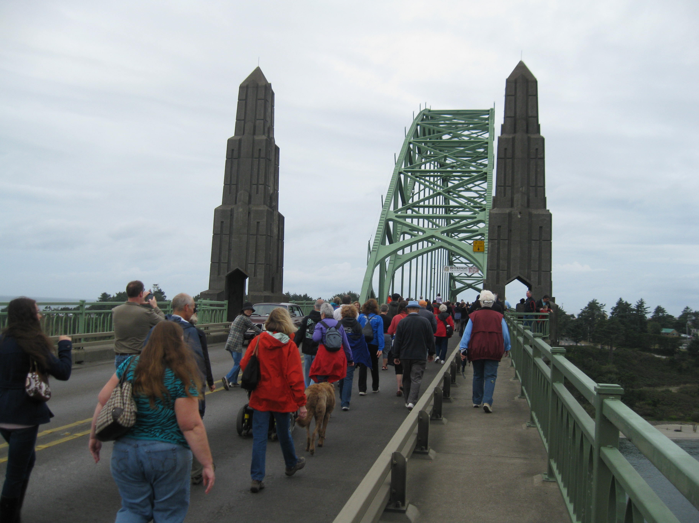
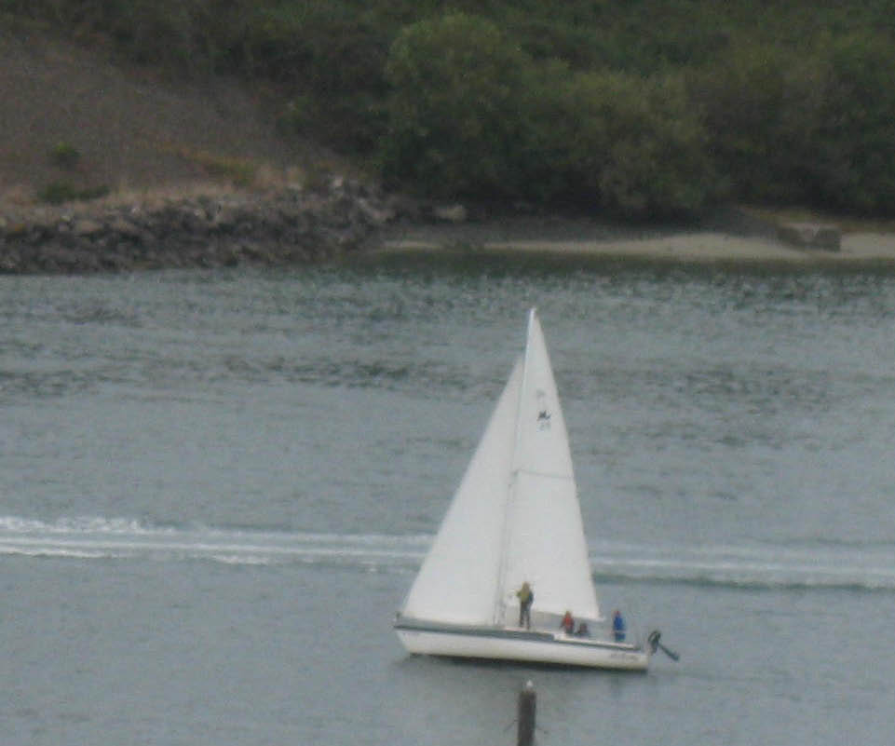
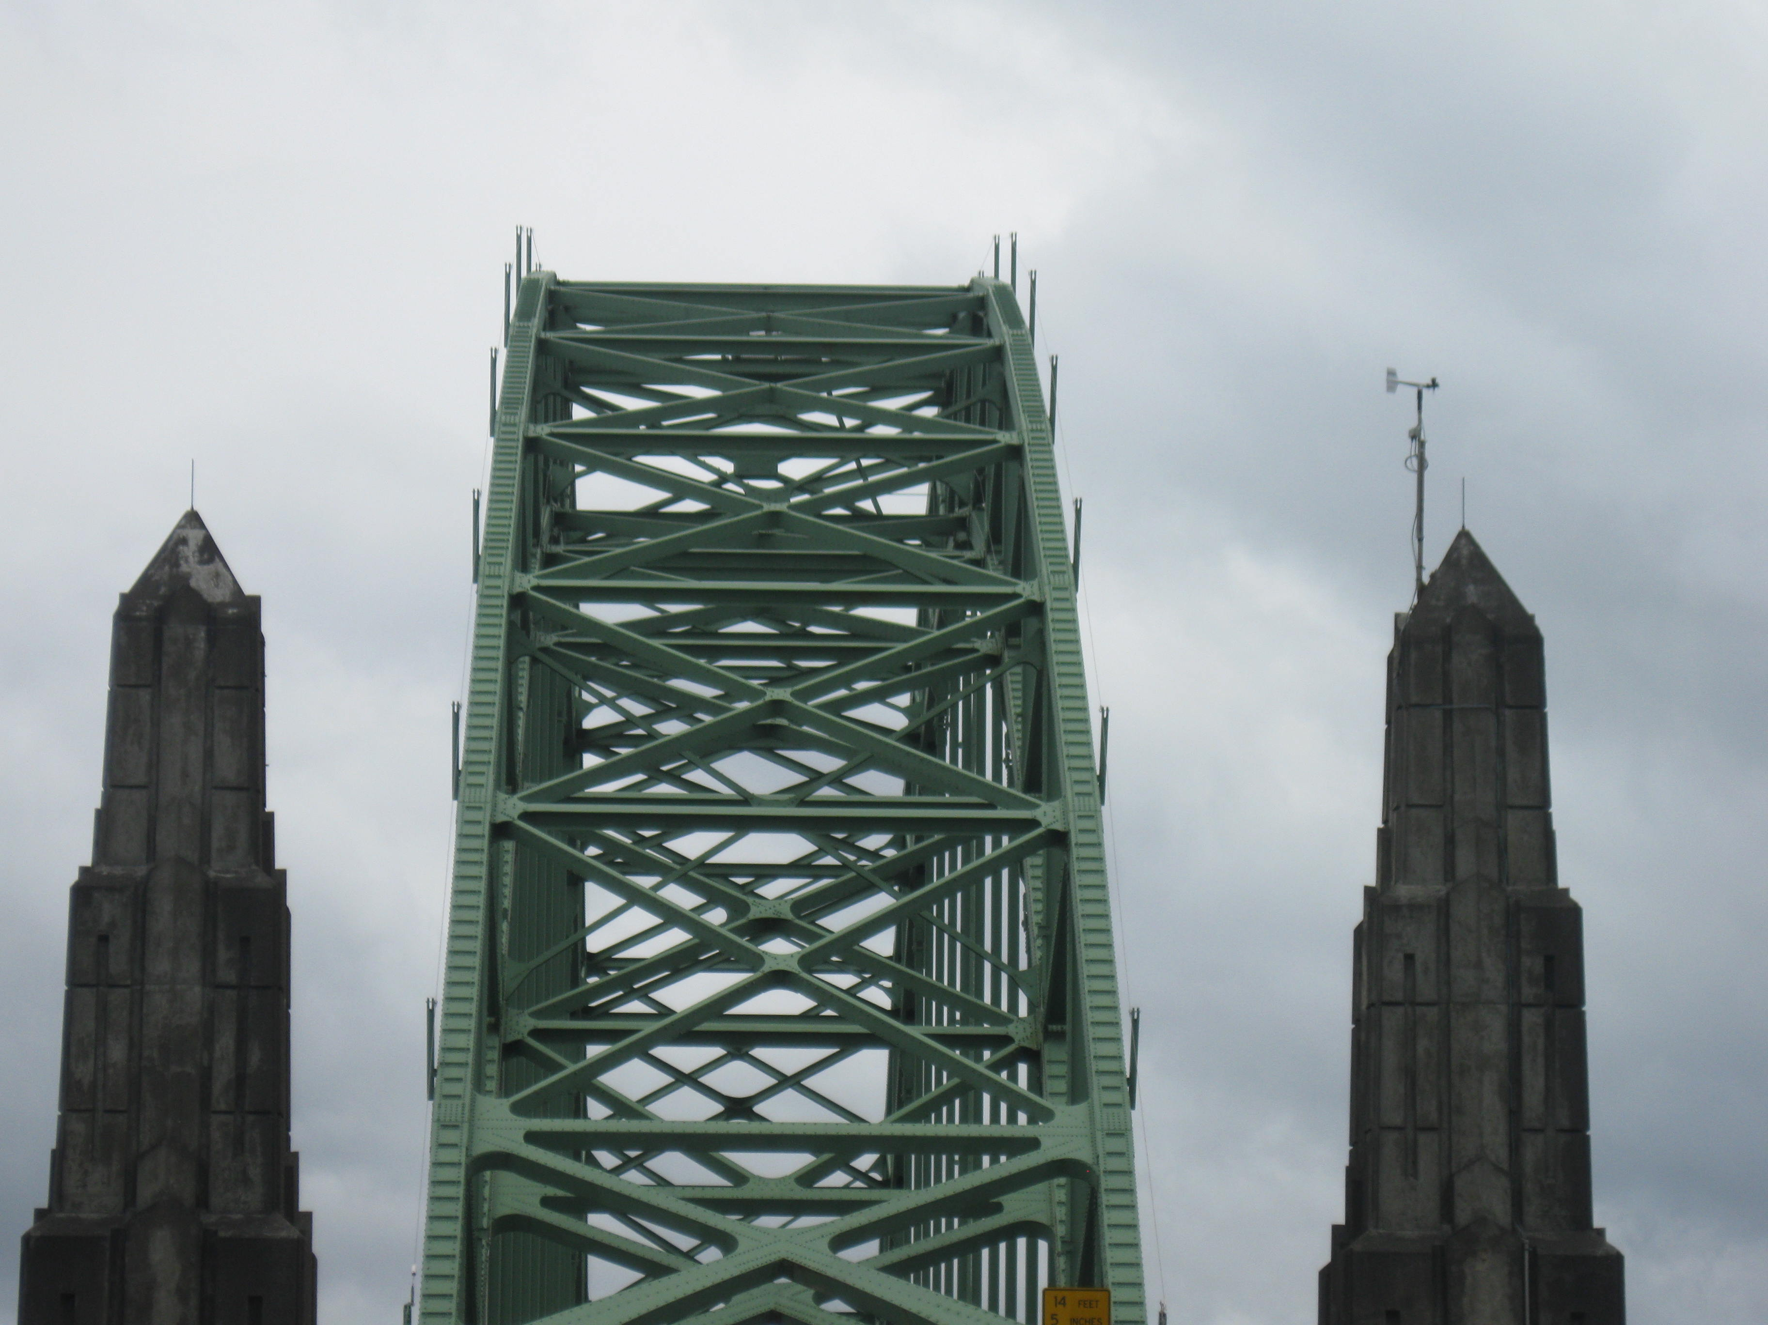
Commodore Greg aboard S/V Alchemy

Sailing News from ‘Round the World

Let's be honest. Would you want the America's Cup if someone gave it to
you? What a pain in the butt! Thank goodness Larry Ellison has a ton of
money to take on the task of shining up this tarnished trophy.
To create interest again, the America's Cup World Series was invented. But
again, let's be honest. It's been a work in progress. The first event in
Portugal wilted under the bright lights. And in the UK, only the 'crash &
burn' angle rescued the show. If this was Broadway, it'd likely be a very
short run.
What's been missing is a legitimate sailing venue. Thus far it's solely
been about entertainment, and the actors have been performing on a sound
stage. But now, with the circuit coming to San Diego (Nov. 12-20), the
racers will finally get a chance to race their boats on a tested track.
And the organizers of the San Diego event are for real too. Sailing Events
Association San Diego is chaired by Chuck Nichols. Chuck has been Commodore
of the world famous San Diego Yacht Club and was President of both the 1995
America's Cup and the 1998 Super Bowl. And Chuck is bullish on the venue
too
"We have a natural amphitheater," said Nichols. "We have developed areas
around the bay that will facilitate on-land spectating. We have Harbor
Island with all the open space. We have Coronado Island, which we hope to
have available with the Navy's cooperation. And then we have the city front
area. All of this is close enough to be able to enjoy the races from shore.
"With the cooperation of the Navy and Coast Guard, we can push the sailing
area to the edges. And the race management is really flexible on course
layout. This isn't like the old America's Cup where everything is set in
concrete. While we know the footprint of the sailing area, how the course
gets set within that area will depend on the wind direction so that it
provides for both good racing and shoreside viewing."-from sailingscuttlebutt.com


Monthly Potluck and Meeting

Join us October 15 to scare up a good time! Bring a dish to share and
come in costume if you dare..
6-7 Social time - Appetizers and Eyeball punch
7pm Haunted Patio is open for those brave enough to walk that plank.

Volunteer zombies and/or zombie victims desired - makeup artist will be onsite. Dress appropriately. Also needed are some setup helpers from 430-600pm.
Decor items still in need - three more 10x10 pop up awings - a chest or trunk - straw bales or other spooky items.
Contact Stephanie 541-265-9326 to help or if you have items to lend out for this funhouse or if you have questions!

Quote of the Month
"A small craft in an ocean is, or should be, a benevolent dictatorship." Tristan Jones


Board Bits

Prior to the Board meeting, the nominating committee met to draft a slate of officers to be presented for election at the November meeting.
The YBYC Board of Directors met on Thursday, Oct. 6. Among items of their agenda were the following:
The November board meeting will be on Tues., 11/8 at 6:30 PM- Plans for a boat storage structure are moving forward. - Clubhouse improvements such as carpeting, and additional sound-quality enhancements are being considered. -Possible changes to next year's race and regatta programs were discussed and will be pursued upon the election of the new Race Committee chair.-The Board approved funds for a regular October club meeting, rather than combining it with this week's regatta- Also approved were the final drafts of proposed by-laws changes. These will be presented to the general membership soon, and voted upon at the November meeting. The Board is now considering nominees for Volunteer of the year and Sportsperson of the year, as well as the Jeff Longmore award. Please submit your suggestion to any board member.-Alice McNamara


Notes From the Rear (Commodore, that is)

They say it doesn’t count, isn’t important, and is otherwise almost a complete waste of time, but the Fall Series was once again big fun for Team Grinner. Sure there wasn’t enough wind for anyone to finish the third race, and admittedly the rest of them were light air affairs, but dealing with difficult conditions is what racing is all about, and Grinner happens to love the light stuff. There was that day that Little Annie got her Fannie across the finish line before we did, but thanks to the trial two-class fleet breakdown, we still kept our “A” series complete with bullets. Thanks to the courage of the fearless crew, the Grinner never lost!
There are still folks who have trouble getting logged on, or trouble posting pics, etc, on the Yahoo Yaquina Bay Yacht Club members group. I have proposed using Facebook as an alternative, but perhaps people won’t want to have so many more FB friends clogging their newsfeed. With the new “custom list” feature, though, we can add our new YC FB friends to a separate list and be able to look at it only when we want to. Please offer any comments or suggestions about how we may be able to improve interclub communications.
The nominations committee has been busy looking at potential new board members, stay tuned for an announcement of who we have decided to present to you all at the big November meeting. If you want to get involved with helping to run your club, we are always looking for volunteers for various and sundry committees. It’s way more fun when you’re part of the action! Also, a few changes to the bylaws will be voted on at that meeting.
We want to extend a warm welcome to our new member Angela Sivers who was one half of my final keelboat class, the “A” team.
If you haven’t seen Joe Novello’s post on the Yahoo group, he’s putting together a basket of goodies (items, gift certificates, etc) to auction at the Newport Boosters Banquet on October 14 to raise funds for Youth Sailing. He’d like them available the 13th to pick up. I’m donating an intro sail, what do yawl have?-Mike Fulmor

Funny Bonz
Definitions from: SAILING (a pocket dictionary) by Henry Beard
and Roy McKie, c. 2001 Workman Publishing, NY.

CAULK, n., Any number of substances introduced into the spaces between planks or other components of the hull and deck of a boat that give a smooth, finished appearance while still permitting the passage of a significant amount of seawater.
CHANNEL, n., Narrow stretch of deep or dredged waterway, bounded by markers, that separates two or more grounded boats.
CLEW, n., 1. The corner of a sail where the foot and leech meet. 2. Evidence that a sail is missing when all that remains of it is a small piece of sailcloth torn from the bottom of the foot or the edge of the leech.-Tom “the Joker” McNamara



Membership Committee

Our membership is now at 96 with 17 Students, 21 Individuals, 49 Families, 2 Crew, 7 Lifetime and 1 Military. This is a gigantic surge from a couple of years ago when our membership hovered around 50. The quality of our membership is diverse as are their interests from Sailing to Kayaking and other water sports. We offer, for club member use, a keelboat, dinghy’s, kayaks, motorboats, our wonderful clubhouse and of course the camaraderie of others with similar likes and the vision quest of building our youth sailing program with the audacious dream of putting a youth sailor in the Olympics one day. I think this is a pretty special organization with some pretty special people and by galley, we do have a great time---I think you’ll agree.

We have one new member, Angela Sivers from Lincoln City. She took the sailing class with Mike Fulmor and is looking to becoming more involved in the Club and its many activities including cruising, classes and potlucks. Welcome Mate, it’s good to have you aboard this good ship with its happy crew.-Mac McConnell


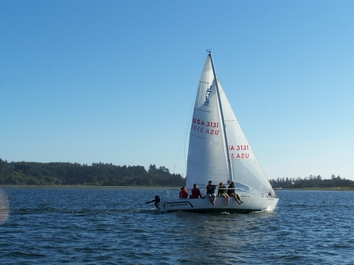

Ken and Stephanie Brown’s S/V Cheap Sunglasses

Flotsam and Jetsam 

- Remember you can make a tax-deductible donation through the Oregon Boating Foundation. The money is used to provide community boating education and all donations are greatly appreciated. Please contact Ron Cole for further information.

- The club has a fleet of sailboats available for club member use. These include Lidos, 420s and a small keel boat. These boats are fun to sail and explore Yaquina Bay. Check the Member's Handbook or with the YBYC Fleet Chair Tom Mcnamara at ; mailto:mcntm@msn.com for details on vessel use and to make reservations. Reservations are posted online on the club’s website http://www.yaquinabayyachtcluborg under the ‘Calendar’ tab.

Wednesday 420 reservation website-
https://spreadsheets0.google.com/spreadsheet/ccc?hl=en&key=tZvTrAppsstef-nGGCMmWDA&hl=en#gid=12

- Don’t forget to use our Yahoo group site at http://groups.yahoo.com/group/ybycgroup/ It’s the best place to keep up on club and member activities, chat and exchange info with fellow members. You can also read Board minutes. The Club also has a Facebook page, check it out! It’s updated frequently so you can be sure to keep abreast of club activities.

- Ships Store- Please do not forget to check out all the fine items at the ships store. Not only are you buying quality merchandise you can use, but it helps support the YBYC!


Editors Corner

The Bridge Anniversary was a really nice Community event. The weather held off just long enough to enjoy it. We are so fortunate to live in an area with both manmade and natural beauty.
The Regatta dinner was well attended and the race weather was considerably less ominous than last year.
Our Halloween potlucks are usually something special, especially with Steph at the helm. Dust off your vampire cape, eat some garlic, bring a silver bullet, or whatever you need to ward of the ghouls which will surely take over the Clubhouse.
Thanks to Ken and Stephanie for being our members of the month. The Jib Sheet will debut a new historical feature next month focusing on articles from our newsletter archive, it should be fun. Please be safe on the water as our weather changes. Cheers, Jeff

Member-2-Member Network
Have you ever needed a carpenter, cabinet maker, tile setter, tire company and didn’t know who to call? Ever needed to have an item on your boat or home repaired, but had no idea where to call? Rather than calling a stranger or looking in the yellow pages, call another YBYC member! Every member who runs a business or performs a service is encouraged to signup. It’s totally FREE to members! Non-members pay a nominal fee. Want to get yourself listed? Email the YBYC newsletter editor at jcressy@charter.net with your listing information. We need to support our own, especially in this economic climate. Please consider doing what you can.

Alan Brown Tire Center (Les Schwab)
Ken Brown manager (541) 265-6604
1155 SW Coast Hwy
Newport, OR 97365
Email: tyrguy@yahoo.com

Dr. Kenneth S. Bishop
Chiropractic Physician
111 SE Douglas
Suite F-1
Newport, OR 97365
541-264-8138
www.yaquinachiropractic.com

Amy Lynn Greer
Certified Public Accountant
Ph/fax: 541-961-6814 Cell: (541) 961-6814
60586 Ridge Hts Bend, OR 97702
amygreercpa@bendbroadband.com

Vicki Krutzikowsky
Shaklee product distributor
www.healthydedication.com
541 264-8039
vickihoosky@hotmail.com
American Home and Stone---541-929-3100
Members: Shane and Mac McConnell
Cabinets, tile, granite countertops, stoves (wood, gas, pellet), spas: Discounts
www.americanhome
Ocean Pulse
Custom Surfboards, Skateboards, and Snowboards
Tom McNamara (541) 265-7745
428 SW Coast Hwy
Newport, OR 97365
www.oceanpulsesurf.com

Bike Newport
Elliott & Daniella Crowder, Owners
150 NW 6th Street
Newport, OR 97365
(541) 265-9917
website: bikenewport.net
email: bikenewport@charter.net

Member-2-Member-(cont.)
Kevin Raichl Cindy Milligan LMT# 6107
Visual Thinking Northwest Drift Away Massage
828 SE Crescent Pl. 310 NW 5th St. Suite 102
Newport, OR 97365 Corvallis, OR 541-753-4785
541-264-8343
541-480-2355 cell
www.visual-thinking.com

True Cut Engraving
Stephanie Brown
403 SW 10th Street
Newport, OR 97365
TrueCutEngraving@qwestoffice.net
541-265-9326

YBYC Classified

For Sale and Looking for a good home.

S/V Vela, 1965 Mercator 30, Tall Rig with Sprit (Located on B Dock)

F/G hull, with wooden deck, house & spar; 4 cyl gas engine, rebuilt trans w/variable pitch prop; new standing rigging, mainsheet traveler, head & upholstery; rebuilt mast; many additional upgrades. Hauled out Fall, 2011. Electronics include a GPS, VHF, Depth and Stereo. Sail inventory is in good shape & extensive. The boat come fully equipped with gear, parts, tools, receipts and housekeeping items. There are several unsourced leaks in the house and the wiring should be upgraded. She performs beautifully in light air and has a responsive helm. She is a delight to sail and a beautiful vessel. We no longer have the time to maintain a wooden boat and believe that the price is reflective of on-going projects. Asking $14,750.00 obo. Contact Ron at (541) 265-5900.


Gard's Auto
European - Japanese - Domestic
Diagnostics, Service & Repair
541-867-7123
4909 S Coast Hwy #115 South Beach
Right behind the South Beach Post Office
Show us your Yacht Club membership card for a 10% discount
Archie & Irene Bailey

