Yacht Club Calendar
19th-Annual meeting and prime rib dinner

The Jib Sheet
November 2011
A publication for the Members and Friends of the Yaquina Bay Yacht Club-est. 1947
Our Mailing Address is 750 SE Bay Boulevard, Newport, OR 97365

Our Website URL
Is www.yaquinabay yachtclub.org

For questions about the Club, contact us at YBYC.email@gmail.comFor questions about or contributions to this newsletter contact Jeff Cressy, editor, at jcressy@charter.net
YBYC 2010 Officers- Commodore: Greg Krutzikowsky
Vice Commodore : Paul Erskine
Rear Commodore: Mike Fulmor
Secretary : Alice McNamara
Treasurer : Dorothy Bogumil
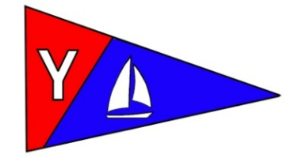

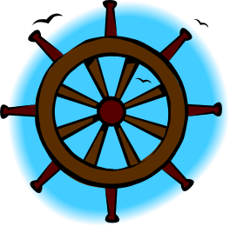
Commodores Log
It is hard to believe a whole year has passed and that the YBYC annual meeting is upon us. Preparations are well underway for the November 19 meeting at the clubhouse. There is a full agenda of club business, awards, and YBYC camaraderie planned, so don't miss out. The annual meeting will feature a delicious prime rib dinner. Members attending will need to bring their favorite side dishes to share for this pot luck extravaganza! In addition to electing a new Board at this meeting, members will consider whether to amend the club's bylaws. You should have received an invitation in the mail along with and RSVP slip. Hopefully you have already RSVP-ed and included your membership dues for next year to take advantage of the early bird discount. If for any reason you have not received an invitation, please call Dorothy Bogumil to let her know how many to plan for ASAP! As always, festivities start at 6 PM.
I am working on putting together a slide show of some of this year's activities and would love to include your best shots. I've got a pretty good start, but pictures of the Loyalty Day parade, the Toledo Wooden Boat show, Bridge to Bridge event, the Wild Seafood Brunch, the wonderful dancing at the clubhouse when the band played, High School regattas, kayaking and/or the Columbus Day Regatta would be welcome. You can add them to the photos in the Members Only section of our website.
The club has had a busy and successful year fulfilling its mission promoting the enjoyment of water sports and serving the social needs of its members. YBYC is living up to its values of engaging in community partnerships, promoting responsible growth, good sportsmanship and goodwill, and creating positive learning experiences and opportunities. The time has come to pass the helm of the club to a new Commodore and Board. Please join us to celebrate our success and help chart our future.
Fair winds, Greg

YBYC Member Profile- Paul and Sharon Erskine

I first became interested in Sailing when a friend with whom I had grown up in Sausalito, CA and his family took off for Tahiti aboard the Wanderer with Sterling Hayden and his family sans his wife much to her chagrin, it was January of 1959 and I was 8 years old...ah the romance of the sea...(there is a book on the trip by Sterling Hayden that is called "Wanderer", it is a great read as is "Voyage" his next book)
Kit came back to school the following year with adventures galore and I listened with rapt attention to his stories...I was hooked.
At age 10, in 1961 the Sausalito Yacht Club started a Junior Program, membership to which I was given as a gift from one of the members who had long been friends with my Dad before he and my mother divorced and he moved to Nevada. In that program I learned to sail in a El Toro...nifty little boat, very durable and fairly easy to sail, the program was a success and I have continued with my interest in sailing to this day.
At about 17 or so I became interested in racing when a pair of brothers who I knew got a Snipe and started racing it, twice the length of an El Toro, it had a Jib and was a lot more fun to sail. In the ensuing years I raced on a lot of different boats in the San Francisco Bay, almost always with one of the brothers who had the Snipe who is one of my oldest friends and also still sails and is a sail maker. We sailed in the PHRF equivalent down there, it is called YRA or Yacht Racing Association, and we would sail in the bay or out in the ocean off of the coast, for instance the Farralons Race which is about 56 miles and quite a demanding day of sailing in the ocean.
When I met Sharon in 1972, there was an immediate attraction and I chased her until she caught me, we were married in 1973 and shortly after that moved to Santa Cruz and bought our first house in 1974, we hadn't been there long when I started to miss the Fire Department, I had been a volunteer in Sausalito and thought it to be a pretty good option to maybe have a reliable career rather than being at the mercy of the economy doing Tree Work like I had been doing so I checked with a friend at the department, they weren't hiring but Novato was opening a new station and going to Hire 15 people, I had tested for another fire department so I knew more or less what to expect...They had been hiring 6 people and I came in 12th out of 650 applicants so knowing there were 6 less applicants, and 15 jobs, I sold my house in Santa Cruz and we moved to Petaluma CA, 10 miles north of Novato where I just knew I was going to be working...did I mention that we had a baby girl? (now 36) and so I needed to provide for my little family. I got the job and started as a "Fireman", just before Whitney's 1st birthday, I worked there until I was forced to retire in 2003 due to a serious knee injury, by that time I was a Captain and assigned to the Truck Company which was a perfect fit for me, I still miss it at times...less as I get older.
In 1977 we had our second child, a son named Nicholas, he still lives in CA and we see him a couple of times per year either there or when he comes up to visit, I'll get him out on Flamingo in the near future I hope, we had a couple of boats when the kids were growing up but nothing like this boat.
The pay at the Fire Department was rather pathetic when I started my career so to enable my wife to stay home and raise the kids I always worked 2 jobs, the Fire Department would pay the Mortgage and utilities and food but little else, however it provided health care and retirement security so the second job enabled us to do stuff...
We retired and travelled to the east coast in the fall of 2003, we took our trailer and did 10,000 miles in 6 weeks, saw the colors back east, and lots of sites between here and there, it was a wonderful trip but we wanted to move and be closer to the ocean so in 2004 we came up to visit Oregon, we had been going up and down the coast for years but hadn't really thought about moving here till then, we looked at roughly 100 homes in this area, we wanted to be between Yachats and Lincoln City and as luck would have it found what for us is a nearly perfect home in Otter Rock, we've been here for over 7 years now and love the area, the people and even tolerate the weather...it isn't that different from growing up in Sausalito and Sharon is from Santa Cruz which is quite similar.
Sharon is an avid gardener and has made quite a display in our yard, it is +- 1 acre and I do the trees and the lawn and any building, she does the rest and it is quite lovely if I say so myself, she isn't fond of sailing like "we" like to sail, she would rather have a BIG powerboat...so I suffer through it on my own...with friends like all of you.
Flamingo is my first foray into racing my own boat and with a wonderful crew I have really enjoyed our Competition and Camaraderie, I also really enjoy Kayaking.
This club is so welcoming and low key, I hope to be affiliated for many years and to be able to help us continue on the path toward the goals we have set as well as look to the future and be all we can be.
Fair Winds, Paul and Sharon Erskine


More News You Can Use

Notes From the Rear (Commodore, that is)

It’s been quite a learning experience this past year being Rear Commodore. I never expected to be nominated even though I did jokingly check that certain little box on my membership application. Besides getting to know the great bunch of people active in the club, I’ve had to learn how to be a Board member with no previous organizational experience of any kind. Luckily Barb has some experience and has been patiently coaching me. Hopefully this next year as Vice Commodore I’ll do a better job!

By the way, though I have been a member of a few yacht clubs in my life, I had never learned how to get past that “outside looking in” stage where I never got involved and felt a bit like an alien. The cure for that is easy, I’ve found, just volunteer to help! There’s no better way to get to know your fellow members and feel like a part of things. Our new slate of chairpersons will all be looking for helpers, and right now Stephanie needs your help soliciting and collecting prize donations from local businesses and doing other jobs to make the December 3rd Parade of Lights a big success once again. Are you entering your boat? It was great fun last year.

By now you’ve heard about the big November meeting next weekend; hopefully everyone who can make it will be there. There was a motion made to suspend the traditional charge for the prime rib this year due to a banner year of clubhouse rentals and unspent money in the Hospitality budget. We also hoped that free roast beef might attract more folks for the important membership voting on bylaws changes and new board nominees, as well as being another reward for membership. If you bring non-member guests, however, or feel like a donation is in order for whatever reason, there will be some little buckets available to collect them, don’t be shy!
Though attendance could have been better, the last-minute Halloween-theme party October 15 was great fun for those of us who made it. Stephanie’s instant Haunted Patio was full of spooky fun stuff and was professional enough we could have charged for admission. It was hard to believe the whole dark scary maze only took an hour or so to put together and even less time to disappear. Let’s hope it happens again next year and more people find their way there.
In closing, the days may be getting ridiculously short, the weather may be getting ridiculously wet, but the sight of my Grinner sitting on her trailer out in the yard makes me smile and think of the warm days of summer past and summer to come. Now if only I can get all the boat projects done in time- April will be here all too soon.
See you at the Club,
Mike Fulmor

Annual Meeting November 19th
6:00 p.m. YBYC Clubhouse



Sailing News from ‘Round the World
Continuing coverage of the run-up to the America’s Cup

Torrential rains were the order of the day in San Diego as the racing got underway this afternoon.
In extremely fluky conditions, Artemis Racing took the first win of the event in what was a race of snakes and ladders. Then in the second race, the Swedish team finished fourth, to claim second place overall on count back for the day, tied on points with Emirates Team New Zealand.
Commenting on today’s racing Skipper Terry Hutchinson said, “It was about being in the right place at the right time today. It was a bit cold and wet. They say it is never like this here so it is good to get this out of the way this weekend!”
“Days like today are very good practice and training. That is what it is all about. We also continue to be mindful of how good the people are around us. We have two new guys on the boat here as part of our ongoing crew rotation plan, so it is as much about racing the AC45 as it is about preparing for the America’s Cup in San Francisco.”
Artemis Racing
Artemis Racing is the Challenger of Record for the 34th America’s Cup. Artemis Racing competes in the America’s Cup World Series, Extreme Sailing Series, RC44 Championship Tour and Vulcain Trophy. Artemis Racing represents the Royal Swedish Yacht Club (KSSS).


Youth Sailing Program
High School Sailing team members have been busy with many fund raising activities over the past few months. Various events included the Wild Seafood Weekend, Serving Bike America participants Dinner and Breakfast, and waiting tables at the Elks Club’s formal banquet. Students are helping to raise money to help maintain the Club 420s, purchase uniforms, and offset costs of regattas.-Joe Novello

Quote of the Month
"The sea is the same as it has been since before men ever went on it in boats."
Ernest Hemingway

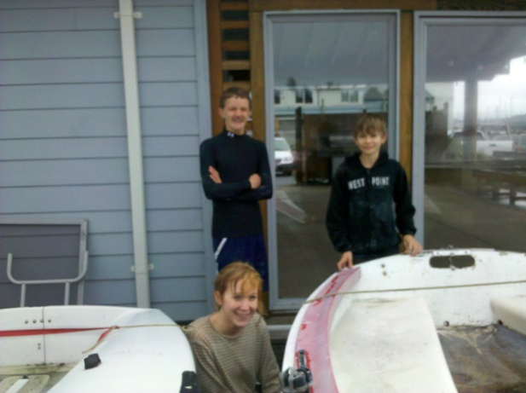
Dillon Doll and Landon Reno take a break from securing boats for the winter and watch Kim smith tying down a Lido

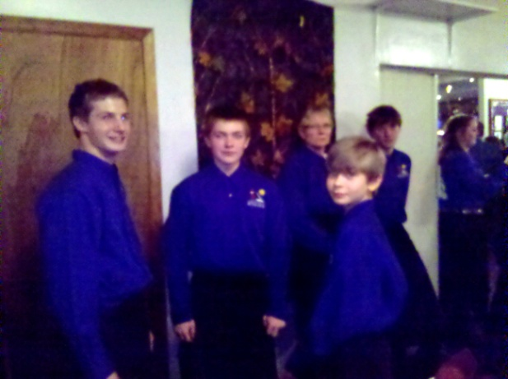
Josh Viar, Austin Versteeg and Landon Reno take a break from serving the Elks sporting their new teamshirts

Board Bits

On Tuesday, Nov. 8, the YBYC board met for its final meeting with Greg Krutzikowsky as
Commodore. And on that note, they reviewed the slate of nominees for the 2012 Board of Directors, upon which the general membership will vote at the annual meeting on Nov. 19. Final arrangements for that meeting were also discussed. Of particular importance is the need for members to RSVP, so that we are sure to have enough Prime Rib. Paul Erskine reported on the recent meeting between YBYC and the OBF.
Upcoming projects for dry boat storage and the proposed launch dock were discussed. Clubhouse rentals have been busy. Ideas for education events were presented.
And we were reminded that YBYC has taken over the Lighted Boat Parade, and volunteers are needed to organize this popular event.


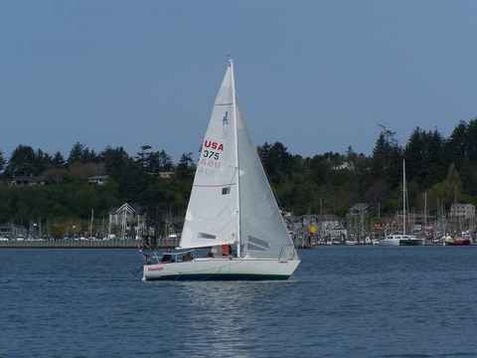

Paul and Sharon Erskine’s S/V Flamingo

Funny Bonz
Definitions from: SAILING (a pocket dictionary) by Henry Beard
and Roy McKie, c. 2001 Workman Publishing, NY.

Foul Weather Gear, n., collective. Type of weatherproof clothing usually needed only in Fall, Winter, Spring and Summer months.
Fog, n. Condition of greatly reduced visibility that occurs when the air temperature approaches the dew point, or the boat approaches the harbor.


2012 Proposed Board Slate
Commodore, Paul Erskine
Vice Commodore, Mike Fulmor
Rear Commodore, Elliot Crowder
Treasurer, Dorothy Bogumil
Secretary, Alice McNamara
Education, Anne Williams
Fleet, Tom McNamara
Hospitality,, Pat Blackburn
House, Barbara Fulmor
Membership, Linda Wilkinson
Newsletter, Jeff Cressy
Publicity, Bruce Wilkinson
Race, Greg Krutzikowsky/Jim Rice
Cruise, Mike Blackburn
Store, Pat Blackburn
Website, Pam Voss
and we are hoping to develop a position for Youth Sailing Coordinator and fill it if the position is approved by the membership.

Fundraiser
This was posted on Yahoo Groups but bears repeating. “Girls night out” will be held for cancer victim Stephanie VanDamme. Her twin sons Casey and Kody are members of our youth sailing team. For more info, please see this link: http://www.newslincolncounty.com:80/?p=36967

Flotsam and Jetsam 

- Remember you can make a tax-deductible donation through the Oregon Boating Foundation. The money is used to provide community boating education and all donations are greatly appreciated. Please contact Ron Cole for further information.

- The club has a fleet of sailboats available for club member use. These include Lidos, 420s and a small keel boat. These boats are fun to sail and explore Yaquina Bay. Check the Member's Handbook or with the YBYC Fleet Chair Tom Mcnamara at ; mailto:mcntm@msn.com for details on vessel use and to make reservations. Reservations are posted online on the club’s website http://www.yaquinabayyachtcluborg under the ‘Calendar’ tab.

Wednesday 420 reservation website-
https://spreadsheets0.google.com/spreadsheet/ccc?hl=en&key=tZvTrAppsstef-nGGCMmWDA&hl=en#gid=12

- Don’t forget to use our Yahoo group site at http://groups.yahoo.com/group/ybycgroup/ It’s the best place to keep up on club and member activities, chat and exchange info with fellow members. You can also read Board minutes. The Club also has a Facebook page, check it out! It’s updated frequently so you can be sure to keep abreast of club activities.

- Ships Store- Please do not forget to check out all the fine items at the ships store. Not only are you buying quality merchandise you can use, but it helps support the YBYC!


Editors Corner
Greetings, as we near the end of another year it is time to bid farewell to Commodore Greg. I would like to thank him for his hard work and dedication. It seems the future of the YBYC is a bright one. Thank you to all who served as Board members..
It was a pleasure to feature Paul and Sharon Erskine as our YBYC members of the month. As incoming Commodore I welcome Paul’s turn at the helm and look forward to an exciting and productive year.
As mentioned in two previous articles, the annual meeting and prime rib dinner is on the 19th. I hope to see you there.
Unfortunately, I was unable to attend last month’s Halloween Spooktacular. I heard Stephanie did a great job and several members were scared senseless, those who had sense to begin with anyway!
Don’t forget the Lighted Boat Parade December 3rd. Cheers, Jeff

Member-2-Member Network
Have you ever needed a carpenter, cabinet maker, tile setter, tire company and didn’t know who to call? Ever needed to have an item on your boat or home repaired, but had no idea where to call? Rather than calling a stranger or looking in the yellow pages, call another YBYC member! Every member who runs a business or performs a service is encouraged to signup. It’s totally FREE to members! Non-members pay a nominal fee. Want to get yourself listed? Email the YBYC newsletter editor at jcressy@charter.net with your listing information. We need to support our own, especially in this economic climate. Please consider doing what you can.

Alan Brown Tire Center (Les Schwab)
Ken Brown manager (541) 265-6604
1155 SW Coast Hwy
Newport, OR 97365
Email: tyrguy@yahoo.com

Dr. Kenneth S. Bishop
Chiropractic Physician
111 SE Douglas
Suite F-1
Newport, OR 97365
541-264-8138
www.yaquinachiropractic.com

Amy Lynn Greer
Certified Public Accountant
Ph/fax: 541-961-6814 Cell: (541) 961-6814
60586 Ridge Hts Bend, OR 97702
amygreercpa@bendbroadband.com

Vicki Krutzikowsky
Shaklee product distributor
www.healthydedication.com
541 264-8039
vickihoosky@hotmail.com
American Home and Stone---541-929-3100
Members: Shane and Mac McConnell
Cabinets, tile, granite countertops, stoves (wood, gas, pellet), spas: Discounts
www.americanhome
Ocean Pulse
Custom Surfboards, Skateboards, and Snowboards
Tom McNamara (541) 265-7745
428 SW Coast Hwy
Newport, OR 97365
www.oceanpulsesurf.com

Bike Newport
Elliott & Daniella Crowder, Owners
150 NW 6th Street
Newport, OR 97365
(541) 265-9917
website: bikenewport.net
email: bikenewport@charter.net

Member-2-Member-(cont.)
Kevin Raichl Cindy Milligan LMT# 6107
Visual Thinking Northwest Drift Away Massage
828 SE Crescent Pl. 310 NW 5th St. Suite 102
Newport, OR 97365 Corvallis, OR 541-753-4785
541-264-8343
541-480-2355 cell
www.visual-thinking.com

True Cut Engraving
Stephanie Brown
403 SW 10th Street
Newport, OR 97365
TrueCutEngraving@qwestoffice.net
541-265-9326

YBYC Classified

For Sale and Looking for a good home.

S/V Vela, 1965 Mercator 30, Tall Rig with Sprit (Located on B Dock)

F/G hull, with wooden deck, house & spar; 4 cyl gas engine, rebuilt trans w/variable pitch prop; new standing rigging, mainsheet traveler, head & upholstery; rebuilt mast; many additional upgrades. Hauled out Fall, 2011. Electronics include a GPS, VHF, Depth and Stereo. Sail inventory is in good shape & extensive. The boat come fully equipped with gear, parts, tools, receipts and housekeeping items. There are several unsourced leaks in the house and the wiring should be upgraded. She performs beautifully in light air and has a responsive helm. She is a delight to sail and a beautiful vessel. We no longer have the time to maintain a wooden boat and believe that the price is reflective of on-going projects. Asking $14,750.00 obo. Contact Ron at (541) 265-5900.


Gard's Auto
European - Japanese - Domestic
Diagnostics, Service & Repair
541-867-7123
4909 S Coast Hwy #115 South Beach
Right behind the South Beach Post Office
Show us your Yacht Club membership card for a 10% discount
Archie & Irene Bailey

