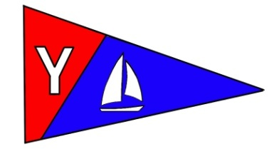
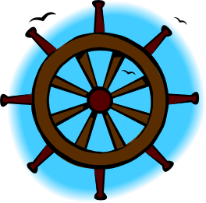
Yacht Club Calendar
19-Monthly meeting/wine tasting

Commodores Log
The Jib Sheet
February 2011
A publication for the Members and Friends of the Yaquina Bay Yacht Club-est. 1947
Our Mailing Address is 750 SE Bay Boulevard, Newport, OR 97365

Our Website URL
Is www.yaquinabay yachtclub.org

For questions about the Club, contact us at YBYC.email@gmail.comFor questions about or contributions to this newsletter contact Jeff Cressy, editor, at jcressy@charter.net
YBYC 2010 Officers- Commodore: Greg Krutzikowsky
Vice Commodore : Paul Erskine
Rear Commodore: Mike Fulmor
Secretary : Alice McNamara
Treasurer : Dorothy Bogumil

The daffodils are blooming and Sailing Season is upon us! The Frostbite Series had its official kickoff on an auspicious Sunday shared with some game played with an odd shaped pigskin ball. It was a lovely winter's day and alas I was ashore watching the sailors enjoy a lovely day on the water. Timing in life is everything and mine was off by an hour. It was great to see the three boats rounding marks and close reaching for the finish. By the time you read this the High School Sailing Team will be starting practices. They are planning on attending three regattas this spring and we are hoping that the sailors will continue to sail with us in the Spring and Summer series. I've heard Coach Joe surmise that it won't be long before these kids will be having their names engraved on the sailor of the year plaque at the clubhouse and adults will be struggling to keep up. Now that's what I call progress, but it may be a hard won honor if I know some of the YBYC sailors.
We are looking forward to the upcoming Wine and Seafood Festival. Make sure that you sign up for your chance to view the action from the inside out. Serving the visitors wine at the YBYC booth is lots of fun and offers free admission to the Festival on the day you serve. The people watching is great and you are bound to have a great time. Don't miss out.
Fair winds and following seas,
Greg


More News You Can Use

Hey YBYC Sailors! Frostbite Series is underway for 2011. The 1st and 3rd Sundays of the month are designated for Frostbite races right up to the Loyalty Days Regatta in April. This is an informal afternoon race series that doesn’t have a committee boat and no scores are kept. Meet at the Coast Guard buoy at noon on the designated Sunday, decide on a course and go for it. Or just follow the leader, weather and conditions permitting, of course.
Hi. I’m Mike Blackburn and I am your 2011 Race Committee Chair. It’s going to be a blast. I especially can’t wait for Regattas. The first, of course, is Loyalty Days in April as I mentioned. It will be the 23rd and 24th of April this year and I hope we get a great turn out. Plan to have your yachts and dinghies ready and get your entry in early. Look for more details and notice of race in March.
I’ve only been sailing for a couple of seasons and a member of YBYC for the same amount of time so I’m pretty green (but not sea sick). I have had a blast! It’s been great fun learning to sail and being part of a great club. You are a fun bunch and you’ve been great to Pat and I and we continue to enjoy meeting and getting to know old members and new.
Races have been great fun even if I’m usually just chasing you around the bay trying to catch up. I haven’t sailed in a regatta yet but I mean to soon. I’ve helped out on committee boat and chase boat during regattas and that’s been great fun and I’ve learned from watching the yachts and dinghies go through starts and maneuvers and finishes.
I’ll be learning about Race Committee now up close and personal throughout the year. Did you know that the Race Committee puts on the Regattas, Spring, Summer and Fall series races and special cruise events? Me neither! That’s because it is all of you, all the members and racers who do all the work. In committee boat, chase boat, clubhouse, cooking, preparing, setting up and all the rest of the hard work that goes into a successful regatta or race series. Don’t worry, there will be lots of opportunities again this year. In addition, Ken and Stephanie are organizing the Bridge to Bridge race again this year which has involved the club as the finish line destination, and a mid-summer event, Sailstice, is being planned.
Stay tuned to this newsletter for more news about racing and cruising. Get ready, get involved and have fun on the water.-Mike Blackburn

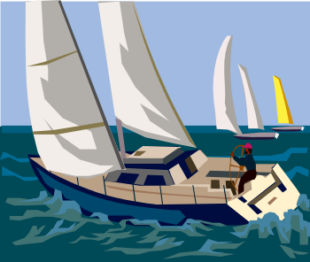
Race Committee News

The Bay – She’s a Changin’
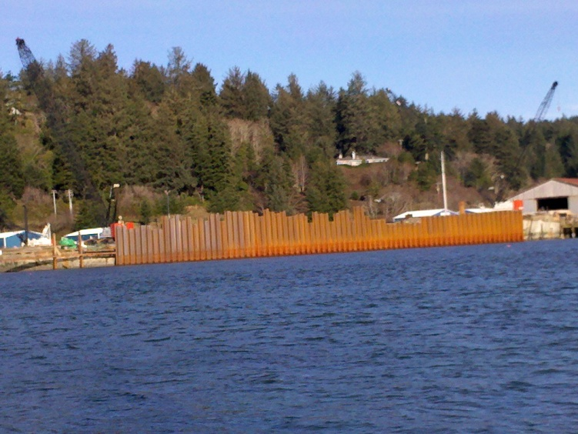
The good news is all the new construction on the bay is an indicator of what is to come with economic development and the hope of fleets of ships filling the coffers. The bad news is our bay is being redefined. I went out for a sail right after the first of the year and was daydreaming in the vicinity of day marker #12 when the boat suddenly jerked sideways about three feet. At first I thought I hit a deadhead or snagged a crab pot. A quick look around revealed that I was in the middle of a whirlpool about 30 yards in diameter. I am unsure if this was a fluke, or if it will become a permanent characteristic of the bay with the new dredging just west of that location. There was about a nine foot ebbing tide that day so we will have to watch and see.

On the same day I noted two other significant changes. There is a new solid steel wall around the terminal docks. I believe this is a temporary coffer dam, but don’t take my word for it. That same ebb tide was hitting that wall creating one to two foot waves that went from the wall on the north side all the way to the beach on the south side of the bay in that area.

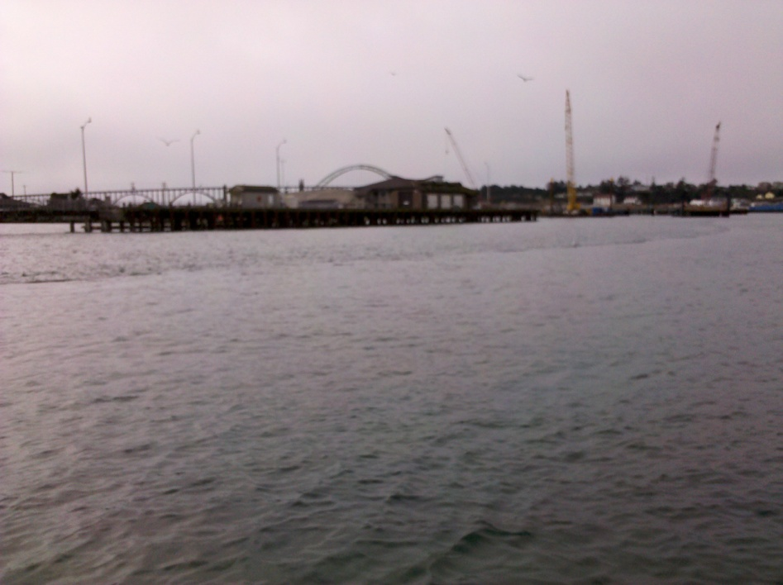
Other changes noted are shoaling occurring in the area between buoy #11 and the breakwater in front of Port Dock 3. That area is getting considerably shallow with numerous groundings reported by many club members. The area in front of the new NOAA docks is a bit deeper than it was before, and the shoreline there is no longer tapered. It appears the current is running a lot faster along the south side of the bay to the point where there are one to three foot standing waves between Day Marker #10 and the bridge, again on the ebb tide. The new ship docks are being constructed much further out into the bay than the OSU dock, shrinking the amount of navigable water between that area and buoy #11.

One more thing to watch out for; the floating dredge line that runs from the NOAA dock to the staging area near the terminal docks towards the LNG plant. Orange floats are supposed to be marking the line, however while sailing today; we noticed the line floating 10 – 15 yards away from the floats. If you look carefully you can see change on the surface of the water where the line is floating just under the surface.. This line snakes along the south shore of the bay and crosses between the Day Marker #12 and the terminal docks. I’ve heard that it is about six feet under water, but cannot seem to get that confirmed.
All this construction is a sign of good times to come. However, we need to pay attention to the changes. It will certainly be an interesting racing season this year. Be careful and pay special attention to the new face of our sailing playgrounds.-Joe Novello

Sailing News from ‘Round the World

Anyone who can paddle across the Atlantic Ocean can surely beat you or I in arm wrestling...hands down! No pun intended. And paddling across the Atlantic is exactly what Aleksander Doba did coming ashore in northeast Brazil Wednesday afternoon the 2nd of February 2011 after completing a transatlantic kayaking expedition that lasted almost 99 days and spanned 3,320 miles. And the guy is only 64 years old. That’s correct, Doba is 64 years old and he KAYAKED across the Atlantic ocean. 3,320 miles.....99 days.....64 years old. Doba left last Oct. 26 from Dakar in West Africa, aboard a customized 23-foot sea kayak, which is only only 39 inches wide. This was his home for 98 days and 20 hours.
Three others have kayaked across the Atlantic: Franz Romer in 1928; Hannes Lindemann in 1956, and Peter Bray in 2001. But none of those expeditions was directly from continent to continent (they utilized offshore islands), and none of those paddlers was a senior citizen. It’s believed to have been the longest-ever solo-kayaking voyage, in terms of time spent at sea. He spent Wednesday afternoon and evening being checked by doctors and sleeping. On Thursday the 64-year-old Polish adventurer, thickly bearded and disheveled but appearing remarkably fit, told a small gathering in the remote fishing community of Acaraú, that after a little more rest he'd like to climb back in and paddle to the United States. From there he just wants to paddle until his arms fall completely off!! -from WXTZ Holland.-ed.


Monthly Meeting Notice
This month’s meeting will be hosted by Rear Commodore and the
House Chair Mike and Barbara Fulmor. The theme is wine tasting.
We will be pouring wines which will be featured at our booth at the
Seafood and Wine Festival. Cheese, salami, fruit, and veggies
will be provided. Please bring finger foods or your favorite wine
accompaniment. If wine is not your drink, or you have your own fave, please BYOB.
Time: 6:00- social 7:00 –Tasting
YBYC Clubhouse
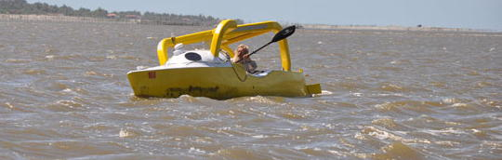
Quote of the Month
“Men in a ship are always looking up, and men ashore are usually looking down."
- John Masefield



High School Sailing
The 2011 High School Sailing season is about to begin. A parent/athlete meeting will be held on Monday February 7th at 7:00 pm. Regular practices begin on Wednesday February 9th and will continue every Monday and Wednesday from 4:00 – 6:30 pm through the Loyalty Days Regatta. All High School activities will be based out of the meeting room at Englund Marine for the entire season due to a scheduling conflict at the yacht club.

High School sailing is open to all youth in grades seven through twelve. The cost to participate is $60 (no charge for regular members) which includes annual club membership and access to all youth sailing activities. Last year we had about twelve students participate in the program on a regular basis.

This year we are looking forward to more on the water time at practice and participation in at least three regattas. At least two other high school teams have expressed interest in having joint practices/races with our club which may add to the excitement of the program this year.

Please contact Coach Joe Novello if you have any questions: joenovello3@gmail.com

January YBYC Chili Cook-off and Meeting
The annual chili cook-off came replete with very stiff competition.
Thanks to Donna, Cindy, Barb, and Betts the Clubhouse had a
distinct southwest flavor. Ten contestants gave it their best culinary
shot and the judges results were:
1st Place- Robert Bertelson (guest of member)
2nd Place-Stephanie Brown-(member)
3rd Place –Cliff Adams-(member) and friend Ken
The YBYC plaque must be awarded to a member so Stephanie gets the coveted plaque
until the next cook-off for her excellent chili. Congratulations to all who cooked and thanks to all the helpers!
Member Renewal Time
It's time to renew your membership! If you didn't receive your notice - contact Membership Chair Mac McConnell at :macmcconnell@peak.org Do you know someone who has everything? This is a great time to gift a membership, too.

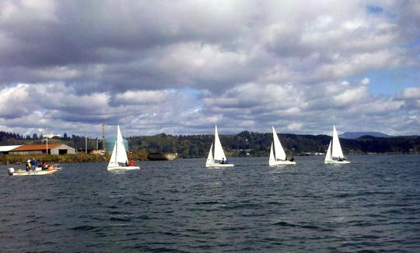


Bridge to Bridge

Early planning has begun for the 2011 Bridge to Bridge. This year's dates are August 19-21. Please-help ASAP. We need 3 or 4 people to help us get things rolling. I need a backup coordinator. More opportunities to help hands-on will come as we get closer, right now I'm looking for people to work with me on planning all the logistics, timing, and execution of this fabulous event. We set the bar high last year and we need to make sure this event continues to be a great success. Please contact at 541-265-9326 or alaskamissy_2000@yahoo.com-Stephanie Brown
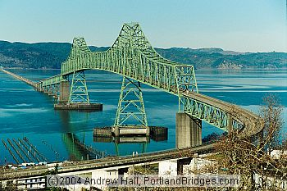

Seafood and Wine Festival
February 24-27

The YBYC Booth Need Servers, setup help, and tear down help - Lots of spots to fill - Every Asterisk Needs a Name next to it. Contact Stephanie or Ken to volunteer. Servers need to carry a valid OLCC Servers Permit or attend one of the free classes offered for volunteers.
Volunteer Server Classes (usually 45 mins or 1 hour)
> Feb 11 - 6pm at Newport American Legion
> Feb 17 - 12:30pm at Agate Beach Best Western
> Feb 23 - 6pm at Newport Elks Lodge

Wine Fest Sign-up (as of 2/10)
Thursday Set up | Friday 130-4pm | Saturday 945-1pm | Sunday 945-1pm
* Paul E  *Jerry D  *Alice M  * | *  *  *  * | *  *  *  * | *  *  *
 | 4pm-7pm  Mike F  Barb F  Greg k  Judy F  Brad F | 1pm-4pm  *John D  *Barb D  *  * | Sunday 1-4  *  *  *
 | 7-930pm  *  *  *  * | 4-6pm  Barry Semple  Anna Semple  *  * | Sunday Tear Down  *Barb F  *Mike F  *Don Baker


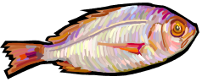

Flotsam and Jetsam 

- Remember you can make a tax-deductible donation through the Oregon Boating Foundation. The money is used to provide community boating education and all donations are greatly appreciated. Please contact Ron Cole for further information.

- The club has Lido 14 sailboats available for club member use. These 2 or 3 person dinghies are fun to sail and explore Yaquina Bay. They’re conveniently located on the port dock near the clubhouse. To use the Lidos, check the online calendar for availability, and place your reservation by contacting Tom Mcnamara at ; mcntm@msn.com reservations are posted online on the club’s website www.yaquinabayyachtcluborg under the ‘Calendar’ tab.

- Don’t forget to use our Yahoo group site at http://groups.yahoo.com/group/ybycgroup/ It’s the best place to keep up on club and member activities, chat and exchange info with fellow members. You can also read Board minutes. The Club also has a Facebook page, check it out! It’s updated frequently so you can be sure to keep abreast of club activities.

- Ships Store- Please do not forget to check out all the fine items at the ships store. Not only are you buying quality merchandise you can use, but it helps support the YBYC!


Editors Corner
Greetings: In any sport or athletic endeavor there are efforts which boggle the mind and feed our imagination. Such is the case with the Paddlin’ Pole, Aleksander Doba. What a stud this guy is, check out his web site http://www.aleksanderdoba.pl/.
The newsletter is sure a lot better thanks to more contributions, please keep them coming. The classified section is gone for now. I think people probably have things to sell, so why not unload it on a fellow club member? One person’s trash is another’s treasure as they say.
The Blessing of the Fleet is Saturday, March 19 at 1:00 p.m. It is an old Sicilian Tradition which has been upheld by Newport’s Fishermen’s Wives since the 1950’s and is open to all sea vessels. Registration forms are at: http://www.newportfishermenswives.com/
Of course, Happy Valentine’s Day!!Cheers, Jeff

American Home and Stone---541-929-3100
Members: Shane and Mac McConnell
Cabinets, tile, granite countertops, stoves (wood, gas, pellet), spas: Discounts
www.americanhome
Ocean Pulse
Custom Surfboards, Skateboards, and Snowboards
Tom McNamara (541) 265-7745
428 SW Coast Hwy
Newport, OR 97365
www.oceanpulsesurf.com

Bike Newport
Elliott & Daniella Crowder, Owners
150 NW 6th Street
Newport, OR 97365
(541) 265-9917
website: bikenewport.net
email: bikenewport@charter.net
Member-2-Member Network
Have you ever needed a carpenter, cabinet maker, tile setter, tire company and didn’t know who to call? Ever needed to have an item on your boat or home repaired, but had no idea where to call? Rather than calling a stranger or looking in the yellow pages, call another YBYC member! Every member who runs a business or performs a service is encouraged to signup. It’s totally FREE to members! Non-members pay a nominal fee. Want to get yourself listed? Email the YBYC newsletter editor at jcressy@charter.net with your listing information. We need to support our own, especially in this economic climate. Please consider doing what you can.

Alan Brown Tire Center (Les Schwab)
Ken Brown manager (541) 265-6604
1155 SW Coast Hwy
Newport, OR 97365
Email: tyrguy@yahoo.com

Dr. Kenneth S. Bishop
Chiropractic Physician
111 SE Douglas
Suite F-1
Newport, OR 97365
541-264-8138
www.yaquinachiropractic.com

Amy Lynn Greer
Certified Public Accountant
Ph/fax: 541-961-6814 Cell: (541) 961-6814
60586 Ridge Hts Bend, OR 97702
amygreercpa@bendbroadband.com

Vicki Krutzikowsky
Shaklee product distributor
www.healthydedication.com
541 264-8039
vickihoosky@hotmail.com

Member-2-Member-(cont.)
Kevin Raichl Cindy Milligan LMT# 6107
Visual Thinking Northwest Drift Away Massage
828 SE Crescent Pl. 310 NW 5th
Newport, OR 97365 Corvallis, OR 541-753-4785
541-264-8343
541-480-2355 cell
www.visual-thinking.com

True Cut Engraving
403 SW 10th Street
Newport, OR 97365
TrueCutEngraving@qwestoffice.net
541-265-9326

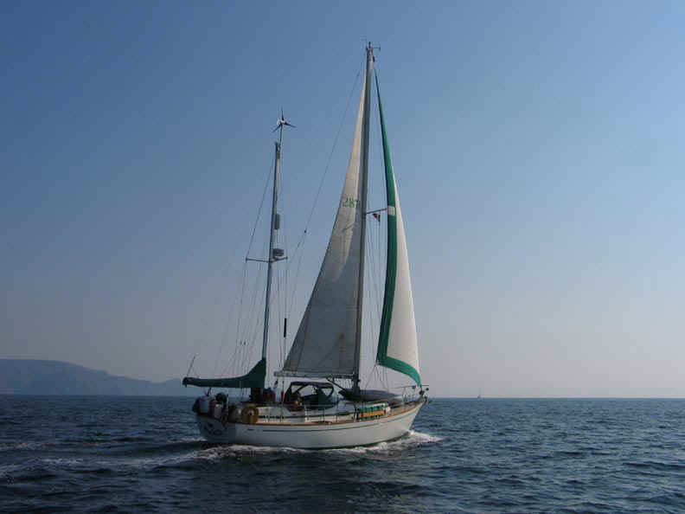
Mike and Barb Fulmor’s previous boat S/Y Arabella off of Mexico

