Yacht Club Calendar
17-Monthly meeting/potluck

The Jib Sheet
December 2011
A publication for the Members and Friends of the Yaquina Bay Yacht Club-est. 1947
Our Mailing Address is 750 SE Bay Boulevard, Newport, OR 97365

Our Website URL
Is www.yaquinabay yachtclub.org

For questions about the Club, contact us at YBYC.email@gmail.comFor questions about or contributions to this newsletter contact Jeff Cressy, editor, at jcressy@charter.net
YBYC 2010 Officers- Commodore: Greg Krutzikowsky
Vice Commodore : Paul Erskine
Rear Commodore: Mike Fulmor
Secretary : Alice McNamara
Treasurer : Dorothy Bogumil
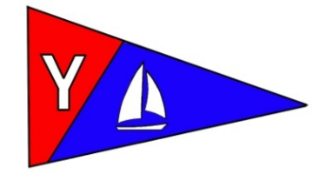

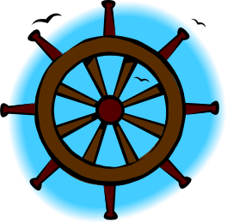
Commodores Log
Hi Allya'all,
Well it is here again, the end of yet another year and one marked by our organization with so many grand achievements, our financial house is in order with the bottom line in a healthy condition and all bills paid. We are embarking on a new year full of promise and continued expansion from sailing, racing, cruising, kayaking, hopefully getting a few more members and a few more directions in which we can go to add more dimension to our diverse portfolio of talent we have in this Club, and continue to promote education and embrace the rest of the rich waterborne culture where we live, work and play.
Our High School Sailing Team is going to be getting back in the swing of things soon and we hope to field a really competitive group to participate in the regattas available for them so they can continue toward their destiny as world class sailors competing on the national and or international stage.
This endeavor requires support both financially and of time, the commitment by our organization will be balanced on the water by the success of these fine young sailors, we have the reward of being able to see the effects of our efforts on their behalf by watching them grow and mature into adults who can adapt to dynamic situations and think on their feet as it were when faced with tough, split second decisions.
There will likely be opportunities to help out in this endeavor if you are so inclined, stay tuned for details.
The Lighted Boat Parade was quite a success and very well attended by pleasure craft, sailing craft, a boat from our new neighbor NOAA, the Coast Guard and even a commercial fishing vessel, the weather, while a bit cool, was clear and the tide and wind were not any kind of an issue, the decorations were from simple to quite complex and all of the lighted boats lent such a beautiful glow to the bay and surroundings, all in all a glorious evening...followed up at the Rogue for libations and food.

With 4 computers and 25,000 lites according to Mac, Joe Novello's boat "Fidelity" as the Polar Express won 1st place. There were many people on the waterfront and the boats were quite full as well, all seemed to enjoy the spectacle.
We (YBYC) are going to be at the helm of the lighted boat parade starting this coming year, Marine Discovery Tours is going to be a participant but not in charge, so if you have any ideas about the process or would like to get involved, this will be a high profile engagement for our club. Stephanie Brown has been instrumental in the production and is well versed in how it goes so if you want to get involved in the planning of this wonderful event contact Stephanie, she will be needing help to put this on.
If you were unable to view the parade go to the website http://www.newslincolncounty.com/ and there is a video about 7 1/2 minutes long which shows all the participants in all their glory and some stills are below the video in the article.
I hope that everyone has a wonderful holiday season no matter what way you celebrate, it is a special season to enjoy the warmth of family and friends and reflect on a year just coming to a close and another to come full of promise and potential and lots of opportunities to help make OUR club all that it can be.
Best wishes for you and yours,
Paul

YBYC Member Profile- The Crowder Family
ed.note-The first three paragraphs were from Jon Bell for Austin Family Business, after the Crowders won the Family Business of the Year Award from OSU. Daniella Crowder authored the remainder. Their diversity represents the YBYC well.
Bike Newport keeps bikers on track while spreading the word about the joys of cycling
After seven years spent running their own restaurant in Grants Pass, Daniella and Elliott Crowder decided it was time to get back to the beach.
Born and raised on the coast in Santa Cruz, Calif., the couple had just had their first child, Elliott, and were looking for a business that might be a little less labor intensive than a restaurant.
And, both the Crowder’s have long been avid cyclists. So when the opportunity to buy a bike shop on the coast in Newport arose in 2005, they had their solution. They bought the shop, named it Bike Newport and headed for the beach. “Leaving a business that was working, selling our house and uprooting our family to move to a separate town. It was a very big decision in our lives,” says Elliot Crowder.
Nearly six years later, it appears to have been a good one as Newport has grown into a popular pit stop for cycle tourists pedaling the length of the Oregon Coast. Cycling has also become more widespread in the small coastal town, partly as a result of Bike Newport’s advocacy efforts, which have included hosting regular rides and safety events, lobbying for bike signs and “sharrows” on the roads and otherwise spreading the gospel of good riding.
Elliott & I have two sail boats; a San Juan 21, Ducky, which we mostly sail at our cabin on Ten Mile Lake and raced in the San Juan Nationals at the Coos Bay Yacht Club last summer and which raced at the NOODS in Seattle last May. We also have Kiwanda, a Pearson Ariel 26. We enjoy sailing in our off time as well and in November of 2009 bare boat chartered a 32' Beneteau with our son, Little Elliott, who was 5 at the time and began to learn some basic navigation skills to help his parents out. We spent a week sailing around the British Virgin Islands but decided that November is bit early in the season as we weathered through a tropical cyclone but still had a wonderful trip. This January we are heading back to the BVI's for a two week bare boat on a 34' Beneteau and Little E is again going to be handling the navigation while Elliott will be the captain and I will be in charge of the galley and sunbathing! We love being members of the yacht club and enjoy the family atmosphere & camaraderie of the members. Elliott was just elected to Rear Commodore so we plan on being really involved with the yacht club for years to come.


More News You Can Use

Lighted Boat Parade

Thank you, YBYC, for supporting the 18th Annual Lighted Boat Parade. This year the club took the lead organizing role and helped generate over $2000 in funds for the Festival of Trees. The Festival of Trees is a fundraiser benefiting our local hospital, with this year's funds earmarked for upgrading the birthing center and building a Center for Health Education. Big thanks to Stephanie Brown, Jerry Davis, Alice McNamara, and Daniella Crowder for the organizational expertise; Joe Novello, Kevin Almas, Mac McConnell, Ken Brown, Elliott Crowder, and Jerry Davis and respective crews for their fabulous lighted boats. Of the 15 entries, 6 of them are YBYC boats! We had numerous sponsors and supporters throughout the community, please be sure to thank them and share our gratitude. Sponsor list can be found on the Yahoo Group Files. Finally, we could not have done this without the guidance, wisdom, and experience of Don and Fran at Marine Discovery Tours, who have built this event into the community's Shining Star that we know today.-Stephanie Brown

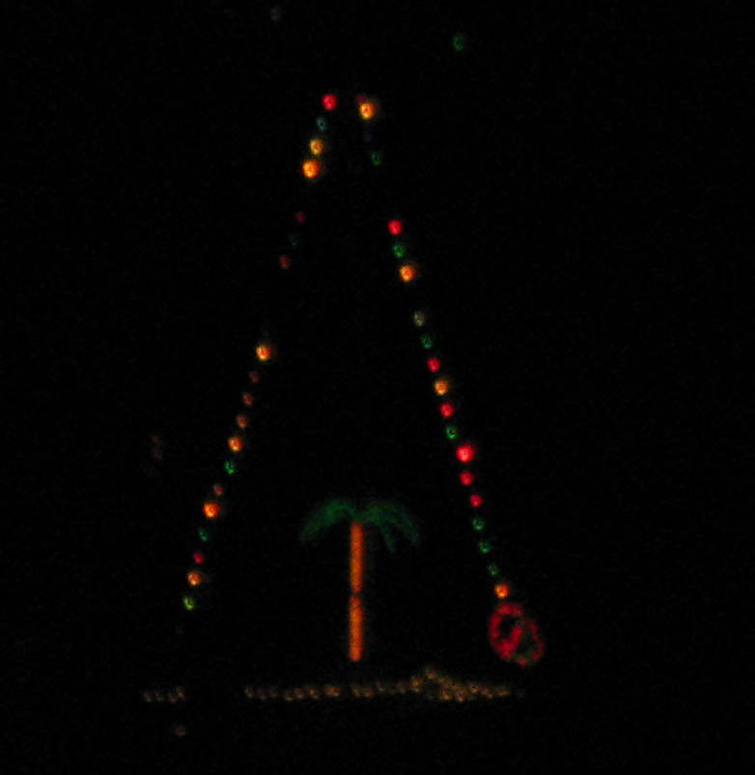

Sailing News from ‘Round the World

By Jennifer Mitchell, Sailing World
For many sailors who live in cooler climes, when the temperature drops, we
put our boats away and take a hiatus from sailing until the spring thaw.
The winter can be a welcome break from a competitive summer, but come
springtime, we find ourselves shaking off the rust and trying to get minds
and bodies into sailing shape.
The best sailors avoid this cycle. In the offseason, they keep their minds
and bodies strong so they're always ready to hit the water. To find out how
they do it, I consulted Olympic medalist Anna Tunnicliffe, Artemis Racing
skipper Terry Hutchinson, and sailing fitness guru Harry Legum.
"I'm currently into CrossFit," explains Anna. "It's such a good workout,
and I always wake up with new sore muscles the next morning. I find that
the variation and intensity is a fun, yet amazing, way to stay fit and
sharp. It mixes all different skill sets that fit into sailing, so it's
great cross training. I started at CrossFit 847 in Chicago and now train at
CrossFit Gables in Miami. When I'm in town, I work with the coaches, but
when I travel, I do the CrossFit travel WOD (workout of the day), or if I
can get to a gym, I do the assigned WOD, both of which are very hard and
kick my butt. In addition, I love to run, so I run for cardio, too."
Read on: http://www.sailingworld.com/experts/how-top-sailors-stay-sharp

December Meeting
When: December 17th
Where: YBYC Clubhouse
Time: 6:00 Social; 7:00 Dinner

Beef Stew, Chowder and Rolls provided, members please bring your place settings, beverages and an appetizer, salad, or dessert to share. Hosted by Pat Blackburn. We will have a gift exchange also. Please keep gifts under $10.

Quote of the Month
"Sailors, with their built in sense of order, service and discipline, should really be running the world."
Nicholas Monsarrat


Board Bits

The YBYC board met on 12/1. New board members were welcomed, and some current members moved into their new positions. This was the first meeting with Paul Erskine as Commodore. A review of the operating procedures was called for in regard to each board member's duties and area of responsibility. More volunterrism is needed among the general membership, so the membership committee will head that effort. A date for the Bridge-to-bridge race is being set. Ideas for improving the 2012 race season were offered, including duties of each week's committee boat. It was decided that the board meetings will take place on the first Tuesday of the month, with the next meeting on Tues. 1/3/2013.


Racing in 2012? Help shape the season

The Frostbite Series will kick off the season for 2012. Although this is not technically a race series nor does it really fall under “cruise” in terms of going off on a cruise or an overnight, it does offer an incentive to get out sailing with friends. Just like last year, Frostbite Series events will be held on the first and third Sunday of the month, with at noon “start” time. As in the past those who want to can set an objective to sail to or even a “course” with a start and finish. Since the clubhouse may or may not be rented, we will meet on the water or see each other on the docks when getting ready. This is a low stress, fun-filled opportunity to take advantage of good weather windows in the winter to go sailing. Guess what? The first Sunday in January happens to fall on New Year's Day this year. What better way to start the New Year. Let's hope for good weather.
The structure of the YBYC race season itself has been like this for a number of years: Racing starts with the regatta in late April now known as the Spring Regatta. Then there are three scored series, Spring, Summer, and Fall. Scoring for the series has been the low score system with two throw outs for the Spring and Summer Series if enough races are sailed, but Fall Series has no throw outs because it is so short. For the Portsmouth Fleet, which is mostly 420s these days, multiple races are often sailed on any given Wednesday evening. There are perpetual plaques for both the PHRF and Portsmouth fleets recognizing winners of Spring and Summer Series. Only those two series count towards deciding who wins the perpetual Sailor of the Year plaque which is open to both fleets. Racing ends for the season with the Columbus Day Regatta.
We have gotten some input from a number of sailors about potential changes to how things have been done in the past. We would like to talk to everyone who plans to race this year to get their input on any potential changes for the year. We would also like to hear from those who don't race their boats as well as those that would like to race this season and are looking to get on a boat. Every now and then it is worth examining how things are done to evaluate what works well and what might be improved. So please contact your Race Co-Chairs to provide us with your thoughts and input. Don't have anything that you are just dying to talk to us about? That's OK; we have a list of questions that we would like to ask you. So please give us a call or take a few minutes to chat the next time you see one of us. Our goal is to get input from sailors and consider suggested changes well in advance of the season opening. We want to ensure that all sailors know what to expect for structure and scoring of racing in Yaquina Bay in 2012.
Your Race Co-Chairs,
Greg Krutzikowsky and Jim Rice

Funny Bonz
Definitions from: SAILING (a pocket dictionary) by Henry Beard
and Roy McKie, c. 2001 Workman Publishing, NY.

Bilge, n., Narrow enclosed space at the very bottom of the inside of the hull where that strange grinding noise and that odd burning smell are coming from.
Calm, n., Sea condition characterized by the simultaneous disapperarance of the wind, and the last cold beverage.-Tom McNamara


January Chili Cook-Off

January 21 is the YBYC annual Chili Cook-Off. Held every year since1993, this is one SMOKIN' HOT meeting! Bring your chili to be judged by special guests and your fellow members. Prizes for 1st, 2nd, 3rd, and People's Choice. First Prize also gets their name forever etched into Yacht Club history on the perpetual plaque and gets to display the plaque at their home or office for the coming year. Visit the International Chili Society website for inspiration, recipes, and history of chili http://www.chilicookoff.com/ Chili not required! You can bring bring a side dish, salad or dessert to share, also!-Stephanie Brown

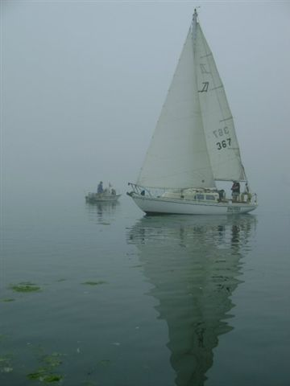


Elliott and Daniella Crowder’s S/V Kiwanda hangin’ out in the fog.

Flotsam and Jetsam 

- Remember you can make a tax-deductible donation through the Oregon Boating Foundation. The money is used to provide community boating education and all donations are greatly appreciated. Please contact Ron Cole for further information.

- The club has a fleet of sailboats available for club member use. These include Lidos, 420s and a small keel boat. These boats are fun to sail and explore Yaquina Bay. Check the Member's Handbook or with the YBYC Fleet Chair Tom Mcnamara at ; mailto:mcntm@msn.com for details on vessel use and to make reservations. Reservations are posted online on the club’s website http://www.yaquinabayyachtcluborg under the ‘Calendar’ tab.

Wednesday 420 reservation website-
https://spreadsheets0.google.com/spreadsheet/ccc?hl=en&key=tZvTrAppsstef-nGGCMmWDA&hl=en#gid=12

- Don’t forget to use our Yahoo group site at http://groups.yahoo.com/group/ybycgroup/ It’s the best place to keep up on club and member activities, chat and exchange info with fellow members. You can also read Board minutes. The Club also has a Facebook page, check it out! It’s updated frequently so you can be sure to keep abreast of club activities.

- Ships Store- Please do not forget to check out all the fine items at the ships store. Not only are you buying quality merchandise you can use, but it helps support the YBYC!
- January 21 NOAA Open House
Insider information reveals plan for another NOAA MOC-P Open House on Saturday, January 21, 2012. Stay tuned for more details as they are announced.
- It is time to think about volunteers for the Seafood and Wine Festival. Keep an eye on Yahoo Groups for more info.


Editors Corner
Greetings of the season to one and all: While it has been cold, the wind and rain has not yet arrived in earnest. I hope everyone has taken advantage of the shining orb in the sky.
I would like to again welcome the new Board, Committee members, and Commodore Paul to their watch. We all look forward to another exciting and productive year.
Congratulations to all who took home awards at the November meeting. A big thank you to Dave Schmaltz and George Benton who cooked and served the roast beast.
I really enjoyed the lighted boat parade, and especially liked the creativity and engineering Joe Novello showed. And everyone laughed when he said he his train could roll on water. It is after all, the season of miracles. May we all be the little engine that could, Cheers, Jeff

Member-2-Member Network
Have you ever needed a carpenter, cabinet maker, tile setter, tire company and didn’t know who to call? Ever needed to have an item on your boat or home repaired, but had no idea where to call? Rather than calling a stranger or looking in the yellow pages, call another YBYC member! Every member who runs a business or performs a service is encouraged to signup. It’s totally FREE to members! Non-members pay a nominal fee. Want to get yourself listed? Email the YBYC newsletter editor at jcressy@charter.net with your listing information. We need to support our own, especially in this economic climate. Please consider doing what you can.

Alan Brown Tire Center (Les Schwab)
Ken Brown manager (541) 265-6604
1155 SW Coast Hwy
Newport, OR 97365
Email: tyrguy@yahoo.com

Dr. Kenneth S. Bishop
Chiropractic Physician
111 SE Douglas
Suite F-1
Newport, OR 97365
541-264-8138
www.yaquinachiropractic.com

Amy Lynn Greer
Certified Public Accountant
Ph/fax: 541-961-6814 Cell: (541) 961-6814
60586 Ridge Hts Bend, OR 97702
amygreercpa@bendbroadband.com

Vicki Krutzikowsky
Shaklee product distributor
www.healthydedication.com
541 264-8039
vickihoosky@hotmail.com
American Home and Stone---541-929-3100
Members: Shane and Mac McConnell
Cabinets, tile, granite countertops, stoves (wood, gas, pellet), spas: Discounts
www.americanhome
Ocean Pulse
Custom Surfboards, Skateboards, and Snowboards
Tom McNamara (541) 265-7745
428 SW Coast Hwy
Newport, OR 97365
www.oceanpulsesurf.com

Bike Newport
Elliott & Daniella Crowder, Owners
150 NW 6th Street
Newport, OR 97365
(541) 265-9917
website: bikenewport.net
email: bikenewport@charter.net

Member-2-Member-(cont.)
Kevin Raichl Cindy Milligan LMT# 6107
Visual Thinking Northwest Drift Away Massage
828 SE Crescent Pl. 310 NW 5th St. Suite 102
Newport, OR 97365 Corvallis, OR 541-753-4785
541-264-8343
541-480-2355 cell
www.visual-thinking.com

True Cut Engraving
Stephanie Brown
403 SW 10th Street
Newport, OR 97365
TrueCutEngraving@qwestoffice.net
541-265-9326

Diane Henkels, Attorney
Based in Newport and Portland
t: 541-270-6001
e: dhenkels@actionnet.net
Biz, environment, Indian law, and energy issues.

YBYC Classified

For Sale and Looking for a good home.

S/V Vela, 1965 Mercator 30, Tall Rig with Sprit (Located on B Dock)

F/G hull, with wooden deck, house & spar; 4 cyl gas engine, rebuilt trans w/variable pitch prop; new standing rigging, mainsheet traveler, head & upholstery; rebuilt mast; many additional upgrades. Hauled out Fall, 2011. Electronics include a GPS, VHF, Depth and Stereo. Sail inventory is in good shape & extensive. The boat come fully equipped with gear, parts, tools, receipts and housekeeping items. There are several unsourced leaks in the house and the wiring should be upgraded. She performs beautifully in light air and has a responsive helm. She is a delight to sail and a beautiful vessel. We no longer have the time to maintain a wooden boat and believe that the price is reflective of on-going projects. Asking $14,750.00 obo. Contact Ron at (541) 265-5900.


Gard's Auto
European - Japanese - Domestic
Diagnostics, Service & Repair
541-867-7123
4909 S Coast Hwy #115 South Beach
Right behind the South Beach Post Office
Show us your Yacht Club membership card for a 10% discount
Archie & Irene Bailey

