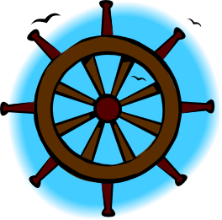
Yacht Club Calendar
April 12th-Board Meeting
April 23rd-Spring Regatta and Monthly Meeting

Commodores Log
The Jib Sheet
April 2011
A publication for the Members and Friends of the Yaquina Bay Yacht Club-est. 1947
Our Mailing Address is 750 SE Bay Boulevard, Newport, OR 97365

Our Website URL
Is www.yaquinabay yachtclub.org

For questions about the Club, contact us at YBYC.email@gmail.comFor questions about or contributions to this newsletter contact Jeff Cressy, editor, at jcressy@charter.net
YBYC 2010 Officers- Commodore: Greg Krutzikowsky
Vice Commodore : Paul Erskine
Rear Commodore: Mike Fulmor
Secretary : Alice McNamara
Treasurer : Dorothy Bogumil
It's April. Rain turns to showers this time of year on the central Oregon coast. The sun is once again making itself felt shining through and is very welcome! We have already had several spectacular spring days this month. April is also the month that really kicks off our sailing season. Our Spring Regatta is on the weekend of April 23 – 24 and our Spring Series start on the Wednesday following the regatta weekend, so sailing season will be in full swing before the end of the month. Our monthly YBYC meeting has been changed to coincide with the Regatta on Saturday the 23rd. Mark your calendars and plan to join in the fun.

Our high school sailor's were at it again. They went up to Portland for a regatta at the Willamette Sailing Club and took the 420s with them. Look for a full report by Coach Joe Novello. Thanks to all YBYC members who helped make this possible. Our high school sailors will also have the opportunity to sail in our upcoming Spring Regatta and have invited their counterparts from Portland to come down and join us.

Last month's meeting was good clean fun. We had a band and dancing girls, literally. It was great fun to see the youngest club members dancing up a storm. These young ladies, with single digit ages, even managed to drag their dad's out onto the dance floor! It was a sight to see and I think all that were there enjoyed themselves immensely. Kudos go to Elliott for cooking up the amazing corned beef, to Betts and Pat for organizing the meeting's festivities, and to the band for their excellent performance.

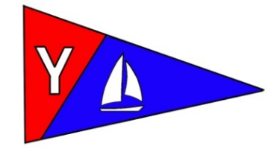

The tall ships Lady Washington and Hawaiian Chieftain are scheduled to be in Yaquina Bay in the early part of the month and will be having, tours, evening sails, and “battle sails”. You can watch them maneuvering for position in a tactical duel for position and hear the booming canons on the weekend of April 9-10. Square rigged sailing ships are a rarity these days, so this is a great opportunity to have a look at these monuments to human ingenuity.

This is a great time of year to get out of the house and get out on the water! Catch spring fever and get out there and enjoy spring!
Fair Winds and Following Seas,
Greg

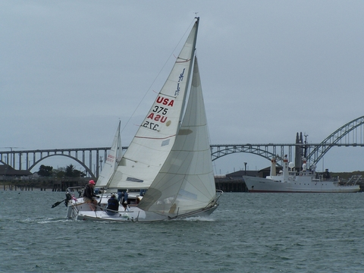
Member boat of the month-Paul and Sharon Erskine’s S/V Flamingo


More News You Can Use

High School Sailing

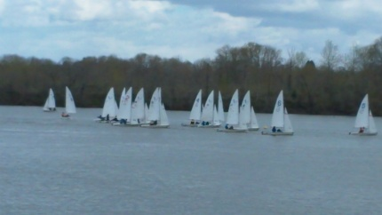
Nearly a month after our first regatta in Seattle and after many hours of practice, thirteen of our student athletes competed in their second regatta at the Willamette Sailing Club in Portland on Saturday and Sunday, April 3rd and 4th. The river was unseasonably high creating a current similar to a strong ebb in our own home waters that just never stopped. On Saturday 23 teams from Oregon and Washington competed in very shifty four to eight knot winds. By quitting time, only eight of the twenty planned races were held. Yaquina Bay Yacht Club fielded three teams.

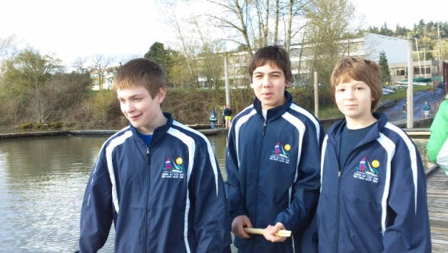
YBYC 1A: Skipper Landon Reno/Kim Smith, crew Zoee Shearer
YBYC 1B: Skipper Austin Versteeg, crew Austin Ligon

YBYC2A: Skipper Josh Viar, crew Robert Pratt
YBYC2B: Skipper Dylan Doll, crew Chandler Turner

YBYC3A: Skipper Kody VanDamme, crew Casey VanDamme
YBYC3B: Skipper Ian Williams, crew Kail Greene

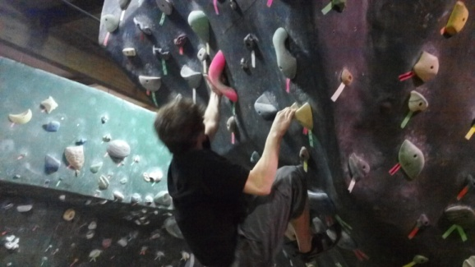
After a long day on the water we enjoyed a delicious chili and corn bread dinner prepared by our host team. After dinner, several of our young people (and one parent) expended their remaining energy at the circuit gym, a large room with mountainous climbing rocks.

Sunday conditions were much better with steady southwest winds at about four to six knots. Racing started early and our teams were able to sail ten races before the mandatory quitting time at three o’clock. Team results for the two day regatta were: YBYC3: 14th, YBYC2: 16th, YBYC3: 17^{th.}

Although our final scores may not reflect it, our athletes did a tremendous job. This being only their second regatta we had several ‘almost’ wins. High School Double-handed Team sailing is a complex sport where not only are good boat handling skills necessary, but also a thorough understanding of the application of the racing rules of sailing is required. Fouls by other teams, as well as a few of our own quickly moved boats from the first third of the fleet to the back of the pack. Kody and Casey VanDamme successfully protested another team who fouled them and did not take penalty turns. Although the other team was disqualified, it did not help move our team back to the front of the fleet which would have improved their scores by three or four positions.

A huge thank you goes out to all the club members and parents who made this regatta possible for our youth. All our kids and the adults too, had a great time. Several parents and coaches drove their own children as well as others and provided meals and lodging out of their own pockets. The club sponsored the team registration and continually provides support in boats, equipment, and facilities. Club members Dan and Diane made an appearance at the docks both days to cheer our kids and offer their home and yard to kids as housing for future regattas. Thank you one and all.

The season has only a few short weeks left with the final event being the Lincoln County High School Challenge Cup race. This race will be held concurrently with the Spring Regatta on Saturday, April 23, 2011. The cup will be awarded at the monthly dinner at 7:00 pm in the clubhouse. Our athletes have trained hard all season and the competition will be fierce for this inaugural event between Newport and Taft sailing teams.-Joe Novello

Notice Concerning Upcoming Meetings
The YBYC Board has decided when we are having a significant event such as Regatta's, Bridge to Bridge and Sailstice, we will combine them with the monthly meeting. This year’s events and meetings:
Loyalty Day's Spring Regatta/Monthly Meeting - April 23rd
Sailstice/Monthly Meeting - June 18th
Bridge to Bridge/Monthly Meeting - August 20th
Columbus Day Regatta/Monthly Meeting - October 8th

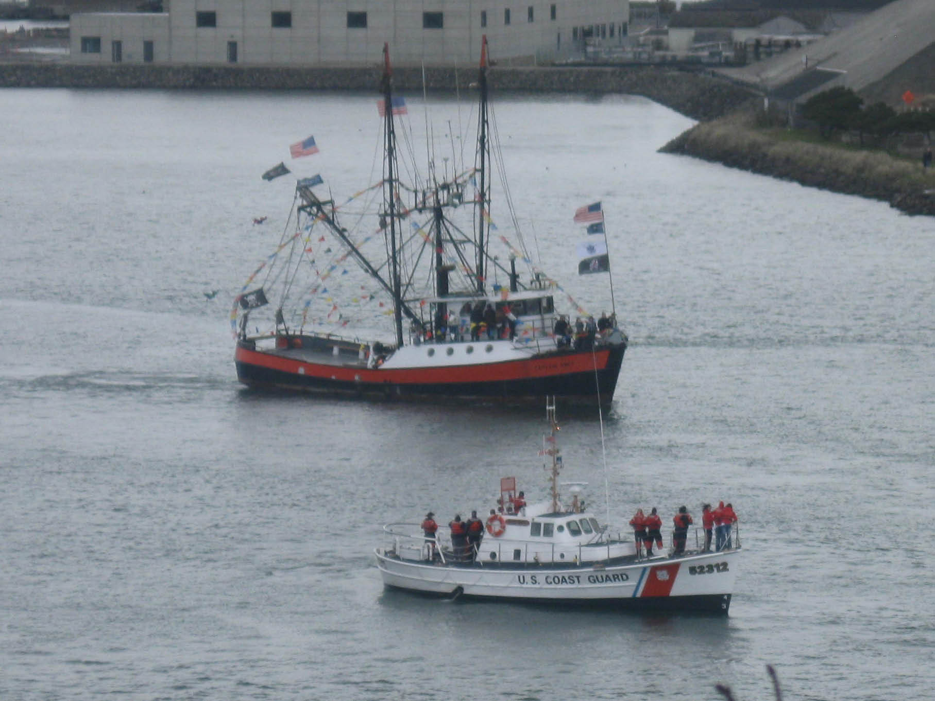
A fishing vessel sails around the Coast Guard during the Blessing of the Fleet

Sailing News from ‘Round the World

(April 7, 2011) - Stan Honey, Rolex Yachtsman of the Year 2010, has been
appointed to Director of Technology for the 34th America’s Cup by the America’s Cup Event Authority (ACEA). As many sailors know, Stan’s list of accomplishments, both sailing and professional, is long and deep, from navigating ABN AMRO to victory in the 2005-2006 Volvo Ocean Race to navigating Groupama 3 in setting the Jules Verne record for the fastest circumnavigation of the world under sail in 2010.

Non sailing fans may know Stan as the guy who led the development of the yellow first-down line widely used in the broadcast of American football and the Race/FX tracking and highlighting system used in NASCAR, among other applications. He’s particularly excited about his new role with ACEA as it combines his two sets of interests.
Honey, who turns 56 on April 8, has spent a good part of the past year working on the system that’s being built to enhance the TV broadcast of sailing through inserting graphic effects using the same kind of animated elements that have appeared in Ian Taylor’s work in Virtual Eye since 1992 and inserting them in the live helicopter video during racing.

“The main goal is to resolve the frustration that people had in the past where if you were looking in the helicopter view you could see the boats but you couldn’t tell who was ahead and who was behind because you couldn’t see the wind direction and you weren’t really sure what perspective you were looking from, whereas when the TV would shift to the animated view, then you could tell who was ahead or behind but you couldn’t see the boats,” Honey explained. “If someone was falling back you couldn’t tell why - did they have a broken halyard, for example.”

Monthly Meeting Notice
April 23rd Social-6p.m. Dinner-7p.m

The Loyalty Days Spring Regatta/Monthly Meeting dinner will be bring your own main course to barbecue. Salads, side dishes, desserts will be provided.
Quote of the Month
At sea, I learned how little a person needs, not how much.
Robin Lee Graham



Spring Regatta and other Eventss

Please check out the Racing section of our website.
The Spring Regatta is April 23r and 24th.
Wednesday Racing starts April 27th.

Notice of Race and Sailing instructions can be found there.
Funny Bonz
Definitions from: SAILING (a pocket dictionary) by Henry Beard
and Roy McKie, c. 2001 Workman Publishing, NY.

AHOY - The first in a series of four-letter words commonly exchanged by skippers as their boats appoach one another. See YAWL
YAWL - 1. Two-masted sailboat with the smaller mast located behind the rudder post. 2. Common substitute for "ahoy" used in inland U.S. waters between Annapolis and Corpus Christi.

BAR - Long, low-lying navigational hazard, usually awash, found at river mouths and harbor entrances, where it is composed of sand or mud, and ashore, where it is made of mahogany or some other dark wood. Sailors can be found in large numbers around both.-Tom “the joker”
Member Handbook Posted
The member handbook is now posted on the Club’s website. This should be read by all members. Thanks go out to the Board for its hard work. Board minutes are also listed so feel free to browse them at your leisure.-Jeff

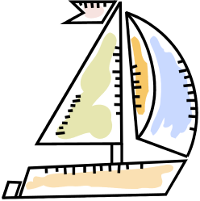


Flotsam and Jetsam 

- Remember you can make a tax-deductible donation through the Oregon Boating Foundation. The money is used to provide community boating education and all donations are greatly appreciated. Please contact Ron Cole for further information.

- The club has Lido 14 sailboats available for club member use. These 2 or 3 person dinghies are fun to sail and explore Yaquina Bay. They’re conveniently located on the port dock near the clubhouse. To use the Lidos, check the online calendar for availability, and place your reservation by contacting Tom Mcnamara at ; mcntm@msn.com reservations are posted online on the club’s website www.yaquinabayyachtcluborg under the ‘Calendar’ tab.

- Don’t forget to use our Yahoo group site at http://groups.yahoo.com/group/ybycgroup/ It’s the best place to keep up on club and member activities, chat and exchange info with fellow members. You can also read Board minutes. The Club also has a Facebook page, check it out! It’s updated frequently so you can be sure to keep abreast of club activities.

- Ships Store- Please do not forget to check out all the fine items at the ships store. Not only are you buying quality merchandise you can use, but it helps support the YBYC!


Editors Corner
Greetings, Spring seems to be teasing us a bit. Not to worry, I saw a few pelicans the other day. Usually that is a sign that we may get a break soon. Inclement weather seldom matters to the hearty sailors of the YBYC. Common sense and safety rule the day, but any Club that has a Frostbite Series is tough! As mentioned earlier, the Spring Regatta and Wednesday series are fast approaching. Good luck to all.
Thanks again to all who helped with the March meeting. Elliott served up his masterful corned beef and Cap’n Fulmor brought in a rockin’ band. These meetings are always hard work for the hosts, thanks to all those who help every month.
Please be sure to check the YBYC facebook page, it can be updated often.
Check out http://www.piratequiz.com/ to get your pirate name and alter ego. Mine be Morty Rackham mates. Cheers,
Jeff

American Home and Stone---541-929-3100
Members: Shane and Mac McConnell
Cabinets, tile, granite countertops, stoves (wood, gas, pellet), spas: Discounts
www.americanhome
Ocean Pulse
Custom Surfboards, Skateboards, and Snowboards
Tom McNamara (541) 265-7745
428 SW Coast Hwy
Newport, OR 97365
www.oceanpulsesurf.com

Bike Newport
Elliott & Daniella Crowder, Owners
150 NW 6th Street
Newport, OR 97365
(541) 265-9917
website: bikenewport.net
email: bikenewport@charter.net
Member-2-Member Network
Have you ever needed a carpenter, cabinet maker, tile setter, tire company and didn’t know who to call? Ever needed to have an item on your boat or home repaired, but had no idea where to call? Rather than calling a stranger or looking in the yellow pages, call another YBYC member! Every member who runs a business or performs a service is encouraged to signup. It’s totally FREE to members! Non-members pay a nominal fee. Want to get yourself listed? Email the YBYC newsletter editor at jcressy@charter.net with your listing information. We need to support our own, especially in this economic climate. Please consider doing what you can.

Alan Brown Tire Center (Les Schwab)
Ken Brown manager (541) 265-6604
1155 SW Coast Hwy
Newport, OR 97365
Email: tyrguy@yahoo.com

Dr. Kenneth S. Bishop
Chiropractic Physician
111 SE Douglas
Suite F-1
Newport, OR 97365
541-264-8138
www.yaquinachiropractic.com

Amy Lynn Greer
Certified Public Accountant
Ph/fax: 541-961-6814 Cell: (541) 961-6814
60586 Ridge Hts Bend, OR 97702
amygreercpa@bendbroadband.com

Vicki Krutzikowsky
Shaklee product distributor
www.healthydedication.com
541 264-8039
vickihoosky@hotmail.com

Member-2-Member-(cont.)
Kevin Raichl Cindy Milligan LMT# 6107
Visual Thinking Northwest Drift Away Massage
828 SE Crescent Pl. 310 NW 5th
Newport, OR 97365 Corvallis, OR 541-753-4785
541-264-8343
541-480-2355 cell
www.visual-thinking.com

True Cut Engraving
Stephanie Brown
403 SW 10th Street
Newport, OR 97365
TrueCutEngraving@qwestoffice.net
541-265-9326

YBYC Classified

For Sail

Jib, condition Fair, hanks, Leech 33' Luff 35' Foot 15.5
$75.00
Jib, condition Fair, hanks, 1 reef, Luff 32.5', Leech 30'3", Foot 16.5'
$75.00
Mainsail off 42' Westsail, no slugs/slides, no battens (full pockets), Dutchman modified, 2 reef points, material & stitching good, batten pockets need stitching at leech, Luff 48'10" Leech 50' Foot 17'3", condition Poor overall due to missing hardware
$75.00

Cascade 36 Main, plastic slide foot & luff, 3 reef points, missing battens, Luff 36' Leech 39'3" Foot 14.5', condition Fair/Poor
$75.00
Contact Dean @ 541-867-2922
or
phezzig@gmail.com



