The Jib Sheet
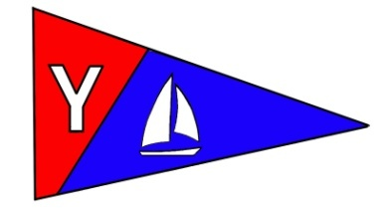

Yacht Club Calendar
November
20-Yearly Meeting
and dinner

Commodores Log
November 2010
A publication for the Members and Friends of the Yaquina Bay Yacht Club-est. 1947
Our Mailing Address is 750 SE Bay Boulevard, Newport, OR 97365

Our Website URL
Is www.yaquinabay yachtclub.org

For questions about the Club, contact us at YBYC.email@gmail.comFor questions about or contributions to this newsletter contact Jeff Cressy, editor, at jcressy@charter.net

YBYC 2010 Officers
Mac McConnell- Commodore
Vice Commodore : Greg Krutzikowsky
Rear Commodore : Paul Erskine
Secretary : Alice McNamara
Treasurer : Dorothy Bogumil
THANKSGIVING
Here I am 5 o'clock in the morning after stuffing bread crumbs up a dead bird's butt!

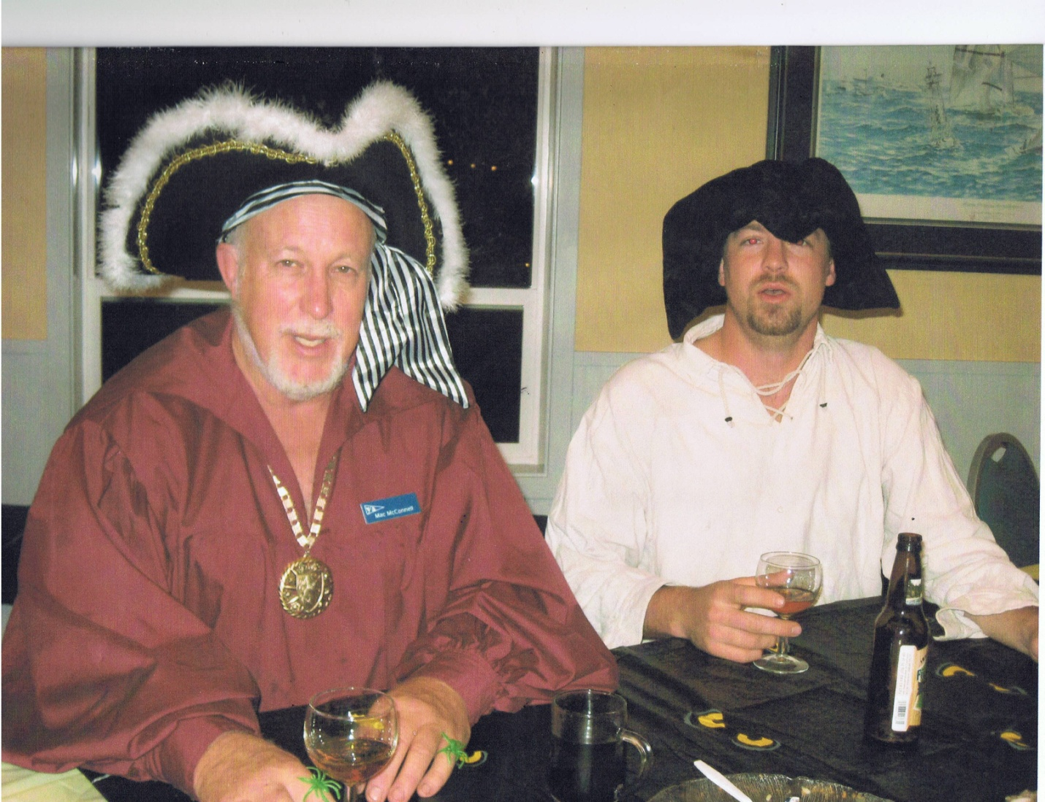

Some complain that roses have thorns… others rejoice that thorns have roses! You, my fine crew have been wonderful mates on this year’s journey and sad I am that it is coming to a close but thankful I am that the journey continues and that you have all been roses. Thank you for allowing me the helm of the YBYC ship and to the first mates, the Board of Directors and volunteers, your accomplishments have been many:
Membership has increased 60% from two years ago and income is up .
Regattas have been exhilarating and profitable.
Seafood and wine has been exciting and lucrative
The Bridge to Bridge extravaganza was wildly successful and the pig succulent.
Education has exceeded expectations both in kayaking and adult and junior sailing as well as the
weekly programs offered to Club members.
The High School racing team had a great first year and with Joe Novello taking that helm will have an outstanding second as youth are prepared for National sailing competition.
Ships Store has made bountiful lucre
Clubhouse rental income is huge and will pay most of our operating expenses
We have purchased a fleet of 7 new Wilderness Systems teaching kayaks
Our special projects, boat shows, parades, Cookbook and the Wild Seafood Weekend anounced our presence in the community and were well received and appreciated.
We are developing new and exciting ways to interact with the Oregon Boating Foundation in planning new education activities, a new dock facility and more.
Wednesday night sailing has been well attended, exciting and the after race camaraderie full of laughter, eating and libation.
Monthly celebrations have been food luscious and the entertainment delightful.
The Newsletter and Website are bright, entertaining, informative and very nice indeed.
The assets of the club, available for Club-member use, include: 10 dinghy’s, 7 kayaks, two motor boats, crab rings and a 23 foot sailboat as well as our fantastic clubhouse.
Volunteers have been fabulous proving that this is your Club and its success is a reflection of your involvement and commitment.

Again, thanks for giving me the helm on our 2010 journey together and look forward as I do to another exciting year under the helmsman-ship of Greg Krutzikowsky and his very capable and exciting crew--- the Officers, The Board of Directors and YOU.
Fair winds and smooth sailing,
Mac McConnell , Commodore No More


News You Can Use

October Meeting

October’s meeting was a ghoulish delight as such delicacies as deviled eyeballs, maggot salad, and severed fingers were served up. Not to worry, no health codes were broken. It was the YBYC’s take on a Halloween Potluck. They were actually terrific dishes which complemented hosts Mike and Patricia Blackburn’s taco/burrito bar. Many thanks to the hosts, those who donned costumes, and all who helped make this another successful monthly event.
November Annual Meeting and Election of Officers and Board

Date: November 20
Time 6pm Social Time, 7pm Prime Rib Served
Cost: 5-11 years $5.00, 12 and up $10.00
Agenda: Season Awards and Recognition, Election of 2011 Officers and Board, Old Business, New Business, Treasurer's Report

Prime Rib, Scalloped Potatoes and Rolls are provided, please bring your beverages, and a side, salad or dessert to share.

RSVP to Dorothy 541-563-3900 or Stephanie at alaskamissy_2000@yahoo.com

Member Renewal Time
It's time to renew your membership! Dues for Household and Individual memberships are $20 less when paid on or before November 20. If you didn't receive your notice - contact Membership Chair Stephanie at 541-961-1823 or alaskamissy_2000@yahoo.com Do you know someone who has everything? This is a great time to gift a membership, too.



December Fourth is the Lighted Boat Parade

This year the YBYC is partnering with Marine Discovery Tours in hosting this event. Now is the time to design your lighting and get festive! Registration forms will be available soon. We're looking for volunteers to work with Marine Discovery Tours to learn the process of putting on such a spectacular community show. If you aren't planning to be on the water, definitely make your reservations now to watch from the shore! Contact Stephanie to help with the event.

Sailing News from ‘Round the World

The chances of the next America's Cup being sailed with a backdrop of the
Golden Gate Bridge, Alcatraz and the Coit Tower improved dramatically
Tuesday (Nov. 9). City officials finalized a host city agreement with the
Golden Gate Yacht Club, which backs America's Cup defender BMW Oracle
Racing. The agreement quickly was submitted to the Board of Supervisors,
which must approve it. Six of the 11 supervisors are co-sponsors of the
agreement.
The Board of Supervisors voted 9-2 on Oct. 5 to approve a term sheet that
was a precursor to a host city agreement. The city pledged in the term sheet
to help raise $270 million from corporate sponsors to help defray the costs
of staging the regatta.
"I think this is more than significant," said Tom Ehman, a spokesman for the
GGYC and member of its America's Cup Committee. "It's a big step forward for
the 34th edition of the Cup. There can be no better venue for sailing than
San Francisco Bay. Personally, I and the GGYC are very excited by the
prospects and delighted with this latest development.
"I think it's fair to say that if Italy does not match or exceed what's on
offer from San Francisco, I would expect San Francisco be given the nod,"
Ehman said. San Francisco's only competition is Italy. Valencia, Spain,
which hosted the America's Cup in 2007 and in February, no longer is under
consideration for the main regatta, Ehman said. However, the Spanish port
could host a preliminary regatta.


Quote of the Month
There is nothing like lying flat on your back on the deck, alone except for the helmsman aft at the wheel, silence except for the lapping of the sea against the side of the ship. At that time you can be equal to Ulysses and brother to him.
Errol Flynn
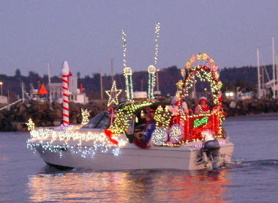
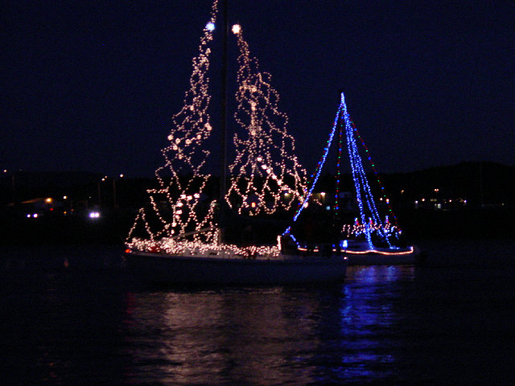

Columbus Day Regatta - Not to Be Forgotten
Friday's predicted strong winds held off until Saturday, then moved in fast & furious. The Club 420s sailed one race, then retired, having lost one shroud, gained one black eye. It was impressive to see the dinghys planing across the water. The High School Team definitely showed what they are capable of!
The other 3 fleets (PHRF, WL, S20) sailed a second race, losing a S20 'One Eyed Jacq' underwater when a jibe went wrong and rolled the boat under. After turning upside down, the keel acted like a sail and caught another puff, finishing the roll. Once back on its side, the cabin burped up an air bubble and the boat headed down; less than a minute had passed. The PHRF fleet lost 1 mast, and a few yachts retired, perhaps the smartest ones. A peak gust was recorded at 42 mph onshore at the Hatfield Marine Science Center. Many of the keelboats sailed in to the dock that afternoon. With the Embarcadero situated crosswise to the South wind, this was just as tough and tactical maneuvering as the racing itself. The Committee Boat, an Ericson 29 with ample freeboard and windage, lined itself with fenders and heaved docklines to the shore crew to combat their strong leeway. Did I mention we got .85 inches of rain on Saturday?
Sunday was dryer and lighter, but strong tides frustrated everyone and tested the tactical side of the racers. Tight competition at the line with multiple fleets struggling to cross against the tide led to a chorus of 'Starboard' at each start. Likewise at the windward and leeward marks, the thumping of feet and the clanking of spinnaker poles and could be heard across the bay.

Big thanks go out to all the YBYC volunteers who helped make this event happen; Anne and Buzz Williams, Becka Baldwin, Joe Novello, Mike Blackburn, Alice, George Benton, Tony Shearer and Ken Brown on Race Committee and Chase Boats. Tom Murphy and the rest of the Coast Guard Auxilliary for their extra help with support boats. Betts, Dorothy, Stephanie, Barb F, Greg K and Paul, Bernie, Cindy and the others who helped with Food Prep, cooking and cleanup. Rogue Ales for the fine beverages, Chalet for their delicious pies, Englund Marine for their courtesy dock, and to all the others, the list goes on. Complete Race results are on the YBYC website at www.yaquinabayyachtclub.org/racing.htm
-stephanie

2011 Board of Directors
YBYC is now recruiting for the 2011 Board of Directors, if you have ideas about the club and how to help, this is your chance! We are still looking for a few members for Board positions. Specifically we would like to hear from anyone who might be interested in the following chair positions for these committees:
Education, Hospitality, and Publicity. Being on the YBYC Board is a great way to help crew this ship, keep her moving in the right direction making good speed in good trim. Interested members should contact Greg, Paul, Stephanie, or Amy.

Flotsam and Jetsam 

i
- Remember you can make a tax-deductible donation through the Oregon Boating Foundation. The money is used to provide community boating education and all donations are greatly appreciated. Please contact Ron Cole for further information.

- The club has Lido 14 sailboats available for club member use. These 2 or 3 person dinghies are fun to sail and explore Yaquina Bay. They’re conveniently located on the port dock near the clubhouse. To use the Lidos, check the online calendar for availability, and place your reservation by contacting Tom Mcnamara at ; mcntm@msn.com reservations are posted online on the club’s website www.yaquinabayyachtcluborg under the ‘Calendar’ tab.

- Don’t forget to use our Yahoo group site at: http://groups.yahoo.com/group/ybycgroup/ It’s the best place to keep up on club and member activities, chat and exchange info with fellow members. You can also read Board minutes. The Club also has a Facebook page, check it out! It’s updated frequently so you can be sure to keep abreast of club activities.

- Ships Store- Please do not forget to check out all the fine items at the ships store. Not only are you buying quality merchandise you can use, but it helps support the YBYC!

- October Birthdays-Judy Fontanini, Sarah Myrick, Jeff Cressy, Sharon Erskine, Cindy McConnell, Jean Geist, Larry Beggs, Pam Voss, Kees Versteeg, and Woody Richards. Happy Birthday! Your name not listed? Contact the Membership Chair for an Information Update Form.

- Racing- The Fall Series has finished and the Wednesday Night races became the Wednesday Night seminars. Future seminars are being created. Join the YBYC group on Yahoo to get all the announcements. Stay tuned for info on the Frostbite Series, which kicks off in January.


Editors Corner
I know the transition for many to the Yahoo Groups has not gone as well as hoped. As of last check we had 53 members in the group. I believe that to be less than we had with Google, so if you still need help, please ask.
We had a bittersweet Columbus Day Regatta as the elements claimed the S/V One Eyed Jacq. She has since been reclaimed from the sea.
Kevin Raichl and Visual Thinking did a great job on the video for the YBYC. If you have not seen it, it is on you tube.
I need Jib Sheet help. Virtually all contributions come from Stephanie, thank you Steph. I know people are busy, but if the Jib Sheet is to continue to grow, I need more stories and pictures from more members please. Please look at other clubs newsletters, that is what we need to be.
Lastly, with a tip of the ‘ol tricorne, we bid farewell to Cap’n Mac. It has been a pleasure to serve, the Clubs many accomplishments speak to your leadership. I look forward to an exciting year under incoming Commodore Greg at the helm. Cheers, Jeff

American Home and Stone---541-929-3100
Members: Shane and Mac McConnell
Cabinets, tile, granite countertops, stoves (wood, gas, pellet), spas: Discounts
www.americanhome
Ocean Pulse
Custom Surfboards, Skateboards, and Snowboards
Tom McNamara (541) 265-7745
428 SW Coast Hwy
Newport, OR 97365
www.oceanpulsesurf.com

Bike Newport
Elliott & Daniella Crowder, Owners
150 NW 6th Street
Newport, OR 97365
(541) 265-9917
website: bikenewport.net
email: bikenewport@charter.net
Member-2-Member Network
Have you ever needed a carpenter, cabinet maker, tile setter, tire company and didn’t know who to call? Ever needed to have an item on your boat or home repaired, but had no idea where to call? Rather than calling a stranger or looking in the yellow pages, call another YBYC member! Every member who runs a business or performs a service is encouraged to signup. It’s totally FREE to members! Non-members pay a nominal fee. Want to get yourself listed? Email the YBYC newsletter editor at jcressy@charter.net with your listing information. We need to support our own, especially in this economic climate. Please consider doing what you can.

Alan Brown Tire Center (Les Schwab)
Ken Brown manager (541) 265-6604
1155 SW Coast Hwy
Newport, OR 97365
Email: tyrguy@yahoo.com

Dr. Kenneth S. Bishop
Chiropractic Physician
111 SE Douglas
Suite F-1
Newport, OR 97365
541-264-8138
www.yaquinachiropractic.com

Amy Lynn Greer
Certified Public Accountant
Ph/fax: (541) 563-5147 Cell: (541) 961-6814
PO Box 1341 Waldport, OR 97394

Vicki Krutzikowsky
Shaklee product distributor
www.healthydedication.com
541 264-8039
vickihoosky@hotmail.com

Member-2-Member-(cont.)
Kevin Raichl
Visual Thinking Northwest
828 SE Crescent Pl.
Newport, OR 97365
541-264-8343
541-480-2355 cell
www.visual-thinking.com
YBYC Classified

For Sale: 1974 Catalina 27, can be seen at B-98 Embarcadero I would like $8,000 but am very willing to listen to reasonable offers. If you would like more information call Jeff Longmore 541-225-7533 to arrange a tour.

NRS Women's Boaters Gloves, medium
http://www.nrsweb.com/shop/product.asp?pfid=24302&pdeptid=944
Bought 1 month ago, wore only a handful of times. Perfectly fine, just
realized I should have gotten a different style. $10 OBO ($24.95 new).
Email me at cpvoss@comcast.net.



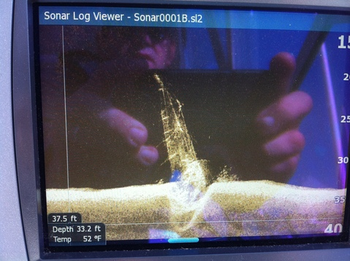
Here is a sonar view of the S/V One Eyed Jacq resting at the bottom. For an update on her ultimate fate, check out our facebook page.

