Yaquina Bay Yacht Club
Newsletter
June 2009

A publication for the Members and Friends of the Yaquina Bay Yacht Club
Commodore’s Log
Well it looks like our Membership drive is gaining momentum and has produced 11 new members so far. It’s great to see so many people that share the same interests in what the club has to offer and want to be a part of an active fun group.
The Wednesday night racing season has been interesting for all who have been able to participate. We have seen nuclear winds, big tides and nights that had very little wind. This has shown just how good a group of sailors we have by being able to adapt and change to it all. It’s a good thing the crew always remembers to bring the correct amount of libations for all to enjoy.
It seems this year we haven’t had any shortage on new crew members for any boats, or if you are new sailor and would like to enjoy a cruise around the bay we have had a large number of people that have shown up for the Thursday night social sail. In fact, we have had several Thursdays where we had more people than boat and have had to (sadly) turn people away until the next week. So Steph and I are asking anyone with a boat that is available on Thursdays to take a few willing sailors on a cruise around the bay and meet some great people that want to get involved (12 people on Chey Breeze is way too MUCH).
The summer sailing classes have started, with adult classes going on now, and the youth classes are starting soon. The upcoming kayak classes are always very popular and fill fast so sign up now. For more info on these classes you can contact our new Education chair Mac McConnell or the “Oregon Boating Foundation”(OBF) President Ron Cole (It’s nice that they have simplified the name). The foundation and the board are working as hard as we can to make the classes beneficial to all involved so it can grow into the best sailing classes in Oregon. If you would like to become involved in the Education committee or the OBF by donating either time or money please contact Mac or Ron.
This summer is full of fun activities that everyone can enjoy from sailing classes, kayak classes, club monthly meetings, the Bridge to Bridge race, to the Emerald Cup by TYC. And it won’t be long before the Columbus Day Regatta sneaks up.

Remember, this is your club; its voyage
is as only good as its crew. Ken

Calendar in Brief

June

9 – Board Meeting
20 – General Meeting

July

4 – Fireworks at dusk
14 – Board Meeting
18 – General Meeting

August

1 – Raft up
8-9 – Bridge to Bridge
11 – Board Meeting
22 – Sailfest and General Meeting

Our Mailing Address is 750 SW Bay Boulevard, Newport, OR 97365

Our Website URL
Is www.yaquinabay yachtclub.org

For questions about the Club, contact Commodore Ken Brown at tyrguy@yahoo.com
For questions about or contributions to this newsletter contact Stephanie Brown, editor, at 265-4575 or alaskamissy_2000@yahoo.com

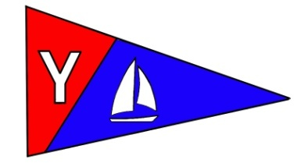
Yaquina Bay Yacht Club
Newsletter

June 2009 Page 2

June Monthly Meeting and Wine Tasting Potluck
Date: Saturday, June 20
Where: Clubhouse
When: 6:00-6:30 to greet new members, share stories and cocktails. Dinner is at 7:00. Club meeting and guided wine tasting to follow.

For those of you who missed it at February’s meeting, we’ll be doing wine tasting of the 4 Red Diamond Wines that we pour at our booth during the Seafood and Wine Festival. These are affordable table wines that are very good to enjoy with food. YBYC is providing the wine; we need you to provide the food.
Last Names A-F - Main Dish
Last Names G-M – Salad or Side Dish
Last Names N-Z – Bread or Dessert
Remember: Your place settings and beverage of choice if you prefer something other than Red Diamond Wines.
The fall meetings for September, November, & December still need meeting hosts. Contact Laurie Weitkamp or any board member to volunteer.

Another Successful YBYC Group Effort
Thank you to all members that helped with the Chamber Ambassador visit to YBYC on the morning of May 15th. Ken Brown, Ron Cole and Tom Murphy all shared their insight about different aspects of the club, how our club is involved in the community, some of the benefits of membership, and also fielded questions – Great job guys! Dorothy Bogumil, Donita Cole , Laurie Garbarino, Cindy McConnell, Vicki Mines & Karel Murphy all very generously provided a splendid array of delicious dishes and delivered supplies for a great breakfast buffet – thank you ladies!! Thank you also to Barbara Le Pine (new YBYC member with husband Ted) for being the Ambassador host and to Tim and Jane Myrick for attending and helping me with planning and set up!
The club received some great exposure to a group of people that are active in the community, and it went a long way in making personal connections and sharing what our club is about. – Sarah Myrick

Yaquina Bay Yacht Club
Newsletter

June 2009 Page 3
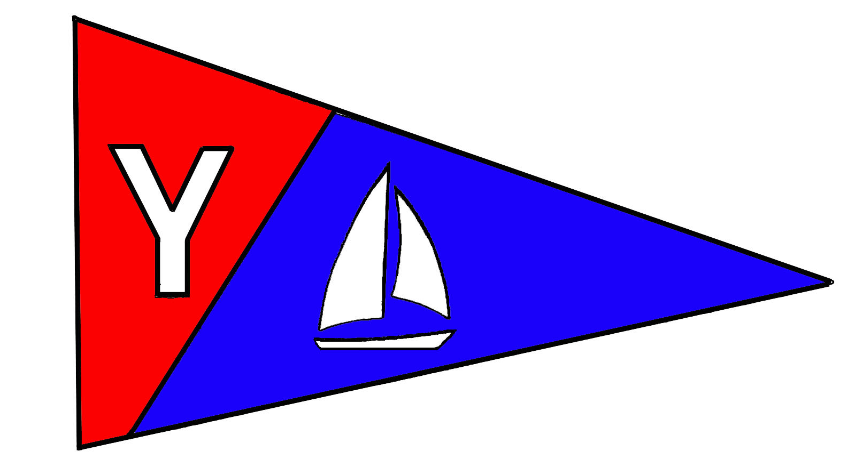

Members’ Corner
Our membership drive is proving to be a huge success. At the June Board of Directors meeting we approved another seven new memberships. With all this new energy and interest in our club, we should have a very exciting summer. Please greet these people when you see them at the club meeting, and invite them to join you in club activities. Our new members are:

Jalene Case and Keith Matteson from Newport. They have a West Wight Potter 19 named "Chill Pill"
Barbara and Ted LePine from Toledo. They have a power boat named Babbigale. They were formerly members of Windjammers Yacht Club in Marina Del Rey.
Shane and Jessica McConnell from Halsey. Shane is Mac's son and they share in the use of the 23' North American Spirit, "Son-o-Beech"
Bernie and Tamara Stoll from Newport. They have a Wilderness 21' "Western Flyer, a 19' Dory Skiff, "Taco", and 2 Kayaks.
Scott and Jessica Walters from Newport. They are new to Newport and new to sailing. They are enrolled in the adult sailing class. Welcome to the water!
Russ and Carolyn Harper from Otis. They have a San Juan 26 named "Shaman"
Ken Bishop from Newport. He has been sailing with members on Wednesday Racing.

We currently have three more applicants who will be voted upon in July. Thanks to all of you who have invited people to join our club.

Mary Ann & Larry Beggs, Membership Chairs
Applications can be found at the clubhouse or they can be downloaded from the web site. Go to yaqunabayyachtclub.com and on the left side click on "Joining the Club” and at the bottom of that page click on "Membership Application".
The roster has been updated and can be found on the club’s Google group. If you see errors, please let me know at maryannbeggs@mac.com. One change you'll notice is that Carl and Dee Dudley, life members, have moved to Albany after more than 40 years in Newport. They would like to stay in touch with YBYC, so don't forget to give them a call when events are being planned.

-Larry and Mary Ann Beggs, Membership Chairs

Tell Your Friends and Family

You’ve been waiting all year for this and now it’s time to register for a sailing or kayak class. Take advantage of the membership discounts available to YBYC members. Let your friends know they too can qualify for these discounts when they take one of the classes and join YBYC. Tell your friends and family about the wonderful educational opportunities available this season.

Please check out the YBYC web site at www.yaquinabayclub.org for additional information about any the classes offered. Go to ‘classes’ and hit the ‘detail’ button on each individual class. All sailing classes are taught by US Sailing Certified Instructors and the kayak instructor is certified as a Coastal Kayak Instructor by the American Canoe Association.

The first Beginning Youth Sailing class of the year begins soon with on-the-water classes the week of June 15 -19 on Devil’s Lake in Lincoln City. For registration information for this Lincoln City class, call the Lincoln City Parks & Recreation at (541) 994-2131. If you’ve missed this one, there will be another Lincoln City class starting on August 7.
Continued……Page 7
….Continued from Page 3
For registration for this class call Jennifer Puentes at (541) 765-4574. In addition to Lincoln City, there will be a July class in Toledo. Register for the Toledo class by calling Ocean Spray Family Center at (541) 265-5326, ext. 317. (For purposes of insuring the kids, the above organizations are registering the students.)
This year the first Intermediate Youth Sailing class will be held, beginning July 20. This is a great way for kids to become more experienced sailors. Please encourage any of the graduates of this or previous years Beginning Youth Sailing Classes to attend. To register for this class, call Lincoln City Parks & Recreation at (541) 994-2131.
The spring Beginning Adult Sailing class is underway but you’ll have another chance with the September class starting on the 10th. You can register online on the YBYC web site.
The first Kayak class of 2009 will be held starting June 27 and followed by classes in July and August. For details see the club website or call Tom Murphy at 541-265-9648 or visit his website at coastalkayak@msn.com. Kayaking is a great way to explore the beautiful Yaquina Bay and enjoy nature.

Help make this year’s educational program a success by telling your family and friends about these classes. And be sure to sign up for one yourself!

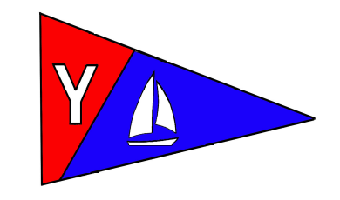
Yaquina Bay Yacht Club
Newsletter

June 2009 Page 4
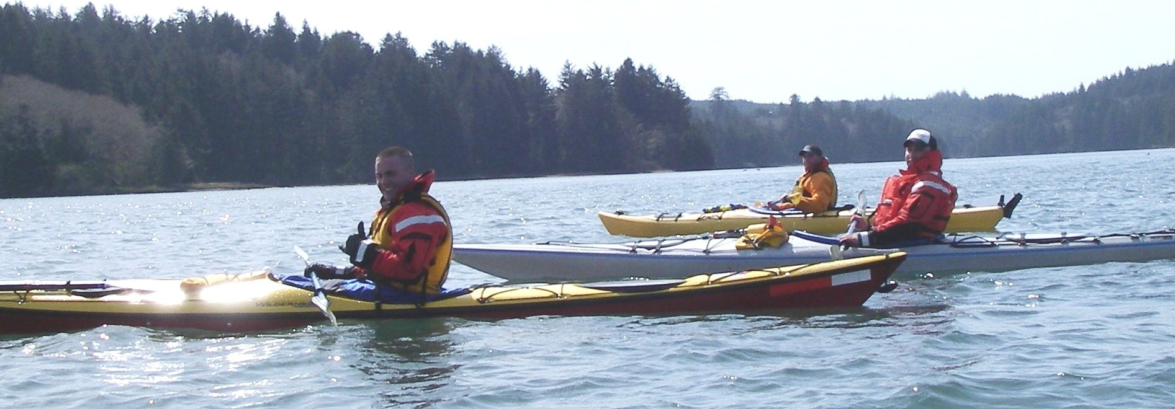

SUMMER KAYAKING CLASSES IN NEWPORT

Learn to enjoy the pleasures of kayaking safely by enrolling in the “Basic Coastal Kayak Strokes and Rescues” class taught by Tom Murphy, an American Canoe Association Certified Coastal Kayak Instructor. As part of its community boater education program, the Yaquina Bay Yacht Club is offering this course to the public as a way to encourage the safe and enjoyable use of kayaks at the coast.
The first class is 1-1/2 days long and will begin on Saturday, June 27, from 12:00-5:30 pm. Class participants will meet at the YBYC Clubhouse for classroom instruction followed by safety and rescue practice at a local lake.
On Sunday, June 28, the class will start at 9:00 am with on-the-water instruction on the Yaquina Bay/Estuary, or a more protected area if needed. This experience will allow practicing the knowledge and skills learned the previous day. Additional topics will include launching and landing, various strokes and maneuvers, boat control, as well as opportunities for sampling a variety of experiences related to kayaking at the coast. We will be finishing up around 5:00 pm.
Cost for the course is $100, which includes the use of a sea kayak, spray deck, paddles and safety equipment. Participants will need to furnish their own wetsuits and Coast Guard approved life jackets which can be rented from local surf/dive shops or borrowed from a friend.
For a registration packet or further information, please contact Tom Murphy at 541.265-9648 or e-mail: coastalkayak@msn.com. Due to a limited class size, early registration is encouraged. The enrollment deadline is June 22, 2009.

Two other classes are scheduled for July 18-19 and August 29-30, with registration deadlines of July 13 and August 24 respectively.

Yaquina Bay Yacht Club
Newsletter

June 2009 Page 5
YBYC’s Bridge to Bridge Offshore Race
This race is one of the most exciting sailboat races in the Pacific Northwest! Sail through 100 miles of sunshine, blue skies and the most beautiful coastline on the West Coast.
The race starts at the mouth of the Columbia River and finishes in beautiful Newport, Oregon; it is measured at just under 100 nautical miles and is usually an overnight race.
We need a welcome crew for the finish line. We’ll also need chase boat operators, food prep, hot towel dispensers, cheering throngs of adoring offshore racing fans and folks who love to hear wild stories of their adventures at sea!
Contact Stephanie or Ken Brown for information on any part of the Bridge to Bridge. Alaskamissy_2000@yahoo.com tyrguy@yahoo.com

There’s a discussion forum started on Yahoo where you can follow on the race updates and exchange messages with the racers. Great place to look for crew or skippers. Go to http://sports.groups.yahoo.com/group/Bridge2Bridge/

Want to Make a Tax Deductible Donation?
That’s right. We have the ability to accept tax-deductible donations! We can do that through the newly formed Oregon Coast Boating Safety and Education Foundation (OCBSEF). This Corporation has been formed for the purposes of community boating education and, as such, is eligible for 501(c) (3) tax-exempt status. So, please keep us in mind if you are thinking about making a charitable donation. We are looking for items that can be resold that have significant value, though your cash donation is always graciously appreciated.
Ron Cole, OSBSEF

You can sail a Lido 14

The club has Lido 14 sailboats available for club member use. These 2 or 3 person dinghies are fun to sail and explore Yaquina Bay. They’re conveniently located on the port dock near the clubhouse.

To use the Lidos, check the online calendar for availability, and place your reservation by contacting Stephanie Brown at alaskamissy_2000@yahoo.com or 541-265-4575; reservations are posted online on the club’s website www.yaquinabayyachtcluborg under the ‘Calendar’ tab.

The Kelley’s keep on contributing to the sailing community.

Norm and Alice Kelley, who are life members of YBYC, are constantly being recognized for their contributions to the sailing community. If you did not know, life membership is granted to those who have been club members for at least twenty years and who have substantially contributed to the activities of the club. The Kelley’s have benefited YBYC in many capacities and on many levels.

Norm is a past commodore and has served as race committee for many years. Prior to the
……Continued Page 7
……Continued from Page 5 ……
construction of our club house, he worked
tirelessly on trying to figure out how to convert
an old barge into a club house. Norm and Alice
were active on the water and always sailed up
to Toledo for the Fourth of July float.
According to Dorothy, you could always count
on them anchoring either on the way up or on
the way back. When asked why, they said,
“that they were taking a nap”. (Well, that’s
what they said anyways).

The Kelley’s have kept their boat Night Wind at the end of the Embarcadero’s D dock for many years and always slept on it when they were in town. You know that they loved Night Wind because they bought her new in 1976 and have kept her in beautiful condition all these years. In addition to local sailing, The Kelley’s and Night Wind even made it to Alaska for some pristine cruising. It is truly the club’s loss that the Norm and Alice have curtailed their boating activities due to health issues.

Recently, the Kelley’s have made another contribution to the sailing community by donating their O’Day 25, trailer and Embarcadero slip to the Oregon Boating Foundation. If you have an interest in these items, please contact me or call (541) 270-5900.

Thank you again for a lifetime of generosity. -Ron Cole

Yaquina Bay Yacht Club
Newsletter

June 2009 Page 6
Special Events Coming Up!
The summer is full of fun special events that YBYC can participate in. We need your help to make these things great. Some of the parades we can enter around the coast and in the valley include the Gleneden Beach 4th of July, Beachcomber Days, Strawberry Festival in Lebanon, and the Toledo Summer Fest. We also have the Hatfield Marine Science Center’s Seafest coming up in June and our own Sailfest coming up later in the summer. Down the calendar a little further is the Toledo Wooden Boat Show in August.

We need more Volunteers for all these programs, there is no such thing as too many helping hands when it comes to festivities!

Contact Garth or Stephanie to get onboard with any of these special events! Thanks!
garthrenner@charter.net or alaskamissy_2000@yahoo.com

Clubhouse Update

Please respect the privacy of our renters; their return business keeps the club going! Your ongoing help is appreciated in keeping our clubhouse neat and ready to rent, Thanks!
Contact Stephanie for rental or calendar information or go on the website.

If you want to use the clubhouse please check before hand. If you see people at the club please let them enjoy their use and do not assume you are invited.

Do Not Disturb Rental Parties.
They have paid for exclusive use of our facility and it intrudes on their gathering. Interruptions by club members reduces the chance that they will rent our space again.

Did you know? Members can use the clubhouse for small informal gatherings anytime it’s not reserved or rented, with the understanding that other club members may use it also. And, each membership can have one no-charge, exclusive use of the clubhouse per year, with board approval. Check with the house chair before scheduling your event. In the case of informal member use, you may be bumped by a paying renter or asked to pay for renting the space.
COASTAL KAYAK INSTRUCTOR TRAINING OVER LABOR DAY WEEKEND

As many members are already aware, the YBYC kayaking program has been growing and with this growth the need for additional trained instructors. After looking for American Canoe Association Instructor Training we found that few opportunities were available anywhere on the West Coast. An Instructor Trainer from Whidbey Island has agreed to provide a five-day Instructor Development Workshop including the two-day Instructor Examination here in Newport September 3-7. Two members from the Club will be participating, and we have invited several non-members to join us in order to have enough to constitute a class.

Yaquina Bay Yacht Club
Newsletter

May 2009 Page 7
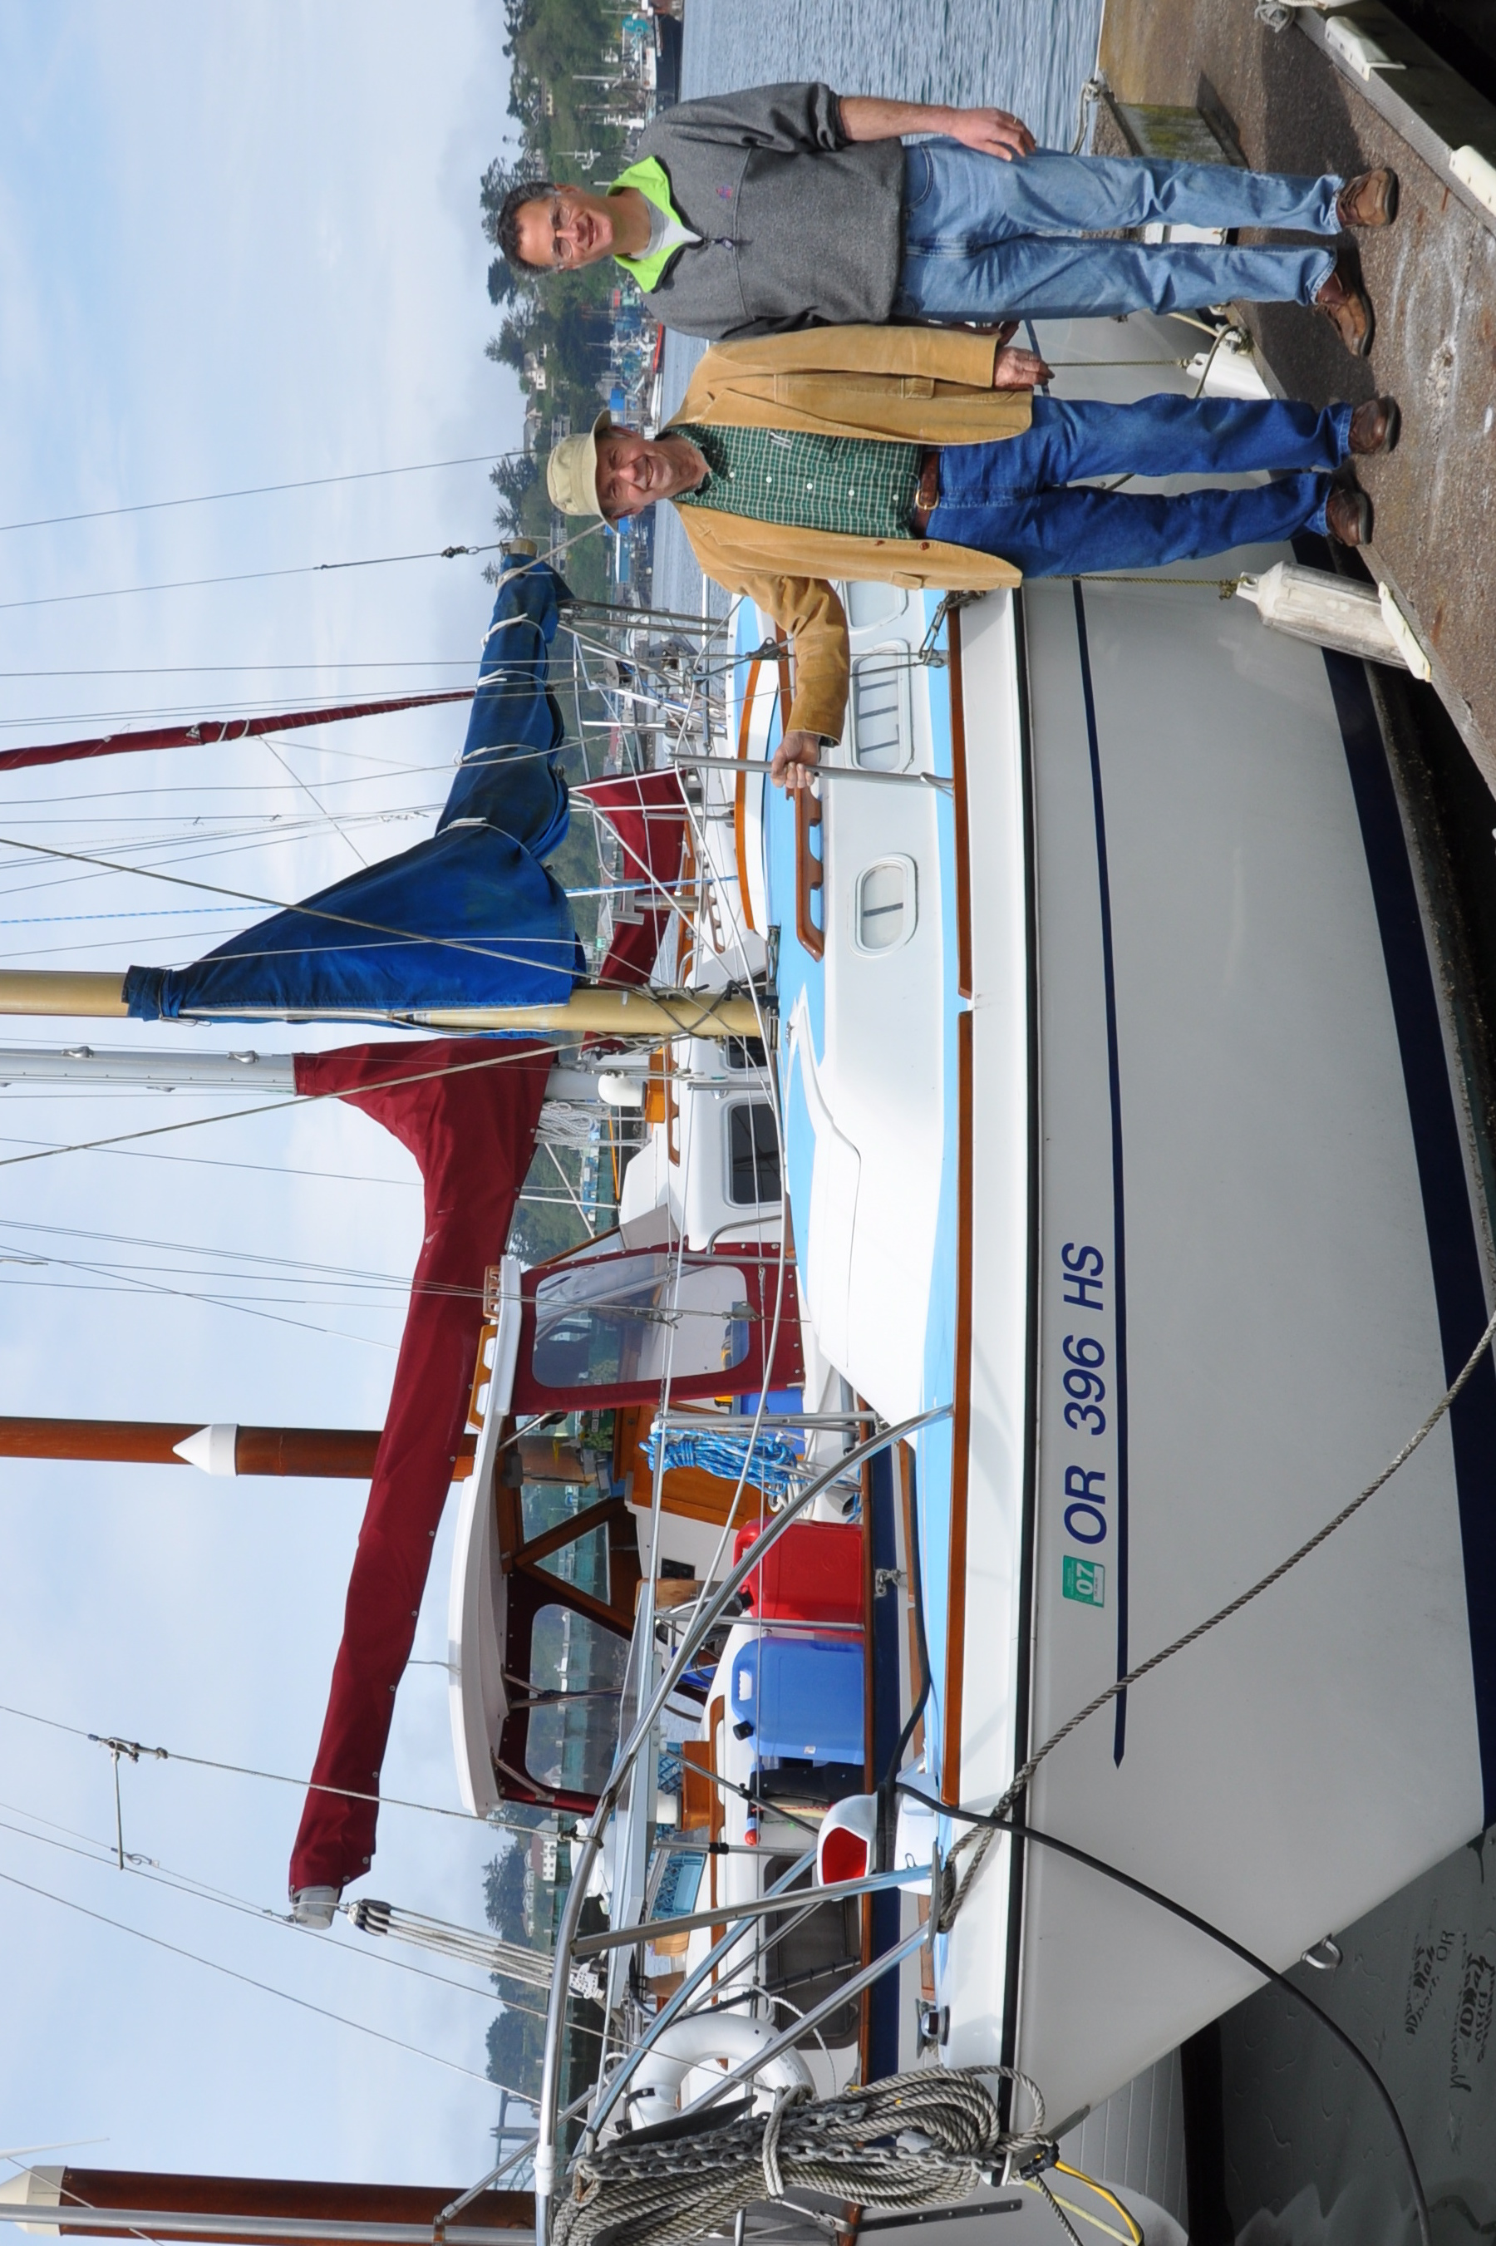
Yaquina Bay Yacht Club
Newsletter

June 2009 Page 8
Section 100 Boats for Sale
We're looking for a good home for our boat Chey-Breeze.
This is a well-known boat on Yaquina Bay, formerly known as Rhapsody, and a proven racer! Winner of the yacht club's PHRF overall award, this is the boat to be on if you want to win and cruise in style.
1981 Catalina 25 Tall Rig with Pop Top, Fin Keel, with 4 headsails, 2 mainsails, 1 spinnaker and spinnaker equipment.
All lines run aft for easy single-handed sailing.
See More about Catalina 25s through this link to the Owners Manual
http://www.catalina-capri-25s.org/manbro/Cat25manpre88.pdf
Talk to us about the boat! Asking $5,600.00 541-265-4575 alaskamissy_2000@yahoo.com

We’ll be happy to take you sailing on it anytime! -Stephanie and Ken Brown
---------------------------------------------

Section 150 – Boats Wanted

The Backpages
Section 200 Parts for Sale
2007 4 stroke Honda 8HP XL shaft outboard engine (smooth cover style) and has never been in the water! (NEW) Make offer!
Scott, Boat: Nancy Jane
(503) 580-3344 (cell)

Section 250 - Parts Wanted
Section 300 - Misc. Merchandise

For Sale: 20' Boat Slip at the Embarcadero (M-211).
Maximum boat size is 22'. Slip has fresh water bib, 20 Amp service and storage locker. Great spot to sail in and out of slip.
Asking $3,500. Please check on HOA fees. Ron. 270-5900.

Section 400 - Crew Available
Section 450 - Crew Wanted
Section 500 – Services
Section 600 – Personals
Section 999 - Anything Else?


