Yaquina Bay Yacht Club
Newsletter
February 2009

A publication for the Members and Friends of the Yaquina Bay Yacht Club
Commodore’s Log

Aloha from Waikoloa, I hope everybody is enjoying this beautiful weather.
This month is kind of a short one for us, two weeks suffering in Hawaii then hustle back home to get things rolling for the seafood and wine fest, and no chance to sail at all. I don’t know how we are going to make it, but we will survive. Speaking of seafood and wine, it is approaching rapidly and seems to be going smoothly. We still have a few spots open for volunteers to pour wine (for those of you that have or will take your OLCC class) and the theme for this year is “Wonders of the ocean” which I hear that Steph and her band of merry helpers have decorating ideas swimming in their heads. We are pouring the same wine again this year; Red Diamond from Chateau St. Michelle, which has proved to be a great label that has been very accepted by patrons who return to buy more each year. I am hoping that with the downturn in the economy that attendees are going to show up and drown their problems in wine (responsibly, of course) and will focus on the more reasonably priced product like ours. We are also going to be selling some ships stores to help raise some additional revenue.
This month’s general meeting is going to be on SUNDAY the 15th with social time starting at 6:00 and the meeting/potluck starting at 6:45. Vice Commodore Mac is in charge of this month’s meeting and will, as always, provide us with an enlightening function. I know that the hospitality committee is working very hard to make these functions as fun and rewarding as possible, and is always looking for ideas and help from all members so please contact any board member if you would like to help.
The frostbite series is still going on every other Sunday for those interested is honing their skills for the fast approaching race season and the Loyalty Days regatta.
Remember, this is your club; its voyage
is as only good as its crew. Ken

Calendar in Brief

February
15 – General Meeting
17– Board Meeting
20-22 - Seafood and Wine Festival

March
10 – Board Meeting
21 – General Meeting
21 – Blessing of the Fleet

April
14 – Board Meeting
18-19 – Depoe Bay Wooden Boat Show
25 – General Meeting
25-26 – Loyalty Days Regatta
29 – Wednesday Sailboat Racing Begins

May
2 – Loyalty Days Parade
12 - Board Meeting
16 – General Meeting
16 – Rhododendron Days Parade
25 – Memorial Day
Our Mailing Address is 750 SW Bay Boulevard, Newport, OR 97365

Our Website URL
Is www.yaquinabay yachtclub.org

For questions about the Club, contact Commodore Ken Brown at tyrguy@yahoo.com
For questions about or contributions to this newsletter contact Stephanie Brown, editor, at 265-4575 or alaskamissy_2000@yahoo.com


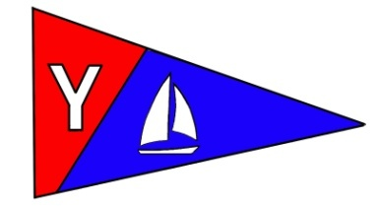
Yaquina Bay Yacht Club
Newsletter

February 2009 Page 2

February Monthly Meeting
Where: Clubhouse
When: 6 p.m. Sunday February 15
Theme: Wine Tasting
Please Bring: A side, salad
or dessert to share. Bring your place settings and
beverages, too. Vice Commodore Mac will be hosting this
meeting and guiding us through a wine tasting to preview
the wines we will be serving at our booth at the upcoming
Seafood and Wine Festival.



Free Class: Intro to Racing
The Yaquina Bay Yacht Club is sponsoring a beginning small boat racing class. A follow-up to the beginning sailing course, this is a way to introduce new sailors to racing. The 4 week course is intended for crews of two who stay together aboard Lido 14s throughout the course, then participate in the Loyalty Days regatta after the last lesson.

There is no charge or age limit for this class. Skippers and crew should plan to register as a team of adults, youth, or a combination of an adult and a youth. The class size is limited to the first five teams.

Requirements: Both skipper and crew must be club members and passed the YBYC basic sailing course or demonstrate basic skills aboard a small boat (Lido).

Dates: Saturdays, March 28, April 4, 11, 13.
Time: 9:00 – 2:00
If you would like more information, or want to sign up for the class, contact Joe Novello JoeNovello3@gmail.com.

Want to Make a Tax Deductible Donation?
That’s right. We have the ability to accept tax-deductible donations! We can do that through the newly formed Oregon Coast Boating Safety and Education Foundation (OCBSEF). This Corporation has been formed for the purposes of community boating education and, as such, is eligible for 501(c) (3) tax-exempt status. So, please keep us in mind if you are thinking about making a charitable donation. We are looking for items that can be resold that have significant value, though your cash donation is always graciously appreciated.
Ron Cole, Education Chair

Yaquina Bay Yacht Club
Newsletter

February 2009 Page 3
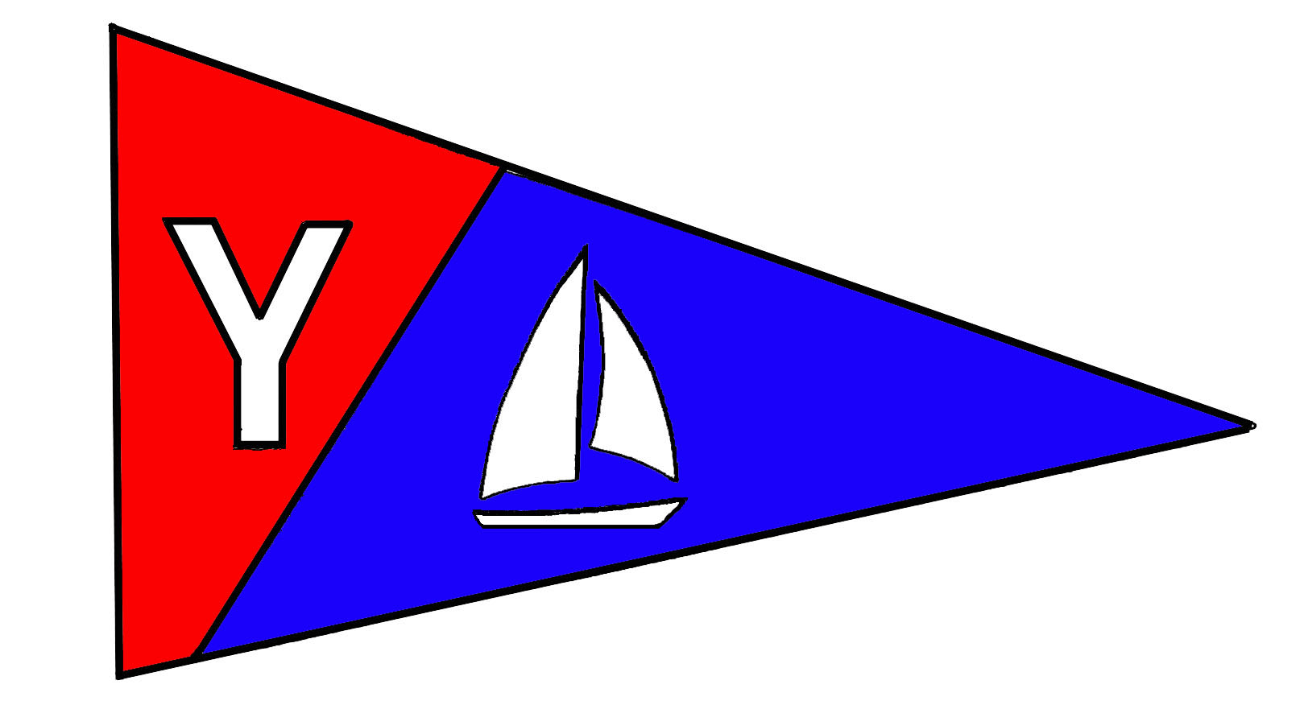

Members’ Corner
Please let MaryAnn and Larry Beggs, the new YBYC Membership Chairs, know if any of your contact information has changed so the roster can be updated.
The YBYC Membership Roster is online at the YBYC Google Group and updated regularly. To access YBYC’s discussion group on Google, use this web address: http://groups.google.com/group/ybyc You will be prompted to Log In or Apply for Membership (new log ons only)

What: Sail School "Work" Party
When: February 21 10am – 5pm (Rigging repair and 1st coat of varnish)
Again: March 7 10am - 4pm ( 2nd coat of varnish )
Who: Volunteers needed to work with kids, sandpaper and varnish, and some rigging.
Contact: Merry Petitclair m.petitclair@gmail.com or 541.913.4322
RSVP: Please contact Merry if you plan to attend.
We need your help in helping others. We taught them to sail. Let’s teach them proper boat maintenance too. The plan is to have some of the youth sailors from prior seasons meet at the YBYC club house to learn hands on maintenance of the JY Trainers and possibly some work on the Lido's as well. Our primary goal is to repair sails and replace rigging. And also we plan to sand and varnish the rudders and centerboards for the JY Trainers. We need varnish, brushes, sandpaper, and a place for them to dry. We have lines in stock for rigging replacement. At the US Sailing National Symposium I attended in early January, I learned some more beneficial ways to rig these little boats to improve their longevity of service. I will provide instructions for these improvements at the work party.
After we complete our chores for the day, we are hoping to take the kids and helpers out for a sail on either some Lidos and/or on some member owned boats (weather permitting). I have asked the kids to be there at 10am wearing clothes they can slop varnish on, and to pack a lunch and change of clothes.
There will also be a simultaneous YBYC work party on March 8, providing other vital efforts for the health and well being of the club this same day. Read more about those activities here in the newsletter. If sanding and varnishing are not your cup of tea, I'm sure we could use your valuable time and assistance in other activities. Come and have fun with all of us.
Thank you.
Merry Petitclair
Email: m.petitclair@gmail.com
Phone: 541.913.4322

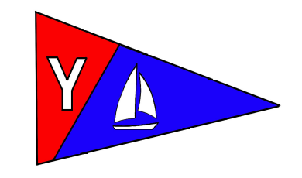
Yaquina Bay Yacht Club
Newsletter

February 2009 Page 4
Weekend Cruises

Join us for sailing excursions on the 1st and 3rd Sundays of each month. Upcoming dates are February 15, March 1, and March 15. Rally begins at noon near the CG buoy outside the Embarcadero Marina. All boats are encouraged to get out and enjoy our beautiful bay.
There’s a discussion open on the Google Group, let’s use the forum to check on cruise plans and add cruising ideas. It’s open for us all to post messages.

Upcoming Cruise Directors

February 15 – Open
February 21-22 – Wine Cruise anyone?
March 1 – Open
March 15 - Open
Club Lido 14s on the dock

Two of YBYC's Lido 14s are on the dinghy dock and available for club member use. These 2 or 3 person dinghies are fun to sail and explore Yaquina Bay.
To use the Lidos, check the online calendar for availability, and place your reservation by contacting Stephanie Brown at alaskamissy_2000@yahoo.com or 541-265-4575; reservations are posted online on the club’s website www.yaquinabayyachtcluborg under the ‘Calendar’ tab.
Lido sails, rudders/tillers, and safety equipment are kept in the shed along with a sign-out sheet: indicate when and where you're headed and whether the boat needs repair once you return. Lido users must have a signed club waiver on file (available on the YBYC website). Happy sailing!
Hi Everyone,

The Hospitality Committee wants to let you know about the time change for the monthly general meetings. Effective immediately, the new time (still on the third Saturday of every month unless otherwise announced) will be:
Happy Hour from 6pm to 6:45pm with dinner following.

We have made this change to accommodate some of our members who are unable to attend club meetings due to the earlier dinner time. Hope to see you all there for the upcoming February meeting.

The Hospitality Committee - Laurie Weitkamp, Vicki Mines, Donita Cole

32nd Annual Seafood and Wine Festival
February 20-22, 2009 we will have a booth at the Seafood and Wine Festival, pouring Red Diamond Wines. We need volunteers to staff the booth and pour wine. We also need helpers at set-up on Thursday night and tear down Sunday afternoon. Anyone who plans on pouring at the festival needs to attend an OLCC orientation class or have a current OLCC Servers Permit. Class times are Feb 11 Waldport Moose Lodge 7 p.m.
Feb 12 Newport Elks Lodge 8 p.m.
Feb 18 Newport PUD 7 p.m.
Contact Ken to schedule your shift at the booth! tyrguy@yahoo.com

Yaquina Bay Yacht Club
Newsletter

February 2009 Page 5
Chili Cook-Off spices up January YBYC meeting
The nine entries for the 2009 YBYC Chili Cook-Off helped stave off the winter cold for all who attended the January 17 meeting. In a new development for 2009, guest chefs Michael Waliser of Saffron Salmon and Bruce Jackson judged all entries. They interviewed each competitor about the details of the recipe, then shooed them away to test each one.
Members and guests alike enjoyed the cornbreads, salads, snacks and desserts - including a gorgeous fruit tart - and washed it all down with good beer, wine and soda.
Stephanie Brown took first-place and people's choice honors for her Wasabi Chili, made with white beans, chicken, ginger, cilantro and edamame. Marge Burak took second place for her classic ground beef and red spiced chili, and Diane Henkels took third for her deep red Elk Chili, with its complex flavors of chipotle, many kinds of beans and vegetables.
The guest chefs thoroughly enjoyed themselves and commented on the surprising depth of variety in such a small field, and once again, YBYC proved itself as the premier eating and boating club in Newport ~

A Bit of Missing History
After many years of storage, we have located the YBYC Chili Cook-off trophy. But we need your help to fill in the missing winners’ names. Below is the list of recorded champs to help jog your memory.

2003 and 2004 were held in the Embarcadero’s fireside room; 2005 through 2007 were held in the clubhouse. If you can fill in the blanks, let me know!
-Stephanie alaskamissy_2000@yahoo.com
1993 – Jill Pridgeon 2002 – Sara Skamser
1994 – Anne Williams 2003 - Unrecorded
1995 – Jim & Lee Fouts 2004 - Unrecorded
1996 – Maryann Sabanskas 2005 - Unrecorded
1997 – Mike Smith 2006 - Unrecorded
1998 – Tim Myrick 2007 - Unrecorded
1999 – Dorothy Bogumil 2008 – MaryAnn Beggs
2000 – Steve Klein 2009 – Stephanie Brown
2001 – John Dougherty

Ron and Barbie?

Just like the Daytona 500, the Guggenheim Museum, Alaska and Hawaii, and the Barbie Doll, Ron Cole turns 50 years old this month! While 50 might be over the hill to some, we know that fifty is nifty.

Instead of 50, let’s just think of Ron as an 18 year old with 32 years of experience!

Happy Birthday!




Yaquina Bay Yacht Club
Newsletter

February 2009 Page 6
Monthly meeting hosts needed!

Please help make YBYC monthly meetings the type of events you'd like to see by hosting a meeting! Meeting hosts have free rein to do anything they want at the meeting: chose the theme, decorate, enlist others, bring in speakers, organize activities, decide how to spend $100 on the meeting, and generally create an enjoyable time for all.

We have lots of open dates this year and encourage you to make meetings the type of event you'd like to attend--if you don't, who will?
Open dates are:
April 25 (Loyalty Days Regatta) October 17
June 20 November 21 (Annual meeting)
September 19 December 19
If you'd like to host a meeting, please contact Laurie (laurie3665@hotmail.com, 541-867-4603).

Clubhouse Update
February 7 – Rented All Day March 7-8 Work Party –Boat and Club
February 10 – Board Meeting 7 p.m. March 10 – Board Meeting 7 p.m.
February 14 – Rented all day March 21 – Monthly Meeting & Potluck
February 15 – Monthly Meeting & Potluck March 28 – Racing Clinic
February 21-22 – Work Party – Boat Maint.

Please respect the privacy of our renters; their return business keeps the club going! Your ongoing help is appreciated in keeping our clubhouse neat and ready to rent, Thanks!
Contact Stephanie for rental or calendar information or go on the website.

Did you know? Members can use the clubhouse for small informal gatherings anytime it’s not reserved or rented, with the understanding that other club members may use it also. And, each membership can have one no-charge, exclusive use of the clubhouse per year, with board approval. Check with the house chair before scheduling your event. In the case of informal member use, you may be bumped by a paying renter.

Yaquina Bay Yacht Club
Newsletter

February 2009 Page 7

The Backpages
Classified Ads
To place your ad email the editor at ybyc.email@gmail.com Classified ads from individuals are free. Commercial ads may be subject to advertising fees.
Section 100 – Boats for Sale Section 400 – Crew Available
Section 150 – Boats Wanted Section 450 – Crew Wanted
Section 200 – Parts for Sale Section 500 - Services
Section 250 – Parts Wanted Section 600 - Personals
Section 300 – Misc. Merchandise Section 999 – Anything Else
Section 100 Boats for Sale
We're looking for a good home for our boat Chey-Breeze.
This is a well-known boat on Yaquina Bay, formerly known as Rhapsody, and a proven racer! Winner of the yacht club's PHRF overall award, this is the boat to be on if you want to win and cruise in style.
1981 Catalina 25 Tall Rig with Pop Top, Fin Keel, with 4 headsails, 2 mainsails, 1 spinnaker and spinnaker equipment.
All lines run aft for easy single-handed sailing.
**Bonus** -- Includes Moorage at Embarcadero through March 2009.
See More about Catalina 25s through this link to the Owners Manual
http://www.catalina-capri-25s.org/manbro/Cat25manpre88.pdf
Talk to us about club member sale price.

We’ll be happy to take you sailing on it anytime! -Stephanie and Ken Brown
U20: #22, The Full Monty

Asking: $18,000.00
Contact: Ron Cole
Description: Deck: Excellent condition, all hardware recently re-bedded. Cockpit pockets are worn and cockpit hatch has leak. Includes two compasses and Speed Mate.
Hull: Excellent condition, red boot stripe, Shark White ablative bottom paint. Standing rigging: All wire replaced approximately five years ago with Ronstan no-tool turnbuckles. Running rigging: New main halyard. Vang, outhaul and traveler have been upgraded with additional purchase and new lines. Sails: Beer-can quality, not regatta quality. Additional five year old spinnaker used three times. Trailer: Galvanized, spare tire, buddy bearings, new LED lights. Needs new U-bolts for springs. Outboard: Mercury 4HP, four stroke, approximately five years old. Excellent condition. Serviced each year by a certified mechanic.
…Continued Next Page

U20 #22 Cont. …

General Comments: Boat has been lightly used mostly for Wednesday night races and two to three regattas per year. Deck and engine have been fresh water rinsed after each use. Testimonials are available as proof. Flawless repair of a Laser hit and a broken sprit replacement render both incidences undetectable. Boat price recognizes need for regatta white sails.

Location: Newport, Oregon.
Delivery: Will consider neighboring states. Able to deliver to CA in mid-February. Would prefer to keep boat local or in Northwest. Contact: Ron Cole at ron@roncolemortgage.com or (541) 270-5900 (Cell).

Section 200 Parts for Sale
2007 4 stroke Honda 8HP XL shaft outboard engine (smooth cover style) and has never been in the water! (NEW) Make offer!
Scott
Boat: Nancy Jane
(503) 580-3344 (cell)

Yaquina Bay Yacht Club
Newsletter

February 2009 Page 8
Section 150 – Boats Wanted

Section 200 - Parts for Sale

Section 250 - Parts Wanted

Section 300 - Misc. Merchandise

Section 400 - Crew Available

Section 450 - Crew Wanted

Section 500 – Services

Section 600 – Personals

Section 999 - Anything Else?


The Backpages

