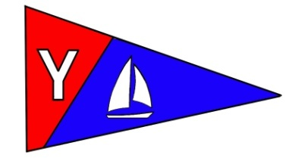
Yaquina Bay Yacht Club
Newsletter
September 2008

A publication for the Members and Friends of the Yaquina Bay Yacht Club
Commodore’s Log


I hope you all had a great summer with lots of time on the water. My log this month is similar to Tenderly's log for the past month, fairly short. That activity called 'work' pretty much dominated my life as we prepared our schools for another generation of students. Speaking of kids, our club's youth activities are in full swing, thanks to the efforts of many folks. The video from the Sail Fest was delivered to me and I'm planning to show it at the next club pot-luck on September 20th at 6:00 p.m. Peggy and I will be hosting the event which will be a Back To School Picnic theme. No, you don't need to bring a brown bag lunch. Hot dogs and chicken will be provided, bring along all the fix'ns, your favorite beverage and desserts. We will have a trivia game with lots of fun a prizes.

Other upcoming events include the Columbus Day Regatta and the annual November General meeting. The Wednesday night sailors are out in force, preparing for the upcoming regatta. Be sure to contact our Race Chair, Terry, if you are interested in participating, either as a competitor or support staff. Club Board members will be out recruiting in the next few weeks for new crew to take the helm of our club. Please contact Ken Brown or Mac McConnell if you would like to help out in that area.

Take advantage of these beautiful fall days and we will see you on the water.

--Joe

Calendar in Brief

September
15 – Board Meeting
20 – General Meeting
October
11-12 – Columbus Day Regatta
13 – Board Meeting
18 – General Meeting
November
10 – Board Meeting
15 – Annual Meeting
December
8 – Board Meeting
20 – General Meeting

Our Mailing Address is 750 SW Bay Boulevard, Newport, OR 97365

Our Website URL
Is www.yaquinabay yachtclub.org

For questions about the Club, contact Commodore Joe Novello at joenovello3@gmail.com
For questions about or contributions to this newsletter contact Stephanie Brown, editor, at 265-4575 or alaskamissy_2000@yahoo.com

Yaquina Bay Yacht Club
Newsletter

September 2008 Page 2
September Monthly Meeting and Potluck

Where: Clubhouse
When: 6 p.m. Saturday, September 20
Theme: Back to School Picnic

Hot dogs and Chicken will be provided

Bring: Bring along all the fix'ns, your favorite beverage and desserts. We will have a trivia game with lots of fun a prizes.

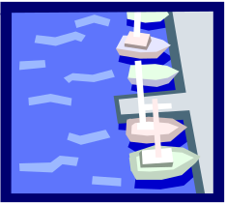

Rear Commodore’s Log

ACCOLADES in lore were given to persons for Personal Merit by touching them on their shoulders with a sword and declaring their knighthood. Yaquina Bay Yacht Club Accolades those who have given so selflessly as VOLUNTEERS with HEARTFELT thanks in lieu of the sword. Our club wouldn’t be what it is and what it is becoming without you.

ACCOLADES TO OUR FIRST MATES

George Benton–Coordination of sailing fleet repairs and rigging of our Lido fleet, Pig roast master
Dave Schmaltz-Rigging and repairs of our Lido fleet, Master of meals and roasts
Barbara Schmaltz-Designs of clothing and trophies for the YBYC club and Regattas, Meals extraordinaire
Tim Myrick–Acquisition of parts for rigging repairs, sailboat mentor, chase boat operator
Dorothy Bogumil- Bookkeeping, and keeping us balanced.
Dick Schwartz-Ships stores
Tom McNamara–Repair of the Lido fleet, fiber-glassing, good humor
Alice McNamara-Clubhouse gardens and Ships Stores
Ken Brown-Servicing trailers and Whaler, Liaison with the Port, Chase boat and Sailboat
mentor
John Dougherty- Servicing of the Whaler, chase boat, master of good cheer
Stephanie Brown- Creativity with Newsletter, Publicity and Outstanding work keeping the Club building ship-shape and rented
Doug Mecham-Youth Sailing Instructor developed the countywide youth program, Wrote and received grants for chase boat and program development, Participated in continuing education classes, Sailboat mentor, and Mission development idea guy
….Continued, Page 5

Yaquina Bay Yacht Club
Newsletter

September 2008 Page 3
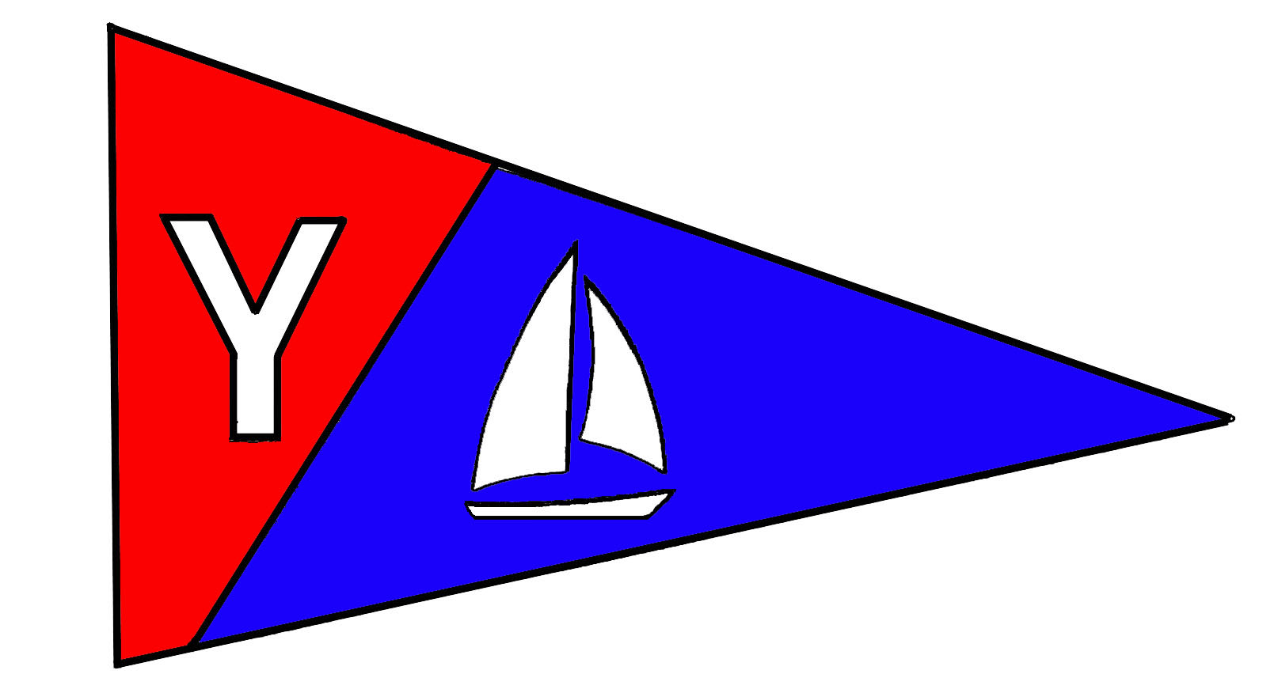

Members’ Corner
Please welcome Jerry and Diane Yearous and their daughter Miranda, as new members to YBYC. Miranda has been taking the youth sailing classes in Lincoln City for the past several years. Diane will be taking our adult sailing class this September. Please introduce yourselves and help them feel welcome.
The 2008 YBYC Membership Roster is on G-mail and updated regularly. Please let me, Donita Cole, know if any of your contact information has changed so club members know how to reach you. To access YBYC’s discussion group on Google, use this web address: http://groups.google.com/group/ybyc You will be prompted to Log In or Apply for Membership (new log ons only)
Please remember to wear your new name tags at the meetings to help new (and old members) get to know you. Following the meeting, please return name tags to the name board in the hallway. The first name tag is free to club members but you will be asked to pay for the cost for a replacement. A note on nametags; they use strong magnets as fasteners, do not use if you have a pacemaker device! We’ll get you another tag, instead.

I will be resigning as Membership Chair at the end of this year. I have enjoyed working in this important position for the past four years. My plan is to help with the administrative duties of the club’s Educational and Non Profit activities. Please consider stepping forward to help the club as Membership Chair in this rewarding and necessary position. If you would like help learning the duties of this position, I am willing to help you.
--Donita

Columbus Day Regatta October 11-12

On October 11-12 YBYC hosts our largest regatta of the year.
With 30-40 boats on the water, we need lots of volunteers to
help with Committee Boat, Chase boat, Shore-side Hospitality
and more. Notice of Race and Entry forms are available on the
YBYC website. Contact Terry Lettenmaier, Race Chair, for
information on Racing or Volunteering lett@peak.org or 867-4603

If you’re racing, don’t forget to enter early- it saves you money and helps planning!



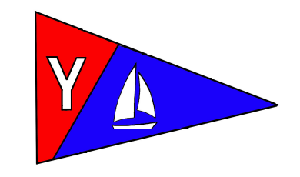
Yaquina Bay Yacht Club
Newsletter

September 2008 Page 4

Weekend Cruises
Join us for sailing excursions on the 1st and 3rd Sundays of each month. Upcoming dates are September 7 and 21 and October 5 and 19. Rally begins at noon near the CG buoy outside the Embarcadero Marina. All boats are encouraged to get out and enjoy our beautiful bay.

To really get these cruises going, we need skippers to choose dates that they’d like to be the Cruise Director. As Cruise Director, you can plan what sort of adventure we embark on. It’s as easy as telling us, “We’re going to picnic at Riverbend on Sunday.” Or “I’m heading to the Lighthouse at 11am.” Or whatever else you might like to do on the water on your day as Cruise Director.

There’s a discussion open on the Google Group, please use the forum to check on cruise plans and add your own ideas. It’s open for us all to post messages. Your input is needed! -Stephanie

Upcoming Cruise Directors

September 7 - Open
September 21 – Open
October 5 – Open
October 19 - Open

Sailboat Racing News
Racing continues each Wednesday now through October 8. Sailing instructions and liability waiver forms are now posted on the web site and club bulletin board. Please see Terry Lettenmaier, race chair (lett@peak.org or 867-4603) during a club meeting to submit liability form and sign up for race committee or dinner host duties.

The starting sequence (with the fleet flags identified) is available on the website! Get ready for racing by learning the flags and audible signals.

Race results can be found on the Club’s website and at the clubhouse.

The November Annual Meeting needs your help!
We need volunteers to organize the meeting, bake prime rib, provide side dishes, decorate, and clean up afterwards. Please help make the annual meeting the pleasant evening we've all come to expect by lending a hand--if you don't do it, who will? Contact Laurie Weitkamp by email at laurie3665@hotmail.com or phone
867-4603 if you can help in any way.
Fall River Cleanup
September 27 is the Fall River Clean-up. This is your chance to give back to the community and clean up our bay at the same time. Once again, the Yaquina Bay Yacht Club is the west end start point. Come by the clubhouse in the morning between 8 and 9 a.m. For information contact Thompson Sanitary Service at (541) 265-7249.

Yaquina Bay Yacht Club
Newsletter

September 2008 Page 5
YBYC Has a Non-Profit!
That’s right. We now have the ability to accept tax deductible donations! We can do that through the newly formed Oregon Coast Boating Safety and Education Foundation (OCBSEF). This Corporation has been formed for the purposes of community boating education and, as such, is eligible for 501(c) (3) tax exempt status. So, please keep us in mind if you are thinking about making a charitable donation. We are looking for items that can be resold that have significant value.
Ron Cole, Education Chair

…..Accolades, Cont from Page 2

Merry Petitclair-Youth sailing Instruction---Gave her whole summer to the youth program, repaired and sold Lido 14 for the club’s benefit
Terry Lettenmaier- Racing Chair, Adult sailing, Mentoring
Laurie Weitkamp-Adult sailing, Mentoring, Grub and grog
Steve Leonard-Keeping the club grounds magnificent
Paul Erskine—Dock repairs, cradles for Lidos, Chase boat
Jerry Davis—Dock repairs
Donita Cole-Enlisting and mentoring new members, Keeping the Clubhouse and grounds looking great, Sail-fest and being a special friend to all.
Ron Cole–Endless and Ongoing work in Continuing education, Mission development, Chase boat operation, Sailboat mentoring and support of everything else the club does.
Joe Novello–Continuing education, Mission development and Sailboat mentoring
Peggy Novello-Club secretary, keeping the goings on of the Board in front of all
Dan Van Calcar–Adult sailing instruction
Diane Henkels-Adult sailing instruction, Legal counsel
Tom Murphy- Coast guard liaison, Tribal dancer, Chase boat operator and Kayak instructor

Heartfelt thanks to you from your YBYC crew!
There are many more people whose names are not mentioned but we do honor for their works and deeds to make the YBYC what it is and is becoming. If you know of persons who deserve our heartfelt thanks contact Rear Commodore Mac at Macmcconnell@peak.org.
From the YBYC Vessel whose charted course is fun and excitement on and around the water, may our celebrations be many, may we honor those deserving and sail well into the wind of our charted future with jib and main unfurled.

Yaquina Bay Yacht Club
Newsletter

September 2008 Page 6

YBYC Education Program Goes for the Record Books!

This year has been and continues to be a record breaking year for the club’s education program. Tom broke a YBYC record by teaching four kayaking classes. Doug and Merry are tied for the gold by having also broken a Club record with four youth classes. The adult sailing classes was/is more like a four person relay race. There was the Off-Shore class (Joe) and the Beginning Sailing – Spring (Terry). The Beginning Sailing – Fall (Dan & Diane) and the Keel Boat class (Ron) are currently being offered this month.
There is an additional opportunity for gold, via the club’s attempt to hold the second annual US Sailing Instructor’s class. We currently have six sign-ups and we need eight. Please let me know if you, or someone you know, would like to be an instructor.
To support all of this activity and training, George coordinated the Fleet Maintenance Team which brought our dingy fleet back up to operating condition. Joe coordinated the Shed Building Team for much needed storage. Terry coordinated the Dock Rehab Team which expanded and improved our floating dock facilities. All of these teams are eligible for gold in my book.
Everyone involved, named or not, are true Olympians. Your dedication to our sport and your willingness to volunteer your time, for the benefit of others, deserves many laurels. All of you are going to look mighty good on the podium. Go Team YBYC!

-Ron Cole, Education Chair

4th Annual Toledo Wooden Boat Show a Success

Thanks to all those club members and friends who helped promote YBYC and boating at the Toledo Wooden Boat Show. Dick Schwartz, Mac McConnell, Alice McNamara for their time at the booth, Stephanie Brown, Steve Swan for set-up and tear down of the booth, Doug Mecham, Diane Henkels, Dan VanCalcar, Tom McNamara for their time on the water demonstrating sailing and transporting the boats. In addition, there were club members that participated in the boat show in other capacities: Tom Murphy gave kayak safety demonstrations, Karel Murphy worked hard all weekend at the Port Booth. Thanks again to you and to everyone who helped make this event a continued success for the YBYC and the Port of Toledo! YBYC’s Ship’s Store had $165 in sales over the weekend!

Yaquina Bay Yacht Club
Newsletter

September 2008 Page 7
Adult Sailing Classes
The next round of Adult Sailing courses are here. Be sure to spread the news to your friends, family and co-workers. Space is limited so sign up now. Registration information is available on the YBYC website at www.yaquinabayyachtclub.org
Adult Small Boat Beginning Sailing - September 20-21, 27-28

Adult Keel Boat Beginning Sailing -September 13-14, 20-21

Club Lido 14s on the dock

Two of YBYC's Lido 14s are on the dinghy dock and available for club member use. These 2 or 3 person dinghies are fun to sail and explore Yaquina Bay.
To use the Lidos, check the online calendar for availability, and place your reservation by contacting Stephanie Brown at alaskamissy_2000@yahoo.com or 541-265-4575; reservations are posted online on the club’s website www.yaquinabayyachtcluborg under the ‘Calendar’ tab.
Lido sails, rudders/tillers, and safety equipment are kept in the shed along with a sign-out sheet: indicate when and where you're headed and whether the boat needs repair once you return. Lido users must have a signed club waiver on file (available on the YBYC website). Happy sailing!

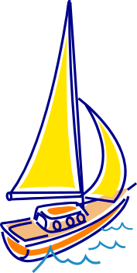
Volunteer opportunities

YBYC has opportunities for you to help. As a non-profit organization, our success depends on the strength of you, our members, and your involvement. Ways you can help include gardening, cleaning, teaching, joining the board, towing trailered boats to or from classes, representing the club at community events, work parties to maintain our buildings, docks, and boats, helping with races, hosting a meeting, sharing your experiences at meetings, mentoring new members and the list goes on.

Current Board positions available for 2009 term:
Historian
Publicity Coordinator
Membership

Talk to any Board Member about how you can get more involved in your yacht club’s activities.

For 2009 Board position information, contact Ken Brown or Mac McConnell.

Yaquina Bay Yacht Club
Newsletter

September 2008 Page 8
Clubhouse Update
September 3 – Summer Series, Evening October 1 - Fall Series - Evening
September 6 – Rented all Day October 2 – Skills Class – 5:30 p.m.
September 10 – Fun Race, Evening October 4 – Rented All Day
September 12 – Rented all Day October 8 – Fall Series - Evening
September 15 – Board Meeting, 7 p.m. October 9 – Skills Class – 5:30 p.m.
September 17 – Fall Series, Evening October 11-12 – Columbus Day Regatta
September 20 – Monthly Potluck, 6 p.m. October 13 – Board Meeting 7 p.m.
Sept 20-21 Adult Class- Beginning Small Boat October 16-19 – Instructor Training
September 24 – Fall Series, Evening October 18 – Monthly Potluck, 6 p.m.
Sept 27-28 Adult Class – Beginning Small Boat October 21 – Rented all Day
September 27 Fall River Clean-up AM

Please respect the privacy of our renters, their return business keeps the club going! Your ongoing help is appreciated in keeping our clubhouse neat and ready to rent, Thanks!
Contact Stephanie for rental or calendar information or go on the website.

Wednesday Night Race Results, Summer Series
PHRF | 7-9 | 7-16 | 7-23 | 7-30 | 8-6 | 8-13 | 8-20 | 8-27 | 9-3 | Total
Cheap Sunglasses | 1 | (11  DNS) | 2 | 1 | 2. | 2 | 1 | 3 | (9 DNF) | 12
Full Monty | 2 | 2 | (8 DNS) | 3 | 5.0 | 1 | (12 DNC) | 1 | 1 | 13
Annie’s Fannie | (4) | 3 | 3 | (4) | 3 | 3 | 3 | 2.8 RC | 2 | 18.8
Chey Breeze | (11  DNS) | 3.9  RC | 1 | 5 | 1.0 | 8DNF | 2 | 2 | (9  DNF) | 22.9
Slam Dunk | (3) | 1 | (8  DNS) | 2 | 4 | 4 | (12 DNC) | 4 | 9DNF | 33
Son O Beech | 8DNS | 5 | 6.7 RC | 7 | (12.0  DNC) | 5 | 5 | 5 DNS | (9 DNF) | 42
El Coyote | 8DNS | 4 | 4 | (12  DNC) | 7.0 DNF | 7.6 RC | (12 DNC) | 12 DNC | 3 | 44.6
Tenderly | 10.4RC | (12  DNC) | (12  DNC) | 12  DNC | 10.4 RC | 8 DNF | 10.4 RC | 8 DNF | 10.4 RC | 69.6
Crystal Echo | (12  DNS) | 6 | 5 | (12  DNS) | 12  DNC | 12  DNC | 12  DNC | 12  DNC | 12  DNC | 71
Kai Mu | (12) | (12) | 12 | 12 | 12 | 12 | 12 | 8 | 9 DNF | 77
Vela | 8 DNS | (12  DNC) | (12  DNC) | 12  DNC | 12 DNC | 12  DNC | 12 DNC | 12 DNC | 12 DNC | 80

