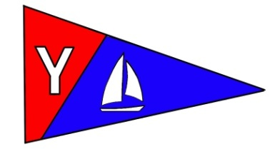
Yaquina Bay Yacht Club
Newsletter
October 2008

A publication for the Members and Friends of the Yaquina Bay Yacht Club
Commodore’s Log

It seems like the sailing season should be drawing to a close. You would think that with the unsettled wet weather moving in, but I’ve had several wonderful days on the water in the past few weeks. The crabbing has been great in the bay, and the salmon are just beginning to make a presence.

This coming weekend we have one of our biggest events – the Columbus Day Regatta, and the weather looks like it will cooperate nicely. Englund Marine is also sponsoring the “You Da Man” fishing tournament on Saturday. Luckily, the fishermen should be off the water or upriver by the time we get our races under way.

The preparations for the regatta are just about completed all we need to do is just add sailors. I hope to see you on the water, or if you are not sailing, at the tuna dinner on Saturday night.

In the wake of the Columbus Day Regatta we have our annual membership meeting on November 15th. Along with the election of new officers, the board will propose some changes to the club by-laws. I hope you plan to attend this meeting to participate in the voting and hear about plans for 2009.

The board has worked hard this year to standardize procedures and practices. We’ve put together Operating Procedures so future officers will be consistent in the application of rules and processes involving club resources and activities. Several members of the education committee have been working on a strategic plan document to help formalize and guide the educational component of the club.

Continued….Page 4
Log….Cont. from Page 1

2009 promises to be a year full of activities and growth for our club. In the meantime, we have several activities to keep us busy. Remember there are still great sailing days between storms. Be sure to take advantage when you can.

See you on the water.

-Joe

Calendar in Brief

October
11-12 – Columbus Day Regatta
13 – Board Meeting
18 – General Meeting
November
10 – Board Meeting
15 – Annual Meeting
December
8 – Board Meeting
20 – General Meeting
January
12 – Board Meeting
17 – General Meeting

Our Mailing Address is 750 SW Bay Boulevard, Newport, OR 97365

Our Website URL
Is www.yaquinabay yachtclub.org

For questions about the Club, contact Commodore Joe Novello at joenovello3@gmail.com
For questions about or contributions to this newsletter contact Stephanie Brown, editor, at 265-4575 or alaskamissy_2000@yahoo.com

Yaquina Bay Yacht Club
Newsletter

October 2008 Page 2
October Monthly Meeting and Potluck

Where: Clubhouse
When: 6 p.m. Saturday, October 18
Theme: Pirate’s Banquet

Ahoy mateys! Get yer eye-patch, parrot and peg leg out of the closet. Come to this month’s Pirate Banquet in costume. Any landlubbers not in proper pirate attire will be dressed by the captain and crew, so come as you are --- if you dare!

YBYC will provide Pirate Stew, bring along your favorite side, salad or desserts to share, your place setting. And don’t forget the yer GROG!

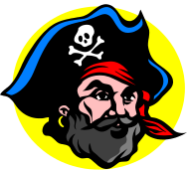

2009 Proposed Slate of Officers and Board Members

2009 Proposed Nominees, to be voted into office at the November 15 annual meeting of the Yaquina Bay Yacht Club membership.

#* | Commodore | Ken Brown
#* | Vice Commodore | Mac McConnell
#* | Rear Commodore | Open for Nominations
#* | Secretary | Alice McNamara
#* | Treasurer | Dorothy Bogumil
* | Fleet Chair | Tom McNamara
* | Race Chair | Terry Lettenmaier
* | Education Chair | Ron Cole
* | Membership Chair | Open for Nominations
* | House Chair | Stephanie Brown
* | Hospitality | Open for Nominations
* | Publicity Chair | Donita Cole
* | Newsletter and Web | Stephanie Brown
@ | Ship’s Store | Alice McNamara
@ | Historical Committee | Open for Nominations
# Denotes Club Officers *Denotes Board Members
@ Denotes Support Committees

Yaquina Bay Yacht Club
Newsletter

October 2008 Page 3
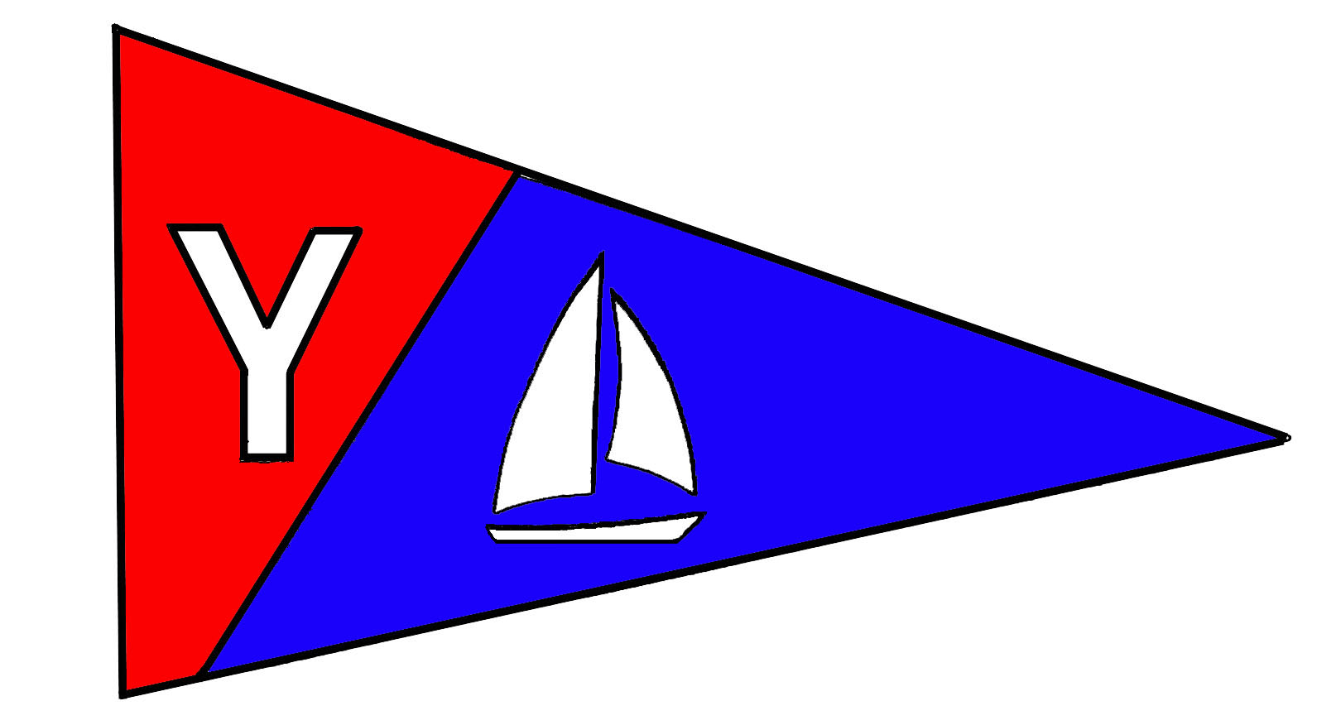

Members’ Corner

The 2008 YBYC Membership Roster is on G-mail and updated regularly. Please let me, Donita Cole, know if any of your contact information has changed so club members know how to reach you. To access YBYC’s discussion group on Google, use this web address: http://groups.google.com/group/ybyc You will be prompted to Log In or Apply for Membership (new log ons only)
Please remember to wear your new name tags at the meetings to help new (and old members) get to know you. Following the meeting, please return name tags to the name board in the hallway. The first name tag is free to club members but you will be asked to pay for the cost for a replacement. A note on nametags; they use strong magnets as fasteners, do not use if you have a pacemaker device! We’ll get you another tag, instead.

I will be resigning as Membership Chair at the end of this year. I have enjoyed working in this important position for the past four years. My plan is to help with the administrative duties of the club’s Educational and Non Profit activities. Please consider stepping forward to help the club as Membership Chair in this rewarding and necessary position. If you would like help learning the duties of this position, I am willing to help you.
--Donita

Columbus Day Regatta October 11-12

On October 11-12 YBYC hosts our largest regatta of the year.
With 30-40 boats on the water, we need lots of volunteers to
help with Committee Boat, Chase boat, Shore-side Hospitality
and more. Notice of Race and Entry forms are available on the
YBYC website. Contact Terry Lettenmaier, Race Chair, for
information on Racing or Volunteering lett@peak.org or 867-4603

We are offering a Fresh Grilled Tuna dinner on Saturday night, you
can purchase your dinner tickets at the clubhouse on Saturday
morning for $15.00. And you don’t even have to race!



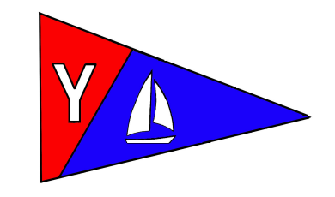
Yaquina Bay Yacht Club
Newsletter

October 2008 Page 4

Weekend Cruises
Join us for sailing excursions on the 1st and 3rd Sundays of each month. Upcoming dates are October 5 and 19 and November 2 and 16. Rally begins at noon near the CG buoy outside the Embarcadero Marina. All boats are encouraged to get out and enjoy our beautiful bay.

To really get these cruises going, we need skippers to choose dates that they’d like to be the Cruise Director. As Cruise Director, you can plan what sort of adventure we embark on. It’s as easy as telling us, “We’re going to picnic at Riverbend on Sunday.” Or “I’m heading to the Lighthouse at 11am.” Or whatever else you might like to do on the water on your day as Cruise Director.

There’s a discussion open on the Google Group, please use the forum to check on cruise plans and add your own ideas. It’s open for us all to post messages. Your input is needed! -Stephanie

Upcoming Cruise Directors

October 5 – Open
October 19 – Open
November 2 – Open
November 16 - Open

The November Annual Meeting needs your help!

The YBYC’s Annual Election of Officers and prime rib dinner is here. We need volunteers help this meeting go smoothly. Please help make the annual meeting the wonderful evening we've all come to expect by lending a hand--if you don't do it, who will? See list below for the sort of assistance we’re looking for.

Bake Scalloped Potatoes – 2 needed
Set-up, Decorate – 4 needed
Carve and Serve Dinner – 2 needed
Clean-up – 4 needed

Contact Stephanie Brown to help 541-265-4575 alaskamissy_2000@yahoo.com

Your invitation will arrive in the mail with your 2009 Dues Notice. Please RSVP early so we can plan the best event possible!

Yaquina Bay Yacht Club
Newsletter

October 2008 Page 5
Want to Make a Tax Deductable Donation?
That’s right. We now have the ability to accept tax deductible donations! We can do that through the newly formed Oregon Coast Boating Safety and Education Foundation (OCBSEF). This Corporation has been formed for the purposes of community boating education and, as such, is eligible for 501(c) (3) tax exempt status. So, please keep us in mind if you are thinking about making a charitable donation. We are looking for items that can be resold that have significant value, though your cash donation is always graciously appreciated.

Ron Cole, Education Chair

Club and Community Involvement

More and more people are getting involved in the club and the education program. Here are two examples:
Last month, Dan and Diane taught an Adult Beginning Sailing class. They had a full class with 10 students, 4 of which are interested in assisting with future classes. (Nice Job, you two!)

Terry will be overseeing the US Sailing Instructor class that is being held this month. I believe that 7 students are signed-up, with many of them being club members who are interested in teaching future classes. (Well done, Terry!)

Club and community involvement are what is making the club and the education program so strong. For those of you who are not yet involved, pleased consider joining us for next year. It is a gratifying way of giving back.

I can’t thank the instructors, the maintenance team, and all of the students enough. The education program has grown by leaps and bounds this year due to your contributions. None of this would have happened if it were not for your efforts. Thank you one and all!
-Ron Cole, Education Chair
Sailboat Racing News
Wednesday racing is all done for the year, but we can still have fun on the water. We have scheduled sailing excursions twice a month on the 1st and 3rd Sundays. See the article about Weekend Cruises for information (Page 4). There may not be scoring or trophies, but everyone always has a good time!
Now is a great time to join the Race Committee and get prepared for next year. We have opportunities for volunteers to help Terry with race planning, learning about racing strategy and tactics, learning to operate the chase boat, and learning how to be part of the Committee Boat’s crew.
2008 Race and Regatta results can be found on the Club’s website and at the clubhouse.

Yaquina Bay Yacht Club
Newsletter

October 2008 Page 6
Proposed Change to YBYC Bylaws

At November’s general meeting, we will be asking the general membership to vote on the following proposed addition to the YBYC Bylaws:

“The approval of a memorandum of agreement of memorandum of understanding requires a majority vote of the Board of Directors at a Board Meeting.”

Q: What is a memorandum of agreement?
A: “A memorandum of agreement is basically a contract among entities where each will do/give something(s) to the other.” Diane Henkels

Q: What is a memorandum of understanding?
A: “A memorandum of understanding is more a reflection of aspiration of where the two or more entities would [like] their relationship to take them.” Diane Henkels

Q: Who are the Board of Directors members?
A: “Members: the Board of Directors is Composed of the Commodore, Vice Commodore, Rear Commodore, Secretary, Treasurer, and the Chairpersons of the eight Operational Committees.” (Bylaws of YBYC, Article VI(A))

Q: Why do we want to change the Bylaws?
A: Our current Bylaws are silent as to who can approve either of the above memorandums on behalf of the club. This proposed change would define the approval process of such agreements. Requiring a majority vote of the Board of Directors has value because these agreements could have ramifications that could affect the whole club.

Q: Has the Club ever entered into such an agreement?
A: Yes. A memorandum of understanding was entered into for the benefit of this year’s youth sailing program.

Q: Does the Club expect to enter into these agreements in the future?
A: Yes. One expected use of a memorandum would be for an annual educational agreement with outside organizations and/or the Oregon Coast Boating Safety and Education Foundation. Another helpful use could be for documenting agreements between the Club and the Winery as it relates to the Seafood and Wine Festival.

If there are any unanswered questions, please feel free to contact me or any board member.
-Ron Cole, Education Chair

Yaquina Bay Yacht Club
Newsletter

October 2008 Page 7


Club Lido 14s on the dock

Two of YBYC's Lido 14s are on the dinghy dock and available for club member use. These 2 or 3 person dinghies are fun to sail and explore Yaquina Bay.
To use the Lidos, check the online calendar for availability, and place your reservation by contacting Stephanie Brown at alaskamissy_2000@yahoo.com or 541-265-4575; reservations are posted online on the club’s website www.yaquinabayyachtcluborg under the ‘Calendar’ tab.
Lido sails, rudders/tillers, and safety equipment are kept in the shed along with a sign-out sheet: indicate when and where you're headed and whether the boat needs repair once you return. Lido users must have a signed club waiver on file (available on the YBYC website). Happy sailing!

Volunteer opportunities

YBYC has opportunities for you to help. As a non-profit organization, our success depends on the strength of you, our members, and your involvement. Ways you can help include gardening, cleaning, teaching, joining the board, towing trailered boats to or from classes, representing the club at community events, work parties to maintain our buildings, docks, and boats, helping with races, hosting a meeting, sharing your experiences at meetings, mentoring new members and the list goes on. Many of the board chairpersons need helpers on their committees.

Current Board positions available for 2009 term:

Historian
Membership Chair
Boat Show Coordinator

Talk to any Board Member about how you can get more involved in your yacht club’s activities.

For 2009 Board position information, contact Ken Brown or Mac McConnell.

Yaquina Bay Yacht Club
Newsletter

October 2008 Page 8
Clubhouse Update
October 1 - Fall Series – Evening November 10 – Board Meeting 7pm
October 2 – Skills Class – 5:30 p.m. November 15 – Annual Meeting and
October 8 – Fall Series – Evening Election of Officers
October 9 – Skills Class – 5:30 p.m. November 16 – Rented All Day
October 10 – Rented Daytime
October 11-12 – Columbus Day Regatta
October 13 – Board Meeting 7 p.m.
October 16-19 – Instructor Training
October 18 – Monthly Potluck, 6 p.m.
October 21 – Rented all Day

Please respect the privacy of our renters, their return business keeps the club going! Your ongoing help is appreciated in keeping our clubhouse neat and ready to rent, Thanks!
Contact Stephanie for rental or calendar information or go on the website.

Did you know? Members can use the clubhouse for small informal gatherings anytime it’s not reserved or rented, with the understanding that other club members may use it also. And, you can have one no-charge, exclusive use of the clubhouse per year, with board approval. Check with the house chair before scheduling your event. In the case of informal member use, you may be bumped by a paying renter. For guaranteed exclusive use of the club, use your one annually allowed use, or you can always take advantage of the deeply discounted member-rental rates and rent the club as often as you like!

Wednesday Night Race Results, Fall Series
Unofficial Results
PHRF | 9-17 | 9-24 | 10-1 | 10-8 | Total
Cheap Sunglasses | (4) | 1 | 1
Annie’s Fannie | 2.0 | (8 DNC) | 5 RC
Chey Breeze | 3.0 | 5 RC | (7 DNF)
Full Monty | 1.0 | (8DNC) | 7 DNS
Son O Beech | 7 DNF | (8 DNC) | 7 DNF
Tenderly | (8 DNC) | 8 DNC | 7 DNF
Kai Mu | 7 DNF | (8 DNC) | 7 DNF



