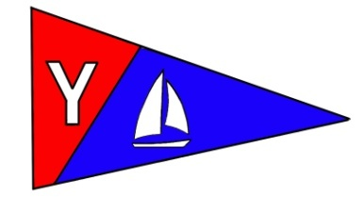
Yaquina Bay Yacht Club
Newsletter
July 2008

A publication for the Members and Friends of the Yaquina Bay Yacht Club

Commodore’s Log
 I hope you are all enjoying your summer. So many activities are happening with our club I am not able to participate in them all. Many of our members are working very hard to enhance our youth activities. July 19 these activities will culminate with a day-long celebration including racing, demonstrations, barbeque and more. The event promises to be great fun for all – drop by if you are in town.

One of the kids who will be at the fiesta is Asher Doyle. Asher is building his own eight foot sailboat. He has been working on the boat for just over a month and is just about finished. Asher will be at the fiesta, sailing his boat and sharing his experience building the boat with all who are interested.

Last night, July 9, was the first race of the summer season. The wind was 20 – 25 knots. Going out we knew this would be a test for boats and crew alike. Unfortunately El Coyote was the first to fall victim on their first race outing of the season with a broken halyard. Terry and Laurie took students from the sailing class out on the Lidos, and one broke a halyard. They both headed back to the docks for repairs.

The race was short, but it took
teamwork for the crews to get to the
finish line. It was nice to see Tim, Sarah,
and Jane together on The Full Monte. The
contest was hot between them and Cheap
Sunglasses – the results are yet to be
determined. The fleet was rounded out
with Slam Dunk and Little Annie’s Fannie.

……Continued Page 3
Inside this issue:
_____________

Monthly Meeting
Kayak Classes
….Page 2
Membership Corner
….Page 3
Racing
Cruising
….Page 4
Education Report
…Page 5
Seafest
…Page 6
Clubhouse Use
Race Results
…Page 8

Our Mailing Address is 750 SW Bay Boulevard, Newport, OR 97365

Our Website URL
Is www.yaquinabay yachtclub.org

For questions about the Club, contact Commodore Joe Novello at joenovello3@gmail.com
For questions about or contributions to this newsletter contact Stephanie Brown, editor, at 265-4575 or alaskamissy_2000@yahoo.com

Asher working on his boat
Yaquina Bay Yacht Club
Newsletter

July 2008 Page 2
July Monthly Meeting and Potluck

Where: YBYC Clubhouse
When: 1-5 p.m. Saturday, July 19
Theme: Sail Fest Youth Celebration
What's new about this upcoming YBYC general meeting? Lots! As you know, YBYC is busy this summer providing adult and youth learn to sail classes. The July 19th meeting will be highlighting the youth sailing classes with these kids racing in the club Lidos. Additionally, we will be providing rides in the Lidos to anyone else interested. Tom Murphy will be providing a kayak demonstration and the Coast Guard will be providing a helicopter and boat show. The festivities are open to the public so invite all your friends and neighbors. The day begins at 1 PM and culminates with a club sponsored barbeque at 5 PM. That's right! No need to bring a dish this month. And, since this is a youth oriented day, we are requesting you limit alcoholic beverages on the club house grounds. Just come enjoy a day at the clubhouse, rooting the kids on in their races and showing your support of the YBYC instructors.

Summer Kayak Classes – Register Now
Learn to enjoy the pleasures of kayaking safely by enrolling in the “Basic Coastal Kayak Strokes and Rescues” class taught by Tom Murphy, an American Canoe Association Certified Coastal Kayak Instructor. As part of its community boater education program, the Yaquina Bay Yacht Club is offering this course to the public as a way to encourage the safe and enjoyable use of kayaks at the coast.
The class is 1-1/2 days, held on Saturdays and Sundays . Saturday sessions are classroom instruction from 12:00 p.m. to 3:00 pm, followed by a 3:30-5:30 pm session at a local lake for safety and rescue practice. Sunday’s sessions start with on-the-water instruction on the Yaquina Bay/Estuary, or a more protected area if needed. This experience will allow practicing the knowledge and skills learned the previous day. Additional topics will include launching and landing, various strokes and maneuvers, boat control, as well as opportunities for sampling a variety of experiences related to kayaking at the coast.
Cost for the course is $100, which includes the use of a sea kayak, spray deck, paddles and safety equipment. Participants will need to furnish their own wetsuits and Coast Guard approved life jackets which can be rented from local surf/dive shops or borrowed from a friend. July’s classes are full already, but please contact Tom for availability of other classes coming up this summer and fall.

For a registration packet or further information, please contact Tom Murphy at 541.265-9648 or e-mail: coastalkayak@msn.com. Class size is limited to 5 students, and the registration deadline is coming fast. More classes may be offered if needed to meet demands of the students.

Yaquina Bay Yacht Club
Newsletter

July 2008 Page 3
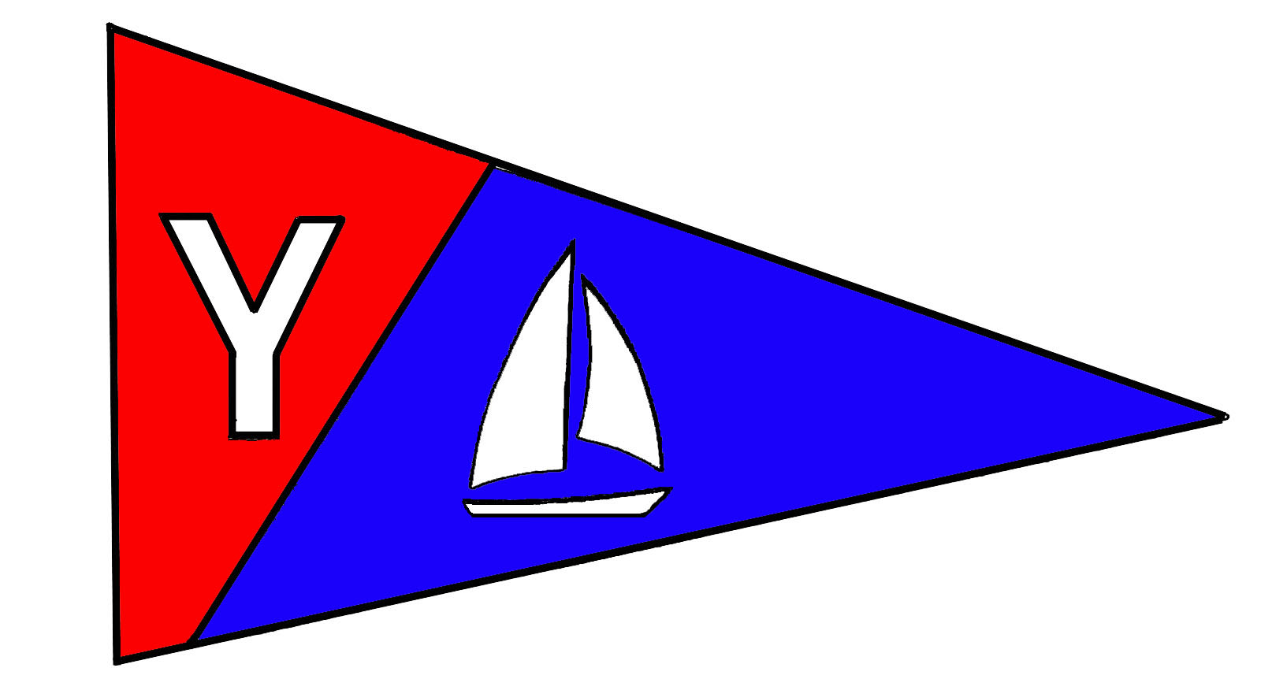

Members’ Corner
The 2008 YBYC Membership Roster is on G-mail and updated regularly. Please let me, Donita Cole, know if any of your contact information has changed so club members know how to reach you. To access YBYC’s discussion group on Google, use this web address: http://groups.google.com/group/ybyc You will be prompted to Log In or Apply for Membership (new log ons only)
Please remember to wear your new name tags at the meetings to help new (and old members) get to know you. Following the meeting, please return name tags to the name board in the hallway. The first name tag is free to club members but you will be asked to pay $5 (cost) for a replacement. A note on nametags; they use strong magnets as fasteners, do not use if you have a pacemaker device! We’ll get you another tag, instead.

4th Annual Toledo Wooden Boat Show August 23-24

Join us at the Port of Toledo to celebrate wooden boats of all shapes and sizes. This festival is growing fast and features live music, sailboat rides on our lidos, boat building and restoration, kayak demonstrations, non-motorized boat race, rowing competitions, beer garden by Rogue Ales, log rolling, and a Puddle Duck race. We need volunteers to staff the booth and talk to people about boating. Call Stephanie (265-4575) to help on this weekend, we need folks to help on both days at the booth for a couple of hours at a time, and to help transport Lidos.

……Commodores Log Continued from Page 1

After the PHRF fleet finished their race, the Lidos came back out for their own race. I was especially impressed when I heard Terry and Laurie explaining race starts and strategies to our new members.

Great things are happening in our club and I hope you are enjoying the activities as much as I am.

See you on the water.
-Joe

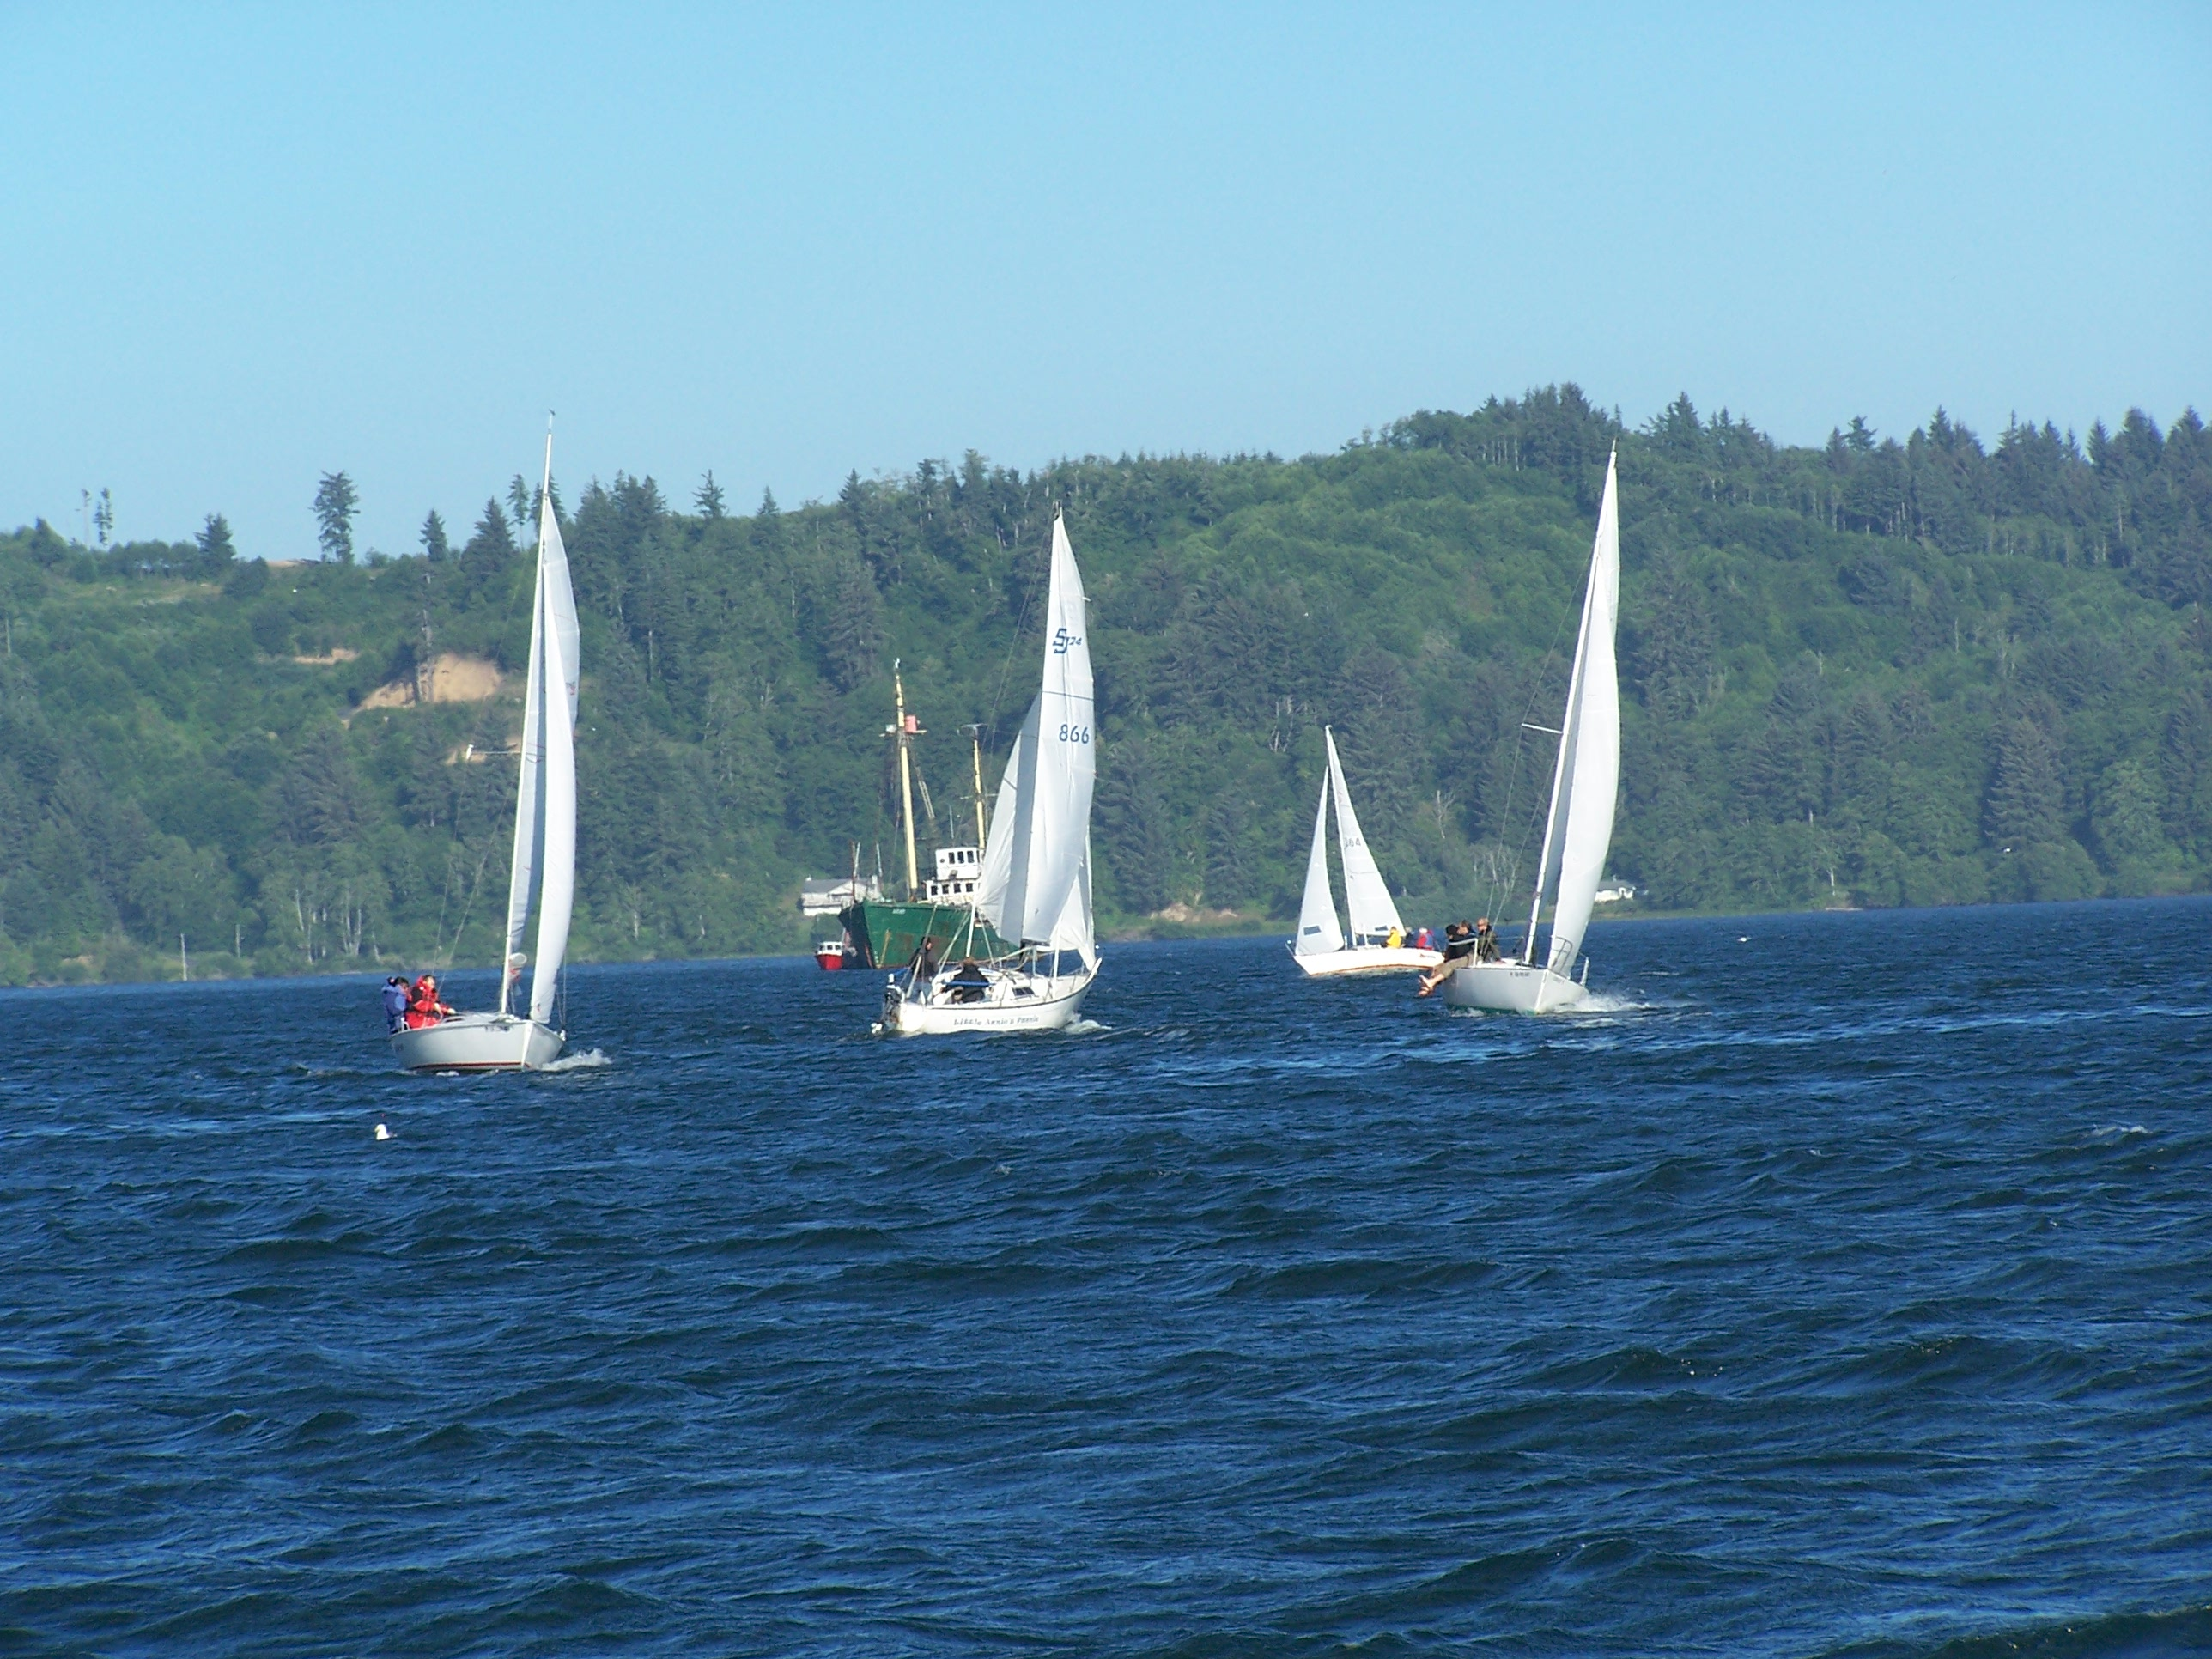

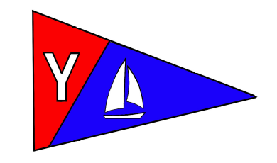
Yaquina Bay Yacht Club
Newsletter

July 2008 Page 4

Weekend Cruises
Join us for sailing excursions on the 1st and 3rd Sundays of each month. Upcoming dates are and July 20, August 3 and August 17. Rally begins at noon near the CG buoy outside the Embarcadero Marina. All boats are encouraged to get out and enjoy our beautiful bay.

To really get these cruises going, we need skippers to choose dates that they’d like to be the Cruise Director. As Cruise Director, you can plan what sort of adventure we embark on. It’s as easy as telling us, “We’re going to picnic at Riverbend on Sunday.” Or “I’m heading to the Lighthouse at 11am.” Or whatever else you might like to do on the water on your day as Cruise Director.

There’s a discussion open on the Google Group, please use the forum to check on cruise plans and add your own ideas. It’s open for us all to post messages. Your input is needed! -Stephanie

Upcoming Cruise Directors

July 20 –Doug Mecham
August 3
August 17

Sailboat Racing News

Spring series is in the books, and Summer series has just begun. Racing continues each Wednesday now through October 8. Sailing instructions and liability waiver forms are now posted on the web site and club bulletin board. Please see Terry Lettenmaier, race chair (lett@peak.org or 867-4603) during a club meeting to submit liability form and sign up for race committee/dinner host duties.

Race results can be found on the Club’s website and at the clubhouse.

Independence Day at YBYC!

4th of July saw many of the club’s members enjoying our clubhouse and it’s front-row view of the fireworks. George and Dave had a barbecue-in-a-box known as a Caja China, and were cooking up some fine pork. Max and Dorothy Blust even made the trip from Albany to say hello.


Yaquina Bay Yacht Club
Newsletter

July 2008 Page 5
Sailing Education Progress Report

The 2008 sailing education program has grown by leaps and bounds. Our new instructors are enthusiastically offering additional classes. There are new classes to take, such as Joe’s offshore class. To support the classes the club’s boats have been improved due to intensive maintenance. We even have a new boat.

A big congratulation to Terry on teaching his first adult learn-to-sail class with Laurie’s assistance. If you will recall Terry took the US Sailing instructor training course last year. The class had eight students and two families have become members. Great job Terry and Laurie. A big welcome to new members Steve, Ellen, Nathaniel and Alison Germaneri and to Gary and Vicki Mines!

Merry (who was also a graduate of last year’s US Sailing instructor’s class) and Doug have recently completed a very successful youth class in Lincoln City. I hope you saw the newspaper article covering the class. If not, it is posted at the club house. The article was impressive and our sister yacht clubs, EYC and TYC, are taking note of YBYC’s efforts.

In addition, Merry and Doug have youth classes at Waldport, Depoe Bay and Toledo. Please see our website for dates and sign-up sheets. A big round of thanks goes to Merry for her commitment to the youth program. She has committed almost every weekend of her summer to the kid’s program.

Doug has also made huge strides for the youth program this year. He and Debbie Jackson (Yachats Youth & Family Activities Program) have taken our once a year youth Lincoln City class and have expanded it into a countywide four class program. In addition, Doug has received a grant from the Oregon State Marine Board and YBYC is now the recipient of a new inflatable and outboard motor. In addition, Doug has also secured a substantial donation for the purchase of a new Club 420 sailboat. Thank you, Doug and Debbie.

While it is easy to recognize the efforts of the sailing instructors, we also need to remember those who support the instructor’s activities. George, Dave, Tom, Ken and Tim have put a lot of effort into the boats and trailers. Terry, Laurie, Larry D., George, Paul and Ken have put a lot of time into our new floating dock. Thank you one and all.

As you can see for yourself, a large percentage of our club members are contributing their time and energy to the education program. I would like to personally invite all club members to become involved in this worthwhile endeavor. Everyone in the club has something to offer. If you would consider volunteering your time, I would assure you that the rewards far exceed the investment.

Ron Cole, Education Chair

Yaquina Bay Yacht Club
Newsletter

July 2008 Page 6
YBYC Has a Non-Profit!
That’s right. We now have the ability to accept tax deductible donations! We can do that through the newly formed Oregon Coast Boating Safety and Education Foundation (OCBSEF). This Corporation has been formed for the purposes of community boating education and, as such, is eligible for 501(c) (3) tax exempt status. So, please keep us in mind if you are thinking about making a charitable donation. We are looking for items that can be resold that have significant value.
Ron Cole, Education Chair

Want to help kids connect with science?
YBYC had a kiosk at the HMSC Sea-Fest last month. We shared booth space with the Hatfield Students’ Organization. Our booth had a display about the club’s activities, photo albums to enjoy, and a knot tying demonstration. The Students’ group had a bubbling tank of ‘Sea Monkeys’ and a microscope to illustrate just what being a marine biology student is all about. It was a great opportunity to help the community learn about our club and how they can enjoy the waters where we live.

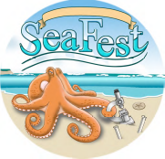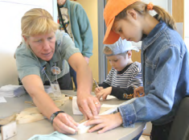
Club member Laurie Weitkamp

Join us for Sail Fest!
A premier event not to be missed! Join your fellow YBYC members in celebrating the successes of the sailing youth across Lincoln County. On Saturday July 19 from noon to 5pm, at YBYC we are hosting the first annual Sail Fest! celebration. This is your chance to lend a helping hand and an encouraging smile to cheer the graduates of the Youth Sailing program. Come and see the skills and confidence these sailors from Yachts, Waldport, Toledo, Newport, Depoe Bay and Lincoln City as they compete in our challenge course and Lido Match Racing in "Pirate Cove" (Area behind the sea wall). These hearty sailors will work up quite an appetite for more sailing as well as for our BBQ which YBYC is of course hosting. Join us for one afternoon of your time to support the youth in the community as well as your yacht club. Don't miss this opportunity. Call Ron & Donita Cole at 541.270.5900 to find out how you can make a difference in your community and the sport of sailing. Call today!
"But I can't make it to the Sail Fest! event. How else can I contribute?"
The continued success of the Youth Program has other needs as well. Got time? Help out by towing a small boat to/from the next class. Got more time? Stay for the day and help with the class. Got no time but want to contribute? You can make a tax deductable donation to the youth program, or Sail Fest!. Ron Cole can tell you the details about donations. 541.270.5900

Yaquina Bay Yacht Club
Newsletter

July 2008 Page 7
Adult Sailing Classes
September may seem a long time off, but the next round of Adult Sailing courses are just around the bend. Be sure to spread the news to your friends, family and co-workers. Space is limited so sign up soon. Registration information is available on the YBYC website at www.yaquinabayyachtclub.org
Adult Small Boat Beginning Sailing - September 20-21, 27-28

Adult Keel Boat Beginning Sailing -September 13-14, 20-21, 27-28

Club Lido 14s on the dock

Two of YBYC's Lido 14s are now on the dinghy dock at Port dock 7 and available for club member use. These 2 or 3 person dinghies are fun to sail and a great way to explore Yaquina Bay or practice your sailing skills.
If you would like to use the Lidos, check the online calendar for availability. To place a reservation, please contact Stephanie Brown by email or phone at alaskamissy_2000@yahoo.com or 541-265-4575; reservations are posted online on the club’s website www.yaquinabayyachtcluborg under the ‘Calendar’ tab.
Lido sails, rudders/tillers, and safety equipment are kept in the shed along with a sign-out sheet: please indicate when and where you're headed and whether the boat needs repair once you return. All Lido users must have a signed club waiver on file (available on the YBYC website). Happy sailing!

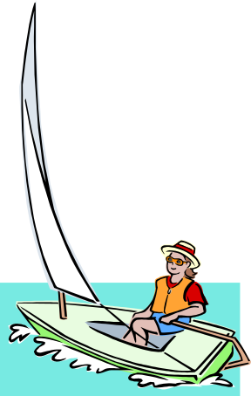
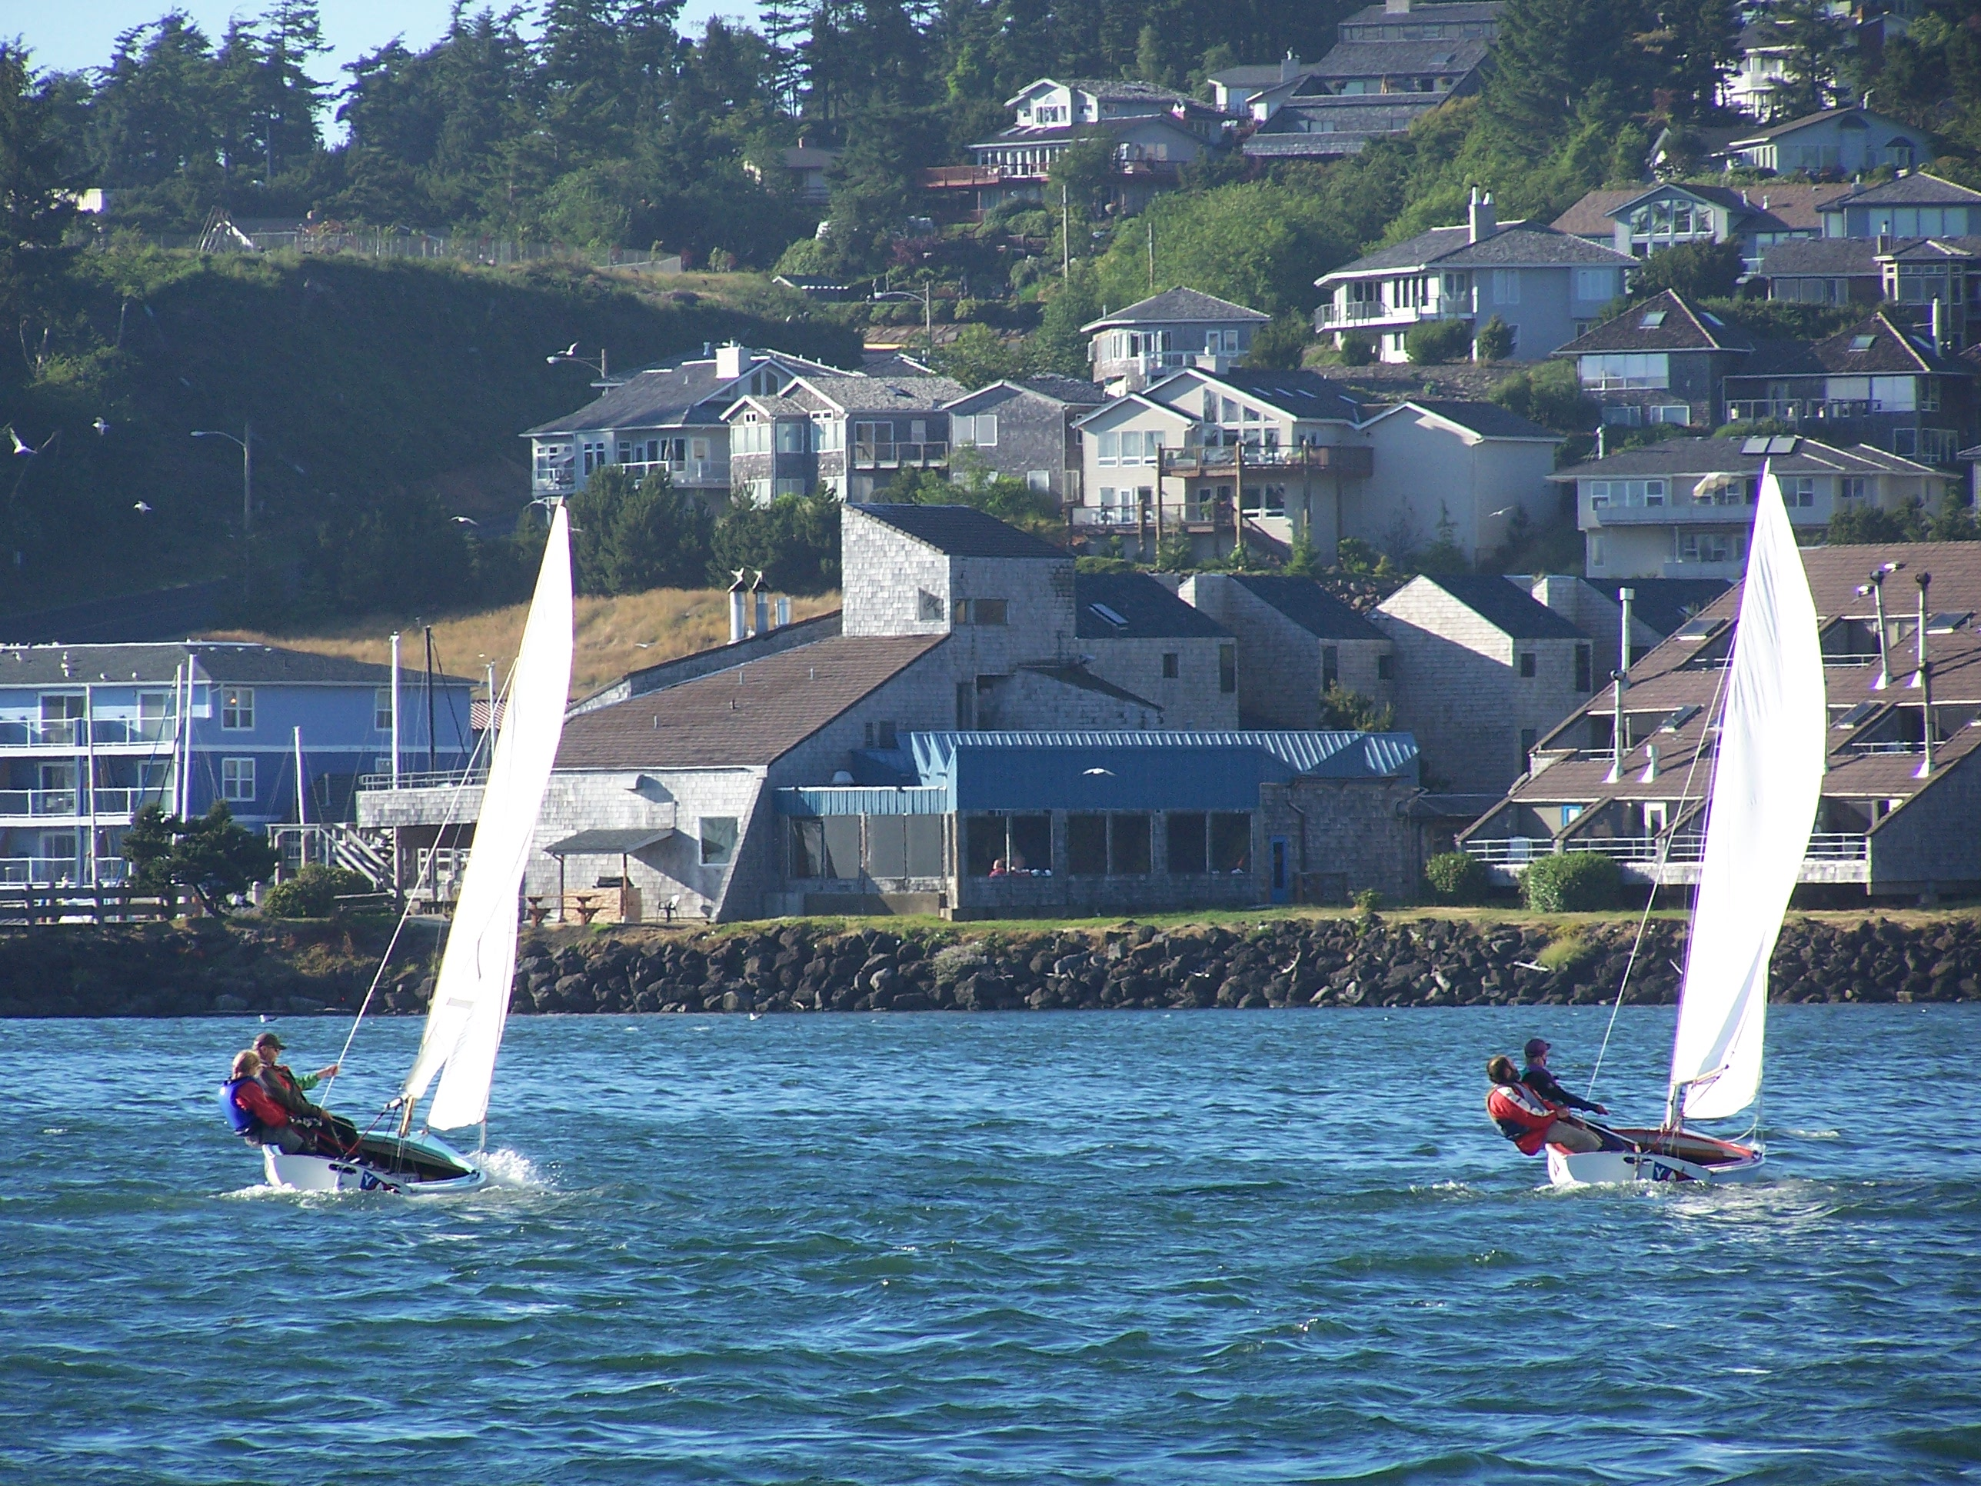
Terry and Laurie mentoring new sailors aboard the club’s Lido 14s
Yaquina Bay Yacht Club
Newsletter

July 2008 Page 8
Clubhouse Update
July 9 – Summer Series, Evening August 2 – Rented – All Day
July 10-11 Rented August 6 – Summer Series, Evening
July 13 Rented Daytime August 11 – Board Meeting, 7p.m.
July 14 – Board Meeting, 7 p.m. August 13 - Summer Series, Evening
July 16 – Summer Series, Evening August 16 – Monthly Potluck, 6 p.m.
July 17 – OSMB Class – Evening August 16 – Kayak Class - Daytime
July 19 – SailFest! 12 p.m. August 20 – Summer Series - Evening
July 23 – Summer Series, Evening August 22 – Rented All Day
July 24-25 – Rented Daytime August 27 – Summer Series, Evening
July 26 – Kayak Class, Afternoon
July 30 – Summer Series, Evening

Please respect the privacy of our renters, their return business keeps the club going! Your ongoing help is appreciated in keeping our clubhouse neat and ready to rent, Thanks!
Contact Stephanie for rental or calendar information or go on the website.

Wednesday Night Race Results, Spring Series
PHRF | 4-30 | 5-7 | 5-14 | 5-21 | 5-28 | 6-4 | 6-11 | 6-18 | 6-25 | Total
Full Monty | (1) | (1) RC | 1 | 1 | 1 | 1 | 1 | 1RC | 1 | 7
Cheap Sunglasses | (3) | 1 | (2) | 1.9 RC | 2 | 2 | 2 | 1 | 2 | 11.9
Annie’s Fannie | 2 | 2 | (3) | 3 | 3 | (5) | 3.8 RC | 9  DNC | 3 | 19.8
Chey Breeze | (4.4) RC | 4 | 4 | 4 | (6)  DNF | 3 | 3 | 2 | (9  (DNC) | 24.4
Tenderly | (9) DNC | 3 | (4.8) RC | 2 | 4 | 4 | 4 | 3 | 9 (DNC) | 24.8
Son O Beech | 5 DNF | 5 | (9)  DNC | (9)  DNC | 9  DNC | 9 DNC | 9  DNC | 4 | 9  DNC | 50
Crystal Echo | (9)DNC | (9)  DNC | 9 DNC | 5 | 9  DNC | 7 DNF | 6 | 9  DNC | 9  DNC | 54
El Coyote | (9) DNC | (9)  DNC | 9 DNC | 9 DNC | 9 RC | 9 DNC | 9DNC | 9  DNC | 9DNC | 63
Portsmouth
Terry | (1) | (1) | 1 | 1 | 1 | 1.4 RC | (2) | (3) | 1.4 RC | 7.8
Laurie | (3) DNC | (3)  DNC | 2 | 2 | 2 | 3 DNC | 1 | 3 | 2.4RC | 15.4

