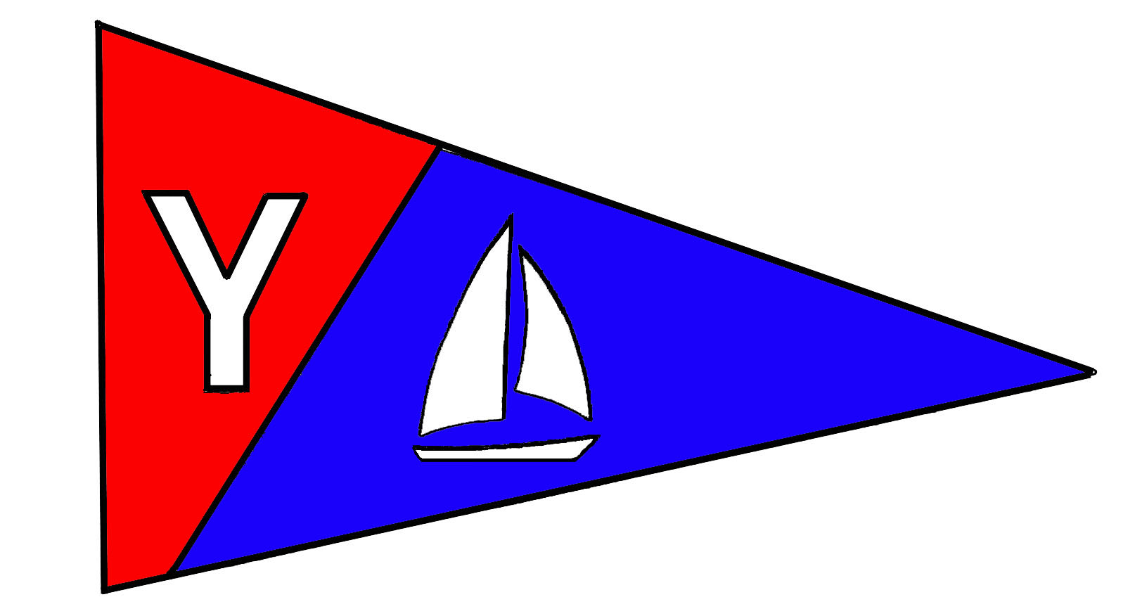
Yaquina Bay Yacht Club
Newsletter
December 2007

A publication for the Members and Friends of the Yaquina Bay Yacht Club
Commodore’s Log
 The new board of directors met for the first time as a team this week and we had a very productive meeting. It is exciting to hear all the great ideas folks have to support the growth and well being of the club. Peggy Novello has filled in as the club secretary and the board kept her busy logging all the activities planed for the coming year. Our treasurer Dorothy Bogumil returned from her South America trip (our finances are still intact) and will keep track of the growing budget, including the Non-Profit.
Vice Commodore Ken Brown is organizing the annual Newport Wine and Seafood Festival booth. Be sure to check your calendar and contact Ken if you would like to reserve one of the available time slots in the booth. Rear Commodore Mac McConnell is working with Membership Chair Donita Cole to develop a new member mentoring program. The program will include a list of mentors and a checklist of activities they may help new members participate in.
Race Chair Terry Lettenmeier will be busy with the regular race schedule of regattas and Wednesday night racing plus the addition of year round weekend racing and the Rogue Commodore's Challenge. We are looking for some of our members with power boats who may like to help provide a platform for the race committee.

Inside this issue:
Monthly Meeting
YBYC Non-Profit
….Page 2
Nov. Meeting Recap
Commodore’s Ball
….Page 3
Clubhouse News Boat Parade
….Page 4
Incoming Board
…Page 5
2008 Calendar
Clubhouse Use Policy
….Page 6

Our Mailing Address is 750 SW Bay Boulevard, Newport, OR 97365

Our Website URL
Is www.yaquinabay yachtclub.org

For questions about the Club, contact Commodore Joe Novello at NovelloJ@charter.net
For questions about or contributions to this newsletter contact Stephanie Brown, editor, at 265-4575 or alaskamissy_2000@yahoo.com

We are also looking for members who may not have their own boats who would like to learn to be race committee under the guidance of some of our more experienced members.
Ron Cole has taken on a huge responsibility with the Education program including Fleet and Moorage. Ron has some very exciting plans for coming year and I'm sure you will be hearing about all the activities each month as we move forward with youth sailing and the non-profit sailing program. Laurie is still looking for some hosts and helpers for the monthly pot luck meetings, please give her a call if you can assist.
Stephanie Brown is really stepping up to the plate with the House, Newsletter, Calendar, and Webpage. More information about these activities can be found in this newsletter. Marge Burak and Dick Schwartz are taking over the Ship's Store with ideas emerging about selling our wares online and in stores around town.
So many exciting things are going on thanks to the many hours our members put into the club. Please contact any of your board members if you would like to join in to enhance any of the activities mentioned, or suggest others that will support the growth and prosperity of our club.
See you on the water,

-Joe Novello

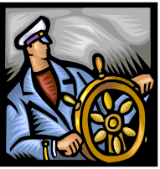
Yaquina Bay Yacht Club
Newsletter

December 2007 Page 2

December Monthly Meeting and Potluck

Where: YBYC Clubhouse
When: 6 p.m. December 15
Theme: Holiday Cocktail Party
Provided: Punch and Cookie Decorating
Bring: Appetizers or Desserts to share, Beverages, and your Place Settings.

Instead of the usual gift exchange, we are accepting your $10 donation to Lincoln County Food Share. Wear your Holiday Attire and celebrate the holiday season at this month’s meeting. YBYC is providing Punch, both adult and regular, and Cookie Decorating Supplies.



YBYC Gains Non-Profit Status
That’s right. We now have the ability to accept tax deductible donations! We can do that through the newly formed Oregon Coast Boating Safety and Education Foundation (OCBSEF). This Corporation has been formed for the purposes of community boating education and, as such, is eligible for 501(c) (3) tax exempt status.
It is our hope that we can use this entity to fund the purchase of a newer fleet of boats for training purposes. If it goes really well, it might even be able to fund the construction of a structure adjacent to the club house. Such a structure would be useful for storing our boats and equipment out of the weather, as well as give us a place to make repairs.
So, please keep us in mind if you are thinking about making a donation for the 2007 tax year. We are looking for items that can be resold that have significant value. If you are accustomed to donating the usual menagerie of odds and ends to the likes of Salvation Army or Goodwill, please continue to do so. We do not have the ability to convert those items into cash. Speaking of cash, we would be happy to accept any checks that you would care to tender. (Big Smile.)
Thanks again to Jeff Pridgeon and Mike VanBlokland for the professional services needed to make this happen. A thank you also goes to the Brittains for their donation of artwork and to the Batemans for the donation of their sailboat.

We appreciate you keeping us in mind.

Ron Cole, Education Chair

Yaquina Bay Yacht Club
Newsletter

December 2007 Page 3

November’s Annual Meeting and 60th Anniversary Celebration
The November General meeting was a tremendous success. To help celebrate the 60th anniversary of our club, several past commodores came and shared the highlights of their tenure at the helm.
We would like to thank the commodores for celebrating with us. The clubhouse was what one member described as "magical" with crystal centerpieces, glittery sparklies, and festive lighting. Thank you to Donita and Ron Cole, Vicki Meyer, Sarah Myrick and others.
Prime rib was prepared by George Benton and Dave Schmaltz, under the careful watch of Barb Schmaltz. The festivities were coordinated by Mary Ann Beggs and Laurie Weitcamp. Laurie provided the slide show of our history. Ted did a nice job as emcee. Thank you to all the members who stepped in at the end of the meeting to help clean the clubhouse. We had yet another memorable annual meeting.

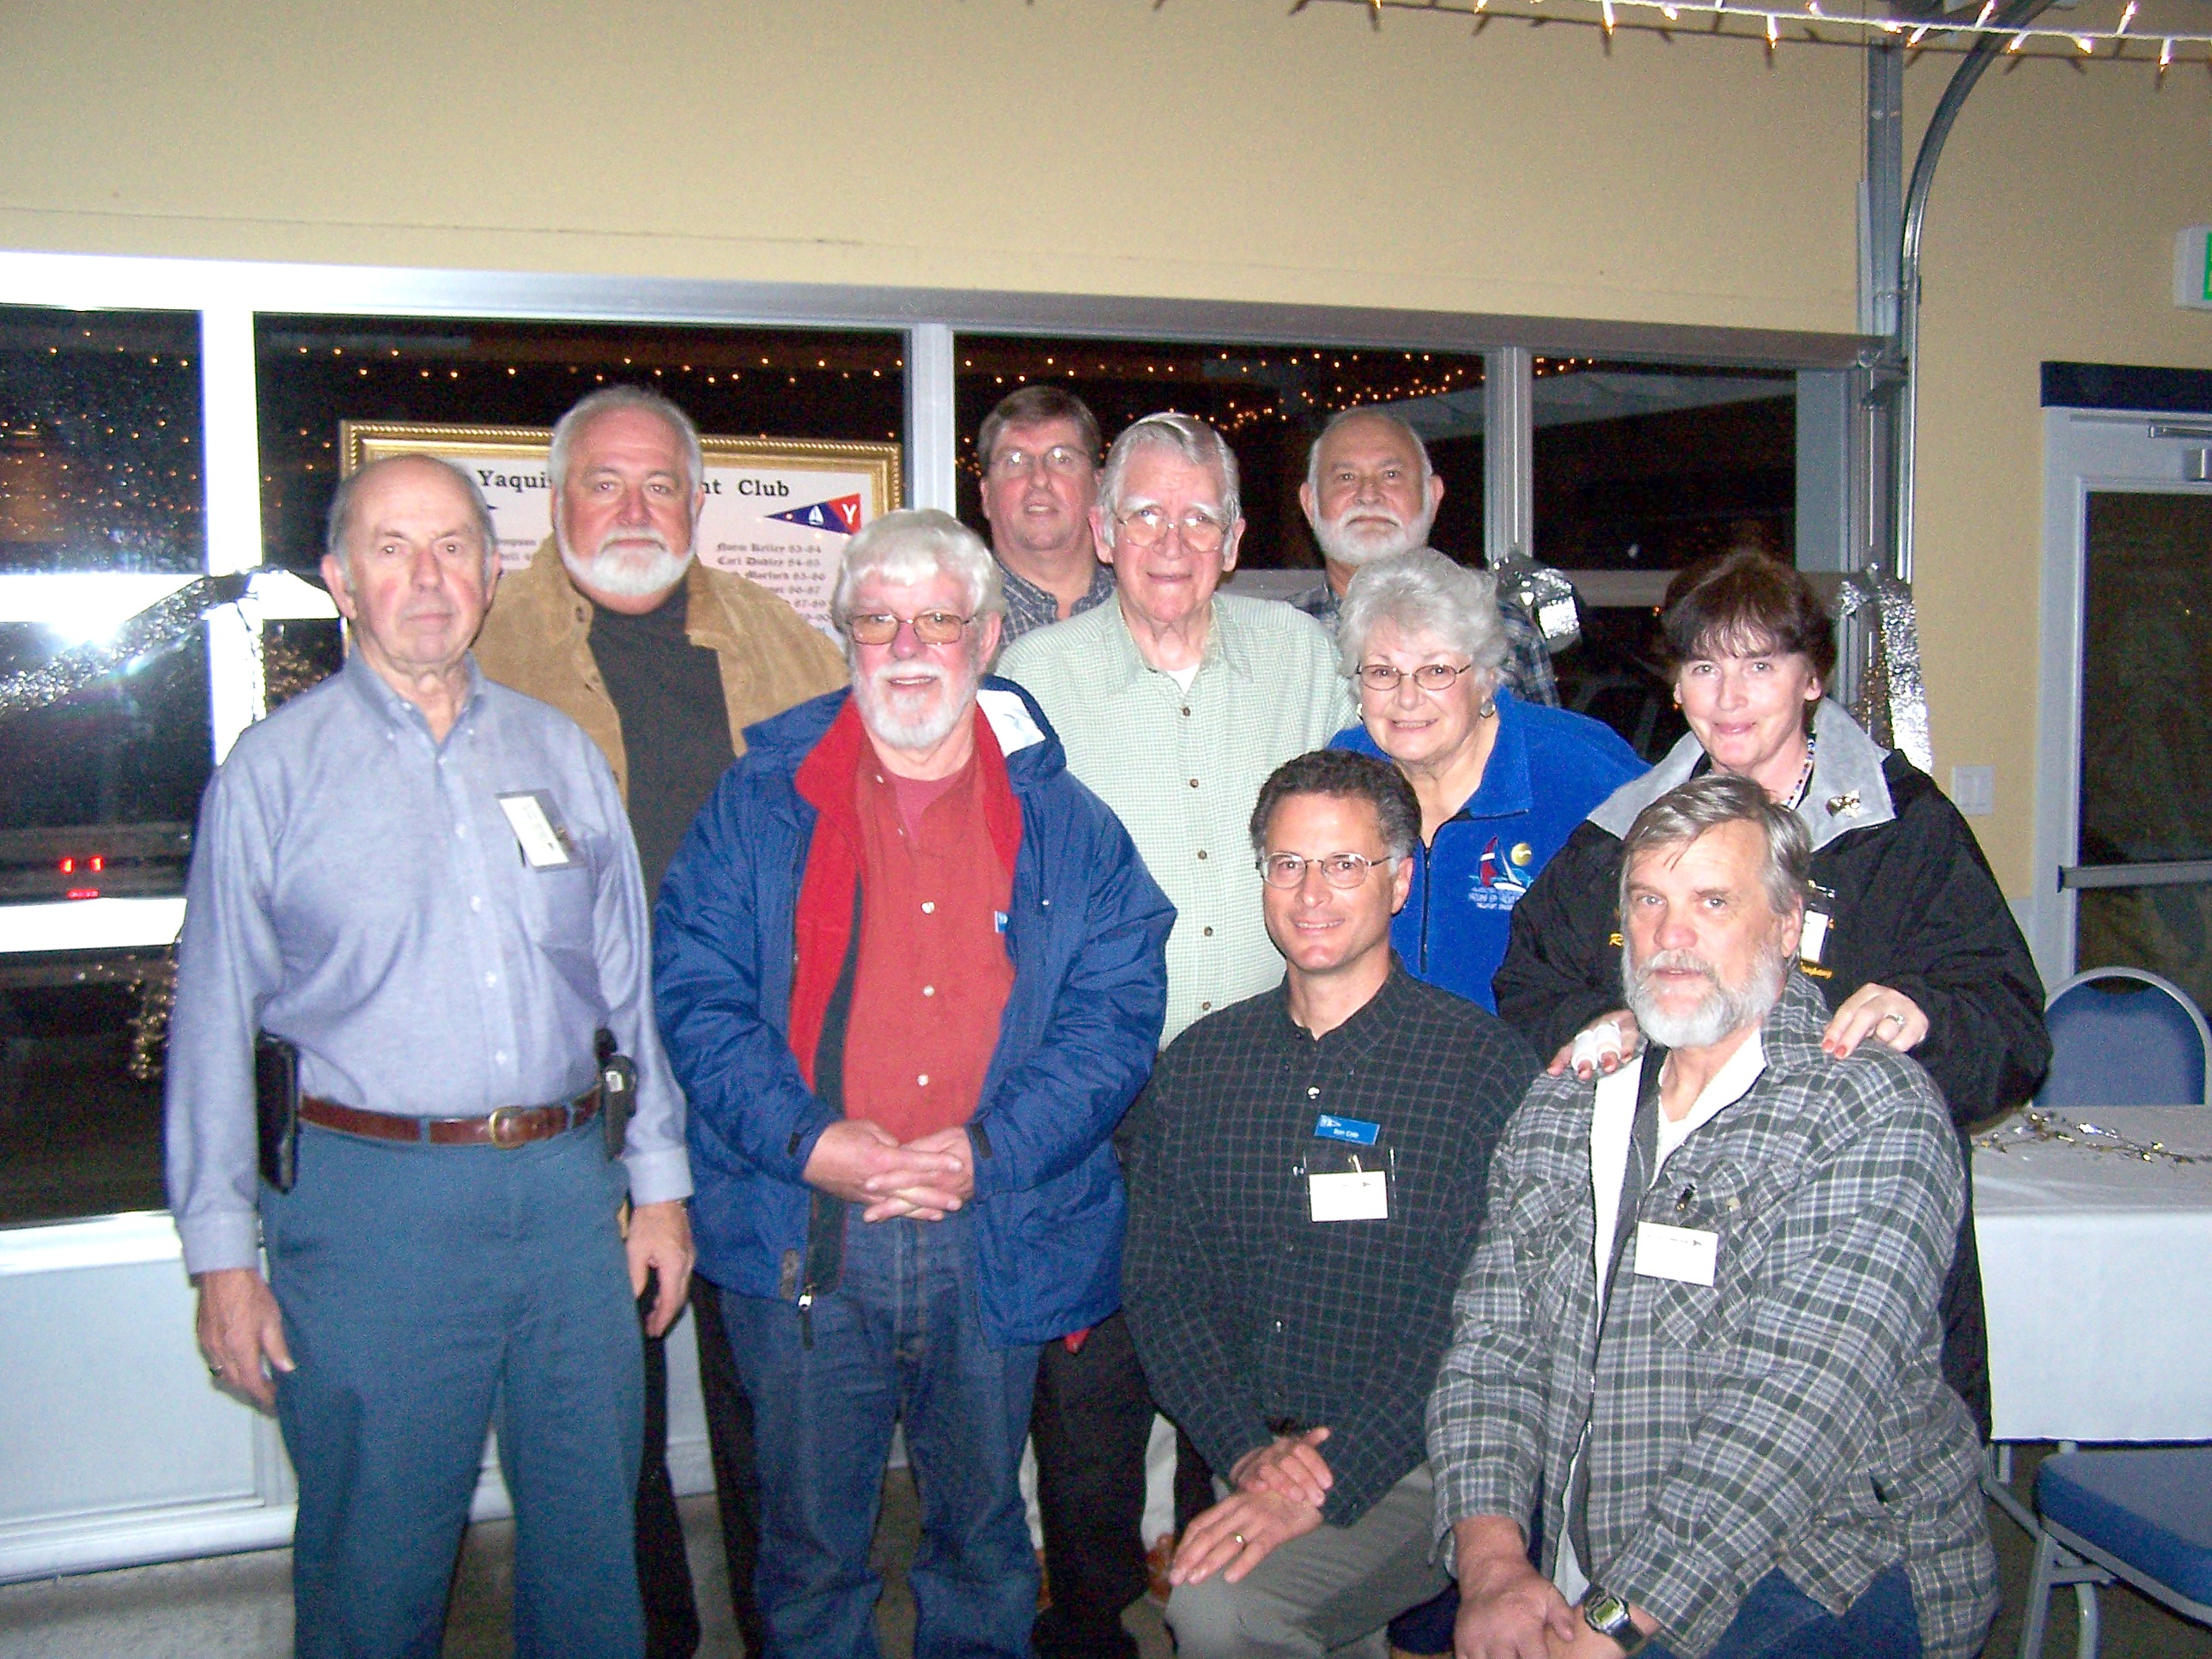

Past Commodores, from left,
Norm Kelley, Ted Thurman, Buzz Williams, Tim Myrick, Carl Dudley, Ron Cole (kneeling), Bart Boyer, Dorothy Bogumil, Dave Morford (kneeling), and Ruth Morford.

Mark your calendars for our upcoming formal gala. Join us February 16 at 6pm to kick off the YBYC Commodore’s Ball. Prices are still being negotiated for this catered dinner and dancing event, featuring cuisine from Local Ocean Seafoods and a live band! Watch in the newsletters and the Google group for details as they emerge.

Clubhouse Update
Dec 7 Rented – Afternoon –Evening
Dec 12 Rented Daytime
Dec 13 Rented Daytime
Dec 15 6 p.m. Monthly Potluck
Dec 16 Rented Evening
Jan 3 Board Meeting 7pm
Jan 9 Rented Daytime
Jan 19 General Meeting 6 pm

Please respect the privacy of our renters, their return business keeps the club going! Your ongoing help is appreciated in keeping our clubhouse neat and ready to rent, Thanks!
See our calendar on the website for a complete list of rentals and activities.
http://www.yaquinabayyachtclub.org

Board Meetings Changed

YBYC board meetings have been moved to the second Monday of each month at
7 p.m. at the clubhouse. This change goes into effect beginning in January. The board meetings are open for all club members to attend.


Membership Corner
Please remember to send your renewal form and dues in to Dorothy Bogumil as soon as possible. After January 15th you will lose your YBYC membership if your dues have not been paid.
We have new permanent name tags thanks to Stephanie Brown’s efforts. Please note the large print so those of us with failing eye sight can read them!
To find the most recent roster information, log on to the YBYC Google Group. To access YBYC’s discussion group on Google, use this web address:
http://groups.google.com/group/ybyc
You will be prompted to Log In or Apply for Membership (new logons only).

14th Annual Lighted Boat Parade
Despite the impending storm, a dozen boats paraded around the bay on Saturday, December 1 showing off their Christmas spirit in lights. A fund raiser for the hospital, this event kicks off the Festival of Trees. YBYC was well represented by members Blaine Crichton and his sailboat, Ken, Stephanie and Annabelle and their sailboat, and Tom Murphy and his kayak.
The grand prize for best decorated boat went to former club members Don and Pam Holthofer and their sailboat, Silent Running.

Yaquina Bay Yacht Club
Newsletter

December 2007 Page 4
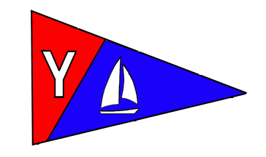
Yaquina Bay Yacht Club
Newsletter

December 2007 Page 5
 Weekend Cruising
By popular request, weekend sailing has been extended from only winter to stretch all year round. Each month on the 1st and 3rd Sundays at Noon, join the fleet on the water for a sail. These aren’t races; they aren’t timed or scored, they’re just for fun! Events are open to anyone and, of course, are weather dependent. Upcoming dates are December 16, January 6, 20, February 3, 17.

Special Thanks
During the past couple of years many people have helped with special events including regattas, annual meetings, and Wednesday night racing.
One person in particular has been a key part of all these events, working in the background. This month we would like to say a special thank you to Barb Schmaltz. Barb's latest efforts include coordinating the cooking of the prime rib at our annual November.
Barb has designed many of the tee shirts and trophies for our regattas as well as coordinating and cooking the food at all the events. Thank you Barb!

2008 Board of Directors

At the November meeting we installed YBYC’s 2008 Board of Directors and Committee Chairs. There are many committees with opportunities to help, contact any board member if you’re interested.

Joe Novello – Commodore
Ken Brown – Rear Commodore
Mac McConnell – Rear Commodore
Peggy Novello – Secretary
Dorothy Bogumil – Treasurer
Terry Lettenmaier – Race and Cruising
Stephanie Brown – House
Ron Cole - Fleet
Laurie Weitkamp – Hospitality
Donita Cole - Membership
Stephanie Brown – Newsletter / Web
Ron Cole - Education
Marge Burak and Dick Schwartz – Ship’s Store

Club Historian Needed

60 years and still going strong, YBYC is looking for someone to help compile records and memorabilia of the club’s events. Scrapbookers, this is a job for you! Contact a board member or come to the next board meeting.
Yaquina Bay Yacht Club
Newsletter

December 2007 Page 6

YBYC 2008 Calendar of Events
The upcoming year has something for everyone! If you receive this newsletter by email, the Calendar is attached in PDF format. You can also view and print it from the Google group. For even more detail, the YBYC website has a calendar that is up to date with all the clubhouse reservations on it, too. Highlights for 2008; Seafood and Wine Festival February 22-24, Loyalty Days Regatta April 26-27, Columbus Day Regatta Oct 11-12, Offshore Classes Wednesday Evenings in March, Adult Sailing Class in May, Keelboat Sailing Class in September, Youth Classes in March and June.

Member Clubhouse Use Policy
A new year upon us, here’s a refresher for using the clubhouse. Contact Stephanie Brown with questions or for help scheduling your event.

Members are welcome to use the clubhouse unless it has been reserved for private use. Please check the calendar in the clubhouse or the YBYC website for a schedule of events and respect the privacy of our renters.
Members may use the clubhouse for a small informal gathering of friends or family as long as it is understood that other members may be using the clubhouse at the same time. Members must remain with non-members at all times.
Members who want to schedule a private party must schedule it with the House Chair, pay the posted fee and security deposit. Gatherings such as business meetings, family reunions, large birthday parties, holiday parties, anniversary parties, weddings and/or wedding receptions will be subject to fees.
Each Membership may sponsor one non-profit use of the clubhouse, at no charge, each calendar year.
You can find the rental forms and rates on the club’s website.

Before Using the building: Check the calendar and contact Stephanie Brown to schedule your event. While using the building: No Smoking in the building. Do not make holes in the walls or wood, do not use tape on painted surfaces. Be careful with the club’s furniture. Stay with non-members. When you’re done: Remove your items from the refrigerator. Clean up the building and grounds. Place bagged trash in the trash can and place the trash can(s) outside for pick-up. Turn off appliances, fireplace, and lights, turn down the heat. Lock the garage door, windows, and doors.

